Libyan International Medical University
Faculty of Applied Medical Science

The Incidence Rate of Asymptomatic Bacteriuria among Of Participants: 63 (33 Females and 30 Males) Of LIMU Students
Student name: Nouralhuda Abdalsalam Ali
Student number: 3073
Supervisor name: Dr. Asma
Tutors name:

Abstract:
UTI and asymptomatic bacteriuria occur due to bacteria present on the skin and around the rectum and vagina The aim of this report to know the incidence rate of asymptomatic bacteriuria among of participants: 63 (33 females and 30 males), also understand the correlation between it and the gender and because there is a confusion between it and the UTI. A macCkonkey and blood agar were used to wipe the urine sample on it in the experiment. The biostatics was done by chi square shows 00 of females and 00 of males was significant no growth and 00 of females was positive. The result shows more infection in female than males.

Introduction
UTI refers to a group of common diseases, that caused by bacterial infection occurs by ascension of normal enteric flora through the urethra ‘most of the time’ into the urinary bladder, known as cystitis and as pyelonephritis when the infection happened in kidney, they both have a different symptoms.
There was also some cases how have not symptoms, and latter falls under the asymptomatic bcteriuria which refers to isolation of bacteria from a urine sample from individual without symptoms of UTI.
UTI in general were more common in females then males; due to their anatomy ‘shorter urethra than males’, sexual activity, types of birth control for example women that use diaphragms or spermicidal agents for birth control may had a higher risk than others, and increase in incidence after the menopause. some studies refered that to the decline in the estrogen, catheter use and urinary tract abnormalities may cause it. MacConkey and blood agar have been used for the test. MacConkey agar was a selective and differentiating agar that have been used for gram-negative bacterial species. The differentiation based on their lactose metabolism; MAC contains a pH indicator that turn into pink colonies under acidic conditions, if the bacteria is a lactose fermenting and off-white colonies in the non-lactose fermenting, some examples for the lactose positive species are Escherichia coli, Klebsiella, Enterobacteria and some examples for the lactose negative species are Proteus, Yersinia, Salmonella, Pseudomonas. Blood agar is widely used in developing countries to differentiate and detect hemolytic bacteria ‘the ability of bacteria to destroy the RBC’ from clinical specimens especially those that are more difficult to grow, this agar differentiate the bacteria in to β-hemolysis refers to complete hemolysis such as Staphylococcus, α- refers to partial hemolysis such as Streptococcu and γ-hemolysis or non-hemolytic bacteria such as Enterococcus, the aim of this report; to explain the relation between the gender and the UTI and because there was a confusion between it and the asymptomatic bactiruira.
The result of the test in this lab report was that females were clearly more vulnerable than males.

Materials and methods
Before any test or experiment, you should make sure that the surface around was free and sterile, also you need to make sure that you wearing a mask, gloves, and scrub or lab coat, the first procesure was to flame a calibrated wire loop, after that mix the urine sample well, take the loop and insert it vertically into the urine to allow the urine adhere to the loop, hold the agar and spread the urine over its surface by streaking down middle of agar plate, then with the same loop go back and streak across the center inoculum to dilute, when you finish the wiping put the culture in the incubator for 24h at 37 C in air, after a day count the colonies on each plate, the number of CFUs is multiplied by 1000 if a 0.001 ml loop used or by 100 if a 0.01 ml loop was used to determine the number of microorganisms per ml in the original specimen. For this test the media that used in urine culture was 5% sheep blood agar plate, CLED and macCkonkey agar plate allows detection of most gram negative bacilli, staphylococci, streptococci and enterococci.
For the colonies number in samples obtained from a midstream void, ≥1 × 105 CFU/µL is consistent with infectionand and in samples collected via catheterization, ≥1 × 102 CFU/µL is consistent with infection.

Results and discussion
In this experiment we worked in incidence rate of asymptomatic bacteriuria among of participants; to know and understand the different between UTI in males and females. After doing SPSS statics “chi square test” for the results that shown in the lab, where the number of individuals who have been underwent this experiment are 63 ‘33 females and 30 males as a result we found that there no growth in (2) 16.7% of females and (9) 75% in males which means all of the males were negative. The overall no significant growth was (8) 66.7% in females and (3) 25% and the significant growth was (0) 0% in males and (2) 16.7% in females. The results prove that it is more present in females then in males due to different reasons some of them were mentioned in the introduction such is short urethra and sexual activity ect…
5% sheep blood agar plate, CLED macCkonkey were used and the result shows positive growth for E.coli bactereia, it is a Gram -ve (Negative) organism that characterized by straight, rod shape (bacillus) bacterium in shape, about 1–3 µm × 0.4–0.7 µm (micrometer) in size, arranged singly or in pairs, could be motile or non-motile, it is a flagellated bacteria with peritrichous flagella arrangement and it is also non–sporing bacteria.
In MacConkey Agar medium, the colonies of Escherichia coli are pink in color because it is a lactose fermenting bacteria and that is importance in differentiating E. coli from other Bacteria.
In Blood Agar medium, some of the strains show beta hemolysis, especially which are isolated from the pathologic conditions whereas those which are isolated from normal persons may or may not show hemolysis on blood agar.
The surface in both media was smooth ‘fresh isolation’ and muciod capsulated stains.
We need to mention that if there is no or little growth on the agar after 24 to 48 hours of incubation, the urine culture is considered negative.
As a treatment for UTI Antibiotics are the mainstay of treatment. During the first few days of a bladder infection, phenazopyridine is sometimes prescribed in addition to medicines to treat with the burning and urgency that can occur. However, due to safety concerns about its use, particularly an increased risk of methemoglobinemia, it is not usually advised (higher than normal level of methemoglobin in the blood). Fevers can be treated with paracetamol. There is no good evidence that cranberry products can be used to treat present illnesses. Fosfomycin is an effective treatment for both simple and serious urinary tract infections, including acute pyelonephritis.. When fosfomycin is given in IV form, the typical treatment for severe UTIs is an oral 3g dose given once every 48 or 72 hours for a total of three doses, or a 6g dose given every 8 hours for 7 days to 14 days.
And for asymptomatic bacteriuria; antibiotics should not be offered to those who have germs in their urine but no symptoms. The elderly, those with spinal cord injuries, and those who use urine catheters are all included. Pregnancy is an exception, and women are advised to take antibiotics for seven days. If left untreated, it can lead to pyelonephritis in up to 30% of mothers, increasing the risk of low birth weight and preterm birth. Some also advocate for diabetes mellitus medication and treatment prior to urinary tract treatments that are likely to induce bleeding.
 | No growth (N)% | Overall no significant growth (N)% | significant growth (N)% | P- value
Males | (9) 75% | (3) 25% | (0) 0%
Females | (2) 16.7% | (8) 66.7% | (2) 16.7% | 0.020^{b}

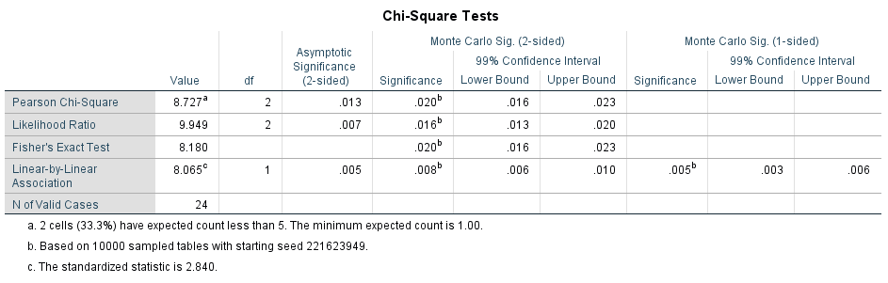

bacterialgrowth * Gender Crosstabulation
 |  |  | Gender |  | Total
 |  |  | Male | Female
bacterialgrowth | 1.00 | Count | 9 | 2 | 11
 |  | % within bacterialgrowth | 81.8% | 18.2% | 100.0%
 |  | % within Gender | 75.0% | 16.7% | 45.8%
 | 2.00 | Count | 3 | 8 | 11
 |  | % within bacterialgrowth | 27.3% | 72.7% | 100.0%
 |  | % within Gender | 25.0% | 66.7% | 45.8%
 | 3.00 | Count | 0 | 2 | 2
 |  | % within bacterialgrowth | 0.0% | 100.0% | 100.0%
 |  | % within Gender | 0.0% | 16.7% | 8.3%
Total |  | Count | 12 | 12 | 24
 |  | % within bacterialgrowth | 50.0% | 50.0% | 100.0%
 |  | % within Gender | 100.0% | 100.0% | 100.0%

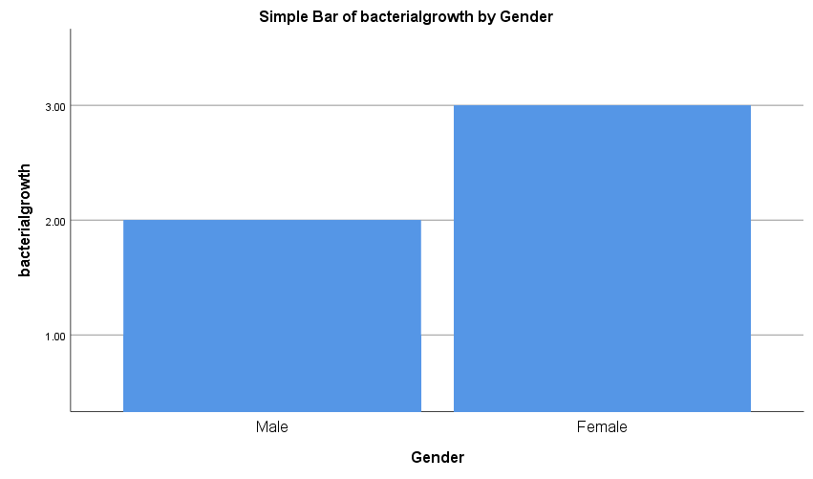

Conclusions
UTI and asymptomatic bacteria is a serious issue that needs more attention to it and its dangers, this experiment we talked about the incidence rate of asymptomatic bacteriuria among of participants: 63 (33 females and 30 males). A macCkonkey and blood agar were used and the result shows that it is more common in female than males due to a lot of causes such as the anatomy of the female urethra
UN treated UTI can spread into the kidneys and cause more serious illness or could be life threatening. Treatment includes antibiotics, and a person should drink plenty of fluids and contact a healthcare professional.

Referencing Vancouver system AMA style
- Caretto M, Giannini A, Russo E, Simoncini T. Preventing urinary tract infections after menopause without antibiotics. Maturitas. 2017;99:43-46. doi:10.1016/j.maturitas.2017.02.004

- Jung B, Hoilat GJ. MacConkey Medium. In: StatPearls. Treasure Island (FL): StatPearls Publishing; October 5, 2021.

- Abou Heidar NF, Degheili JA, Yacoubian AA, Khauli RB. Management of urinary tract infection in women: A practical approach for everyday practice. Urol Ann. 2019;11(4):339-346. doi:10.4103/UA.UA_104_19

- L; WMLG. Laboratory diagnosis of urinary tract infections in adult patients. Clinical infectious diseases : an official publication of the Infectious Diseases Society of America. https://pubmed.ncbi.nlm.nih.gov/15095222/. Accessed June 1, 2022.

- Givler DN, Givler A. Asymptomatic Bacteriuria. [Updated 2022 May 1]. In: StatPearls [Internet]. Treasure Island (FL): StatPearls Publishing; 2022 Jan-. Available from: https://www.ncbi.nlm.nih.gov/books/NBK441848/

