

LIBYAN INTERNATIONAL MEDICAL UNIVERSITY
APPLIED MEDICAL SCIENCES –THIRD YEAR
P.T.S. BLOCK
Assignment
Project management workshop

Name: Omar Yousef Alsaiti Roll number: 2591 Group: A3

- Develop a network diagram for the project specified below. (50 %)
- Identify the Critical Activities and the total duration of the project. (35%)
- Justify which activity would you crash based on some rationale (15%)
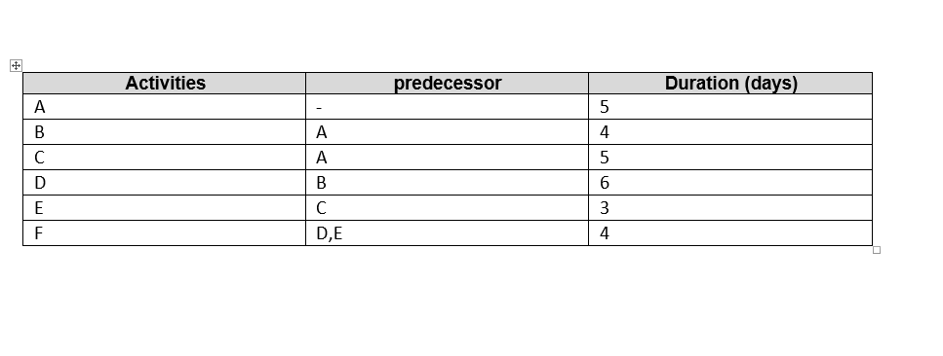

Answer 1: Diagram network for the project
F
E
D

B

A

C

Answer 2:
The project's critical activities and total duration:
• Path number one: A B D F is the longest path; it takes 19 days to complete.
• The second path is A C E F, with a total duration of 17 days.
The project will take a total of 27 days to complete.

Answer 3:
Number D is the action that might cause a crash.
• It takes more days to complete; • It is located on the project's longest path.
• The project's opposing stage (E) has a few days, which provides it flexibility.
Other factors influence the decision. If there is a cost value for any of the steps, or if some of the steps require a lot of labor and others do not. In addition to the production quantity for each step.

