
Libyan International Medical University
Faculity Applied Medical Science (AMS)
3rd year medical science
PTS: Final Report

Effect of Furosemide on adult males and females

Supervisor: Basma Faraj
Hwuida khattab
Student Name :Taqwa muftah
Student Number : 2348

Assistant by : Ahmed Aiyad Gaibani

Abstract
Throughout medical history, there have been very few instances of gender disparities in the correlation between dosage and effectiveness of a treatment. The purpose of this research was to investigate whether or not there was a difference in the pharmacodynamic properties of furosemide (FUR) between males and females. In both sexes, conventional renal clearance experiments were conducted in the absence and presence of a FUR dose required to produce similar FUR urine excretion ,in the absence of FUR , male and female fractional excretions of sodium, potassium, and water were identical . When stated in fractional terms , female had considerably higher natriuretic, kaliuretic, and diuretic responses to FUR , Female had higher diuretic, natriuretic,and kaliuretic efficiency than male. This could be explained by the reduced abundance of the Na-K-2Cl cotransporter found in homogenates from female kidney medullae compared to male kidney medullae.

- Introduction
The availability of evidence on female pharmacokinetics and the possibility of gender differences in dose and efficacy or dose and adverse drug reaction connections. Only a few research could clearly detect clinically gender (male and female ) effects from a pharmacodynamic standpoint.^{1–3} As a result, the impact of sex on drug pharmacokinetics and pharmacodynamics should be considered. Sex alters the pharmacokinetics of organic anions, according to research conducted recently in our lab. Because of their poorer renal clearance, female have lower furosemide (FUR) clearance.^{3,4} Female have a lower abundance of the renal organic anion transporter (OAT1) than male , which may contribute to this.⁴ FUR is a diuretic organic anion that works by binding to the Na-K-2Cl cotransporter (NKCC2) in the thick ascending limb (TAL) and preventing ion transport. FUR is often used to treat edema, congestive heart failure, liver cirrhosis, and nephrotic syndrome. Circulatory collapse, thromboembolic events, ototoxicity, hearing damage, deafness, vertigo, hypotension , and tinnitus have all been documented as adverse effects to FUR .⁴ It was interesting to investigate the impact of sex on the pharmacodynamics of FUR in order to continue our prior research on gender differences in FUR pharmacokinetics. The purpose of this study is to examine the difference between adult male and female in urine output after Lasix (furosemide) consumption.

- Methods
Renal clearance examinations included four experimental groups throughout the experiment:
(1) 6 Females
(2) 6 Males
(3) 6 Females plus FUR
(4) 6 Males plus FUR
FUR was given as a priming dosage and in the infusion solution in addition to the inulin dose.
Inulin clearance was used to determine the glomerular filtration rate (GFR).
measurement of urine output in male and female after 6 hours from administration of FUR.

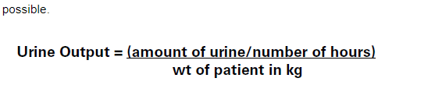

- Results
Group Statistics
 | Gender | N | Mean | Std. Deviation | Std. Error Mean
Urinoutpout6hr | male | 6 | 468.0000 | 114.02400 | 46.55010
Urinoutpout6hr | female | 6 | 367.2000 | 104.93244 | 42.83849
Table 1: Shows Results for urine output in males and female

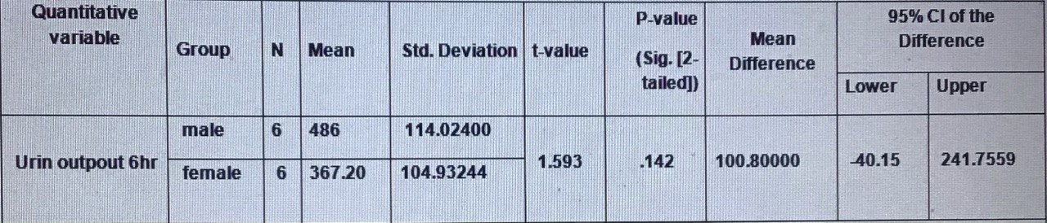
Table 2: Summary Table for Resulte

- Discussion
Since the p-value for t-test is not significant, we conclude that there is no significant because Since P-value greater than alpha = 0.05 . But from a clinical point of view there is a difference between males and females in urine output (100.800). The drug (furosemide) has a higher effect on males rather than female in the urin outpout, so urine output in male is (468.000), and in female is (367.2000). So Because of their poorer renal clearance, female have lower furosemide (FUR) clearance. This proves that female have lower urine output rather than male. Female had a lower GFR than male , which is consistent with our prior findings.³ and those of other investigators.⁴ Due to the diuretic's largely renal vasoconstrictor effects, which have been previously reported,administration of FUR resulted in a decrease GFR in female.^{5–6} The reduced efficacy of FUR in lowering GFR in female could be owing to increased circulating levels of PGE2 in females, as previously described.⁷
- Conclusion
The researcher conclude that Female had a lower GFR than male, have different in quantity of urine output between male and female, the FUR have high effect on male more than female, so quantity of urine output in female lower than male due to the diuretic's largely renal vasoconstrictor effects on female, and few of renal clearance and furosemide clearance.

Reference
1- I, B., B, M. and H, D., 2022. Gender differences in pharmacokinetics and pharmacodynamics. [online] PubMed. Available at: <https://pubmed.ncbi.nlm.nih.gov/10584975/> [Accessed 14 June 2022].
2- I B, B M, H D. Gender differences in pharmacokinetics and pharmacodynamics [Internet]. PubMed. 2022 [cited 14 June 2022]. Available from: https://pubmed.ncbi.nlm.nih.gov/10584975/.
3 - Gleiter C, Gundert-Remy U. Gender differences in pharmacokinetics. 2022.
4- [Internet]. 2022 [cited 14 June 2022]. Available from: https://www.semanticscholar.org/paper/Effects-of-gender-on-the-pharmacokinetics-of-drugs-Cerrutti-Quaglia/170d685907827971e6bab20dcb91a0e7b05d9374.
5. AM T, JV R, MM E. Vulnerability of the thick ascending limb to glutathione depletion in rat kidney: effects of diuretics and indomethacin [Internet]. PubMed. 2022 [cited 14 June 2022]. Available from: https://www.ncbi.nlm.nih.gov/pubmed/2746501.

6-Torres A, Rodriguez J, Elías M. Vulnerability of the thick ascending limb to glutathione depletion in rat kidney: effects of diuretics and indomethacin. [Internet]. Journal of Pharmacology and Experimental Therapeutics. 2022 [cited 14 June 2022]. Available from: https://jpet.aspetjournals.org/content/250/1/247.

7-[Internet]. 2022 [cited 14 June 2022]. Available from: https://www.semanticscholar.org/paper/Renal-Hemodynamic-Effects-of-Diuretics-Navar/a5611101547e4054d38e1260820f58eb6ecea4d0.

