

Incidence rate of asymptomatic bacteriuria
and urinary tract infection

By Jumanah rahal 2651... 2rd year medical science
Supervisor:
د. انتصار الناجي
assisted by:
أ. ناجي الحمري
أ. أسماء الكوافي

Date of submission:

Abstract
A urinary tract infection (UTI) is a collective term for infections that involve any part of the urinary tract. It is one of the most common infections in local primary care. The incidence of UTIs in adult males aged under 50 years is low, with adult women being 30 times more likely than men to develop a UTI. Bacteriuria, or the presence of bacteria in urine, is associated with both asymptomatic and symptomatic urinary tract infection and underpins much of the dynamic of microbial colonization of the urinary tract. The prevalence of bacteriuria in dissimilar patient groups such as healthy adults, institutionalized elderly, pregnant women, and immune-compromised patients varies widely.

Introduction

Bacteriuria is the presence of bacteria in the urine and can be classified as symptomatic or asymptomatic. A patient with asymptomatic bacteriuria is defined as having colonization with one or more organisms in a urine specimen without symptoms or infection. Symptomatic bacteriuria is associated with an infection in the urinary tract, usually by a single organism. ⁽¹⁾
Urinary tract infection (UTI) is a collective term that describes any infection involving any part of the urinary tract, namely the kidneys, ureters, bladder and urethra. The urinary tract can be divided into the upper (kidneys and ureters) and lower tract (bladder and urethra). ⁽¹⁻²⁾
The urinary tract is a common source of infection in children and infants and is the most common bacterial infection in children < 2 years of age, both in the community and hospital setting. During the first six months of life, UTIs are more common in boys. The outcome is usually benign, but UTIs can progress to renal scarring in early infancy, especially when associated with congenital anomalies of the urinary tract. Renal scarring may lead to complications in adulthood including hypertension, proteinuria, renal damage and even chronic renal failure, which requires dialysis treatment. ⁽²⁾
In general, 40% of women develop a UTI at some point in their life. In Singapore, 4% of young adult women are affected and the incidence increases to 7% at 50 years of age. Adult women are 30 times more likely than men to develop a UTI, with almost half of them experiencing at least one episode of UTI during their lifetime. It is reported that one in three women have their first episode of UTI by the age of 24 years. UTIs are most seen in sexually active young women. Other susceptible adults include the elderly and patients requiring urethral catheterization. ⁽³⁾

Aim of study to show incident rate of asymptomatic bacterial infection among Libyan students.

Methods and material

We take a sample of urine from 63 participant (33 females and 30 male) then we flame a calibrated wire loop, and we Mix the urine with insert the loop vertically into the urine to allow the urine to adhere to the loop.
spread the urine over the surface of the agar plate without flaming insert the loop vertically into the urine again to transfer of loopful to a second plate.

Then incubate for 24hr at 37 C in air Colonies are counted on each plate. The number of CFUs is multiplied by 1000(if a 0.001 ml loop used) or by 100 (if a 0.01 ml loop was used) to determine the number of microorganisms per ml in the original specimen. Then we analysis the data using SPSS.

Result
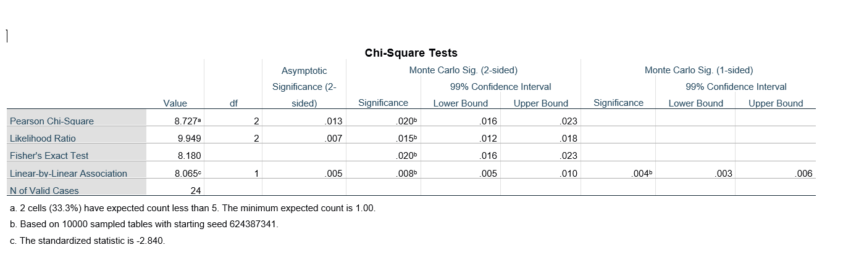

Discussion
Asymptomatic bacteriuria is very common in clinical practice. While few infants and toddlers have asymptomatic bacteriuria, the incidence increases with age. The incidence is up to 15% or greater in women and men aged 65 to 80 years and as high as 40% to 50% after age 80. Most patients with asymptomatic bacteriuria will never develop symptomatic urinary tract infections and will have no adverse consequences from asymptomatic bacteriuria. ⁽¹⁾
As shown in this study there’s significant bacteria overgrowth in urinary sample in college student which means asymptomatic bacteriuria is common, with varying prevalence by age, sex, sexual activity, and the presence of genitourinary abnormalities. In healthy women, the prevalence of bacteriuria increases with age, from about 1 percent in females five to 14 years of age to more than 20 percent in women at least 80 years of age living in the community. ⁽²⁾ Escherichia coli is the most common organism isolated from patients with asymptomatic bacteriuria. Infecting organisms are diverse and include Enterobacteriaceae, Pseudomonas aeruginosa, Enterococcus species, and group B streptococcus. Organisms isolated in patients with asymptomatic bacteriuria will be influenced by patient variables: healthy persons will likely have E. coli, whereas a nursing home resident with a catheter is more likely to have multi-drug–resistant polymicrobic flora (e.g.,P. aeruginosa). Enterococcus species and gram-negative bacilli are common in men. ⁽³⁾
Asymptomatic bacteriuria in pregnancy has been associated with an increased risk of premature delivery and low birth weight in pregnancy.
Treatment of asymptomatic bacteriuria during pregnancy reduces these complications and improves perinatal morbidity and mortality. Without treatment, asymptomatic bacteriuria will persist in more than 80% of women and may progress to symptomatic urinary tract infection or acute pyelonephritis. Screening for asymptomatic bacteriuria with a urine culture is recommended during the first prenatal visit and is repeated only in high-risk women, such as those with a history of recurrent urinary infections or urinary tract anomalies. ⁽⁴⁾

Urinary tract infections are responsible for an estimated 7 million office visits, 1 million emergency room visits, and 100,000 hospitalizations each year, and account for 25% of all infections in geriatric patients. Healthcare providers often confuse asymptomatic bacteriuria (ASB), with UTI, and unnecessary antibiotic treatment of ASB in older adults is common. In the United States, the prevalence of antimicrobial resistance in urinary organisms in the community is increasing. Colonization with multidrug resistant organisms is high in nursing home settings, and these organisms spread to other settings along with the colonized patients [6]. Multi-drug resistant bacteria implicated in UTIs include extended-spectrum beta-lactamase (ESBL) producing organisms, carbapenem-resistant Enterobacteriaceae (CRE), and now colistin-resistant Gram-negative bacilli. At the same time, we increasingly recognize that commonly prescribed antibiotics are associated with severe and sometimes life-threatening adverse events. These trends highlight the need for renewed emphasis on antimicrobial stewardship in the treatment of UTIs, including increased recognition and a proper understanding of ASB. ⁽⁵⁾

For patients with a UTI, antibiotics provide symptomatic relief and may help prevent complications such as pyelonephritis, perinephric abscess, and bacteremia. The 2010 Infectious Diseases Society of America guidelines recommend 3 agents for the treatment of uncomplicated cystitis in women: nitrofurantoin; Fosfomycin; pivmecillinam. ⁽⁴⁻⁵⁾

Conclusion
Bacteriuria is the presence of bacteria in the urine and can be classified as symptomatic or asymptomatic. A patient with asymptomatic bacteriuria is defined as having colonization with one or more organisms in a urine specimen without symptoms or infection. Asymptomatic bacteriuria is very common in clinical practice. While few infants and toddlers have asymptomatic bacteriuria, the incidence increases with age. As shown in this study there’s significant bacteria overgrowth in urinary sample and Escherichia coli is the most common organism isolated from patients with asymptomatic bacteriuria. Asymptomatic bacteriuria has been associated with an increased risk of premature delivery and low birth weight

The Future studies are designed to decrease incident of asymptomatic and correct using of antibiotics

References

- Crader MF, Kharsa A, Leslie SW. Bacteriuria. In: StatPearls. Treasure Island (FL): StatPearls Publishing; November 27, 2021.

- Rowe TA, Juthani-Mehta M. Urinary tract infection in older adults. Aging health. 2013;9(5):10.2217/ahe.13.38. doi:10.2217/ahe.13.38

- Colgan R, Nicolle LE, McGlone A, Hooton TM. Asymptomatic bacteriuria in adults. Am Fam Physician. 2006;74(6):985-990. (methods)

- Schaeffer EM. Infection and Inflammation of the Genitourinary Tract. J Urol. 2021;205(2):610. doi:10.1097/JU.0000000000001498

- Bono MJ, Reygaert WC. Urinary Tract Infection. In: StatPearls. Treasure Island (FL): StatPearls Publishing; June 23, 2021.

