The slide centrifuge gram stain as a urine screening method in women

Student name : yomna kroosh
Student number : 3032
Date : 2022 / 6 /20
Supervisor name : dr.Entisar Elnaji
Assistant by:
Dr.Asma alkowafi
Dr. Lojain

ABSTRACT :

In order to screen for bacteriuria in women, a side centrifuge gram stain was done.
4161 urine specimens were submitted in urine preservative tubes for routine culture for slide centrifuges gram staining. Each urine sample was mixed well, and 0.2 ml of each sample was pipetted into a slide centrifuge chamber and spun at 2,000 rpm for 5 minutes.

The slides were heat fixed, gram stained, and examined by laboratory personnel who scanned 12 oil-immersion fields in a predetermined sequence.

A positive urine screen (E.coli isolated in 75% of the females under research) was defined as the presence of the same organism in six or more fields. Urine samples were cultured using a 0.001ml loop and comparison
When a lower colony count of 10,000 or more CFU/ml was used as a comparison, the screen showed a sensitivity rate of 88 percent, a specificity rate of 95 percent, a negative predictive value of 99 percent, and a positive predictive value of 65 percent.

INTRODUCTION:

UTIs are one of the most prevalent bacterial infections in women, with enteric bacteria (E.coli) being the most commonly isolated pathogen.
Rapid identification of bacteriuria is desirable since it improves female genitourinary health.
A reliable urine screening approach can provide the clinician with meaningful, timely information and may also eliminate the need for culture for some urine specimens that exhibit negative results.

The gram stain has been used to detect the presence of bacteriuria.
Kass reported in 1956 that gram stain smears of uncenterfuged urine were positive in 80% of specimens with bacteria counts of 100.000 or more CFU/ml.
We assessed the slides centrifuge's utility as a quick urine screening method in an adult female population because it was designed to be beneficial in concentrating bacteria for gram stain of body fluid specimens.
The findings were then compared to quantitative culture.

MATERIAL AND METHOD:

1684 urine specimens were collected at first, and 0.2 ml of each specimen was deposited into a centrifuge chamber, capped, and centrifuged at 2000 rpm for 5 minutes in a slide centrifuge.
The slides were heat fixed and stained with gram staining using the following procedures:

- solutions of crystal violet , gram’s iodine , 95% ethanol and/or isopropanol-acetone mixture ( 3:1 ) and safranin.
- clean glass slides.
- Inoculating loop.
- Bunsen burner.
- Microscope.
- Immersion oil.
- Difco.
- Slide warmer
- Staining rack.
- Bacto gram stain regents from difco for the three step gram stain.

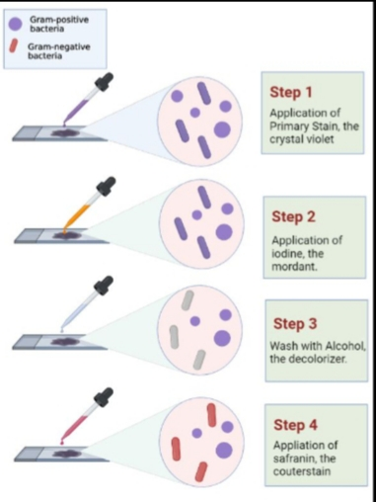

Beginning in the center of the slide centrifuge spot, oil-immersion microscopy was used to quickly scan 12 consecutive fields on each slide using the pattern shown in the figure.
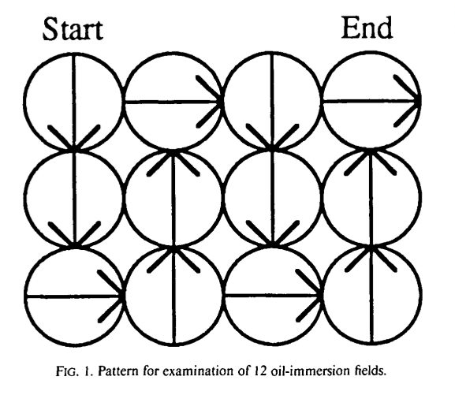
The number of fields in which organisms were seen was recorded and results obtained.

RESULT AND STATISTIC ANALYSIS:

The goal of this study was to look for germs in urine samples from 24 LIMU understudies in their middle years. There were twelve young girls and twelve young gentlemen in attendance.

a group of young males 54.2 percent of LIMU students have a disability.

Bacteriuria with no symptoms was identified.

There were 7 (29.2%) understudies whose pee tests were negative.

6 (25%) cases had less than 10,000 CFU/mL, and 6 (25%) cases had less than 10,000 CFU/mL.

10,000 CFU/mL or above, and 11 (45.8%) with none.

development. As a result, asymptomatic bacteriuria became a thing of the past.

18% of LIMU understudies were found to have this condition.

(75% completion)

Table summarizes the distribution of combined gram staining and culture results for the 1684 specimens.

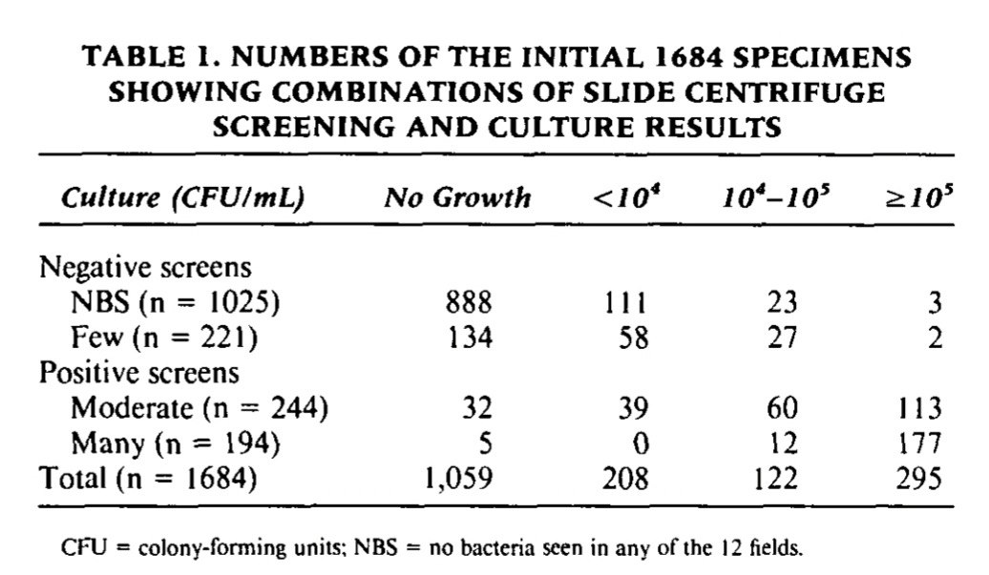
For the 1684 specimens studied, the sensitivity of the slide centrifuge screen in detecting 100,000 or more CFU/ml on culture was 98%, the specificity was 89%, the negative predictive value was 99%, and the positive predictive value was 66%.

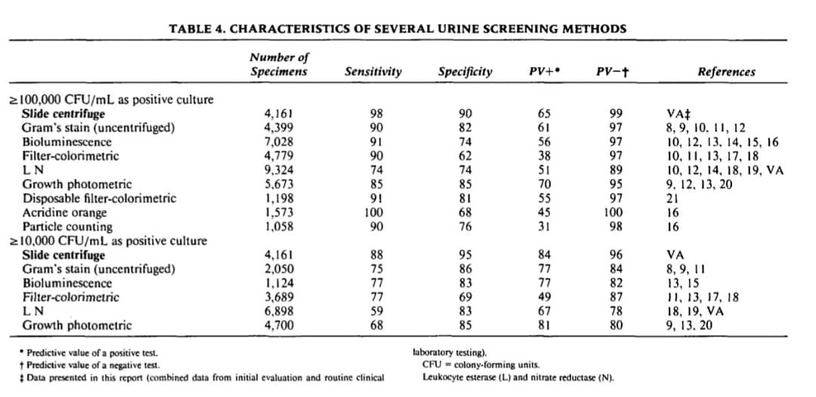

The most common organism isolated was entoric bacteria (E.coli) isolated in 75% of the samples under study .
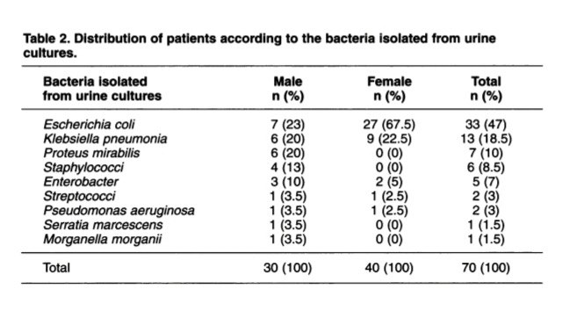

STATISTIC ANALYSIS:

Chi-Square Tests
 | Value | df | Asymptotic Significance (2-sided)
Pearson Chi-Square | 8.727ª | 2 | .013
Likelihood Ratio | 9.949 | 2 | .007
Linear-by-Linear Association | 8.065 | 1 | .005
N of Valid Cases | 24
a. 2 cells (33.3%) have expected count less than 5. The minimum expected count is 1.00.

CFUcat * Gender Cross tabulation
 |  |  | Gender |  | Total
 |  |  | Female | Male | Total
CFUcat | No growth | Count | 2 | 9 | 11
CFUcat | No growth | Expected Count | 5.5 | 5.5 | 11.0
CFUcat | No growth | % within Gender | 16.7% | 75.0% | 45.8%
CFUcat | Overall no significant growth | Count | 8 | 3 | 11
CFUcat | Overall no significant growth | Expected Count | 5.5 | 5.5 | 11.0
CFUcat | Overall no significant growth | % within Gender | 66.7% | 25.0% | 45.8%
CFUcat | Significant growth | Count | 2 | 0 | 2
CFUcat | Significant growth | Expected Count | 1.0 | 1.0 | 2.0
CFUcat | Significant growth | % within Gender | 16.7% | 0.0% | 8.3%
Total |  | Count | 12 | 12 | 24
 |  | Expected Count | 12.0 | 12.0 | 24.0
 |  | % within Gender | 100.0% | 100.0% | 100.0%

Case Processing Summary
 | Cases
 | Valid |  | Missing |  | Total
 | N | Percent | N | Percent | N | Percent
CFUcat * Gender | 24 | 64.9% | 13 | 35.1% | 37 | 100.0%

Chi-Square Tests
 | Value | df | Asymptotic Significance (2-sided) | Monte Carlo Sig. (2-sided) |  |  | Monte Carlo Sig. (1-sided)
 |  |  |  | Significance | 99% Confidence Interval |  | Significance | 99% Confidence Interval
 |  |  |  |  | Lower Bound | Upper Bound | Significance | Lower Bound | Upper Bound
Pearson Chi-Square | 8.727ª | 2 | .013 | .018^{b} | .014 | .021
Likelihood Ratio | 9.949 | 2 | .007 | .012^{b} | .009 | .015
Fisher's Exact Test | 8.180 |  |  | .018^{b} | .014 | .021
Linear-by-Linear Association | 8.065^{c} | 1 | .005 | .006^{b} | .004 | .008 | .004^{b} | .003 | .006
N of Valid Cases | 24
a. 2 cells (33.3%) have expected count less than 5. The minimum expected count is 1.00.
b. Based on 10000 sampled tables with starting seed 2000000.
c. The standardized statistic is -2.840.

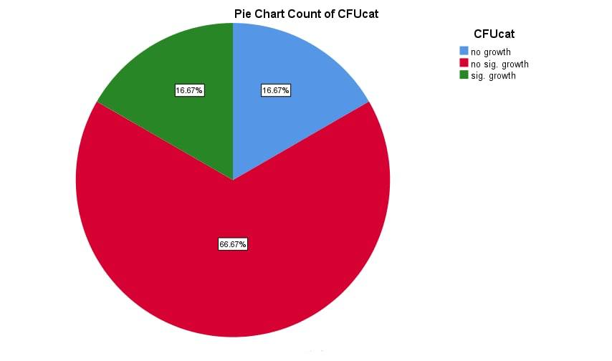

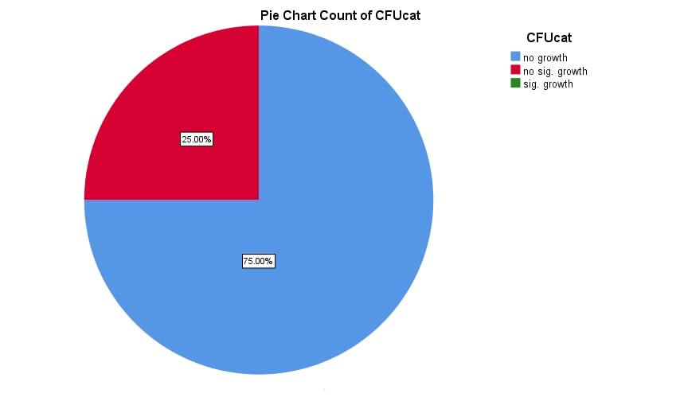

DISCUSSION:

According to recent studies, oil-immersion microscopy of gram-staining traditionally centrifuged urine is reliable in detecting bacteriuria at 100,000 CFU/ml.
Our slide centrifuge data was compared to previously modified data and published data for various screening procedures.
The slide centrifuge screen was shown to be a very sensitive screening method (98%), with a high specificity rate of 90% in detecting 100,000 or more CFU/ml.
Over conversional microscopic procedures, the slide centerifuge approach has significant advantages.
The slide centrifuge deposits cells and microorganisms from a liquid sample onto a region that can readily be brought into focus, enabling reading a big batch of screens faster, easier, and less tiring than other methods.
A more recent study found that in specific groups (young women with acute dysuria and frequent urination or with short-team catheter-associated infection), colony counts as low as '100 CFU/ml may be scientific, due to the scientific of early diagnosis of UTI in females.

CONCLISSION:

Finally, the slide centrifugation urine screen is a particularly sensitive approach for detecting bacteriuria.
This screen can be done on conserved urine to improve anaerobe, fastidious organism, and yeast defection.
The screen has a clinically useful turnaround time and gives the clinician with gram stain features that may be beneficial in directing first antibiotic therapy.
Most notably, it has great sensitivity, a strong predictive value of negative results, and a low occurrence of false-negative outcomes.

REFRENCES:

1. Winquist A, Orrico M, Peterson L. Evaluation of the Cytocentrifuge Gram Stain as
a Screening Test for Bacteriuria in Specimens From Specific Patient Populations.
2. E C, PF, GR S. The use of a differential fluorescent staining method to detect
bacteriuria. PubMed. https://pubmed.ncbi.nim.nih.gov/15575310/. Published
2022. Accessed June 20, 2022.
3. Rippin K, Stinson W, Eisenstadt J, Washington J. Clinical Evaluation of the Slide
Centrifuge (Cytospin) Gram's Stained Smear for the Detection of Bacteriuria and
Comparison With the Filtracheck-UTI and UTIscreen,
4. Olson M, Shanholtzer C, Willard K, Peterson L. The Slide Centrifuge Gram Stain as
a Urine Screening Method.
5. Levinson, Warren. Review of medical microbiology and immunology. 14rd ed. The .McGraw-Hill Companies, 2016

