
LIBYAN INTERNATIONAL MEDICAL UNIVERSITY
APPLIED MEDICAL SCIENCES –THIRD YEAR
P.T.S. BLOCK
Assignment
Project management workshop

Name: Rahmah faiz al-zarouq
Roll number: 2360
Group: A2

- Develop a network diagram for the project specified below. (50 %)
- Identify the Critical Activities and the total duration of the project. (35%)
- Justify which activity would you crash based on some rationale (15%)
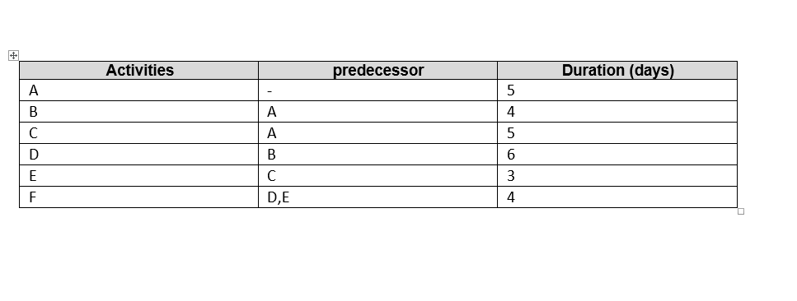

Answer Q1: for the site's network diagram
F
E
D

B

A

C

Answer Q2: the project's critical activities and total duration:
Path number 1: A B D F, It is the longest pathway taking 19 days in total.
Path number 2: A C E F, The duration is 17 days in total
The project will take a total of 27 days to complete.

Answer Q3: Number D is the action that might cause a crash
Because it takes a longer time .
Because it is present in the project's longest path
The project's opposite stage (E) has a few days (3 days) to allow for flexibility.

Other considerations play a role in the decision. If any of the processes have a cost value, or if some of the steps take a lot of labor while others do not. In addition to the quantity of each step's manufacturing.

