Title: The incidence rate of Asymptomatic Bacteriuria among LIMU students

Name: Nora Nori Al-faitory
Student No: 2822
University: Libyan international medical university
Faculty: Applied medical science

Abstract:
A urinary tract infection (UTI) is an infection within urinary system (UT). Your UT is made up of your kidneys, bladder, and the tubes that link them all together.
The risk of (UTI) rises with age, especially in women. In fact, (UTIs) are most frequent infections among the elderly, also more prevalent among those who are diabetic or kidney problems.
When you have bacteria in your urinary system but don't have the symptoms associated with UTIs, you're said to have asymptomatic bacteriuria; the most common gram negative that can cause asymptomatic bacteriuria is E. coli.

Introduction:
Urinary tract infections are frequent infections that occur when bacteria enters the urethra and infect the urinary system, usually through the skin or the rectum. The infections can affect any region of the urinary system (upper or lower), although the bladder infection is the most prevalent (cystitis); Another kind of UTI is kidney infection (pyelonephritis). They're less prevalent than bladder infections, but they're more dangerous. (1)
UTIs are more frequent in women, but they can also affect males, and children; the UTI accounts for 8 to 10 million medical visits every year.
The presence of bacteria in correctly collected urine of a patient who has no signs or symptoms of a urinary tract infection is known as Asymptomatic bacteriuria. While asymptomatic bacteriuria is uncommon in newborns and toddlers, Most people with asymptomatic bacteriuria will never acquire symptomatic urinary tract infections, and asymptomatic bacteriuria will have no negative repercussions.
A variety of factors are considered to contribute to the improvement of asymptomatic bacteriuria: (2)
- obstructive uropathy (stones, cystocele, etc).
- fecal soiling of the perineum (especially in women).
- indwelling urinary catheters.
- frequent instrumentation of the urinary tract.
The most prevalent organism and the one most likely to infect healthy people is Escherichia coli. Enterobacteriaceae, Pseudomonas aeruginosa, Enterococcus species, and group B Streptococcus are among the organisms that can be discovered. Enterococcus species and gram-negative bacilli are commonly seen in males.
Antibiotic therapy for asymptomatic bacteriuria does not help children, diabetic, the elderly, patients with spinal cord injuries, or patients with urinary catheters. Treatment does not increase survival or reduce the prevalence of symptomatic urinary tract infections. However, it increases risk of antibiotic-related adverse effects and the development of antibiotic-resistant bacteria, Treatment of asymptomatic bacteriuria in pregnant women, on the other hand, has been found to be helpful. (2)

Material and Methods:
Materials: gloves – urine sample – urine dipstick – centrifuge- cover slide- microscope – loop – Bunsen burner - culture media – incubator – antibiotic dicks.
Methods: First, gloves were worn and a urine sample was collected from the middle stream. A physical examination was performed on the urine sample to examine the color, appearance, reaction, and S.gravity, and then a biochemical examination was performed using a urine dipstick. Compare the colors of the dipstick with the urine dipstick chart, then place the urine sample in a centrifuge, fill the centrifuge with water opposite to each urine sample, and run the centrifuge for 5 minutes. Remove the upper portion of the urine which was diluted and take a drop by loop from the lower portion and place it in a slide, which is then placed under the urine dipstick chart. The urine was cultured in the cystine lactose electrolyte deficient culture media and placed in the incubator for one day after microscopic examination.

Results and Statistical analysis:
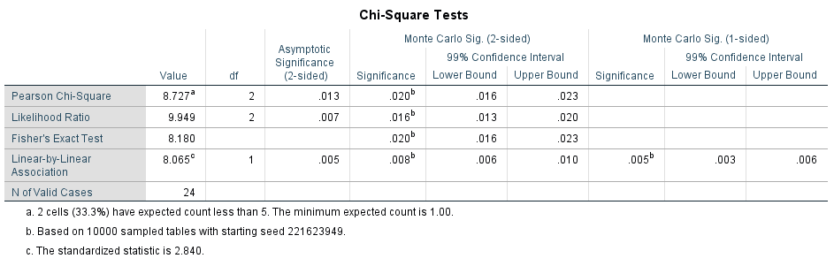
bacterial growth * Gender Crosstabulation
 |  |  | Gender |  | Total
 |  |  | Male | Female | Total
bacterial growth | 1.00 | Count | 9 | 2 | 11
bacterial growth | 1.00 | % Within bacterial growth | 81.8% | 18.2% | 100.0%
bacterial growth | 1.00 | % Within Gender | 75.0% | 16.7% | 45.8%
bacterial growth | 2.00 | Count | 3 | 8 | 11
bacterial growth | 2.00 | % Within bacterial growth | 27.3% | 72.7% | 100.0%
bacterial growth | 2.00 | % Within Gender | 25.0% | 66.7% | 45.8%
bacterial growth | 3.00 | Count | 0 | 2 | 2
bacterial growth | 3.00 | % Within bacterial growth | 0.0% | 100.0% | 100.0%
bacterial growth | 3.00 | % Within Gender | 0.0% | 16.7% | 8.3%
Total |  | Count | 12 | 12 | 24
 |  | % Within bacterial growth | 50.0% | 50.0% | 100.0%
 |  | % Within Gender | 100.0% | 100.0% | 100.0%

Because 20% is less than the projected count of fewer than five, chi-square would not be used, hence a fisher's test would be used instead. Only two of the females exhibited microbial growth, whereas nine of the men had. There hasn't been a significant growth. Only three males are optimistic, compared to eight women. There were no males that tested positive for substantial growth, but there were two ladies who did.

Characteristic | No growth | Overall, no significant growth | Significant growth | P-value
 | 11 | 11 | 2
Gender |  |  |  | 0.020
male | 9(81.9%) | 3(27.3%) | 0(0.0%)
female | 2(18.2%) | 8(72.7%) | 2(100%)

Pie chart 1

Pie chart 2

Discussion:
The significance value is less than 0.05. The null hypothesis was rejected, proving the existence of a link between gender and asymptomatic bacteriuria, it's more likely to occur in females more than males due to the shorter female urethra that allows to the bacteria to spread to bladder, most women have bacteriuria after sexual interaction, but only a tiny fraction of these women will develop symptomatic infections since the body's natural defense systems; The higher prevalence of asymptomatic bacteriuria in the elderly is thought to be linked to incomplete bladder emptying.
Under microscope, it was pink and rod-shaped which means it is gram negative bacilli, their for it is indication for either E.coli or pseudomonas aeruginosa, However, further biochemical testing has done that revealed it was E.coli .
The most prevalent pathogen linked to asymptomatic bacteriuria is Escherichia coli (ABU). The ability of E. coli to cause asymptomatic bacteriuria is associated with the expression of a variety of virulence factors, including adhesins and toxins.

Conclusion:
as a conclusion, asymptomatic bacteriuria is when you have bacteria in your urinary tract but you don’t have the symptoms that usually go along with UTIs it is commonly caused by E.coli, it mainly affect women due to anatomical structure of urethra and many other causes, in rare case may develop symptomatic infection, people who have urinary catheter also have increased risk of having asymptomatic bacteriuria.
Because the bacteria infrequently cause harm, most individuals with asymptomatic bacteriuria do not require treatment; When patients are given antibiotics even though there is no evidence of a bacterial infection, it can lead to "drug resistance."

Reference:

- [Internet]. 2022 [cited 20 June 2022]. Available from: https://www.cdc.gov/antibiotic-use/uti.html
2. Givler D, Givler A. Asymptomatic Bacteriuria [Internet]. Ncbi.nlm.nih.gov. 2022 [cited 20 June 2022]. Available from: https://www.ncbi.nlm.nih.gov/books/NBK441848/#:~:text=Introduction-,Asymptomatic%20bacteriuria%20is%20the%20presence%20of%20bacteria%20in%20the%20properly,the%20incidence%20increases%20with%20age.

