

Libyan International Medical University
Faculty Of AMS
2nd Medicine (2021-2022)
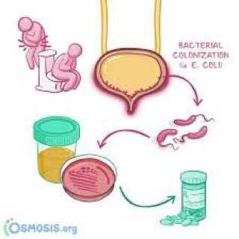
Supervisor: Dr.Lujain Alshumaki /Dr. Entesar Alnagi
Assistant By: Dr. Najee Elhemry
Student Name: Nourhan Ali Albshti
Student No: 2639

Asymptomatic Bacteriuria among male and female students in LIMU (UTIs)
  - (sientific lab report)
: Nourhan Ali Albshti student name

student NO : 2639
Abstract
Bacteriouria, can be symptomatic or asymptomatic, the presence of bacteria in correctly collected urine of a patient who has no signs or symptoms of a urinary tract infection is known as asymptomatic bacteriuria. In clinical practice, asymptomatic bacteriuria is prevalent, and its prevalence rises with age. In women and men aged 65 to 80 years, the incidence is 15% or more, and it can reach 40% to 50% beyond that. Most people with asymptomatic bacteriuria will never acquire symptomatic urinary tract infections, and asymptomatic bacteriuria will have no negative repercussions. While in the elderly, symptomatic urinary tract infection, (UTI) is a prevalent clinical concern. It happens more commonly in functionally impaired women and males, including the difference in the microbiological spectrum of various bacteria infecting different genders, as well as the incidence of asymptomatic bacteria .between male and female genders is noteworthy
Introduction
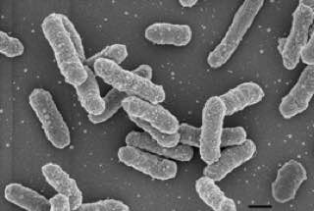
Bacteriuria is presence of bacteria in the urine sample; it has divided into two: asymptomatic and symptomatic. asymptomatic bacteriuria is a patient has one or two organisms in urine specimen collated with no infection or symptom, symptomatic its associated with urinary tract infection, which is common infection in a part of urinary system including cystitis infection in the bladder and in ureters called urethritis in lower part of urinary system and IS COMMON IN female more than male, upper part called pyelonephritis infection in the kidneys. ¹
klebselila pneumoniae 1
1
bacteria are the most common cause of UTIs and E.colli is must common cause community UTI and some author (e.g. pseudomonas aeruginosa ,klebsiella species ) its gram negative rod ,lactose fermenting bacteria , it has the ability to ascend the urethra into bladder and to the kidney, E.olli grows in macConkEy's culture media
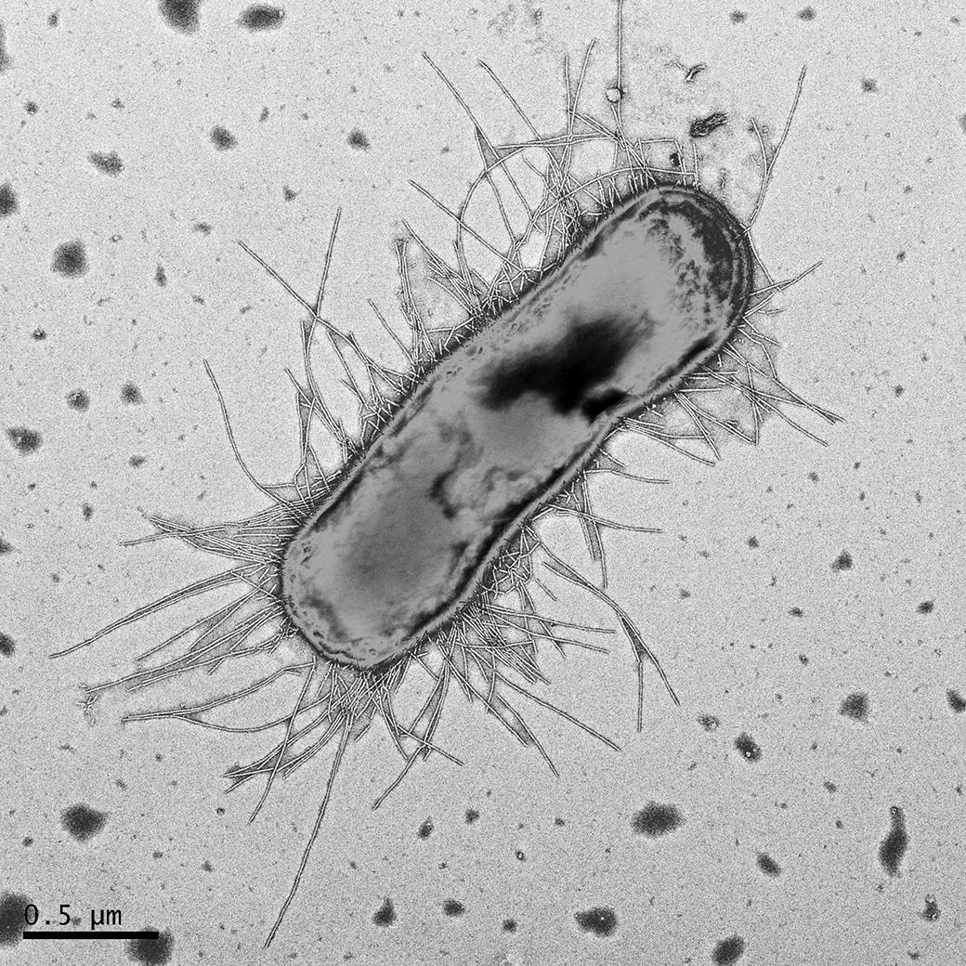
In addition, it may develop from healthcare problem such as diabetes, using of catheters, nosomial (hospital-acquired) or abnormal urinary system that may contribute to the infection. Older people are higher risk to develop in UTI; postmenopausal women may be higher risk of colonization and the sexually active women. ²
the symptoms are depending of the site of disease if only bladder is involved the most prominent symptoms are pain during urination (dysuria ) , frequent in urination , foul smelling in urine and patient are afebrile , in kidney the symptoms are fever ,flank pain ,costovertebral angel tenderness and dysuria may or not occur, in sometimes occur some physiological changing e.g. color change in red refers to a presence of RBCs that called hematuria and WBCs in pyelonephritis called pyuria and other chemical changes e.g. PH, gravity ,proteins and glucose
Escherichia coli 1
It can prevented by a simple measure:
- Drinking water
Keeping genital organs clean and using cotton underwear also do not use irritation product
Also treated by sulfamethoxazol or nitrofurantion. ^{1,3}
Urine Culture Test
Principles: urine culture test is used to detect mainly gram bacteria that causes urinary tract infections that found in urine sample it examined under microscope if the sample shows signs of any bacteria or other such as CRYSTELS, RBCs, Bacteria and Miscellaneous.
. The culture be done one hour after taken the sample or stored in refrigerator at 4c less than 18 hour

Material: gloves, petri dish with maconkey culture, calibrated loop, incubator, tube contain urine sample, centrifuge urine strip, slide cover, microscope, handle Bunsen burner.
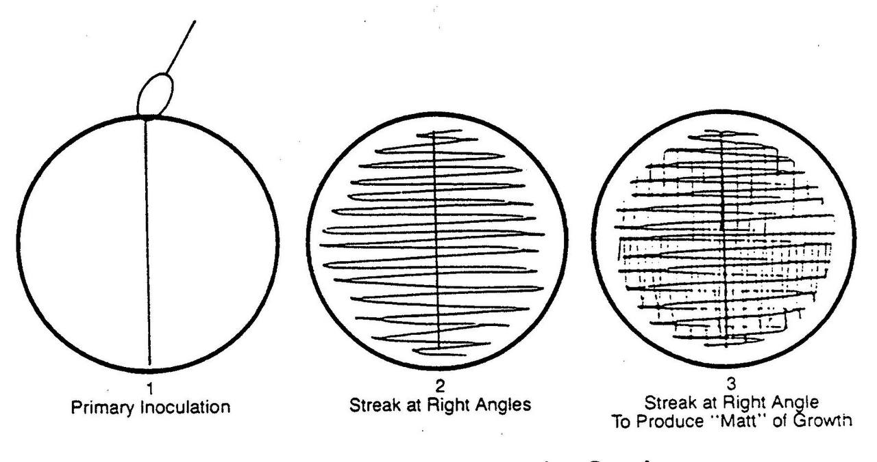
Methods:
- First morning specimen it take in four ways depending on patient satiation and age e.g. (sterile urine bag, CATH, SPA and CC).
- Take a sterile calibrated loop by flame ( 0.001uL )
- Take a macConkey's culture (detect gram bacteria that cause UTIs)
- Mix the urine sample to get as much bacteria as possible
- The loop is inserted vertically into the urine tube to allow urine to stick to the loop to ensure that proper amount of specimen will adhere to the loop
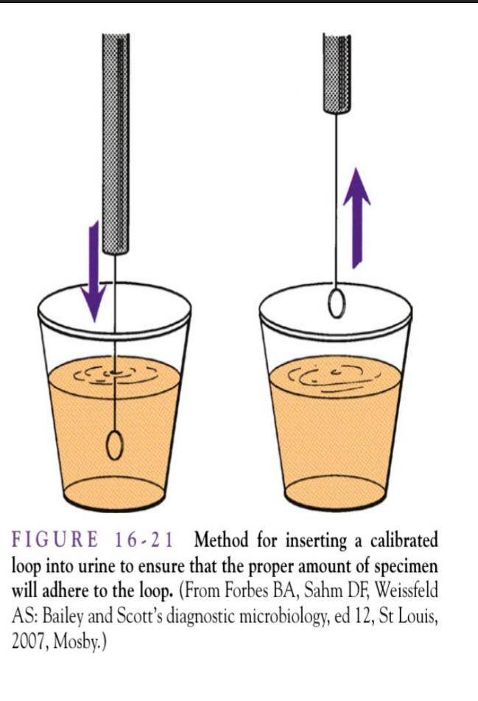
- Spread the urine in the culture media (macConkey's agar) or blood agar in zigzag style streak down in the middle of the plate then using the same loop go back and streak cross the center inoculum to dilute
- Insert the loop again in the urine tube without flaming to take another sample and spirited in the plate again
- Keep the culture in incubated for 24 hours at 37C in air before that the result is negative
- The colonies are counted on agar plate with same calculation depending of the size of the loop to give a results
If there is no or little growth on the culture media after incubation period (12 to48) hours, the urine culture is negative
Result:

Hypothesis: H0: there is No association between gender status and the bacterial growth

Ha: There is an association between gender status and bacterial growth

CFUcat * Gender Crosstabulation
 |  |  | Gender |  | Total
 |  |  | Male | Female | Total
CFUcat | no growth | Count | 9 | 2 | 11
CFUcat | no growth | Expected Count | 5.5 | 5.5 | 11.0
CFUcat | no growth | % within CFUcat | 81.8% | 18.2% | 100.0%
CFUcat | no growth | % within Gender | 75.0% | 16.7% | 45.8%
CFUcat | non sig growth | Count | 3 | 8 | 11
CFUcat | non sig growth | Expected Count | 5.5 | 5.5 | 11.0
CFUcat | non sig growth | % within CFUcat | 27.3% | 72.7% | 100.0%
CFUcat | non sig growth | % within Gender | 25.0% | 66.7% | 45.8%
CFUcat | sig growth | Count | 0 | 2 | 2
CFUcat | sig growth | Expected Count | 1.0 | 1.0 | 2.0
CFUcat | sig growth | % within CFUcat | 0.0% | 100.0% | 100.0%
CFUcat | sig growth | % within Gender | 0.0% | 16.7% | 8.3%
Total |  | Count | 12 | 12 | 24
 |  | Expected Count | 12.0 | 12.0 | 24.0
 |  | % within CFUcat | 50.0% | 50.0% | 100.0%
 |  | % within Gender | 100.0% | 100.0% | 100.0%



Chi-Square Tests
 | Value | df | Asymptotic Significance (2-sided) | Monte Carlo Sig. (2-sided) |  |  | Monte Carlo Sig. (1-sided)
 |  |  |  | Significance | 99% Confidence Interval |  | Significance | 99% Confidence Interval
 |  |  |  |  | Lower Bound | Upper Bound | Significance | Lower Bound | Upper Bound
Pearson Chi-Square | 8.727ª | 2 | .013 | .018^{b} | .014 | .021
Likelihood Ratio | 9.949 | 2 | .007 | .012^{b} | .009 | .015
Fisher's Exact Test | 8.180 |  |  | .018^{b} | .014 | .021
Linear-by-Linear Association | 8.065^{c} | 1 | .005 | .006^{b} | .004 | .008 | .002^{b} | .001 | .003
N of Valid Cases | 24
a. 2 cells (33.3%) have expected count less than 5. The less possible expected count is 1.00.
b. Based on 10000 sampled tables with starting seed 2000000.
c. The standardized statistic is 2.840.

.
Figure 2

This pie chart shows the bacterial growth in males, there is 3 non-significant growth, 9 no growth, and no significant growth

Figure 3

This pie chart shows the bacterial growth in females, there is two significant growth, 8 non-significant growth, and two no growth.

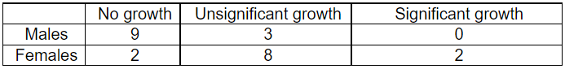

-value is 0.019 decision: accept to reject the null hypothesis (ftr) since p-value lesser than alpha 0.05, we accept to reject the null hypothesis. Conclusion there is association between gender status and bacterial growth.
Gender | Bacteriuria Growth |  |  | P-Value
Gender | No growth (N=35) | No significant growth (N=25) | Significant growth (N=3) | P-Value
Male | 18 (28.6%) | 12 (19%) | 0 (0%) | 0.018
Female | 17 (27%) | 13 (20.6%) | 3 (4.8%) | 0.018

Discussions:
The results show that asymptomatic bacterial growth in women is more than male depending on the microbiology examination of urine samples that takes from student in LIMU university for asymptomatic bateriuria total number of samples are 24 samples were collected each 12 for both male and female student out of 72.7% of female student are positive and 27.3% of male student are positive which is show that the women are more effective of UTI infection more than the males for many reasons first the female urethra is shorter than the male In length 1-2 cm It's the biggest reason the tube that Carrie the urine from the bladder to out of the body which means it has a shorter distance to climb to infect the bladder in females than in males also because that tissue lining the virginal this skin thinner and more sensitive than any other skin on the body unlike the male it's easier to irritate that great an envirmental for bacteria to grows the placement of urethra it can be one of the reasons because its closer to the rectum, which is carries waste and bacteria .
Sexual activity also leads to UTI. ^{1,3}
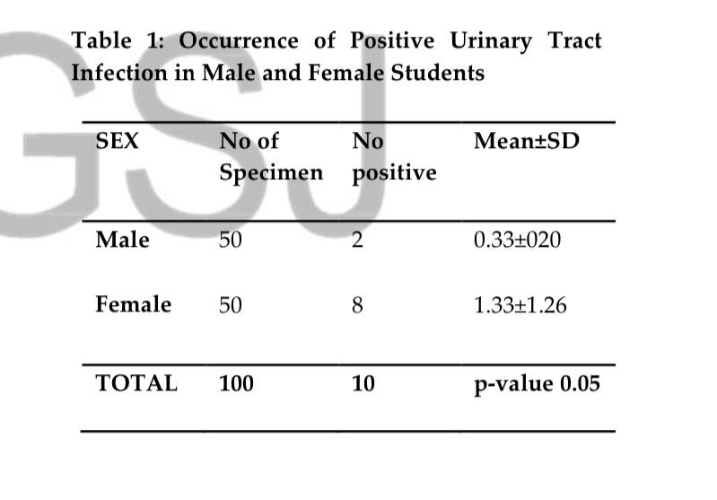
This study investigated UTI in female and male students at AAU university, which supports our findings that females are more impacted than males. There are 50 females and 50 males in this study. The purpose of this study was to investigate the prevalence of urinary tract infection (UTI) among male and female AAU students. This research enlisted 100 seemingly healthy students, 50 males and 50 girls between the ages of 18 and 30.. The samples used were early morning mid-stream urine. The samples were subjected to microscopic examination and cultured on Cysteine Lactose Electrolyte Deficient (CLED), Blood agar and MacConkey agar. Biochemical testing and antibiotic susceptibility tests were performed on the isolates. Results showed that out of the 100 students, only 10 students had UTI. Out of 50 males, only two had UTI and out of 50 females, only eight students had UTI. The age group 21-25 years was found to be the most contaminated (with a value) accounting for 8% of the total isolates with 1 male and 7 females, according to the findings age group 26-30years was the second most infected accounting for 2% of the total isolated with 1 male and 1 females ².
.
Conclusion:
According to these databases that supported by other studies as mentioned above the hypothesis is totally accepted
Bacteriuria is divided into two types: asymptomatic, which refers to the presence of a microorganism such as E.coli, and symptomatic, which refers to the presence of bacteria such as E.coli, which is the most common cause of urinary tract infection (UTIS), which is more common in females than males, and one of the causes is the shortness of the female urethra. Bacteriuria asymptomatic can be treated and prevented by avoiding irritating products and keeping the genitalia organs clean. Treatment of pregnant women with asymptomatic bacteriuria with antibiotics, such as trimethoprim-sulfamethoxazole, has been proven to be helpful. There is evidence that treating asymptomatic bacteriuria lowers the risk of a symptomatic urinary tract infection in these individuals.

References:
- Levinson, Warren. Review of medical microbiology and immunology. 13rd Ed. The McGraw-Hill Companies, 2014
- Researchgate.net. Accessed June 19, 2022.https://www.researchgate.net/profile/Kenneth Iyevhobu/publication/344401784_Urinary_Tract_Infection_among_Male_and_Female_Students_in/links/5f71a0e692851c14bc9ad4ab/Urinary-Tract-Infection-among-Male-and-Female-Students-in.pdf?origin=publication_detail
- Bailey&scotts, diagnostic microbiology, 12th ed. 40

