LIBYAN INTERNATIONAL MEDICAL UNIVERSITY
faculty of applied mediacl scinces – year 3

Name: salsabeel Hamad elgzirey
Roll number: 2357
Supervised by: Dr. Khadija Mansour
Assisted By: Dr. Ahmed Jabani

Asymptomatic bacteriuria and its association with gender

Is it have a serious complication?



Abstract:

Urinary tract infection is a presence of microorganisms that cause diseases in Genito-urinary system. Asymptomatic bacteriuria is present of > 100,000 colony forming units/ml are found in aseptically collected midstream urine without any symptoms, is found in 2.7% of women aged between 15 and 24 years and increases to 50% in women above an age of 60 years. In men the prevalence of ABU is considerably lower, but increases to 20% above the age of 70 years .to do urinalysis sample preparation started, are 3 steps in the order is culture, gram staining, microscopy
there are 3 stages of ABU: no growth, no significant growth, significant growth.
ABU is an important type of UTI, more common in females because the length of urethra is shorter than in males is approximately 3-fold higher in adult women and also the incidence is high in patients with diabetes mellitus, characterized by presence of bacteria in urine without any symptoms, the treatment started with significant growth of bacteria is reached.

introduction:
A urinary tract infection (UTI) is an illness that affects any region of the urinary tract. Urine is generally sterile. This indicates that no microorganism is growing ⁹. The bacteria "Escherichia coli" is the most common cause of UTI, however additional infecting organisms include Enterobacteriaceae, Pseudomonas aeruginosa, Enterococcus species, and group B streptococcus. This infection might be associated to the hospital, such as in patients who are on a urinary catheter, or it could be immune-related.
UTIs are frequent infections that occur when germs from the skin or rectum enter the urethra and infect the urinary system¹, resulting in an estimated 7 million office visits and a million-emergency department visits each year ^{2,1}.
Bacteriuria is defined as the presence of bacteria in the urine (positive urine culture), which can be symptomatic or asymptomatic. A patient with asymptomatic bacteriuria is described as having one or more organisms colonized in a urine sample but no symptoms of illness. Symptomatic bacteriuria is caused by a urinary tract infection caused by a single bacterium. Cystitis and prostatitis are examples of lower UTIs, whereas pyelonephritis and pyonephrosis are examples of upper UTI ⁴
Asymptomatic bacteriuria (ASB) is bacteria in the urine without any symptoms caused by the presence of one or more species of mainly gram-negative bacteria in the absence of signs or symptoms attributable to UTI, the frequency varies among different populations, depending on factors such as age, sex, and underlying disorders e.g., diabetes mellitus, incontinence and dehydration also bladder augmentation. One study in hospitalized patients identified obesity and iron deficiency anemia as independent risk factors for ABU ³.
the prognosis of recurrent UTIs that have been treated for asymptomatic bacteriuria have been found to have higher rates of symptomatic UTIs and a higher prevalence of antibiotic-resistant bacteria, prognosis is good unless the individual develops severe sepsis. In case of severely septic patients; choosing the best antibiotic based on local susceptibility data and clinical history ⁴
asymptomatic bacteriuria does not benefit from treatment. There are, however, a few exceptions. There is sufficient evidence that a pregnant woman with asymptomatic bacteriuria should be treated ^{1,2}
ABU is more common among women than men probably because of the shorter female urethra, which gives bacteria from the urethral meatus and the perineum a shorter distance to the bladder. In fact, most women have transient bacteriuria after sexual intercourse, but few of these women will develop symptomatic infections because the body's normal defense mechanisms prevent symptomatic infection in most cases (immunocompetent) ⁸
there's a study was conducted in Ethiopia 2009 "Tikur Anbessa University Hospital", This issue discusses the justification for not screening or treating ABU. 413 adult patients were enrolled in this study. And their urine samples were positive to asymptomatic bacteriuria and most of them were females ⁶

Materials and methods:
In the microbiology lab, we collect the urine sample from our own in a sterile container with cap, then we labeled it to be used for this experiment.
# Be careful to urinate a little before collecting the sample in the container
The 1st step in sample preparation " culture media ": collect the urine sample in sterile container, take from sample by a loop which 0.5 in size then disrepute urine upon the culture in Zig-Zag way, this step done to see if there's any growth of bacteria.
= we used clit agar because it cost effectiveness, and shows lactose fermentation if there are growth of bacteria.
The 2nd step " gram-staining ": take a drop from urine sample and apply it on a slide then move the slide above flame in speedway.
In same slide which used in step two, application of crystal violet for 60 sec, after that application of iodine for 60 sec, then application of ethyl alcohol for 15 sec, finally counterstain with safranin for 60 sec, remember to wash the slide after adding of any substance.
The 3rd step "microscopy": Appling a drop of oil on a slide, and watch it under the light microscope to see if there's any bacteria.
See the (figure 1) and go from left to right __

Figure 1: steps of urine sample preparation
Discussion and results:
Asymptomatic bacteriuria refers to the detection of bacteria in a properly obtained urine sample from a person who has no symptoms of a UTI. Colonization and infection with antibiotic-resistant bacteria increases with age ².
according to aim of our study which is to determine the incidence of ABU between males and females in LIMU students.
the participant was 24 (12 males, 12 females), the results shows that the ABU grow in significant way in females where in males shows little to no growth, the explanation of this according to the National Institute of Diabetes and Digestive and Kidney Diseases, women are more likely to develop UTIs because they have a shorter urethra than men so bacteria don’t have to travel very far to reach and infect a woman’s urinary system and most of ABU is an ascending infection , ( figure 2 ) , but although an increase is seen in men after the age of 50 ⁴.
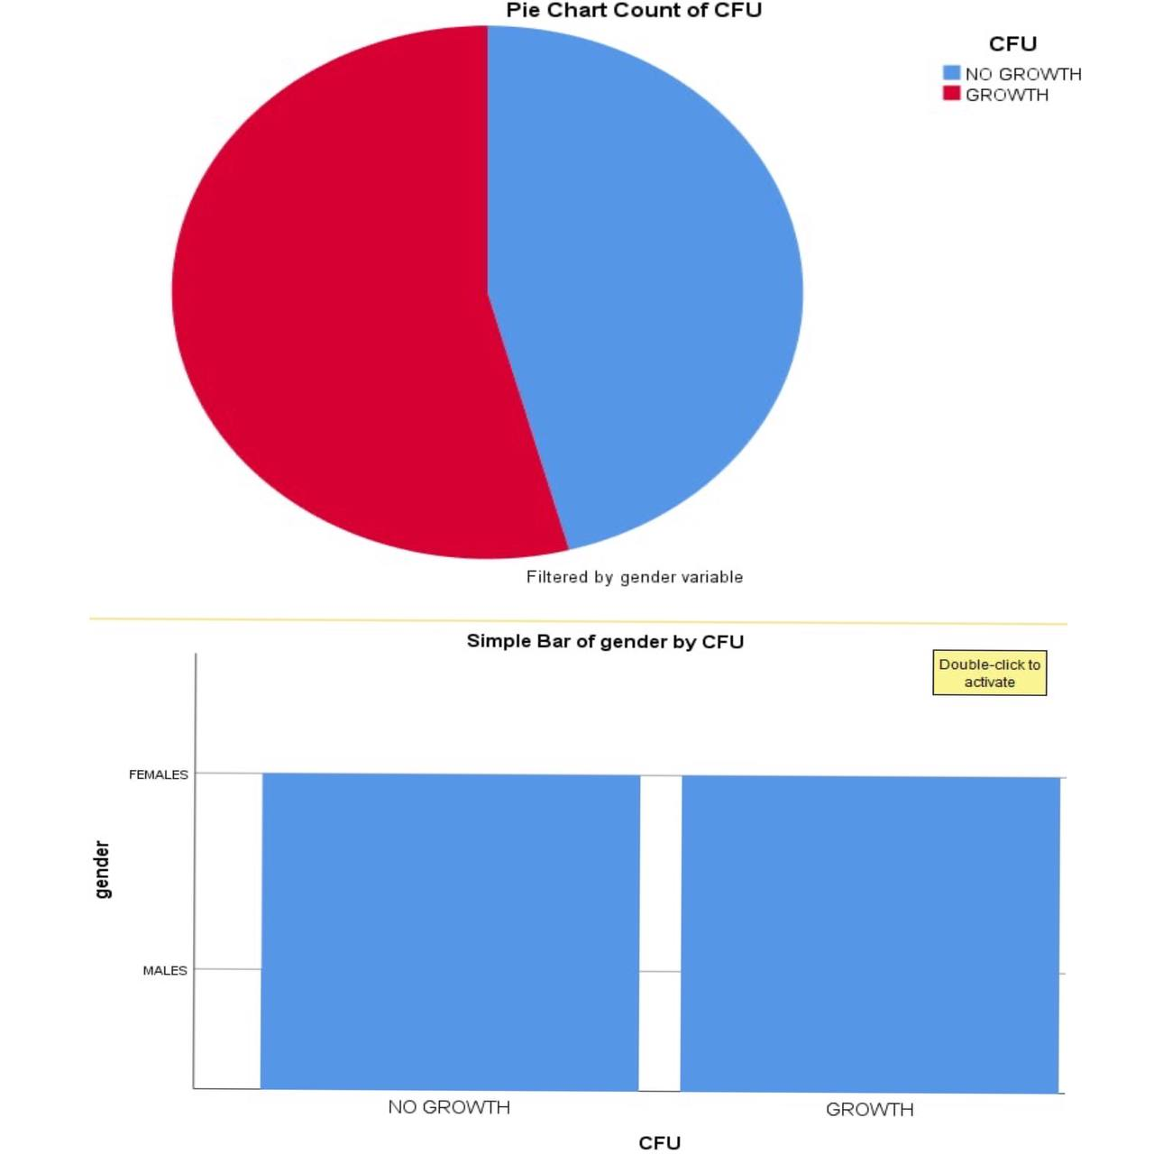figure 2: incidence of bacteriuria with gander
by comparing results from study in literature and our study, the results are matching and reviles same findings.
To diagnose bacterial growing in the urine at specified quantitative "the number of colonies in which significant growth occur " counts (≥105 colony-forming units [CFU]/mL or ≥108 CFU/L), less than this count it considered to be as a normal flora of urinary tract.
In our findings, the culture shows bacterial growth, specifically E. coli which identified by yellow color that indicate lactose fermentation of agar, with some sort of contamination. (Figure 3).
The way used to identify the nature of this positive culture by using the equation mentioned above, in which the number of colonies is multiplied by 10 ^{5,7}, if the result was more than 20,000 this mean that this positive growth is significant.
In our case; the culture shows 5 colonies of E. coli, 5 * 10⁴ = 50.000
So. this result is significant for ABU (significant positive growth)
2 RBCs is shown (normal from 2-5) and no creaseless seen
While macroscopic examination shows clear, concentrated urine, odor less 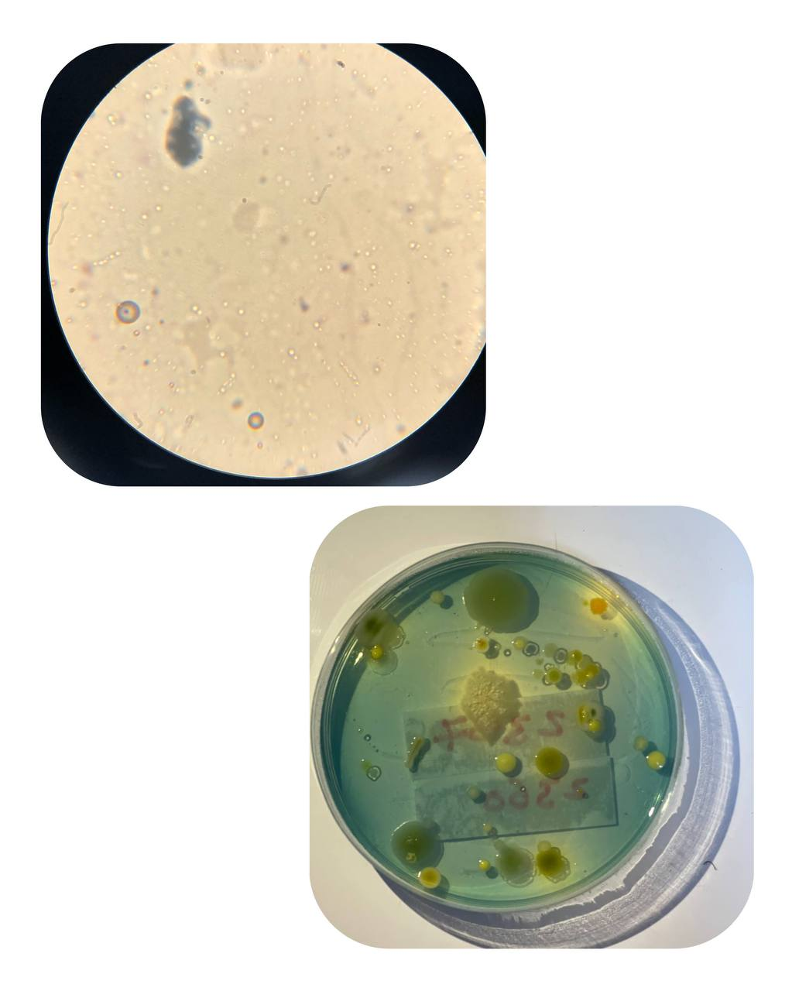

Figure 3: culture and microscopic appearance of urine sample
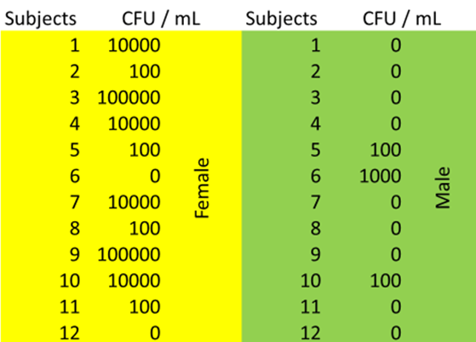
Table 1: the data of our experiment
By using SPSS software (chi-square test) to translate this result to a statistical analysis, and to support our hypothesis which is the incidence of ABU increased in females than in males We need a P-value. (Figure 4).
P-value here is .004 which is a significant, and approve the hypothesis
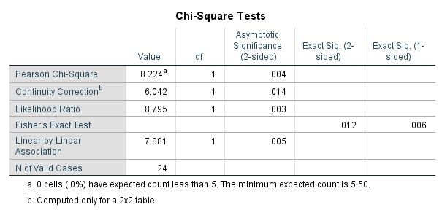figure 4: statistical analysis of data

False-positive results may occur as a consequence of urine contamination from genital secretions or bacterial overgrowth on standing.
False-negative results may be due to misinterpretation of bacteria (especially with cocci) or the lysis of leukocytes ⁵
The Infectious Diseases Society of America (IDSA) issued guidelines for the treatment of ABU Most patients will not develop symptomatic urinary tract infections and will have no adverse consequences from ABU. Specifically, children, patients with diabetes, older patients, patients with spinal cord injuries, and patients with indwelling urinary catheters do not benefit from treatment with antibiotics. Treatment in these patients does not decrease the incidence of symptomatic urinary tract infections. In contrast, treatment of pregnant women with ABU has been shown to be beneficial. Antimicrobial treatment of ABU in pregnancy decreases the risk of pyelonephritis, low-birthweight infants, and preterm delivery and Treatment duration should be for 3 to 7 days for pregnant women. In addition, patients undergoing urologic procedures in which mucosal bleeding is expected, such as with resection of the prostate, and patients who are in the first three months following renal transplantation probably should be treated. There is evidence that treatment of ABU in these patients decreases the risk of symptomatic UTI, Treatment should be guided by the results of urine culture and sensitivity. Amoxicillin, amoxicillin/clavulanate, cefuroxime, cephalexin, and nitrofurantoin are considered safe for use in pregnancy^{8,9}
Special condition in which ABU common:
1_ diabetes millets because weakened immune system + glucose in urine is good media for bacterial growth.
2_ congenital abnormalities or stones in urinary tract

Conclusion:
UTI is the infection of urinary system, the most common cause is a gram-negative bacterium especially E. coli 80% and 10% for gram positive bacteria staphylococcus saprophyticus and other 10% for uncommon UTI infectious bacteria which are Klebsiella, pseudomonas, proteus.
To easy remember of the causative organisms, USMLE mnemonic is the word (KEEPS)
there's a strong association between ABU and gender, the shorter urethra in females Is the main reason for this association in addition to some immunological factors that may contribute.
The number which indicates the significant growth is 20,000, the treatment should be done after the antibiotic sensitivity test to avoid the resistance
Abbreviations and key words:
- abbreviations:
ABU: Asymptomatic bacteriuria
UTI: urinary tract infections
CFU: colony forming unit
IDSA: Infectious Diseases Society of America
- Key words:
bacteria, females, immune status, age
References and resources:
https://www.cdc.gov/antibiotic-use/uti.html1-
2_ Cortes-Penfield N, Trautner B, Jump R. Urinary Tract Infection and Asymptomatic Bacteriuria in Older Adults.
3- Asymptomatic Bacteriuria: Practice Essentials, Children, Adults. Emedicine.medscape.com. https://emedicine.medscape.com/article/2059290-overview.
4- Crader M, Kharsa A, Leslie S. Bacteriuria. Ncbi.nlm.nih.gov. https://www.ncbi.nlm.nih.gov/books/NBK482276/..
https://www.sciencedirect.com/topics/medicine-and-dentistry/bacteriuria5_
6- B Y, S G, Y F. Asymptomatic bacteriuria and symptomatic urinary tract infections (UTI) in patients with diabetes mellitus in Tikur Anbessa Specialized University Hospital, Addis Ababa, Ethiopia. PubMed. https://pubmed.ncbi.nlm.nih.gov/23409407/.
7- https://jamanetwork.com/journals/jamainternalmedicine/article-abstract/613597
8- Bigotte Vieira M, Alves M, Costa J, Vaz-Carneiro A. Análise da Revisão Cochrane: Antibióticos Destinados ao Tratamento da Bacteriúria Assintomática. Cochrane Database Syst Rev. 2015;4:CD009534
9- Encyclopedia M, bacteriuria A. Asymptomatic bacteriuria: MedlinePlus Medical Encyclopedia. Medlineplus.gov. https://medlineplus.gov/ency/article/000520.htm

