The effect gender on the prevalence of asymptomatic bacteriuria

Student: Mohammed salah alfallah
Student number: 3080
Libyan international medical university
Faculty of applied medical science
Supervisor: Dr. Intesar Alnagi
Block: PTS

Abstract:
The presence of bacteria in properly collected urine of a patient who has no signs or symptoms of urinary tract infection is understood as asymptomatic bacteriuria. The lab report was done to find out if gender has any significant effect on the prevalence of ABU. The method that was used involved testing 24 LIMU students 12 of which are males and 12 are female. The urine samples collected were cultured and the bacterial growth was counted. The results showed that females had a higher rate of bacterial growth than the males. For example, 82% of females showed significant and non-significant bacterial growth. This shows that there is a significant difference between males and females in the prevalence of ABU.

Introduction:
The presence of bacteria in properly collected urine of a patient who has no signs or symptoms of urinary tract infection is understood as asymptomatic bacteriuria. In clinical practice, asymptomatic bacteriuria is very common while it affects a small percentage of infants and toddlers, the rate of occurrence more than doubles between the age of sixty-five and eighty, which proves that increase in age has increase in incidence of asymptomatic bacteriuria.² A definitive cause for asymptomatic bacteriuria is still yet to be discovered. The shorter female urethra allows bacteria from the opening and the perineum to travel a shorter distance to the bladder, resulting asymptomatic bacteriuria is more common in women than in men.in general, most women experience temporary bacteriuria following sexual contact. Urine culture is used to diagnose asymptomatic bacteriuria. A catharized specimen or a correctly acquired clean-catch specimen are both acceptable. The purpose of this experiment was to discover whether the gender of a patient will affect the amount of bacterial growth that will be present in their urine culture. This will help us to find out the effect of gender on the overall prevalence rate of ABU. Most of the previous pieces of research that were carried out addressing this specific topic concluded that females tend to have higher rates of bacterial growth in their urine than makes. That is why the hypothesis for the experiment that was carried out is that there is a significant difference between males and females in the amount of bacterial growth. The most common bacteria that was found in urine is E. coli because it is the most common cause of UTIs and ABU.¹
Methods and materials:
The candidates that were used in this experiment were young medical students from the Libyan international medical university in Benghazi. 24 of the students, who were divided into 12 males and 12 females, had their urine collected through a mid-stream catch method. The samples had to be used within the first hour. So, 3 types of agar plates were prepared for each sample, CLED, blood agar and MacConkey agar. These three agar plates had the urine placed in them using a hot wire loop. The loop was inserted into the urine sample after being heated and then, in a zigzag fashion, spread on the agar plates. The cultures were then left to incubate for 24 hours at exactly 37°C. after the incubation period was finished, the results were counted and the Colony forming units (CFU) value was calculated by multiplying the number by 10⁵. The value that was reached were then put into a biostatistics software (SPSS) and statistical analysis was carried out to calculate the significance of the results reached.

Results:
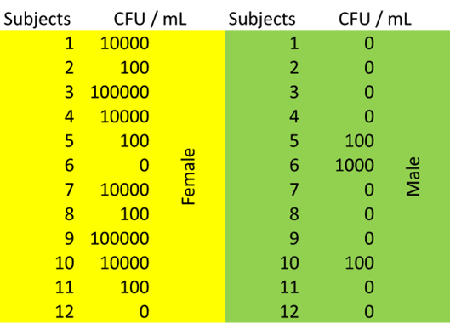
Table 1 shows the CFU value for 24 male and female samples. Only 2 females showed no growth, while 9 males showed no growth.
gender * bacterial growth significance Crosstabulation
 |  |  | Bacterial growth significance |  |  |  | Total
 |  |  |  | no growth | overall | significant | Total
gender | female | Count | 0 | 2 | 8 | 2 | 12
gender | female | % within gender | 0.0% | 16.7% | 66.7% | 16.7% | 100.0%
gender | female | % Within bacterial growth significance | 0.0% | 20.0% | 72.7% | 100.0% | 50.0%
gender | male | Count | 1 | 8 | 3 | 0 | 12
gender | male | % Within gender | 8.3% | 66.7% | 25.0% | 0.0% | 100.0%
gender | male | % Within bacterial growth significance | 100.0% | 80.0% | 27.3% | 0.0% | 50.0%
Total |  | Count | 1 | 10 | 11 | 2 | 24
 |  | % Within gender | 4.2% | 41.7% | 45.8% | 8.3% | 100.0%
 |  | % Within bacterial growth significance | 100.0% | 100.0% | 100.0% | 100.0% | 100.0%

Table 2 shows the percentage of bacterial growth rate in females and males. Such as, 16.7% is the percentage of females without bacterial growth
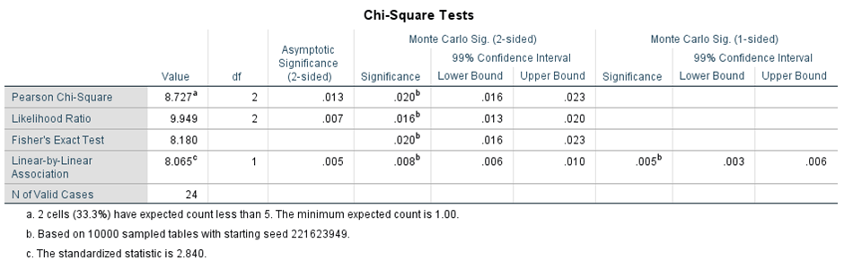

Table 3 shows the P-value for Fisher’s exact test.

Table 4 shows the summary table for the results.

Discussion:
The results that were reached in this experiment that was done to examine how the difference in gender can affect the growth of bacteria in urine, were as expected. Before carrying out this experiment we looked at many previous experiments and results. All the previous results suggested that females have a higher prevalence of ABU than males and our experiment was no different. The results of this experiment showed that only 25% of all the males had samples which showed any bacterial growth, and out of that 25%, none of the growth was significant. Meanwhile, out of the 12 females that were tested, 83.4% showed bacterial growth, both significant and insignificant. These results just from noticing the difference between the levels of growth show that there is a clear difference between males and the females. However, entering those CFU values into the SPSS software and using the Chi square and fisher’s exact test to determine the significance of the difference between men and women. The P-value that was calculated was 0.020, which is below 0.05 making the difference significant and allowing us to accept the hypothesis.
Chi square was the statistical test that was used initially to calculate the p-value, however, after attempting it, it was clear that a different test would have to be incorporated since the chi square test did not have all its assumptions met with the set of results that was present. Hence the use of fisher’s exact test to determine a p-value for our results.
The reason for the differences in prevalence rates of both UTIs and ABU in males and females is already well documented, and many factors can play a part in explaining why. For example, the anatomical difference between the female and male urethra; the female one being almost a quarter of the length of the male urethra. This shorter distance would mean that bacteria that is entering from the lower urinary tract have an easier route to the bladder and into the urine, making the presence of bacteria in urine much mire common in females than males. ²
Some methods that were used in other experiments done before this one had slightly different methods to the one that we used. For example, the method of urine collection differed from one method to another, some using urethral catheterization and suprapubic aspiration, depending on the age of candidates and many other factors. The use of the midstream clean catch method was the most suitable method of collection for this experiment due to the age of the candidates and their physical health. ³
The bacterium that was tested for in this experiment was most likely going to be E.coli. especially with it being the most common cause of UTIs. A few biochemical tests were carried out and later confirmed that the bacterial growth was indeed E.coli.

Conclusion:
In conclusion, there is very clearly a significant difference between the prevalence rates of ABU between males and females as shown by the results. There was no significant growth for any of the male samples, while almost 17% of female samples showed significant bacterial growth. This clear difference is further confirmed by the 0.020 P-value which confirms the significance of that difference. Although the sample size used for this experiment is quite small, if the experiment is carried out again, a larger sample size would allow for more accurate results.

References:
1. Givler D, Givler A. Asymptomatic Bacteriuria. Ncbi.nlm.nih.gov. https://www.ncbi.nlm.nih.gov/books/NBK441848/. Published 2021. Accessed June 20, 2022.
2. R C, GA J, LE N. Asymptomatic Bacteriuria. PubMed. https://pubmed.ncbi.nlm.nih.gov/32667160/. Published 2019. Accessed June 20, 2022.
3. US Preventive Services Task Force, Owens DK, Davidson KW, et al. Screening for Asymptomatic Bacteriuria in Adults: US Preventive Services Task Force Recommendation Statement. JAMA. 2019;322(12):1188-1194. doi:10.1001/jama.2019.13069

