

Libyan International medical university
Faculty Of Applied Medical Sciences
2nd year AMS

ASYMPTOMATIC BACTERURIA IN MALE AND FEMALE

Supervisor: Dr. Entsar Naje
Dr. Eman Elferjane
Mr. alhumre
Student Name : Dana Ahmed
Student Number : 2903
Abstract:
Most the urinary tract infections begin as a cystitis secondary to decreased in blood supply to the bladder, In the female, infrequent voiding and the uninhibited bladder are the most common causes of urinary tract infection and are best treated by healthy voiding regimens; while in the male, structural and functional obstructive uropathy with urinary tract infection are alleviated by lowering the high intravesical pressure via surgical or medical measures Among the bacterial species Escherichia coli, enterococci are considered common bacterial causes of UTI in both genders, In the present study 24 patients with clinical symptoms and suspected to UTI were sampled , clean catch midstream urine of the patients was collected, urine specimens were cultured for isolation of the microbial agents of UTI , The isolated bacteria using urine analysis . For the treatment according to the asymptomatic bacteriuria in the culture media, If it is sensitive or resistant to antibiotics.

Introduction:
Urinary tract infections are the most common infectious diseases worldwide, UTIs involvement a widespread of clinical manifestations, including acute, chronic, complicated, uncomplicated ,symptomatic, asymptomatic and recurrent, UTIs may affect as a cystitis ( lower UTIs ) and/or Pyelonephritis ( upper UTIs ) For the symptoms includes painful and frequent urination in case of cystitis as a consequence of bladder infection whereas conditions like high fever and flank pain are commonly in case of pyelonephritis which is referred to kidney infection, In Despite of there are different types of microbial pathogens for cause urinary tract infections, but the important type is (uropathogenic Escherichia coli) involved in 70_80% of cases [1], [2] , Furthermore the Women at particularly at risk for UTIs than males because their urethra sits close to the anus , where E.coli is present, Also the Urinary tract infection can be a result of poor diagnosis and it is considered as the common hospital acquired infection [3]As for the treatment therapy, It determines the diagnosis of the disease and then it is prescribed for treatment .
Materials and method:
In the present study of 24 patients suspected to UTI were sampled, For the Collection of urine sample in first morning specimen via Put in sterile urine bag, Urethral catheterization, Suprapubic aspiration or Midstream clean – catch , Suprapubic aspiration or Midstream clean - catch , thereafter do urine analysis includes physical character ( Volume, Oder , Color , Turbidity ) Then chemical analysis ( PH , Protein , Glucose , Specific Gratify ) at last Microscopy of sediment ( RBCs , WBCs , Casts , Crystals) take calibrated loop to Mix the urine insert the loop into the urine to allow the urine adherent to the loop then spread the urine over the surface of the culture media ( MacConkey agar or blood agar ) in Zigzag motion without flaming insert the loop into the urine again to transfer of loop to another plate then put it in incubation for 24hr at 37 C in air colonies are counted on each plate , In addition the number of CFUs is multiplied via 1000 ( if 0.001mL a loop was used ) While CFUs is multiplied via 100 ( if 0.01mL a loop was used ) to constricted the number of microorganisms per ml in the original specimen , If there is no growth or a little growth on the agar after 24 to 48 hr of incubation, The urine culture is considered negative . .

Result:
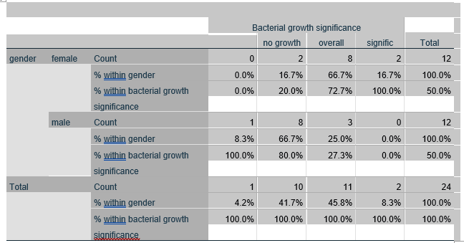
Gender bacterial growth significance crosstabulation

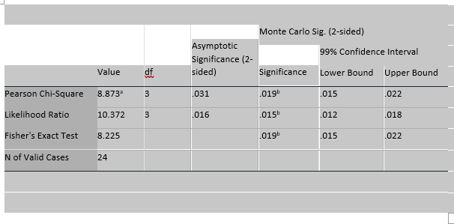
Chi -Square test:

The result is Hypothesis H0 : there is no association gender status and bacterial growth.
Ha ; there is a association between status and bacterial
So p-value of fishers is 0.019 .
Decision except to reject the null hypothesis since p-value lesser than alpha 0.05 , we except to reject the null hypothesis.

Discussion:
The Urinary tract infections are one of the most common infections confer in hospital too community setting [4] , It is affects people of all aga groups and genders but The women are more effective to develop because she has a shorter urethra than men , Although there are many types of microbial pathogens causes UTIs such as proteus microbilise , E.coli , Klebsiella pneumonia and pseudomonas aeruginosa however the E.coli is more common in the women because their urethra sits close to the anus , where E.coli is present , In our study on 24 patient's , 12 male and 12 female according to the growth of microbial pathogens on the planet the overall for the female 8 for the male 2 whilst no growth for female 2 for the male 8 , There are several reasons for negative culture in urine analysis (No growth) possible the patient take antibiotic before sample collection , Nonbacterial causative agent ( viral , fungal , parasitic ) , Inflammation , Non cell wall bacteria need special media , Anaerobic bacteria is the causative agent , for the positive culture that mean the number of colonies bacteria in the urinalysis growth > 100.000 CFU/ml , In despite of there are studies that the UTIs occurs more in the women with diabetes than in the women without diabetes, it has a similar finding have been demonstrated for asymptomatic bacteriuria , The pathogenesis of UTI patients with DM approved to be multifactorial such as diverse risk factors as renal dysfunction , defects in immune function , effects on the retina[6]. , There are a lot types of antibiotics therapy According to their situation of patient, If asymptomatic bacteriuria was discovered should be examined and treated in antibiotic, Early detection and choice treatment useful.

Conclusion:
Asymptomatic bacteriuria disease are more common in the female more than the male caused by the most common micobactiral pathogenic is E.coli lead to asymptomatic bacteriuria Because the P-value was considerable , The female is at high risk to get infected , Therefore advise educating people to avoid holding urine and urinating continuously, to keep sensitive areas clean, to wear cotton underwear, and to avoid alcohol and fluids that contain caffeine .

Reference:
1. Keating KN, Perfetto EM, Subedi P ( 2005) Economic burden of uncomplicated urinary tract infections: direct , indirect and intangible costs. Expert Rev Pharmacoeconomic outcomes Res 5: 475- 466 [PubMed][Google Scholar].
2. warren Levinson . Review of medical microbiology and immunology, 13rd ed, the McGraw-Hill companies 2014 .
3. The American Journal of Medicine // Urinary tract infections in patients with diabetes.

.

