

The Libyan International Medical University
Faculty of Basic Medical Science

Lap report
The rate of occurrence of asymptomatic bacteriuria within LIMU students
Dr.Asma

Name: Abdulgader almukahal
Number: 2833
Date of Submission: 20/6/ 2022

Abstract :

Asymptomatic bacteriuria is the presence of bacteria in correctly collected urine of a patient who has no signs or symptoms of a urinary tract infection (UTI).The incidence rate of asymptomatic bacteriuria in a population of 24 persons was measured in this study. Urine samples were obtained halfway through the urinating process from 24 subjects, 12 males and 12 females. There were two hypotheses: one was that there is a relationship between the two variables, and the other was that there isn't.The null hypothesis is rejected since the p-value is less than 0.05, indicating that A relationship between gender and asymptomatic bacteriuria was discovered in this study.This study discovered a relationship between gender and asymptomatic bacteriuria, suggesting that females are more susceptible to the infection.

Introduction :

A positive urine culture acquired from a patient who does not show symptoms of a urinary tract infection is referred to as asymptomatic bacteriuria. Antibiotic therapy is ineffective for most people with asymptomatic bacteriuria because they have no symptoms or negative consequences. A urinary catheter, old age, pregnancy, sexual activity, and genitourinary disorders are all possible causes of bacteriuria without symptoms. If the midstream catch clean method was employed, the presence of 100,000 or more colony-forming units in a urine culture can be used to identify asymptomatic bacteriuria; if the sample was catheterized, the presence of 100 or more colony-forming units can be used to diagnosis asymptomatic bacteriuria. The purpose of this study was to examine if there was a link between gender and asymptomatic bacteriuria among 24 LIMU students, half of whom were male and half of whom were female. If there was, a statistical analysis was carried out to see how significant the link was. The null hypothesis claims there is no link between asymptomatic bacteriuria and gender, whereas the alternative hypothesis claims there is.

Materials and Methods :

To acquire the best results, urine samples were taken halfway through the peeing process from 24 persons, 12 males and 12 females. The culture was started just a few minutes after the sample was taken, with the intention of finishing in less than an hour. A urine sample test tube, a calibrated wire loop, a Bunsen burner, an incubator, and an agar plate containing culture media, preferably CLED or MacConkey agar because they detect most gram negative bacilli, staphylococci, streptococci, and enterococci, are all required. The loop was heated and the urine was stired, then the loop was inserted vertically into the urine to allow it to adhere to the loop, then it was spread by touching the tip to the center of the plate and dragging across the diameter, the loop was put again in the urine and spread in a Zig-Zag pattern, and the plate was incubated in the air at 37 C for 24 hours. The number of colonies was counted and was multiplies by 100 due to the employment of a 0.01 ml loop if the Colony forming unit is ≥1 × 10^5 CFU/mL then there is a significant growth
Results and statistical analysis:
Significant growth | Insignificant growth | No growth
0 | 3 | 9 | Males
2 | 8 | 2 | Females
Table 1: Gender variations have an impact on the prevalence of asymptomatic bacteriuria.

There is a relationship between gender and asymptomatic bacteriuria, as indicated in Table 1. A Chi-Square test was conducted to assess if the association was significant. The hypothesis was that there is a link between the two variables, but the null hypothesis says there isn't. However, because the requirement of less than 20% of cells having an anticipated value of less than five was not met, a fisher test was utilized instead.

 |  |  | UTICATS |  |  | Total
 |  |  | No growth | No significant growth | Significant growth | Total
Gender | Male | Count | 9 | 3 | 0 | 12
Gender | Male | Expected Count | 5.5 | 5.5 | 1.0 | 12.0
Gender | Male | % within Gender | 75.0% | 25.0% | 0.0% | 100.0%
Gender | Male | % within UTICATS | 81.8% | 27.3% | 0.0% | 50.0%
Gender | Female | Count | 2 | 8 | 2 | 12
Gender | Female | Expected Count | 5.5 | 5.5 | 1.0 | 12.0
Gender | Female | % within Gender | 16.7% | 66.7% | 16.7% | 100.0%
Gender | Female | % within UTICATS | 18.2% | 72.7% | 100.0% | 50.0%
Total |  | Count | 11 | 11 | 2 | 24
 |  | Expected Count | 11.0 | 11.0 | 2.0 | 24.0
 |  | % within Gender | 45.8% | 45.8% | 8.3% | 100.0%
 |  | % within UTICATS | 100.0% | 100.0% | 100.0% | 100.0%
Table 2: The relationship between bacterial growth and gender.

c. The standardized statistic is 2.840.

Chi-Square test

Table 3: The null hypothesis was rejected since the p-value was less than 0.05, indicating that there is a relationship between gender and the prevalence of asymptomatic bacteriuria.

 |  | Value | df | Asymptotic Significance (2-sided) | Monte Carlo Sig. (2-sided) |  |  | Monte Carlo Sig. (1-sided)
 |  |  |  |  | Significance | 99% Confidence Interval |  | Significance | 99% Confidence Interval
 |  |  |  |  |  | Lower Bound | Upper Bound | Significance | Lower Bound | Upper Bound
 | Pearson Chi-Square | 8.727ª | 2 | .013 | .018^{b} | .014 | .021
 | Likelihood Ratio | 9.949 | 2 | .007 | .012^{b} | .009 | .015
 | Fisher's Exact Test | 8.180 |  |  | .018^{b} | .014 | .021
 | Linear-by-Linear Association | 8.065^{c} | 1 | .005 | .006^{b} | .004 | .008 | .002^{b} | .001 | .003
 | N of Valid Cases | 24
 | a. 2 cells (33.3%) have expected count less than 5. The minimum expected count is 1.00.
 | b. Based on 10000 sampled tables with starting seed 2000000.
 | c. The standardized statistic is 2.840.

 | CFU/mL
Characteristic | No growth | Overall, no significant growth | significant growth | P-value
Characteristic | 11 | 11 | 2 | P-value
Gender% |  |  |  | P-value=0.018
male | 9(81.8%) | 3(27.3%) | 0(0.0%) | P-value=0.018
female | 2(18.2%) | 8(72.7%) | 2(100.0%) | P-value=0.018
Table 4: summary table
Males:
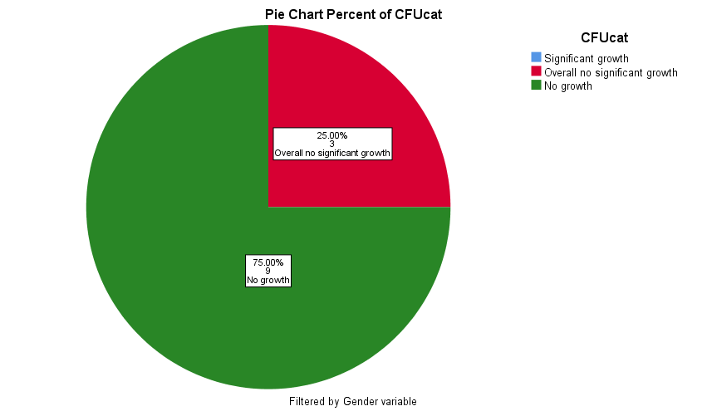

Figure 1
In male 9(81.8%) is no growth and 3(27.3%) are no significant growth and don’t have significant growth

Females:
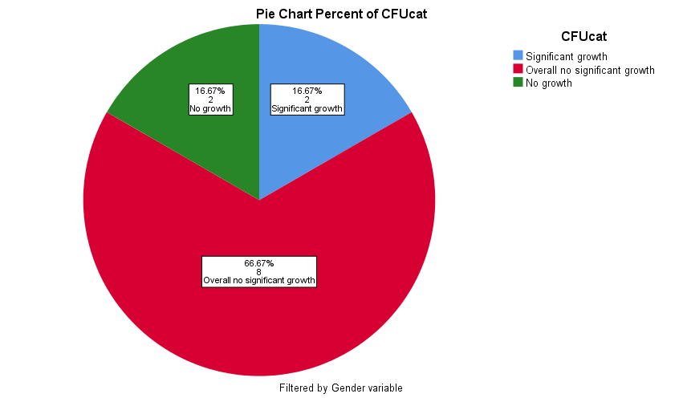

Figure 2
In female 2(18.2%) is no growth and 8(72.7%) no significant growth and about 2(100.0%) significant growth

Discussion :
The findings support the hypothesis that there is a link between gender and asymptomatic bacteriuria. Females have a higher rate than males, as shown in Graph 1, This is due to a number of variables, including the physical shape of the female urinary system. The urethra, which is responsible for transporting urine out of the body, is smaller in females. The urethra is where bacteria enter the urinary tract, and a shorter urethra makes it easier for bacteria to enter because it has to travel a less distance. The proximity of the urethra to the rectum, which contains Escherichia coli, the most common cause of asymptomatic bacteriuria and urinary tract infections, is another reason (UTIs). Because of the anatomical structure of their reproductive system, females are more susceptible to UTIs and asymptomatic bacteriuria. The likelihood of asymptomatic bacteriuria increases during menopause. Estrogen levels diminish during menopause, resulting in weakened vaginal tissue that is more prone to infection. Pregnancy increases the risk of asymptomatic bacteriuria, which can lead to vesicoureteral reflux, in which urine flows back to the bladder and subsequently to the kidney, due to hormonal changes. This raises the risk of pyelonephritis, a potentially fatal condition. Some medications, such as spermicide, can increase the risk of asymptomatic bacteriuria by inducing vaginal irritation, which can create an environment that is conducive to bacterial growth.The majority of persons who have asymptomatic bacteriuria don't have any symptoms. Children, diabetics, and the elderly are among the patients. Patients undergoing urologic surgery who are at risk of mucosal bleeding, as well as those in the first three months after a kidney transplant, should be addressed. To avoid pyelonephritis, low birth weight, and premature birth, pregnant women must be treated as well. It's recommended not to treat patients who don't need antibiotics because this increases the risk of antibiotic resistance.E.Coli is the most common cause of asymptomatic bacteriuria, as previously indicated. This is due to E.Coli being a natural part of the flora of the colon. Other pathogens include Klebsiella pneumoniae, Pseudomonas aeruginosa, Staphylococcal, and Enterococcal species.

Conclusion :

This study discovered a link between gender and asymptomatic bacteriuria, demonstrating that females are more susceptible to the condition for a variety of reasons, including the anatomical anatomy of the female reproductive system. Because asymptomatic infection rarely progresses to a serious infection that causes another disease, it is rarely treated, with the exception of pregnancies, where it can be fatal for both the child and the mother, and kidney transplant patients, where treatment should be avoided to avoid antibiotic resistance. E.Coli is the most common causative agent because it is a natural element of the colon's flora. More research is needed to see if there is a correlation between bacteriuria and age, or if it has anything to do with immune-related disorders like AIDS.

References :

1- Givler DN, Givler A. Asymptomatic Bacteriuria. In: StatPearls. Treasure Island (FL): StatPearls Publishing; May 1, 2022.
2- Colgan R, Jaffe GA, Nicolle LE. Asymptomatic Bacteriuria. Am Fam Physician. 2020;102(2):99-104.
3- Geerlings SE. Clinical Presentations and Epidemiology of Urinary Tract Infections. Microbiol Spectr. 2016;4(5):10.1128/microbiolspec.UTI-0002-2012. doi:10.1128
4- Cortes-Penfield NW, Trautner BW, Jump RLP. Urinary Tract Infection and Asymptomatic Bacteriuria in Older Adults. Infect Dis Clin North Am. 2017;31(4):673-688. doi:10.1016/j.idc.2017.07.002
5- Almaimani AO. Asymptomatic Bacteriuria in Post Renal Transplant Patients: To Treat or Not?. Cureus. 2021;13(6):e15713. Published 2021 Jun 17. doi:10.7759/cureus.15713
6- Levinson, Warren. Review of medical microbiology and immunology. 13rd ed. The McGraw-Hill Companies, 2014

