

Libyan International Medical University

Faculty of applied Medical Science

(The effect of gender on the action of furosemide)
Supervisor: - Dr-basma faraj

Student name: retaj hasan elraeid

Student No: 1658

Abstract
Effects of gender on diuretics, including fluoresemide, and pharmacodynamics. It was found that a dose of fluoresemide must be taken to achieve the same results between the women and men, and there were no noticeable differences, and on the contrary only it was found that the levels of water, potassium and sodium excreted are similar.
Despite the lack of studies and sources, we can assert that there is no difference between the two in terms of urine excretion after taking the diuretic drug fluoresemide.

Introduction: -
A diuretic is a substance that increases urine flow output volume, as the name suggests. So do most diuretics increased urinary excretion of solutes, especially sodium and chloride. In fact, most diuretics used in clinics work by reducing the rate of sodium reabsorption, causing sodium diuresis (increased sodium output), thereby causing diuresis (increased water intake).⁽²⁾
And on the other hand the urinr flow output/volume is the quantity of urine produced per unit of time. Typically, this volume is expressed per day or some fraction of a day (e.g., 8 h, 12 h) or, particularly in the ICU, hourly.⁽¹⁾
fluoresemide a powerful diuretic that reduces active reabsorption in the blood blocking the thick upper limbs of the loop of Henle1-Sodium, 2-Chloride, 1-Potassium symporter, it is located in the luminal membrane of epithelial cells, These diuretics are one of the most powerful diuretics used clinically. ⁽²⁾

Material and method: -
A total of 12 subjects, 6 males and 6 females, received (40 ml/g) of furosemide. The results of monitoring each urinary excretion rate for 6 consecutive hours are as follows.
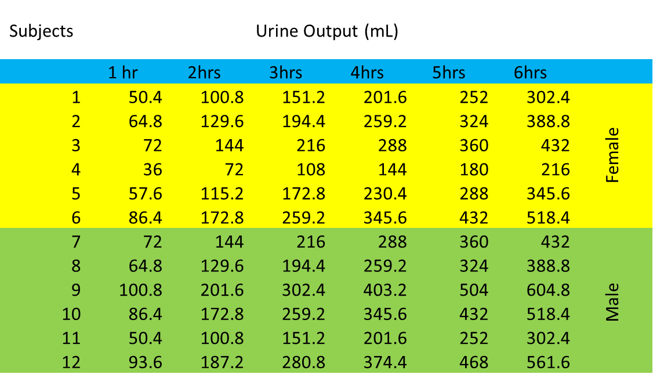

Result and Discussion: -
Using the SPSS program, specifically the t-test, to create a tabulated sample of the volunteers who were randomly selected, and given furosemide to detect any change in the urine volume /output.
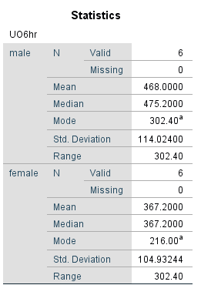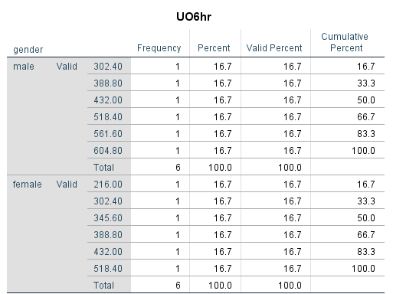

According to the first table, there is no significant correlation between the effect of furosemide and gender differences in urine output after administrating the furosemide. This means that there is no standard on how the drug affects the Na-K-Cl cotransporter along the thick ascending loop of the nephron's loop of Henle.
And this comes with regard to humans, and this contradicts what was stated in another study, which showed that there is a relationship in female mice when they were given drugs to diuretic, and the result was the presence of differences between the net urine between the male and female groups, and this was denied in our study.

Conclusion:
We conclude that the average UO (urine volume) was higher in men than in women
The male was (468.00) and the female was (367.00).
The range of men and women was the same, What is normal? Therefore, these studies have not determined diuretic rates for either gender, and the drug acts on the same mechanism of action in both genders.

Reference: -
1)- Lefebvre CW, Babich JP, Grendell JH, et al. Physiology of urine volume. Encyclopedia of Intensive Care Medicine. 2012:1732-1734. doi:10.1007/978-3-642-00418-6_313
2)- Medicos Times. Guyton and Hall Textbook of Medical Physiology PDF free download [Direct link]. Medicos Times. https://medicostimes.com/guyton-medical-physiology-pdf/. Published October 29, 2021. Accessed June 20, 2022.

