(2021/2022)
LIMU/YEAR2
BLOCK: PTS

Lap Report

The slide centrifuge gram stain as a urine screening method in women

Student name: Aseel Osama Almgarif
Student number: 2835
Supervisor's name: DR. Entisar Elnaji
Assistant by:
DR. Asma alkowafi
DR. Lojain salah
Date: 2022/6/20

Abstract:
To screen for bacteriuria in women, a side centrifuge gram stain
was used.
4161 urine specimens were submitted in urine preservative tubes
for routine culture for slide centrifuges gram staining. Each urine
the sample was mixed thoroughly, then 0.2 ml was pipette-filled into a
slide centrifuge chamber and spun for 5 minutes at 2,000 rpm
The slides were heat-fixed, gram stained, and examined by
laboratory technicians who used a predefined pattern to scan 12
successive oil-immersion areas ds was of the
A positive urine screen was defined as the presence of the same
organism in six or more fields (E.coli was isolated in 75 percent of
the females under research). Urine samples were grown using a0.001
ml loop and comparisons were made.
According to a study published in 1956 by (Kass), gram stain
smears of uncentrifuged urine were positive in 80 percent of
specimens with bacteria counts of 100.000 or more CFU/ml.
use We developed the slides centrifuge to aid in the
the concentration of microorganisms for gram staining of body fluid
specimens and we tested its utility as a fast urine screening
the method in an adult female population.
The quantitative culture was used to compare the results.
Using the sequence illustrated in the image, 12))
successive fields on each slide were scanned
swiftly by oil immersion microscopy, starting in
the center of the slide centrifuge spot.)))

Introduction:
In females, urinary tract infection (UTI) is one of the most ria (E.coli)
prevalent bacterial infections, with enteric bacteria (E.coli) being the most commonly isolated pathogen.
use of its physician culture
ow negative
Because of the excellent impact on female genitourinary health, rapid
identification of bacteriuria is desirable.
Are reliable urine screening methods can provide physicians with
timely and appropriate information and they can also eliminate
the need for culture for some urine specimens that produce
negative results.
The presence of bacteriuria has been detected using the gram stain

Materials and methods :

Initially, 1684 urine specimens were collected, specimens were well mixed and 0.2 ml at each specimen was placed into a centrifuge chamber, capped, and centrifuged at 2000 rpm for 5 minutes in a slide centrifuge.
The slides were heat-fixed and gram stained using :
• solutions of crystal violet, gram’s iodine, 95% ethanol and/or isopropanol-acetone mixture ( 3:1 ), and safranin.
• clean glass slides.
• Inoculating loop.
• Bunsen burner.
• Microscope.
• Immersion oil.
• Difco.
• Slide warmer
• Staining rack.
• Bacto gram stain regents from difco for the three-step gram stain.

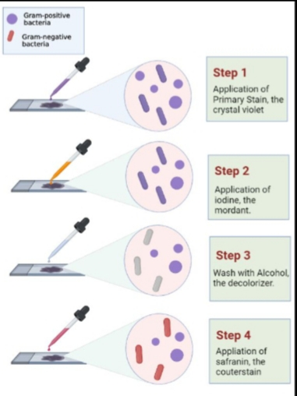

Beginning in the center of the slide centrifuge spot, 12 consecutive fields on each slide were scanned by oil-immersion microscopy, using the pattern shown in the figure

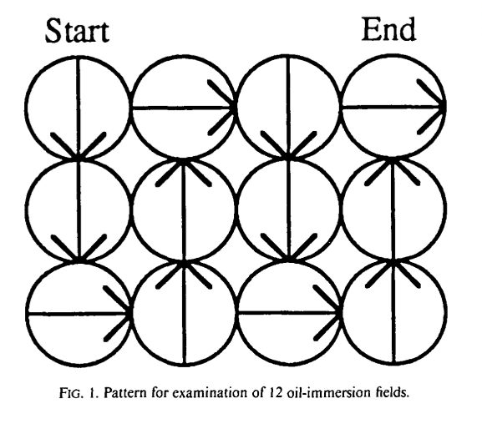

The number of fields in which organisms were seen was recorded and results were obtained.

Result:

The table summarizes the distribution of combined gram staining and culture
results for the 1684 specimens.

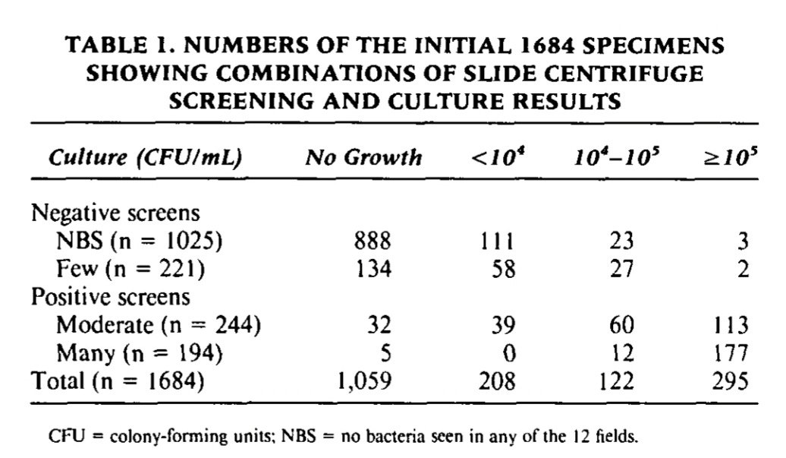

The sensitivity of the slide centrifuge screen in detecting 100,000 or more
CFU/ml on culture was 98 percent and the specificity was 89 percent,
The negative predictive value was 99 percent, and the positive predictive value
was 66 percent for the 1684 specimens tested

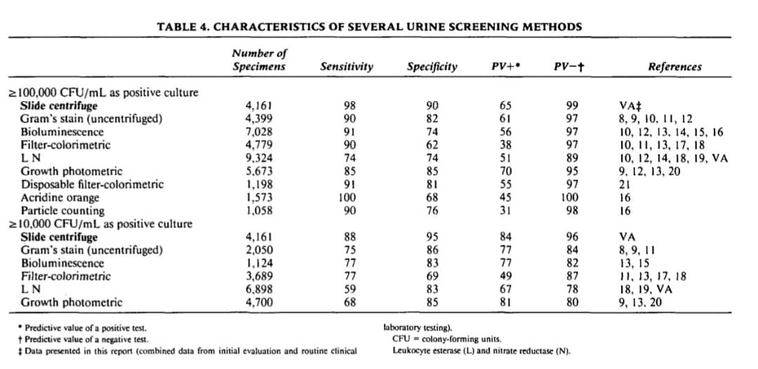
using NBS and a few as negative
results and moderate and many as positive results.

Discussion
According to recent studies, oil-immersion microscopy of gram-staining
conventionally centrifuged urine can reliably detect bacteriuria at 100,000 or
more CFU/ml.
Our slide centrifuge data was compared to newly revised data as well as data
from other screening methods that had been published.
The slide centrifuge screen was found to be a highly sensitive screening
approach (98%) with a high specificity rate (90%) for detecting 100,000 or
more CFU/ml.
Compared to conventional microscopic techniques, the slide centrifuge
The approach has various advantages.
Cells and microorganisms from a liquid sample are deposited on a spot that
is readily brought into the correct position by the slide centrifuge.
Because of the science of early diagnosis of UT! in females, colony counts a
low as '100 CFU/ml may be scientific in specific populations (young woman
with acute dysuria and frequent urine or with a short-team catheter
associated infection).

Conclusion
To summarize, the slide centrifugation urine screen is a susceptible
approach for detecting bacteriuria defects.
Anaerobes, fastidious organisms, and yeast can all be identified with this test,
which can be conducted on preserved urine.
The screen has a therapeutically useful turnaround time and gives the doctor
gram stain features that can assist guide first antibiotic therapy.
Above all, it has a high sensitivity, a high predictive value for negative
outcomes, and a low occurrence of false-negative results.

Result of the statistical analysis:
The purpose of this study was to examine the presence of
bacteria in urine samples from 24 middle-aged LIMU
understudies. There were twelve young ladies and twelve
young men.
asymptomatic bacteriuria was discovered.
There were 7 (29.2%) understudy whose urine tests
developed less than 10,000 CFU/mL, 6 (25%) cases with
10,000 CFU/mL and more, and 11 (45.8%) with no
development. As a result, asymptomatic bacteriuria was
prevalent in 18% of LIMU understudies.
(75%) and as follow in table 1:
 |  |  | Gender |  | Total
 |  |  | Female | Male | Total
CFU | No growth | Count | 2 | 9 | 11
CFU | No growth | Expected Count | 5.5 | 5.5 | 11.0
CFU | No growth | % within Gender | 16.7% | 75.0% | 45.8%
CFU | Overall no significant growth | Count | 8 | 3 | 11
CFU | Overall no significant growth | Expected Count | 5.5 | 5.5 | 11.0
CFU | Overall no significant growth | % within Gender | 66.7% | 25.0% | 45.8%
CFU | Significant growth | Count | 2 | 0 | 2
CFU | Significant growth | Expected Count | 1.0 | 1.0 | 2.0
CFU | Significant growth | % within Gender | 16.7% | 0.0% | 8.3%
Total |  | Count | 12 | 12 | 24
 |  | Expected Count | 12.0 | 12.0 | 24.0
 |  | % within Gender | 100.0% | 100.0% | 100.0%

 | Case processing summary
 | Valid |  | Missing |  | Total
 | N | Percent | N | Percent | N | Percent
CFUcat * Gender | 24 | 64.9% | 13 | 35.1% | 37 | 100.0%
\

Chi-Square Tests
 | Value | df | Asymptotic Significance (2-sided) | Monte Carlo Sig. (2-sided) |  |  | Monte Carlo Sig. (1-sided)
 |  |  |  | Significance | 99% Confidence Interval |  | Significance | 99% Confidence Interval
 |  |  |  |  | Lower Bound | Upper Bound | Significance | Lower Bound | Upper Bound
Pearson Chi-Square | 8.727ª | 2 | .013 | .018^{b} | .014 | .021
Likelihood Ratio | 9.949 | 2 | .007 | .012^{b} | .009 | .015
Fisher's Exact Test | 8.180 |  |  | .018^{b} | .014 | .021
Linear-by-Linear Association | 8.065^{c} | 1 | .005 | .006^{b} | .004 | .008 | .004^{b} | .003 | .006
N of Valid Cases | 24
a. 2 cells (33.3%) have expected count less than 5. The minimum expected count is 1.00.
b. Based on 10000 sampled tables with starting seed 2000000.
c. The standardized statistic is -2.840.

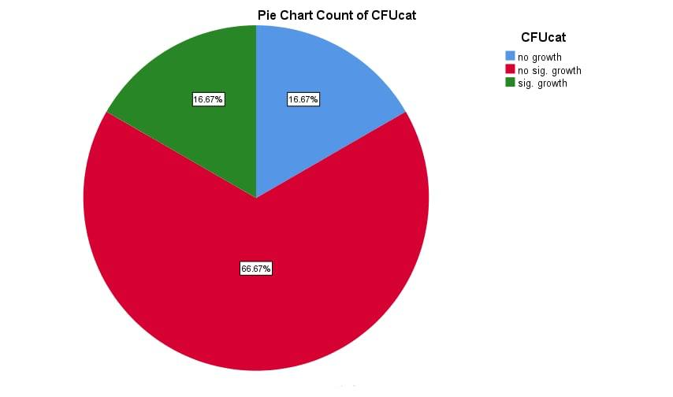
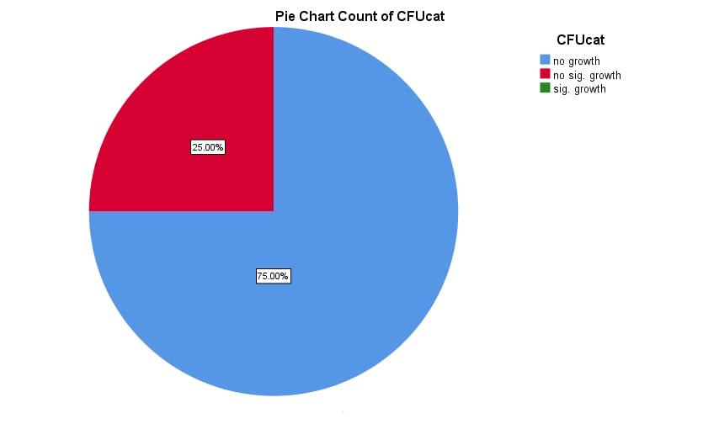

REFERENCES:

- Winquist A, Orrico M, Peterson L. Evaluation of the Cytocentrifuge Gram Stain as a Screening Test for Bacteriuria in Specimens From Specific Patient Populations.
- E C, P F, GR S. The use of a differential fluorescent staining method to detect bacteriuria. PubMed. https://pubmed.ncbi.nlm.nih.gov/15575310/. Published 2022. Accessed June 20, 2022.
- Rippin K, Stinson W, Eisenstadt J, Washington J. Clinical Evaluation of the Slide Centrifuge (Cytospin) Gram’s Stained Smear for the Detection of Bacteriuria and Comparison With the Filtracheck-UTI and UTIscreen.
- Olson M, Shanholtzer C, Willard K, Peterson L. The Slide Centrifuge Gram Stain as a Urine Screening Method.

