

The incidence rate of Asymptomatic Bacteriuria
Among LIMU students

Name: Tasneem ALTarhuni
Student number: 2795
PTS block
Supervised by Dr. Asma Elkwafi
June 20, 2022

Abstract
Urinary tract infections are one of the most common human infections. Organisms reach the urinary system by moving through the bloodstream or through the urethra. This study shows the difference in the incidence of bacteriuria between males and women. Twenty-four participants participated in this study, all of whom were third-year medical students at the Libyan International Medical University, 12 of whom were female and 12 of whom were male. The resulting statistics were analyzed with SPSS software version 26. We then ran Fisher's exact test to determine the importance of the results. This study showed a significant increase in the incidence of bacterial urine in women compared to males

Introduction
Asymptomatic bacteriuria (ASB) is the presence of pathogenic bacteria within a correctly collected urine sample of people that is showing no signs and symptoms of UTI It is clinically common and can increment in chance with age. People with diseases and pathogens that are more resistant to antibiotics are more likely to have a complex UTI. The presence of correctly collected bacteria in the urine of patients with no signs or symptoms of urinary tract infection is known as asymptomatic bacteriuria. A definitive explanation for asymptomatic bacteriuria has not yet been found. Bacteriuria is a common symptom in patients. Asymptomatic bacteriuria becomes more common with age. The incidence of healthy premenopausal women is less than 5%, but can reach more than 15% in women aged 65-80 years. The most common bacterium in bacteriuria is E. coli. Urine cultures are used to diagnose asymptomatic bacteriuria. Both catheter-inserted specimens and properly collected clean catch specimens are acceptable. The ideal timing and frequency of urine culture screening during pregnancy has not yet been determined, but screening urine cultures are recommended to be collected at the end of early pregnancy. People with asymptomatic bacteriuria are less likely to develop symptomatic UTI. Treatment with antibiotics is ineffective for children, diabetics, the elderly, and patients with catheters. Treatment with antibiotics increases the risk of side effects and the development of antibiotic-resistant microorganisms in these patients. The purpose of this study is to show the difference in the incidence of bacteriuria between males and females
Materials and method:
Materials that were utilized to carry out the test incorporate: a urine test, wire/plastic loops, Bunsen burner, incubator, and development media (5% sheep blood agar plate). Media utilized in urine culture can change between - 5% sheep blood agar plate, MacConkey agar, and CLED as all 3 permit for the discovery of numerous staphylococci, streptococci, gram-negative bacilli, and enterococci.
The first step was to gather urine from each subject through a midstream clean capture strategy. Tests were surveyed within an hour from the collection, to keep tests substantial. The wire circle was warmed beneath the flame, at that point embedded inside the urine test to gather a measured volume of urine. Following the wire, the circle was dragged all through the development media employing a particular method of immunization suitable for urine culture. Moreover, without flaring, the wire circle was plunged into the urine culture for the second time and connected carefully to a modern development plate. At last, the societies were brooded for 24hr at a temperature of around 37 °C to empower obviously growth

Results and Statistical analysis:
Table 1
Gender * CFUcat Crosstabulation
 |  |  | CFUcat |  |  | Total
 |  |  | No growth | No significant growth | Significant growth | Total
Gender | Male | Count | 9 | 3 | 0 | 12
Gender | Male | % Within CFUcat | 81.8% | 27.3% | 0.0%
Gender | Female | Count | 2 | 8 | 2 | 12
Gender | Female | % Within CFUcat | 18.2% | 72.7% | 100.0%
Total count |  |  | 11 | 11 | 2 | 24

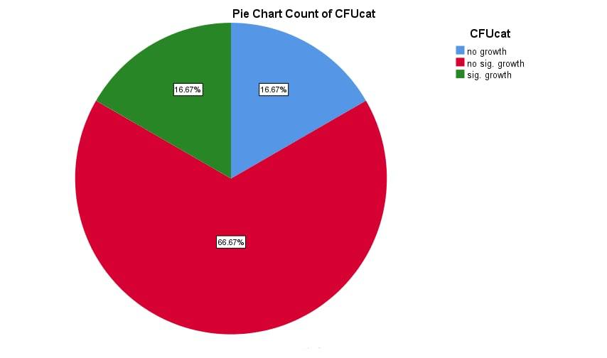
A pie chart appears the CFU categories of the female understudies as it were. Demonstrating that 16.67% of females had no development and 66.67% had no critical development, 16.67% had critical bacterial development on urine culture and were analyzed with asymptomatic bacteriuria

. 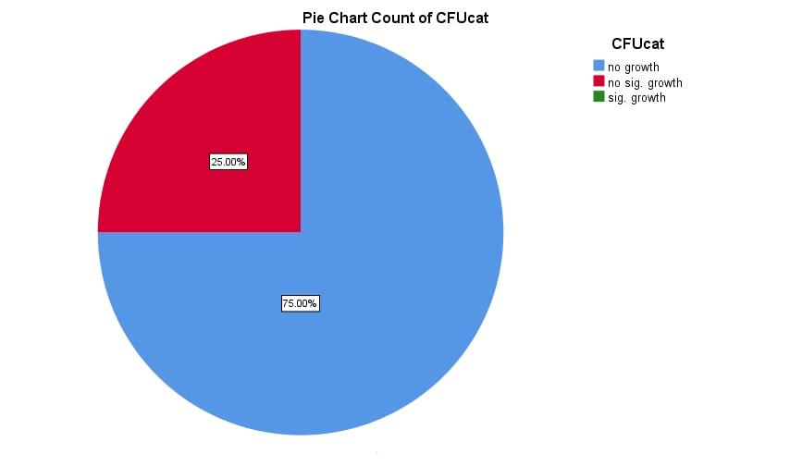
This pie chart counts the CFU of the male students only. 75% (9 of the 12) of the male students had No growth, 25% had No significant growth and zero had significant growth.
Table 2

Discussion
The above statistics show that the incidence of bacteriuria is significantly increased in women compared to men. This is caused by anatomical differences in the male and female urinary system of the urethra, the tube that guides urine from the bladder to the outside for excretion. Males are much longer than females, and the male urethra is 18-20 cm long and is divided into three parts:
Prostatic urethra the prostatic urethra is the part of the urethra that carries semen through the prostate and produces ejaculated sperm.
The membranous urethra is the tube that connects the bladder to the urethra. The pelvic floor transmits fluid through the urethra, which is a short part of the urethra.
The penile urethra (also known as the spongy urethra or spongy urethra) is the longest part of the urethra. This part of the penis runs the length of the body and ends at the urinary meatus or the outer entrance of the body.
In addition, the female urethra the urethra is short, 3-4 cm (1.5 inches) long. The external urethral opening is just in front of the vaginal opening and opens outward.
Serious bacteriuria is most likely due to UTI (urinary tract infection). Most UTIs are caused by bacteria, but can also be caused by fungi and, rarely, viruses. Urinary tract infections (UTIs) are one of the most common human illnesses. The most common causative agent of UTI is E. coli (E. coli) E. coli), E. coli is responsible for 70-95 percent of upper and lower urinary tract infections. S. saprophyticus, Proteus spp. Klebsiella spp. , Enterococcus faecalis, various Enterobacteriaceae, and yeast is all responsible for the remaining infections. Some species, such as Staphylococcus saprophyticus in young women, are more common in certain subgroups. However, S. saprophyticus can cause acute cystitis in older women and younger men and should not be considered a contaminant in urinary cultures.
Urinary tract infections are divided into upper and lower urinary tract infections based on the infected organ.
The urinary tract and bladder are the organs affected by the urinary tract infection.
Urination causes a burning sensation in the body, causing frequent urination without a large amount of urination, and urination becomes more and more important. Bloody urine, cloudy-looking urine, cola or tea-like, strong-smelling urine, female pelvic pain, male rectal discomfort.
.Conclusion
The incidence of bacterial urine in women is significantly higher than in men, which is caused by anatomical differences in the urinary system between men and women. Urinary tract infections (UTIs) are one of the most common human illnesses. The most common organism that causes urinary tract infections is E. coli. E. coli is responsible for 70-95 percent of upper and lower urinary tract infections. UTIs are divided into upper and lower urinary tract infections based on the infected organ. We believe that further research on asymptomatic bacteriuria should be done in the near future.
References
- What if I Get a Urinary Tract Infection (UTI) While I’m Pregnant?. WebMD. https://www.webmd.com/womales/guide/pregnancy-urinary-tract-infection.
- Streaking pattern of urine specimales | Medical Laboratories. Medical-labs.net. http://www.medical-labs.net/streaking-pattern-of-urine-specimales-1565/.
- Reasons Why Womales Get More UTIs Than Males. Virginia Physicians for Womales. https://vpfw.com/blog/7-reasons-why-womales-get-more-utis-than-males/..
- Urinary tract infections (UTI) - Better Health Channel. Betterhealth.vic.gov.au. https://www.betterhealth.vic.gov.au/health/conditionsandtreatments/urinary-tract-infections-uti.
- Urinary Tract Infection (UTI): Symptoms, Diagnosis & Treatment. Healthline. https://www.healthline.com/health/urinary-tract-infection-adults.

