

Lab report supervisor : Dr. Bassma and dr. hwudia, Assiant by dr: Alsanousi alsharif and ahmed giybani
differences between adult male and female in urine output after Lasix consumption

Abdulla Zubi / 2619 / AMS YEAR 3

Abstract
Urine output is a noninvasive method which use to measure the fluid balance once intravascular volume has been restored. The normal urine output is defined as 1.5 to 2 mL/kg per hour. Urine output are helpful physiologic parameters in evaluation acute kidney injury this method commonly used among hospitalized adult patients, using loop diuretic Furosemide must be carefully as its bioavailability differs between oral and intravenous therapy, a solid understanding of its bioavailability is necessary along with dose adjustment kinetics associated with its rout of administration in order to maximize efficiency and at the same time to avoid its several side effects especially in individuals with chronic kidney diseases CKD.
Aim There is difference between adult Male and Female in Urine output after Lasix consumption.
Introduction Urine output normal value is about 800 – 2500mg/day , 1.5 to 2mL/kg/1hr. any decrease can indicate that the kidneys are not functioning normally, A loop diuretic Furosemide can be given intravenously or orally the drug showed a good result in detection and management of acute kidney injury.
Material and method 12 volunteers of both gender males and females divided into 2 groups given single dose of 40mg of furosemide to comparing their urine output using T-test on SPSS.
Result and Discussion P-value is above > 0.05, No statistical significant difference has been dedicated over the both group in urine output after given 40mg of furosemide.
Conclusion Normal value of urine about is about 800-2500mg/day any decrease can be the first sign of kidney injury, Furosemide is the best loop diuretic given emergency in cases of acute kidney failure shows a very good results , the recent study and after comparing it with other studies shows No significant difference in urine output between the two groups of males and females with small variations recorded in rats experiments more studies in future are necessary to make it more clear and to see if there’s difference in urine output among humans and animals or not.
Introduction
Urine output is frequently utilized as a sign of acute kidney impairment, as well as a guidance for fluid resuscitation in critically unwell patients. A drop in urine production may be associated with significant reductions in glomerular filtration rate as a result of a reduction in renal blood flow or renal perfusion pressure, the normal value of Urine output is about 800 – 2500mg/day ¹ , Furosemide is loop diuretic and its one of the most often used pharmacological therapies in critical care units ^{2,3}, showed acceptable indications when given intravenous as extravascular fluid buildup and decreased urine output, have Important role in early detect, treatment and prevention of acute kidney injury ⁴ , loop diuretic Furosemide mechanism of action is inhibiting the sodium , potassium and chloride cotransport of thick ascending limb of loop of henel ^{5,6}; result in excretion of 20-25% of filtered sodium, when administrated Orally its bioavailability differs, bioavailability improves if taken before meals because food disrupt its absorption ⁷, when absorbed from GIT its peak diuretic action occurs 1 to 1.5 hours and when given intravenous it takes just 10 to 30 minutes, it binds to plasma proteins in high percentage and proximal convoluted tubules PCT receives protein-bound furosemide which is then secreted, about 50% of furosemide load excreted in urine unchanged, while the remainder is converted into glucuronide in the kidney, as a result of the reduced urine excretion, individuals with renal impairment have a lower response and a longer plasma half-life for furosemide. ^{3,7}
Previous study has been done showed the diuretic response to oral and intravenous furosemide was assessed on healthy 12 volunteers 6 males and 6 females on 4 separated days, After fasting over- night each participant received a single doses of loop diuretic, Over the next 24 hours, total urine output was collected for volume measurement along with determination of sodium and potassium contractions, No significant difference found between male and female urine output which means there was no statistically significant difference in urine flow rate, salt, or potassium excretion rates between male and female patients throughout the doses, The only difference noticed is when pharmacokinetic of furosemide change where males participants showed a higher peak of sodium excretion rate than female urine output, this occurs when the natriuretic response was adjusted for mg/kg of the intravenous furosemide dosage administered therefore result of this study show that the natriuretic response to diuretics differs and mainly depending on gender. ¹⁵
Materials and Methods
12 volunteers taken from the study database of both gender male and female were divided into two groups, and each group got a 1 litter of water and a single dose of furosemide loop diuretic with in a constant dosage of 40mg that administrated intravenously during their lab stay to perform the urine dilution test Urine output = (amount of urine/number of hours) / weigh of patient in kg , as well as a duration of not less than 6 hours of urinary observation after administration to determine the amount of urine output every hour and record it.
The urine output was compared between the two groups, males and females, using the T-test, which was conducted using the Statistical Package for Social Sciences (SPSS), and the difference was declared significant after 6 hours were completed and all of the volunteers readings were collected for each hour separately in addition to their weights for the two groups, (P < 0.050) will considered significant statistically and if it was (p > 0.050) will considered not significant statistically.

Result and Discussion
A study shows 12 volunteers divided into 2 groups 6 males and 6 females, calculating their urine output by = (amount of urine /number of hours) / weight of patient in kg, the P-value of this study is 0.142
Table no.1 shows the urine output of both genders after six hours of collection, where the highest urine output in males was volunteer No.9 by 604.8, while in females the highest urine output was volunteer No.6 by 518.4 also females recorded the lowest urine output volunteer number 4 by 36.
According to Table no.1 when the dose is at constant value 40mg of furosemide loop diuretic there will be no significant difference by comparing this study with the previous study the previous study also improves that there is no significant difference between male and female urine output except when the natriuretic response modified for mg/kg of intravenous furosemide the male output had a slight peak in sodium excretion, both studies agreed that there is no statistical significant difference for adult male and female in urine output after furosemide consumption.
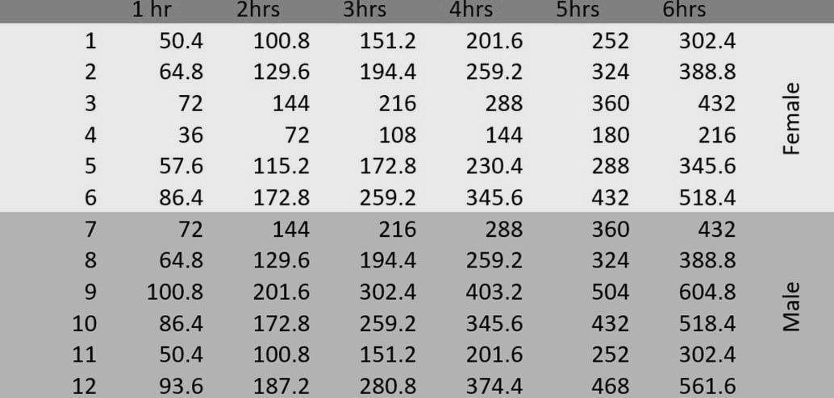 Table no.1
Table no.2 shows the difference in Mean value between males and females, the mean of males is 468 and the females mean value is 367.2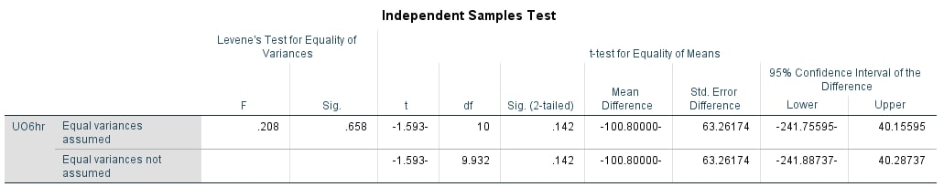Table No.2 (male mean value is higher than female)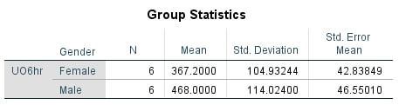
histogram shows the highest urination of both male and female and the mean of both which is 417.60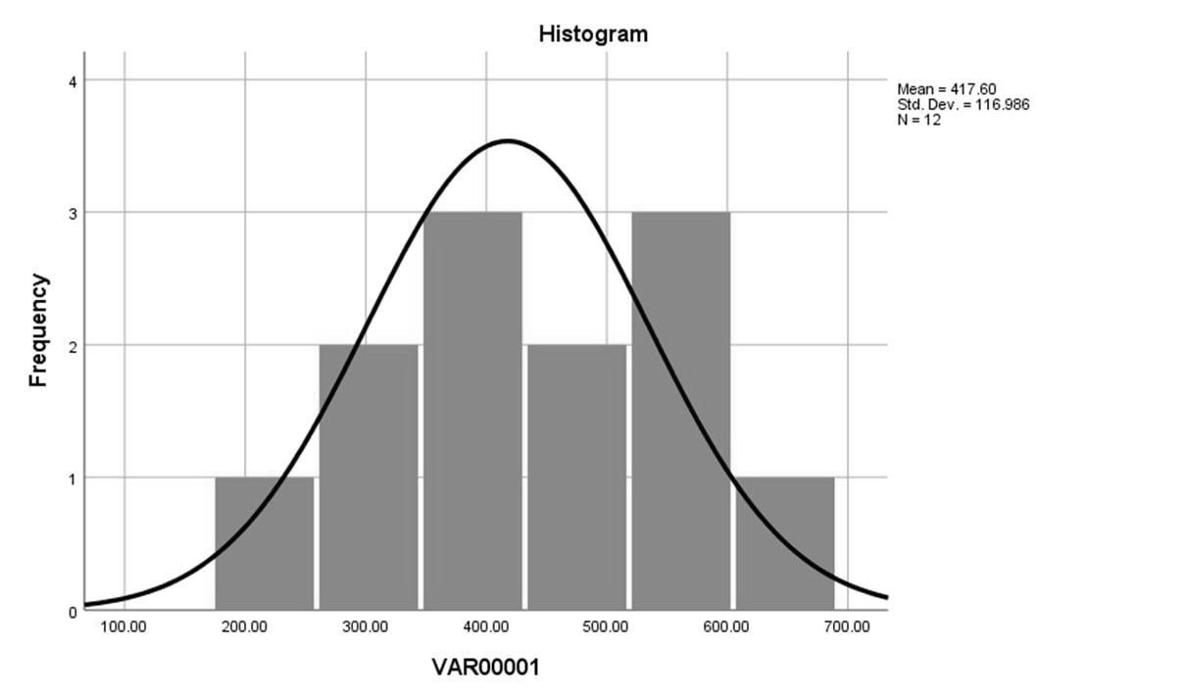

Another study was done on Wistar rats to see if Lasix had any impact on both sexes, the rats divided into 4 groups first two groups were males and females without with no any medication third group were females with furosemide and forth group males with furosemide, furosemide was given in addition to the insulin dosage as a primer dose (10 mg/kg) and in the infusion solution (20g %), the result revealed that the first two groups doesn’t show any changes in the urine output, whereas female rats have a greater natriuretic, kaliuretic, and diuretic response to furosemide than male rats, This could be due to the lower abundance of NKCC2 ( transporter that allows cyclic AMP to bind and activate its role) present in the renal medulla of female rats, which means a greater amount of furosemide reaches the cotransporters, which is probably sufficient to inhibit all of them in female rats but not in male rats, as nitric oxide lowers cAMP levels, NKCC2 transport activities are reduced, which is totally difference in males rats this is because high testosterone levels lower (cAMP) levels, which means more NKCC2 transporters are active, more sodium, potassium, chloride and water is reabsorbed from thick ascending loop of henel and urine excretion is reduced, while in females the high estrogen levels and low testosterone levels act by increase the synthesis of nitric acid and reduce the inactivation of nitric acid by oxygen radicals, that explains why female rats discharge more urine output than male rats. ^{16,17,18}
As loop diuretic furosemide showed appropriate improvement in treatment and prevention of acute renal failure, some theories suggested that furosemide increases the renal blood flow and glomerular filtration rate GFR ¹¹, It is important to remember that its threshold differs according to the clinical condition of the patient for example, In a population with normal renal function, the threshold dosage of intravenous furosemide is 10 mg while in individuals with declining renal function, the dose is increased to 80-160 mg, this improve that in advanced CKD patients furosemide dosages less than 80mg are useless or ineffective, In order to achieve desired effect of the drug higher doses or increasing the frequency of furosemide is required to increase the tubular secretion. ¹⁰
By inhibiting the cotransport of sodium , potassium and chloride furosemide act when given intravenously, but if taken orally many factors affecting and makes its bioavailability change, In order to increase furosemide bioavailability it's been advised to be taken orally before male, due to insufficient gastrointestinal absorption, the action of furosemide may be changed in individuals with severe edema if oral furosemide fails to work, patients should be switched to intravenous furosemide ^{7,11} . If orally furosemide given in high doses one of the most common side effect is that it can lead to reversible ototoxicity, while in individuals with renal impairment or those undergoing concurrent aminoglycoside therapy reversible ototoxicity is seen even with low doses of furosemide although cases of permanent deafness had also been reported ¹⁰, Continuous intravenous infusion is more effective because it maintains an effective rate of furosemide excretion and sodium reabsorption inhibition throughout time, which leads to increased urine output and reduced ototoxicity. ¹²

Conclusion
According to this study and supported by the previous study done on humans and based on the amount of the dose 40mg of furosemide loop diuretic that has been administrated to both groups of males and females volunteers the result shows that there is no significant difference as the P-value is more than > 0.050, which means that the Hypothesis is rejected because the outcomes of the researches were incongruent and shows opposite results, further studies, lab reports, and tests is needed to determine and clarify if this gender-related difference is due to differences in drug metabolism, disposition, or intrinsic diuretic responsiveness at the site of action, some variations in animals urine output recorded in showing a slightly non – significant increase in female rats urine output during the experiment.
Furosemide is a very useful loop diuretic shows a highly appropriate effects commonly in patients with acute renal failure, Its bioavailability completely differs between oral and intravenous therapies, threshold and ceiling doses of furosemide also differs according to the different clinical conditions with many side effects that commonly seen in late stages of chronic kidney injury.

References
- Chen YC, Jenq CC, Tian YC, Chang MY, Lin CY, Chang CC, Lin HC, Fang JT, Yang CW, Lin SM. Rifle classification for predicting in-hospital mortality in critically ill sepsis patientsRifle classification for predicting in-hospital mortality in critically ill sepsis patients. Shock. 2009;31:139–145. doi: 10.1097/SHK.0b013e31817d419e.

- Bagshaw SM, Delaney A, Jones D, Ronco C, Bellomo R. Diuretics in the management of acute kidney injury: a multinational survey. Contrib Nephrol. 2007;156:236-249. doi:10.1159/000102089.

- Brater DC. Update in diuretic therapy: clinical pharmacology. Semin Nephrol. 2011;31(6):483-494. doi:10.1016/j.semnephrol.2011.09.003.

- Bagshaw SM, Bellomo R, Kellum JA. Oliguria, volume overload, and loop diuretics. Crit Care Med. 2008;36(4 Suppl):S172-8. doi:10.1097/CCM.0b013e318168c92f.
- Obermüller N, Kunchaparty S, Ellison DH, Bachmann S. Expression of the Na-K-2Cl cotransporter by macula densa and thick ascending limb cells of rat and rabbit nephron. J Clin Invest. 1996;98(3):635-640. doi:10.1172/JCI118834.

- Nielsen S, Maunsbach AB, Ecelbarger CA, Knepper MA. Ultrastructural localization of Na-K-2Cl cotransporter in thick ascending limb and macula densa of rat kidney. Am J Physiol Renal Physiol. 1998;275(6):F885-F893. doi:10.1152/ajprenal.1998.275.6.F885.

- Shankar SS, Brater DC. Loop diuretics: from the Na-K-2Cl transporter to clinical use. Am J Physiol Renal Physiol. 2003;284(1):F11-21. doi:10.1152/ajprenal.00119.2002.

- Sica DA. Diuretic use in renal disease. Nat Rev Nephrol. 2011;8(2):100-109. doi:10.1038/nrneph.2011.175.

- Rybak LP. Ototoxicity of loop diuretics. Otolaryngol Clin North Am. 1993;26(5):829-844. doi:10.1016/s0030-6665(20)30770-2.

- Wilcox CS. New insights into diuretic use in patients with chronic renal disease. J Am Soc Nephrol. 2002;13(3):798-805. doi:10.1681/ASN.V133798.

- Buturovic-Ponikvar J. Abstracts from the 3rd Slovenian congress of nephrology. Ther Apher Dial. 2005;9(1):3. doi:10.1111/j.1774-9987.2005.00223.x.

- Salvador DRK, Rey NR, Ramos GC, Punzalan FER. Continuous infusion versus bolus injection of loop diuretics in congestive heart failure. Cochrane Database Syst Rev. 2005;(3):CD003178. doi:10.1002/14651858.CD003178.pub3.

- Dormans TP, van Meyel JJ, Gerlag PG, Tan Y, Russel FG, Smits P. Diuretic efficacy of high dose furosemide in severe heart failure: bolus injection versus continuous infusion. J Am Coll Cardiol. 1996;28(2):376-382. doi:10.1016/0735-1097(96)00161-1.

- Wilcox CS, Mitch WE, Kelly RA, et al. Factors affecting potassium balance during frusemide administration. Clin Sci (Lond). 1984;67(2):195-203. doi:10.1042/cs0670195.

- Franson KL, Kuk JM, Lam NP, Lau AH. Gender effect on diuretic response to hydrochlorothiazide and furosemide. Int J Clin Pharmacol Ther. 1996;34(3):101-105.

- Hayashi T, Fukuto JM, Ignarro LJ, Chaudhuri G. Basal release of nitric oxide from aortic rings is greater in female rabbits than in male rabbits: implications for atherosclerosis. Proc Natl Acad Sci U S A. 1992;89(23):11259-11263. doi:10.1073/pnas.89.23.11259.

- Parekh N, Zou AP, Jüngling I, Endlich K, Sadowski J, Steinhausen M. Sex differences in control of renal outer medullary circulation in rats: role of prostaglandins. Am J Physiol. 1993;264(4 Pt 2):F629-36. doi:10.1152/ajprenal.1993.264.4.F629.

- Christensen S, Petersen JS. Effects of furosemide on renal haemodynamics and proximal tubular sodium reabsorption in conscious rats. Br J Pharmacol. 1988;95(2):353-360. doi:10.1111/j.1476-5381.1988.tb11653.

