

Incidence rate of asymptomatic bacteriuria among LIMU students

By: Aseel Elzway 2415 3rd year medical science
Supervisor: Khadiga Muftah Mansour

Assist by : Ahmed Alshareef Alsonossui
Date of submission: 20/6/2022

Abstract
Bacteriuria, or the presence of bacteria in urine, is linked to both asymptomatic and symptomatic urinary tract infections, and it underpins a lot of the microbial colonization dynamics in the urinary tract. Bacteriuria is prevalent in a wide range of patient categories, including healthy people, institutionalized elderly, pregnant women, and immune-compromised patients. Furthermore, determining the significance of bacteriuria' in infected persons is a diagnostic difficulty, partially due to the diversity of causative microorganisms, and necessitates careful evaluation of the numerous etiologies of bacteriuria in different populations and situations. Recent molecular discoveries have revealed how specific bacterial features enable organisms to flourish in human urine, which is likely to influence the progression of bacteriuria in some people as a fitness adaptation.

Introduction
Bacteriuria refers to the presence of bacteria in the urine, which can be symptomatic or asymptomatic. A patient with asymptomatic bacteriuria has one or more organisms colonized in their urine sample but no symptoms of illness. Symptomatic bacteriuria is caused by a single bacterium infecting the urinary system.
Asymptomatic bacteriuria is bacteriuria without obvious symptoms, defined as the presence of more than or equal to 10⁵ cfu/mL of one or more organisms on two consecutive urine specimens and the lack of symptoms attributed to urinary infection for clinical reasons. Although some researchers use the word colonization to describe the presence of bacteria without evidence of a host response, it has not been proved to have any clinical significance in the older population and is thus not used here. Some researchers additionally distinguish bacteriuria from urine infection based on the presence of a host response, which is frequently shown by pyuria. As previously mentioned, asymptomatic bacteriuria in the elderly almost invariably results in signs of a host response.¹
Over the next few decades, the share of old people in our population will skyrocket. Understanding the medical issues that this population faces is becoming increasingly important.
In clinical practice, asymptomatic bacteriuria is fairly prevalent. While asymptomatic bacteriuria is uncommon in newborns and toddlers, it becomes more common as they become older. In women and men aged 65 to 80 years, the incidence can be as high as 15% or more, and it can be as high as 40% to 50% beyond that. Most people with asymptomatic bacteriuria will never acquire symptomatic urinary tract infections, and asymptomatic bacteriuria will have no negative repercussions.
Urinary tract infection (UTI) is a collective term that describes any infection involving any part of the urinary tract, namely the kidneys, ureters, bladder and urethra. The urinary tract can be divided into the upper (kidneys and ureters) and lower tract (bladder and urethra).⁵

Aim of study to show incident rate of asymptomatic bacteriuria.

Methods and material

We took a sample of urine from 24 participants (12 female and 12 male), flames a calibrated wire loop, and mixed the urine, and then inserted the loop vertically into the urine to allow it to adhere to the loop. We spread the urine over the surface of the agar plate.
Then incubate for 24hr at 37 C in air. Colonies are counted on each plate. The number of CFUs is multiplied by 1000(if a 0.001 ml loop used) or by 100 (if a 0.01 ml loop was used) to determine the number of microorganisms per ml in the original specimen. Then we analysis the data using SPSS.
Pearson Chi-Square test, a test for independence
Is used to examine the relationship between two qualitative variables.
The null hypothesis: There is no association (relationship) between the two
variables
The alternative hypothesis: The two variables are associated

Result

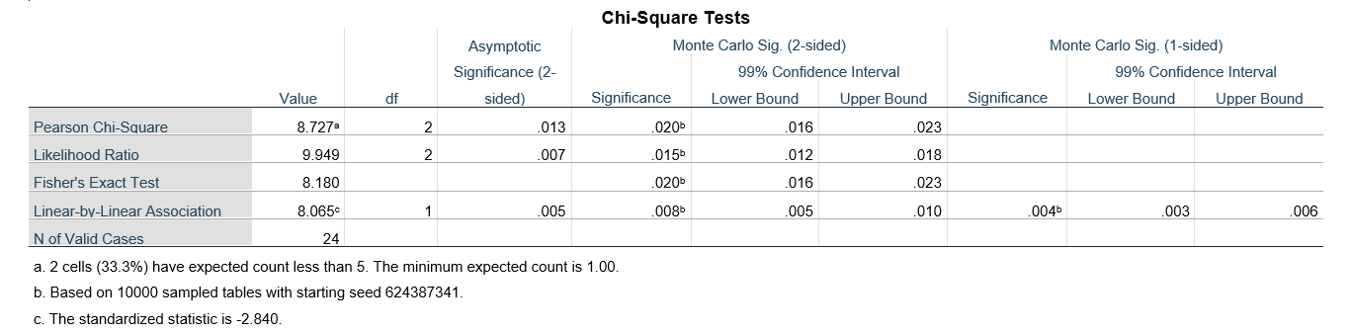
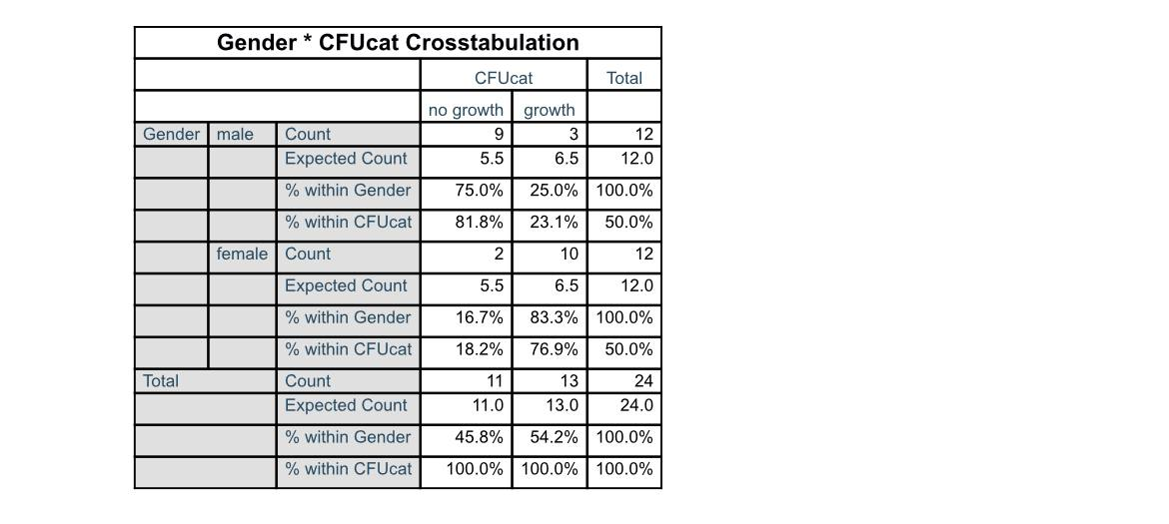

P-Value = 0.013 that means it’s ≤ 0.05.
Decision: We reject the null hypothesis
Discussion
As revealed in this study, considerable bacteria overgrowth was found in a urine sample from a college student, indicating that asymptomatic bacteriuria is prevalent, with frequency varied according to age, sex, sexual activity, and the existence of genitourinary disorders.
Bacteriuria is increasingly common in healthy women as they become older, rising from around 1% in girls aged five to fourteen to more than 20% in women aged 80 and up living in the community. The most prevalent bacterium recovered from individuals with asymptomatic bacteriuria is Escherichia coli. Enterobacteriaceae, Pseudomonas aeruginosa, Enterococcus species, and group B streptococcus are among the organisms that can cause infection.
Patient characteristics will impact the organisms isolated in individuals with asymptomatic bacteriuria: healthy people are more likely to have E. coli, whereas a nursing home resident with a catheter is more likely to have multidrug–resistant polymicrobic flora (e.g., P. aeruginosa). Men are susceptible to Enterococcus species and gram-negative bacilli.³
In clinical practice, asymptomatic bacteriuria is fairly prevalent. While asymptomatic bacteriuria is uncommon in newborns and toddlers, it becomes more common as they become older. In women and men aged 65 to 80 years, the incidence can be as high as 15% or more, and it can be as high as 40% to 50% beyond that . The majority of people with asymptomatic bacteriuria will never acquire symptomatic urinary tract infections, and asymptomatic bacteriuria will have no negative repercussions.
ASB affects fewer than 1% of full-term babies and 3% of preterm babies. Because these young children may have minimal signs and symptoms in the face of an infection, detecting bacteriuria in these otherwise asymptomatic children is critical, as ASB may be a signal of underlying genitourinary illness. Given these concerns, these children should be treated with antibiotics and scanned to rule out any congenital problems that might be causing bacterial colonization. ASB affects 0.8 percent of preschool girls and a far smaller percentage of preschool boys.²
Antibiotics are not needed to remove germs in children in this age group who do not have genitourinary abnormalities since they do not appear to be at risk for recurring symptomatic infections, renal injury, or reduced renal development.
The annual incidence of ASB in school-aged girls ranges from 1% to 2%, with around 5% of all school-aged girls experiencing it.
Routine antibiotic therapy is not indicated in these individuals since it is unlikely to prevent further asymptomatic or symptomatic bacteriuria, and untreated individuals appear to be at minimal risk of having long-term consequences associated to the bacteriuria. In addition, frequent prophylactic medications may cause changes in their microbiome and increasing antibiotic resistance in these people.¹
Conclusion
In clinical practice, asymptomatic bacteriuria (bacteriuria without obvious symptoms) is fairly prevalent. While asymptomatic bacteriuria is uncommon in newborns and toddlers, it becomes more common as they become older. In women and men aged 65 to 80 years, the incidence can be as high as 15% or more, and it can be as high as 40% to 50% beyond that. Most people with asymptomatic bacteriuria will never acquire symptomatic urinary tract infections, and asymptomatic bacteriuria will have no negative repercussions. According to a study conducted among college students, there is a considerable amount of bacteria proliferation in urine cultures.⁴
References

- Colgan R, Nicolle LE, McGlone A, Hooton TM. Asymptomatic bacteriuria in adults. Am Fam Physician. 2006;74(6):985-990.

- Crader MF, Kharsa A, Leslie SW. Bacteriuria. In: StatPearls. Treasure Island (FL): StatPearls Publishing; November 27, 2021

- Rowe TA, Juthani-Mehta M. Urinary tract infection in older adults. Aging health. 2013;9(5):10.2217/ahe.13.38. doi:10.2217/ahe.13.38

- Schaeffer EM. Infection and Inflammation of the Genitourinary Tract. J Urol. 2021;205(2):610. doi:10.1097/JU.0000000000001498

- Bono MJ, Reygaert WC. Urinary Tract Infection. In: StatPearls. Treasure Island (FL): StatPearls Publishing; June 23, 2021.

