

Libyian International Medical University
Libyian International Medical University
Faculty of Applied Medical Science

Gender-Related Differences in the Pharmacodynamics of Furosemide

By: Yasmeen Fathi Alhasi
2033
3rd year medical science
Supervisor: Dr.Iman Alferjani
Date of submission:20-6-2022

Abstract:
The possibility of gender differences in the relationship between dose and efficacy of drugs has historically been limited. The aim of the present study was to evaluate the influence of sex on the pharmacodynamics of furosemide (FUR) in adult Wistar rats. Conventional renal clearance studies were performed in the absence and in the presence of a FUR dose necessary to produce identical urine excretion rates of FUR in both sexes. Fractional excretions of sodium, potassium, and water were similar in male and female rats in the absence of FUR. Natriuretic, kaliuretic, and diuretic responses to FUR, when expressed in fractional terms, were significantly increased in female rats. Diuretic, natriuretic, and kaliuretic efficiencies of FUR were also higher in female rats as compared with males. This might be explained by the lower abundance of the Na-K-2Cl cotransporter observed in homogenates from the medullae of female kidneys as compared with male ones.

Introduction

Pharmacokinetics (PK) is the study of the time course of the absorption, distribution, metabolism and excretion (ADME) of a drug, compound or new chemical entity (NCE) after its administration to the body ¹
The availability of information about pharmacokinetics in women and about the possibility of gender differences in the relationships between dose and efficacy or between dose and adverse drug reactions has historically been limited. From the pharmacodynamic point of view, only few studies could clearly identify clinically important gender effects. Because approximately 50% of the population of any species are females, it is appropriate to consider the influence of sex on the pharmacokinetics and pharmacodynamics of drugs -.
Studies recently done in our laboratory demonstrated that sex modifies the pharmacokinetics of organic anions. Female rats display a lower p-aminohippurate and furosemide (FUR) clearance because of their lower renal clearance. This is mediated, at least in part, by the lower abundance of the renal organic anion transporter (OAT1) in female as compared with male.
Pharmacodynamic differences could potentially be clinically important for drugs having either narrow or wide therapeutic ranges. It is certainly possible that these sex differences may be related to the higher incidence of adverse reactions to drugs observed in women as compared with men trials.
FUR is a well-known organic anion which exerts its diuretic action by binding to the Na-K-2Cl cotransporter (NKCC2) in the thick ascending limb (TAL) and blocking ion transport. FUR is commonly used to treat edematous conditions, congestive heart failure, cirrhosis of the liver, and nephrotic syndrome. Of the adverse reactions to FUR hypotension, circulatory collapse, thromboembolic episodes, ototoxicity, hearing impairment, deafness, vertigo, and tinnitus have been reported. ^{1,2}
Aim of study to show gender difference in Pharmacodynamics of furosemide in human.

Methods and material

We measured the diuretic response to oral hydrochlorothiazide, oral and intravenous furosemide in 6 male and 6 female normal volunteers. After fasting overnight, each subject received single doses of the individual diuretics or no treatment on 4 separate days. Total urine output was collected over the next 24 hours for volume measurement and determination of sodium and potassium concentrations. Then we analysis data using Excel

Result

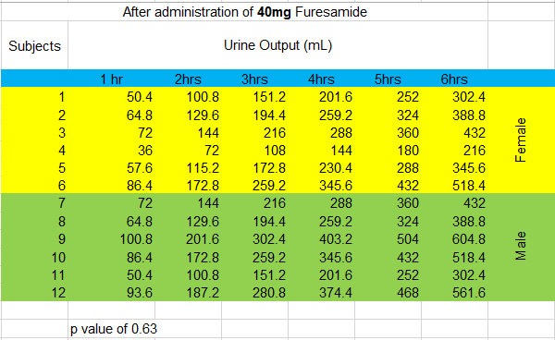
Accordingly, to the results in the current study There was no statistically significant difference found between male and female subjects with respect to urine flow rate, sodium, and potassium excretion rates among the treatments after 6h.

Discussion
In the past, women were underrepresented as participants in clinical drug studies. In most of the cases, when both women and men were studied, the results were grouped together, and there was no analysis of sex differences. Although the FDA and other regulatory authorities required more participation of women in clinical trials after recognizing the problem of underrepresentation of women, little is known about drug effects in women when compared to men. For a number of drugs, it is well recognized that women suffer more frequently from side effects; however, it is often not clear whether this is due to gender differences in the pharmacokinetics or pharmacodynamics of the responsible drug.
Very little is known about these gender-related differences and about the possibility that women may show a treatment response different from that of men.
As FUR is a loop diuretic commonly employed in clinical practice, was of interest to complete the previous pharmacokinetic studies, determining whether gender-related differences are also observed in the pharmacodynamics of the diuretic.
In order to achieve this objective, we administered the FUR dosage necessary to produce identical urine excretion of FUR in both male and female. The urinary excretion rate of a loop diuretic has been shown to be a reliable measure of amounts of a diuretic reaching the site of action and can be used as a surrogate concentration in a typical concentration-response analysis.
There are three main steps of urine formation: glomerular filtration, reabsorption, and secretion. These processes ensure that only waste and excess water are removed from the body.
FUR directly inhibits the reabsorption active NaCl transport in thick ascending loop of hanle by inhibiting NKCC2.
In this study, it was observed that FE% Na, FE% K, and FE% H2O were similar in both sexes in the absence of FUR, as was previously demonstrated by us. The present study shows that female rats have an increased natriuretic, kaliuretic, and diuretic response to FUR in the presence of identical excreted load of FUR.
The administration of FUR caused a reduction in the GFR, due to the predominantly renal vasoconstrictor effects of the diuretic which have been previously reported in rats. The lower efficiency of FUR in decreasing the GFR in female might be due to the higher circulating levels of PGE2 previously reported in females.
The results obtained in this work not only represent scientific opportunities for the future but might be also important for the design of future therapeutic diuretic regimens according to the sex of the patient.³

Conclusion
Fractional excretions of sodium, potassium, and water were similar in male and female rats in the absence of FUR. Natriuretic, kaliuretic, and diuretic responses to FUR, when expressed in fractional terms, were significantly increased in female. Diuretic, natriuretic, and kaliuretic efficiencies of FUR were also higher in female as compared with males. Pharmacodynamic differences could potentially be clinically important for drugs having either narrow or wide therapeutic ranges. It is certainly possible that these sex differences may be related to the higher incidence of side effect.
The Future studies are designed of future therapeutic diuretic regimens
according to the sex of the patient

References

- Fan J, de Lannoy IA. Pharmacokinetics. Biochem Pharmacol. 2014;87(1):93-120. doi:10.1016/j.bcp.2013.09.007

- Soldin OP, Mattison DR. Sex differences in pharmacokinetics and pharmacodynamics. Clin Pharmacokinet. 2009;48(3):143-157. doi:10.2165/00003088-200948030-00001 Shaw G. M., Hunter E (2012). HIV transmission. Cold Spring Harbor Perspectives in Medicine. 2(11):1–23.

- Brandoni A, Villar SR, Torres AM. Gender-related differences in the pharmacodynamics of furosemide in rats. Pharmacology. 2004;70(2):107-112. doi:10.1159/000074675

