

INCIDENCE RATE OF BACTERIURIA AMONG LIMU STUDENT

Student Name: awad talal lenghi
Student Number: 2794
University: Libyan International Medical University
Faculty: Applied Medical Science

Abstract:
The goal of this report is to raise awareness of asymptomatic bacteriuria and to reduce the incidence of this disease in specific populations. Unfortunately, no previous research has been conducted in Libya to highlight and emphasize the importance of understanding the risk factors for asymptomatic urinary tract infection. This was discovered through a cohort study, which revealed a link between gender and asymptomatic bacteriuria, revealing that females are more common for a variety of reasons. It is rarely treated, with the exception of pregnancies, where it can be fatal for both the child and the mother, and kidney transplant patients, where treatment should be avoided to avoid antibiotic resistance. Because E.coli is a typical normal flora in the colon, it is the most prevalent causal agent.

Introduction:
Asymptomatic bacteriuria, also known as bacteriuria or asymptomatic urinary infection, is defined as the presence of harmful bacteria in a properly collected urine sample of patients who have no signs or symptoms of a urinary tract infection. It is clinically common and can increase in chance with age, is a common observation in healthy women, and it is around 40% more prevalent than in males after the age of 80, men are consequently far less likely to be influenced, according to a study that stated: ASB is occasionally seen in middle aged men and is, for the most part, recorded as it were in patients over 50 years of age with prostatic diseases, equally with females affected with this disease.
Asymptomatic bacteriuria is defined as at least 105 CFU/ml of a uropathogen isolated from voided urine specimens in the absence of signs or symptoms of urinary infection.
Two consecutive positive voided specimens are recommended for women, while one specimen is acceptable for men. In and out catheter specimens, including those from patients who undergo clean intermittent catheterization, must have at least 102 CFU/ml.
In persons who have chronic indwelling catheters, the formation of biofilm around the catheter makes detecting bacteriuria more difficult. A quantitative count of at least 105 CFU/ml for these patients is likely to be acceptable.
The most prevalent cause of both asymptomatic bacteriuria and acute UTI is E. coli.
Acute UTI, on the other hand, is a symptomatic genitourinary tract infection characterized by symptoms such as dysuria, urgency, and suprapubic pain.
Asymptomatic bacteriuria is normally unharmful. Bacteriuria-related morbidity is only examined in pregnant women and persons who have had invasive urologic procedures with mucosal damage. Recent articles have increased our understanding of the many aspects of bacteriuria and expanded our understanding of how to manage this condition in distinct populations.
Based on previous findings, female understudies are expected to be significantly more influenced by ASB than boys of the same age. Following a lab inquiry, a test was done among the 24 LIMU students, 12 girls and 12 males.Inquire about testing to back up previous findings at the following lab. Whether or if females have a higher risk of asymptomatic urine infection as a result of their biological deposition
Materials and the Method:
Urine samples from 24 people, 12 males and 12 females, were taken halfway during the urinating process to get the best results. The culture was started just a few minutes after the sample was taken, and it was expected to take less than an hour to complete. To detect most gram-negative bacilli, staphylococci, streptococci, and enterococci, you'll need a urine sample test tube, a calibrated wire loop, a Bunsen burner, an incubator, and an agar plate containing culture media, ideally CLED or MacConkey agar.
The loop was heated to guide the urine, then the loop was inserted vertically into the urine and attached to the loop, then expanded by contacting the tip with the center of the plate and pulling the loop over its diameter. It was added to the urine again, dispensed in a zigzag pattern, and the plates were incubated in air at 37 ° C. for 24 hours. Since we used a 0.01 ml loop, we counted the number of colonies and multiplied by 100. When the colony forming unit is 1105 CFU / mL, a significant increase is seen.
Results and statistical analysis:

Table 1
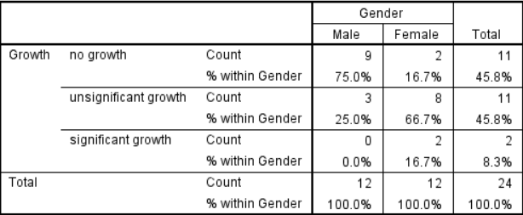
Table 2
There As shown in Table 1, there is a link between gender and asymptomatic bacteriuria. We ran a chi-square test to determine if the association was significant. The hypothesis was that there was a relationship between the two variables, while the null hypothesis states that they are not. However, the requirement that less than 20% of cells have an expected value of less than 5 is not met, so Fisher's exact test was used instead.
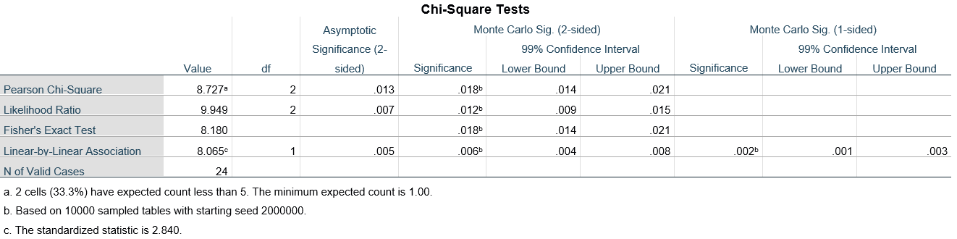
Table 3
The null hypothesis is rejected because the p-value in Table 3 is less than 0.05, indicating an association between gender and bacterial prevalence. Since the p-value in Table 3 was less than 0.05, we reject the null hypothesis. This means that there is a link between gender and
the prevalence of bacteruria

Graph 1
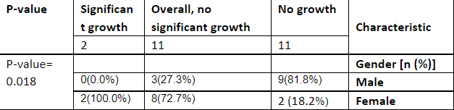
Table 4

Discussion:
The results support the hypothesis that there is a link between gender and asymptomatic bacteriuria. As shown in Figure 1, the proportion of women is higher than that of men, with 75% of men having no growth, 25% growing slightly, and having no asymptomatic bacteriuria, but only about 17% of women. It does not grow, 67% grows slightly. About 17% were asymptomatic bacteriuria. This is due to many variables, including the physical shape of the female urinary system. The urethra, which is responsible for removing urine from the body, is smaller in women. The urethra is where bacteria invade the urinary tract, and shorter urethra makes it easier for bacteria to invade because of the shorter distance traveled. Another reason is the proximity of the urethra to the rectum, which contains Escherichia coli, the most common cause of asymptomatic bacteriuria and urinary tract infections (UTIs). Due to the anatomy of the reproductive system, women are more susceptible to UTI and asymptomatic bacteriuria. The likelihood of asymptomatic bacteriuria increases during menopause. Estrogen levels decrease during menopause, weakening the susceptible vaginal tissue. Pregnancy increases the risk of asymptomatic bacteriuria. This causes vesicoureteral reflux due to hormonal changes, which can cause urine to flow back into the bladder and then into the kidneys. This increases the risk of pyelonephritis, which can be fatal. Some medicines such as B. Spermicide may increase the risk of asymptomatic bacteriuria by creating an environment that causes vaginal inflammation and promotes bacterial growth. The majority of people with asymptomatic bacteriuria are asymptomatic. Among the patients are children, diabetics and the elderly. Patients at risk of mucosal bleeding during urological surgery need to be addressed. Patients in the first 3 months after a kidney transplant should do the same. Pregnant women also need treatment to prevent pyelonephritis, low birth weight, and preterm birth. Patients who do not need antibiotics are advised not to be treated as they increase the risk of antibiotic resistance. As mentioned earlier, E. coli is the most common cause of asymptomatic bacteriuria. This is because E. coli is a natural part of the colon flora. Other pathogens include Klebsiella pneumoniae, Pseudomonas aeruginosa, Staphylococcus, and Enterococcus species
Conclusion:
This study found a link between gender and asymptomatic bacteriuria and showed that women are susceptible to this condition for a variety of reasons, including the anatomy of the female reproductive system. Asymptomatic infections rarely progress to severe infections that cause other illnesses and are rarely treated except for pregnancies, which can be fatal to both children and mothers. .. avoided. E. coli is the most common pathogen because it is a typical component of colon flora. Further research is needed to determine if there is a link between bacteriuria and age, or if it is associated with immune-related disorders such as AIDS..
Referencing:
- https://journals.asm.org/doi/10.1128/microbiolspec.UTI-0001-2012?url_ver=Z39.88-2003&rfr_id=ori:rid:crossref.org&rfr_dat=cr_pub%20%200pubmed. Published 2022. Accessed June 19, 2022.-
- Imop.med.auth.gr. http://imop.med.auth.gr/sites/default/files/reference-3.pdf. Published 2022. Accessed June 19, 2022.
- Hooton, T., 2022. Recurrent urinary tract infection in women.

