
P.T.S. BLOCK
Assignment

Project management workshop

Name: adyan almanbe saleh Roll number: 2478 Group: A4

- Develop a network diagram for the project specified below. (50 %)
- Identify the Critical Activities and the total duration of the project. (35%)
- Justify which activity would you crash based on some rationale (15%)
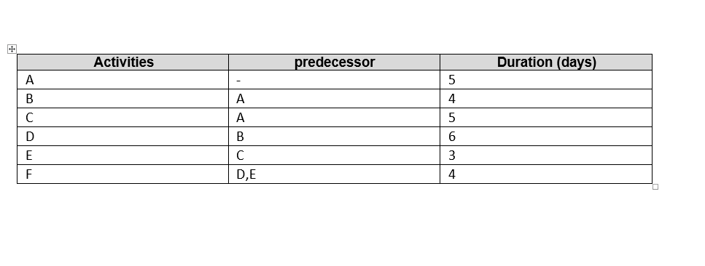

answer 1:

Answer 2:
- Path number 1: A à B à D à F, it is the longest pathway; the total duration is 19 days.
- Path number 2: A à C à E à F, the total duration is 17 days.
- The total duration of all project is 27 days.

Answer 3: the activity that would be crash is number F and D
My theory is to reduce the activity that does not have to be very relied upon We can also choose D because duration takes a lot of time

