
LIMU – 3rd YEAR
PTS BLOCK

Assignment
Project management workshop

Name: Abdulla Salah Zubi 2619 / G A3

- Develop a network diagram for the project specified below. (50 %)
- Identify the Critical Activities and the total duration of the project. (35%)
- Justify which activity would you crash based on some rationale (15%)
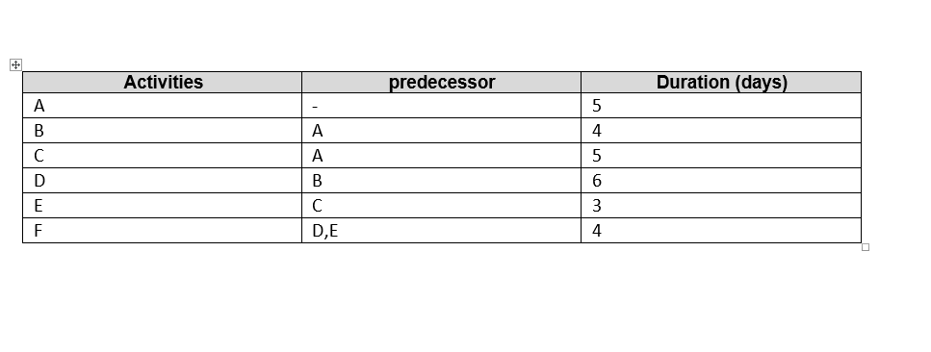

Answer 1 Diagram network for the project
F
E
D

B

A

C

Answer 2

Critical Activities and Total duration Project

Path number 1: A B D F, it is the longest pathway; the total duration is 19 days.
Path number 2: A C E F, the total duration is 17 days.
The total duration of all project is 27 days.

Answer 3

Activity that would be crash is number D
Because it takes more days.
Because it is present in the longest path of the project.
The opposite step it in the project (E) has a few days (3 days) and this allows it flexibility.

