

Abdullah Benali-2448

incidence rate of bacteriuria among limu student

Abstract:
The presence of bacteria in correctly collected urine of a patient who has no signs or symptoms of a urinary tract infection is known as asymptomatic bacteriuria (UTI).
This study was measuring the incidence rate of asymptomatic bacteriuria in a population consist of 24 people 12 males and 12 females, urine samples were taken midway through the urination process from 24 subject. There were two the first hypothesis was that there is a relationship between the two variables, whereas the null hypothesis is that there is not.
We reject the null hypothesis since the p-value was less than 0.05, indicating that This research found a link between gender and asymptomatic bacteriuria,
This research found a link between gender and asymptomatic bacteriuria, demonstrating that females are more susceptible to it for a variety of reasons
Introduction:
The presence of bacteria in correctly collected urine of a patient who has no signs or symptoms of a urinary tract infection is known as asymptomatic bacteriuria, also referred to as bacteriuria or asymptomatic urinary infection. In clinical practice, asymptomatic bacteriuria is pretty ubiquitous [2,3,4]. bacteriuria can be temporary or persistent, lasting from around days to years and involving the same or different species. Bacteriuria may resolve spontaneously or as a result of antimicrobial therapy administered for any indication [3]. Asymptomatic bacteriuria is identified by having at least 105 CFU/ml of an isolated uropathogen in the absence of signs or symptoms of urinary infection in voided urine specimens. For women, two consecutive positive voided specimens are recommended, whereas, for men, a single specimen is sufficient. At least 102 CFU/ml is required for an in and out catheter specimen, including specimens from patients who use clean intermittent catheterization. The presence of biofilm along the catheter complicates the detection of bacteriuria in those who have chronic indwelling catheters. For these individuals, a quantitative count of at least 105 CFU/ ml is likely to be suitable. Bacteriuria that is asymptomatic is typically harmless. Only pregnant women and patients who have undergone invasive urologic procedures with mucosal injuries are considered to have bacteriuria-related morbidity [2].

Materials and methods:
To acquire the best results, urine samples were taken midway through the urination process from 24 persons, 12 males and 12 females. The culture was started just a few minutes after the sample was taken, with the aim of finishing it in less than an hour. A urine sample test tube, a calibrated wire loop, a Bunsen burner, an incubator, and an agar plate containing culture media either CLED or MacConkey agar because they detect most gram-negative bacilli, staphylococci, streptococci, and enterococci, are all required.
The loop was heated and the urine was mixed thoroughly, then the loop was inserted vertically into the urine sample to allow it to adhere to the loop, then it was spread by touching the tip to the center of the plate and dragging across the diameter, the loop was put back in the urine and spread in a Zig-Zag pattern, and the plate was incubated in incubator for 24 hours at 37 C. The number of colonies was counted and multiplied by 100 due to the use of a 0.01 ml loop; if the colony forming unit is ≥1x105 CFU/mL, then there has been a significant increase and significant growth on the culture media.[1]
Results and statistical analysis:

Table 1: Effect of Gender differences on prevalence and of asymptomatic bacteriuria
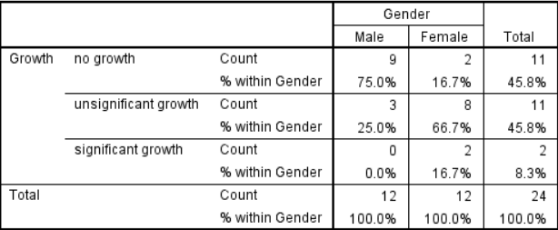
Table 2: bacterial growth and gender correlation.
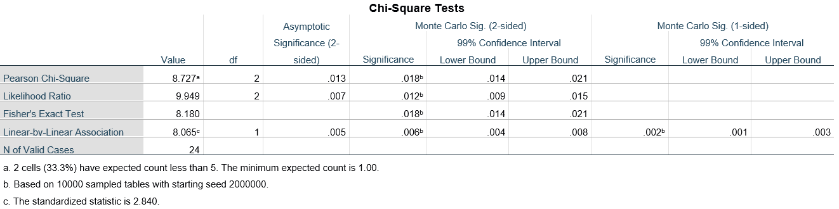
Table 3: Chi - Square Test (Asymp. Sig. (2 - sided) represents the p - value)
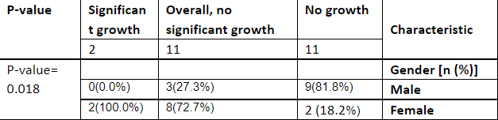
Table 4: summary table

Chart 1: difference in growth between males and females
There is a relationship between gender and asymptomatic bacteriuria, as indicated in Table 1. A Chi-Square test was conducted to assess if the association was significant. The hypothesis was that there is a relationship between the two variables, whereas the null hypothesis is that there is not. However, because the requirement of less than 20% of cells having an anticipated value of less than five was not satisfied, a fisher test was utilized instead.
We reject the null hypothesis in Table 3 since the p-value was less than 0.05, indicating that there is a relationship between gender and the prevalence of bacteriuria.

Discussion:
The data support the hypothesis that there is a link between sex and asymptomatic bacteriuria. The female population has a higher rate than the male population, as shown in Chart 1, with 75 that belongs to males having no overall growth, 25% having insignificant growth and none of them having asymptomatic bacteriuria, whereas only about 17 that belongs to females seem to have no growth, 67 percent had insignificant growth, and about 17 percent were positive for asymptomatic bacteriuria.
This is due to a number of reasons, including the anatomical configuration of the female urinary system. The urethra, which is responsible for transporting urine out of the body, is smaller in females. The urethra is where germs enter the urinary tract, and a shorter urethra makes it easier for bacteria to enter since it has to travel a less distance. The closeness of the urethra to the rectum, which contains Escherichia coli, the most common cause of asymptomatic bacteriuria and urinary tract infections, is another reason for urinary tract infections. Because of the anatomical structure of their reproductive system, females are more prone to urinary tract infections and asymptomatic bacteriuria [6].
The incidence of asymptomatic bacteriuria increases with menopause. Estrogen levels diminish after menopause, resulting in weakened vaginal tissue that is more prone to infection. Pregnancy increases the risk of asymptomatic bacteriuria, which can lead to vesicoureteral reflux, in which urine flows back to the bladder and subsequently to the kidney, due to hormonal changes. This raises the risk of pyelonephritis, a potentially fatal condition. Some medications, such as spermicide, might increase the risk of asymptomatic bacteriuria by inducing vaginal irritation, which can create an environment that is suitable for bacterial growth [5].
The majority of individuals who have asymptomatic bacteriuria don't have any symptoms. Children, diabetics, and the elderly are among the patients. Patients having urologic surgery who are at risk of mucosal bleeding, as well as those in the first three months after a kidney transplant, should be monitored, to avoid pyelonephritis, low birth weight, and premature birth, pregnant women must be treated as well. It is not recommended to treat patients who don't need antibiotics because this increases the risk of antibiotic resistance [7].
Escherichia coli is the most frequent cause of asymptomatic bacteriuria, as previously indicated. This is due to Escherichia coli being a natural component of the flora of the colon .and other pathogens include Klebsiella pneumonia, Pseudomonas aeruginosa, Staphylococcal, and Enterococcal species [4].
Conclusions and future directions:
This research found a link between gender and asymptomatic bacteriuria, demonstrating that females are more susceptible to it for a variety of reasons, including the anatomical anatomy of the female reproductive system. Because asymptomatic infection rarely progresses to a serious infection that causes another disease, it is rarely treated, with the exception of pregnancies, where it can be fatal for both the child and the mother, and kidney transplant patients, where treatment should be avoided to avoid antibiotic resistance. E. coli is the most common causative agent because it is a natural element of the colon's flora. More research may be done to see if there's a correlation between bacteriuria and age, or if it has anything to do with immune-related disorders like acquired immunodeficiency syndrome (AIDS).

References:
1. Levinson W. Medical Microbiology And Immunology. 13th ed. London: McGraw-Hill; 2006.
2. Nicolle L. Asymptomatic bacteriuria. Curr Opin Infect Dis. 2014;27(1):90-96. doi:10.1097/qco.0000000000000019
3. Nicolle L. Asymptomatic Bacteriuria and Bacterial Interference. Microbiol Spectr. 2015;3(5). doi: 10.1128/microbiolspec.uti-0001-2012
4.Givler DN, Givler A. Asymptomatic Bacteriuria. In: StatPearls. Treasure Island (FL): StatPearls Publishing; May 1, 2022.
5.Colgan R, Jaffe GA, Nicolle LE. Asymptomatic Bacteriuria. Am Fam Physician. 2020;102(2):99-104.
6.Geerlings SE. Clinical Presentations and Epidemiology of Urinary Tract Infections. Microbiol Spectr. 2016;4(5): 10.1128/microbiolspec.UTI-0002-2012. doi:10.1128
7.Almaimani AO. Asymptomatic Bacteriuria in Post Renal Transplant Patients: To Treat or Not? Cureus. 2021;13(6): e15713. Published 2021 Jun 17.doi:10.7759/cureus.15713

