

Scientific Lab report
Y2 med
2021-2022

Student name:Reem Khaled

Student number:-2896

Supervisors: Dr.Iman Fergani

Assistant by:-

أ. ناجي الحمري -

أ. أسماء الكوافي -

-

...

Title : -Use of Urinary Gram Stain for Detection of
Urinary Tract Infection in Childhood
•Abstract :- In this study, 100 children with symptoms suggesting urinary tract infection were given a urine culture, a urine Gram stain, and four urinalysis tests: leukocyte esterase, nitrite, microscopy for bacteria, and microscopy for pyuria.
Our goal was to compare the validity of the urine Gram stain to a combination of pyuria with Gram stain and overall urinalysis (nitrite positivity, leukocyte esterase positivity, bacteria microscopy, or white blood cell microscopy)
A positive urine culture was found in 70 (70%) of 100 children aged two to fifteen years: 40 females (57%) and 30 boys (43 percent).
The most commonly isolated agent was Escherichia coli.
The urine Gram stain had a sensitivity and specificity of 80% and 83 percent, respectively, while the combination of pyuria with Gram stain had a sensitivity and specificity of 42 percent and 90 percent, and the overall urinalysis had a sensitivity and specificity of 74 percent and 3.5 percent.
In symptomatic children, neither type of urine screening should be used instead of a urine culture, according to our findings.

•Introduction:- Urinary tract infection (UTI)is a frequent pediatric ailment, affecting around 3 to 5 percent of girls and 1% of boys [1-3].
Prompt treatment is critical in this age range since even a brief delay might result in long-term problems [4-6].
Rapid diagnosis, on the other hand, is required for prompt therapy. Urinalysis (microscopic pyuria), enhanced urinalysis (white blood cell [WBC]
count per cubic millimeter with Gram stain), and urine dipstick are all quick screening methods (leukocyteesterase or nitrite),None of the uriscreen (catalase test) assays have been found to be satisfactory in the diagnosis of UTI [4, 5, 7-9].
Urinary culture, urinary Gram stain, and four assays within the urinalysis, including leukocyte count, were used in this investigation.
In children with symptoms that suggested a UTI, letterate microscopy for bacteria and microscopy for pyuria were evaluated.
The goal of this study was to see if the urine Gram stain was accurate.
In comparison to a combination of pyuria plus Gram stain and overall urinal- ysis
63 (nitrite, leukocyte positivity),For bacteria, use microscopy; for WBC, use microscopy.

•Materials and methods:- materials used:-
solutions of Crystal violet, Gram's jodine, 95 % ethanol and / or isopropa
acetone mixture (3: 1v /v), and Safranin.
clean glass slides.
wire or plastic loops.
Bunsen Burner.
Bibulous paper.
Microscope.
immersion oil.
Difco.
slide warmer.
staining rack.
Bacto Gram stain Reagents frism Difco for the three step Gram Stain.
A total of 100 children were enrolled in the Yüzüncü Yil University's Faculty of Medme for the study.
Between the Departments of Pediatrics and
UTI symptoms were seen between January and June 1999.
Fever with no apparent source, vomiting, poor appetite, and irritability for infants; abdominal pain and voiding frequency with or without fever for toddlers; and dysuria, frequency, urgency, and abdominal/flank discomfort with or without fever for older children.
Children who were taking antibiotics were not included in the study.
Physical examinations:- were conducted on all children, as well as
four urinalysis tests:-1- (leukocyte microscopy for bacteria and microscopy for pyuria),
2-urinary Gram stain, and urinary culture.
The erythrocyte sedimentation rate, complete blood count, and peripheral blood smear were also examined. The children who were diagnosed with UTI were given the appropriate antibiotic based on the antibiogram results.
Urine was collected in babies using an adhesive, sealed, sterile collecting bag after the skin of the genitals had been disinfected. A midstream urine sample was taken from toilet-trained children .
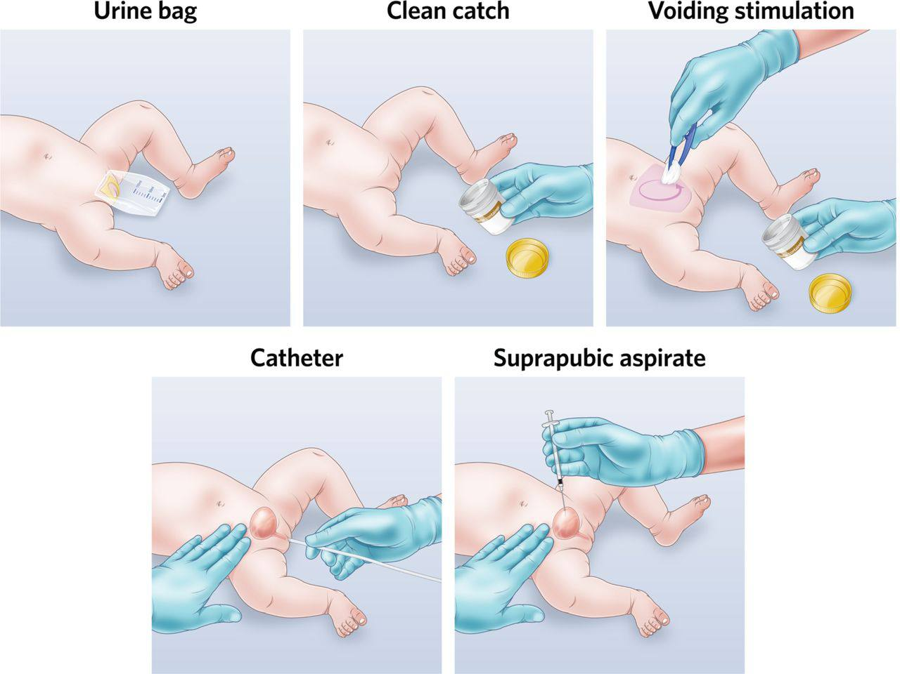
An "overall urinalysis" test was devised in order to improve the sensitivity of urinalysis. If nitrite, leukocvte esterase, direct microscopy without Gram stain for bacteria, or microscopy for WBC were positive, it was termed positive.
If any organisms were found on a survey of 20 oil immersion fields, Gram stains were positive.
Ouanttauve urine culture WaS DET was created by inoculating sheep blood agar and cosine metilen blue agar culture plates with a loop calibrated to deliver 0.01 ml. All plates were incubated at 35°C for 24 and 4 hours before being read.
A positive urine culture was found in 70 (70%) of
100 children aged two to fifteen years: 40 females.
(57%) and 30 boys (43 percent).
The most commonly isolated agent was Escherichia coli.
The urine Gram stain had a sensitivity and specificity of
80% and 83 percent, respectively, while the
combination of pyuria with Gram stain had a
sensitivity and specificity of 42 percent and 90
percent, and the overall urinalysis had a, sensitivity
and specificity of 74 percent and 3.5 percent.
According to our findings, the Neith Back method of urine screening should be use.
•Results and analysis:-
The study comprised 100 children, ranging in age
from two days to fifteen years, with 52 girls 52%)
and 48 boys (48%) participating (48 percent).
A positive urine culture was found in 70 (70%) of
children, with 40 girls (57%) and 30 boys (43 These kids were all under the age of five. There is a significant difference in gender and age groups (p05). (Table 1). 33 (47%) of the cultures tested positive for E. coli, 13 (18.5%) for Klebsiella pneumonia, seven (10%) for Proteus mirabilis, and six (8.5%) for Staphylococci, etc the (Table 2). The clinical and analytical characteristics
of the children with positive and negative urine
cultures are summarized in (Table 3).
There was a significant difference in culture
positiveness between the age groups (× 3.27; p>0.05
Table 4) lists the sensitivity, specificity, and)
predictive values for Gram stain, which is a mixture
of pyura and Gram stain.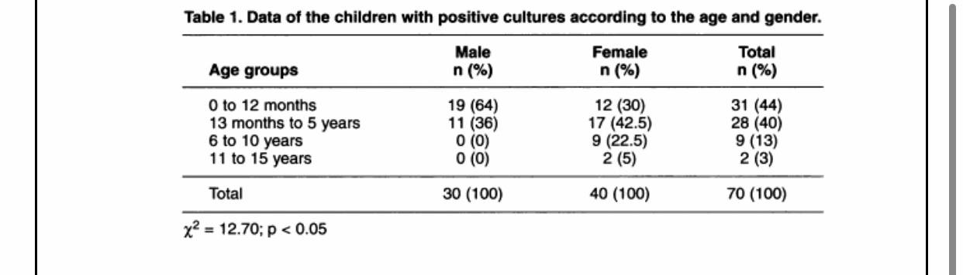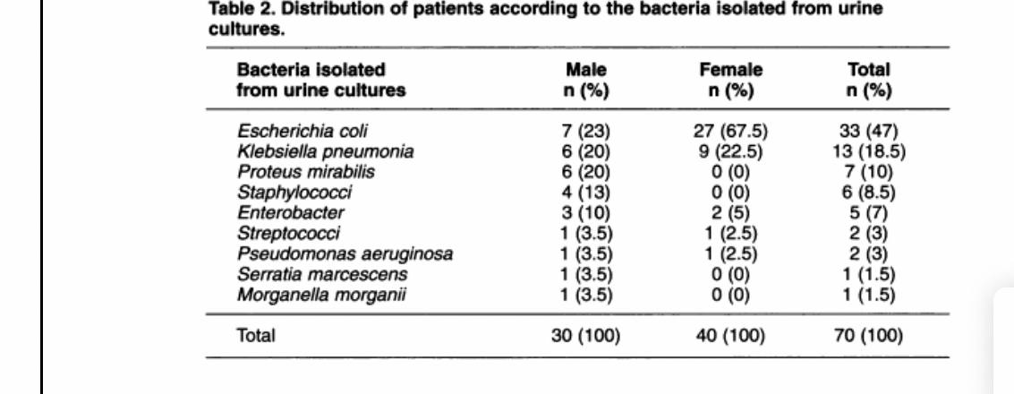
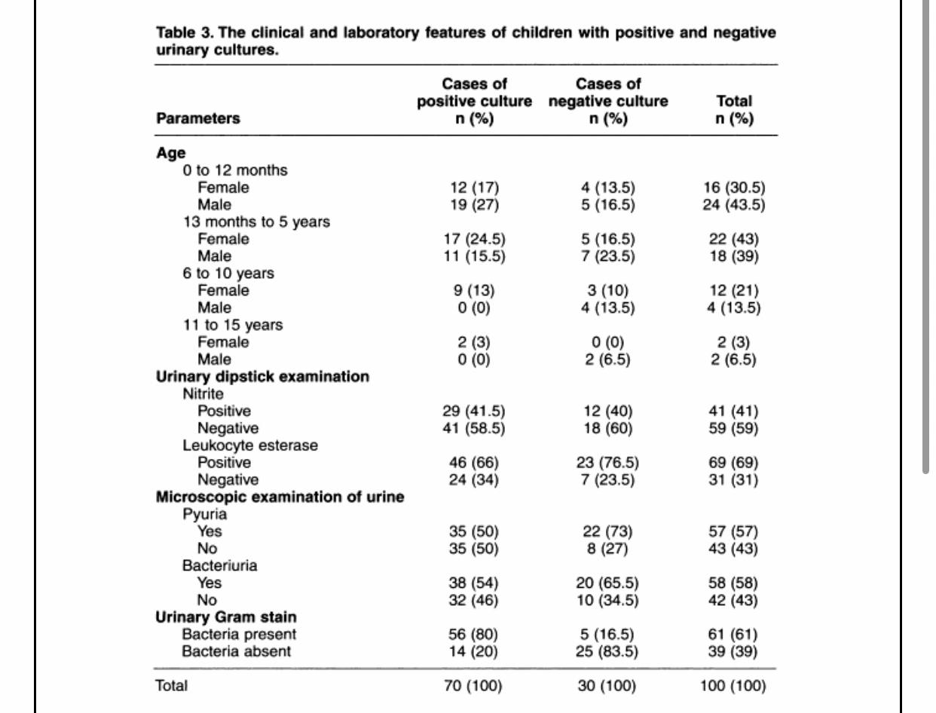
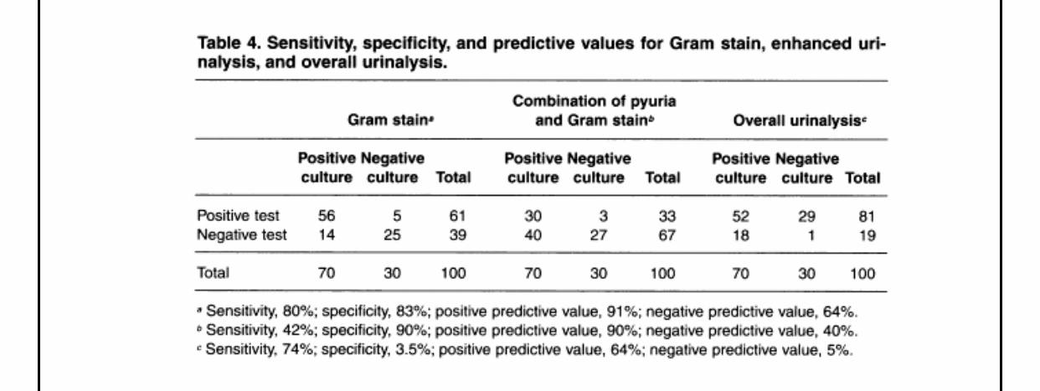
Chi-Square Tests
 | Value | df | Asymptotic Significance (2-sided) | Monte Carlo Sig. (2-sided)
 |  |  |  | Significance | 99% Confidence Interval
 |  |  |  |  | Lower Bound | Upper Bound
Pearson Chi-Square | 8.873ª | 3 | .031 | .019^{b} | .015 | .022
Likelihood Ratio | 10.372 | 3 | .016 | .015^{b} | .012 | .018
Fisher's Exact Test | 8.225 |  |  | .019^{b} | .015 | .022
N of Valid Cases | 24
a. 4 cells (50.0%) have expected count less than 5. The minimum expected count is .50.
b. Based on 10000 sampled tables with starting seed 2000000
gender * bacterialgrowhsignificance Crosstabulation
 |  |  | bacterialgrowhsignificance |  |  |  | Total
 |  |  |  | no growt | overall | signific | Total
gender | female | Count | 0 | 2 | 8 | 2 | 12
gender | female | % within gender | 0.0% | 16.7% | 66.7% | 16.7% | 100.0%
gender | female | % within bacterialgrowhsignificance | 0.0% | 20.0% | 72.7% | 100.0% | 50.0%
gender | male | Count | 1 | 8 | 3 | 0 | 12
gender | male | % within gender | 8.3% | 66.7% | 25.0% | 0.0% | 100.0%
gender | male | % within bacterialgrowhsignificance | 100.0% | 80.0% | 27.3% | 0.0% | 50.0%
Total |  | Count | 1 | 10 | 11 | 2 | 24
 |  | % within gender | 4.2% | 41.7% | 45.8% | 8.3% | 100.0%
 |  | % within bacterialgrowhsignificance | 100.0% | 100.0% | 100.0% | 100.0% | 100.0%

Result

Hypothesis: H0 : No association between gender status and bacterial growth
Ha : There is an association between gender status and bacterial growth.

 | No growth | Overall | Significant growth
Males | 8 | 3 | 0
Females | 2 | 8 | 2

Summary table

p-value of Fisher’s is 0.019
Decision: except to reject the null hypothesis (FTR) Since P-value lesser than alpha 0.05, we except to reject the null hypothesis.
Conclusion there is association between gender status and bacterial growth.
•Discussion:- Despite the fact that a number of research have looked into the use of urine Gram stain in infants and children, the results have been mixed [9-12]. In a study of 207 infants under the age of six months with fever, Lochart et al. [9] discovered that the Gram stain had a sensitivity of 94 percent and a specificity of 92 percent, the total urinalysis test had a specificity of 92 percent. The total urinalysis test was found to have a sensitivity of 67% and specificity of 79%. A study of 1,019 symptomatic pediatric outpatients found that Gram-stained smears were somewhat more sensitive than dipsticks (either leukocyte esterase- or nitrite-positive); 97.6 percent vs. 90.2 percent, although both techniques had modest positive predictive values 11.
For the improved urinalysis, Hoberman and associates [12] found 96 percent sensitivity and 93 percent specificity, and they also noted that the Dresence or either pyuria or bacteriuria, as well as the presence of both, have the highest sensitivity (95 percent) and positive predictive value (85 percent). According to Shaw et al. [10], enhanced urinalysis was the most sensitive (94%) at detecting UTI, although it had more false-positive results (16%) than the urine dipstick (leukocyte esterase or nitrite) or Gram stain (3%).)
We were unable to determine the number of leukocytes per cubic millimeter in urine samples since we did not count them.
•Conclusion:- Our data revealed that a combination of pyuria and gram had the highest specificity (90%) but the lowest sensitivity (42%); urine Gram stain had the highest specificity (90%) but the lowest sensitivity (42%); and total urinalysis had the lowest specificity (3.5%).
In light of these data, we believe that neither urine screening technology nor a urine culture should be used in symptomatic chilhood.
•References:- Arslan S, Caksen H, Rastgeldi L, Uner A, Oner AF, Odabaş D. Use of urinary gram stain for detection of urinary tract infection in childhood. Yale J Biol Med. 2002 Mar-Apr;75(2):73-8

