Project management Assignment 1
Name: Salsabeel Hamad Elgzirey
Roll Number: 2357

Develop a network diagram for the project specified below

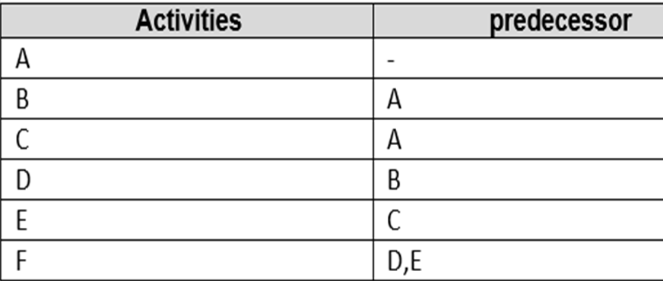
1-Activity A has no predecessor activity, that activity A takes the project from event 1 to event 2
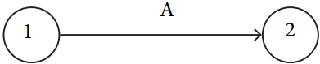

2-Activity B the predecessor activity is A. the B joins nodes 2 and 3
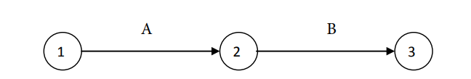

3-Activity C have A as the predecessor activity 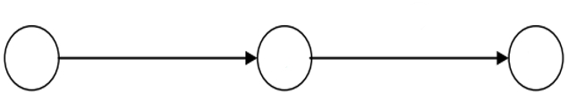
A4
C4
44
2
1

1
4-Activity D have B as a predecessor activity
D
B
4
2
1
5-Activity E have C as a predecessor activity
E
C
6
4
3

6-Activity F have D, E as a predecessor activity
4

5
6

Identify the Critical Activities and the total duration of the project
A-B-C-D-E = 5+4+5+6+3+4 = 27 days " from path 1 "
A to B = 5 B to C=10 C to D = 11 D to F = 9
Total = 35 days " from path 2 "
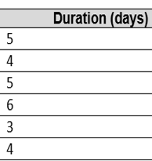

Justify which activity would you crash based on some rationale
The activity F " 6 ", and C "3" because of the:
1 – it needs D and E as a predecessor which need time
2- the D obtained from B, and B obtained from A which is the primary project supporter, and his capital was small the
3 – the activity C also involved, because of the Supplier was A

