

The Libyan International Medical University
Faculty of Basic Medical Science

Effect of Gender differences on prevalence and microbial spectrum of asymptomatic bacteriuria
Student name: Ayah Jamal
Student number: 3100
Date of Submission: 20/ 6/ 2022

Abstract:
Bacteriuria is the presence of certain bacteria in the urine, associated with both asymptomatic and symptomatic urinary tract infections (UTI's).
It has a great influence on the way that microorganisms settle in the urinary system.
The elderly, pregnant women, healthy women, and patients with weak immunity all have very different rates of bacterial urine, women and pregnant mothers are the most inclined, but it is interesting that it has different in many microbiological spectra.
In addition to the predominance of asymptomatic bacteriuria between men and women, microorganisms that infect various genders is different.
This study examines data on the predominance of asymptomatic bacteriuria and the microbiological spectrum as a function of gender.
We also review the value of early detection of asymptomatic bacteriuria (ASB) in the prevention of health complications in pregnant and non-pregnant women.

Introduction:
In primary care, asymptomatic bacteriuria (ASB) affects thousands of people around the world, but is the second most common bacterium associated with the disease.
Developed countries are often as affected as emerging countries, making it a clear issue.
It is estimated that more or less than 20% of all women develop at some point in their lives (ASB) and many women experience repeated infections.
Women are at the highest risk of ASB because of their short lifespan in the urethra and their proximity to the anus, which promotes colonization by bacteria such as E. coli.
Women are more likely to get an infection if they have recently engaged in sexual entertainment and started as shown using the ASB definition. This condition occurs when active bacteria are present in humans.
Although in urine, there are no apparent signs of UTI in the affected person.
The incidence of healthy women is between 5-20%
and the incidence is between 10-40%.
In ASB, the proportion of pregnant women, is an important predictor of UTI potential.
And the most common microorganism for urinary tract infections is E. coli, Klebsiella, and Enterococcus faecalis.
UTI can be detected by taking a urine sample and looking for these microbes.
Asymptomatic bacteriuria is not investigated as often as symptomatic bacteriuria. This is annoying because most people with asymptomatic infections may not know that they have UTI.
If you show signs or symptoms and do not cross for screening, a symptomatic bacteriuria may worsen and cause UTI.
The purpose of this laboratory is to find a solution to the problem of how asymptomatic bacteriuria is not uncommon in all women.
In addition, men and women need to undergo regular screening for asymptomatic urinary tract infections.

Materials and Methods:

Loop

_ Incubator

_ Culture media

_ Slide pipette

_ Paper towels

_ Dipsticks

_ Alcohol Gel

_ Gloves

_ Containers (63)

_ Urine Samples (63)

In this study, urine samples were collected from 63 students (33 males and 30 females) from the Libya International Medical University (LIMU) who were asymptomatic of bacterial urine.
The samples were sent to the laboratory to see if there was an increase in bacterial urine and if it was an average non-significant increase, or whether it was a normal significant increase. Use of sample packaging for each disinfected child, Stain-free, leaks and huge open spots, we collected about 10-15 ml of recently urinated urine samples and caught them along the way.

After that, urine was seeded on a cysteine-lactose-electrolyte-poor (Cled) agar medium and aerobically cultured at 37ºC Celsius degree for approximately 24-48 hours. Then we looked up for a bacterial boom on the infected plate.

Results:

gender * bacterial growth significance Cross tabulation
 |  |  | Bacterial growth significance |  |  |  | Total
 |  |  |  | no growth | overall | significance | Total
gender | female | Count | 0 | 2 | 8 | 2 | 12
gender | female | % within gender | 0.0% | 16.7% | 66.7% | 16.7% | 100.0%
gender | female | % within bacterialgrowhsignificance | 0.0% | 20.0% | 72.7% | 100.0% | 50.0%
gender | male | Count | 1 | 8 | 3 | 0 | 12
gender | male | % within gender | 8.3% | 66.7% | 25.0% | 0.0% | 100.0%
gender | male | % within bacterialgrowhsignificance | 100.0% | 80.0% | 27.3% | 0.0% | 50.0%
Total |  | Count | 1 | 10 | 11 | 2 | 24
 |  | % within gender | 4.2% | 41.7% | 45.8% | 8.3% | 100.0%
 |  | % within bacterialgrowhsignificance | 100.0% | 100.0% | 100.0% | 100.0% | 100.0%

Chi-Square Tests
 | Value | df | Asymptotic Significance (2-sided) | Monte Carlo Sig. (2-sided)
 |  |  |  | Significance | 99% Confidence Interval
 |  |  |  |  | Lower Bound | Upper Bound
Pearson Chi-Square | 8.873ª | 3 | .031 | .019^{b} | .015 | .022
Likelihood Ratio | 10.372 | 3 | .016 | .015^{b} | .012 | .018
Fisher's Exact Test | 8.225 |  |  | .019^{b} | .015 | .022
N of Valid Cases | 24

Hypothesis:

H0: There is No association between gender status and bacterial growth

Ha: There is an association between gender status and bacterial growth

 | No growth | Overall | Significant growth
Males | 18 | 12 | 0
Females | 17 | 13 | 3

Summary table

P-value is 0.019, Decision: accept to reject the null hypothesis (FTR) Since P-value lesser than alpha 0.05, we accept to reject the null hypothesis. Conclusion there is association between gender status and bacterial growth

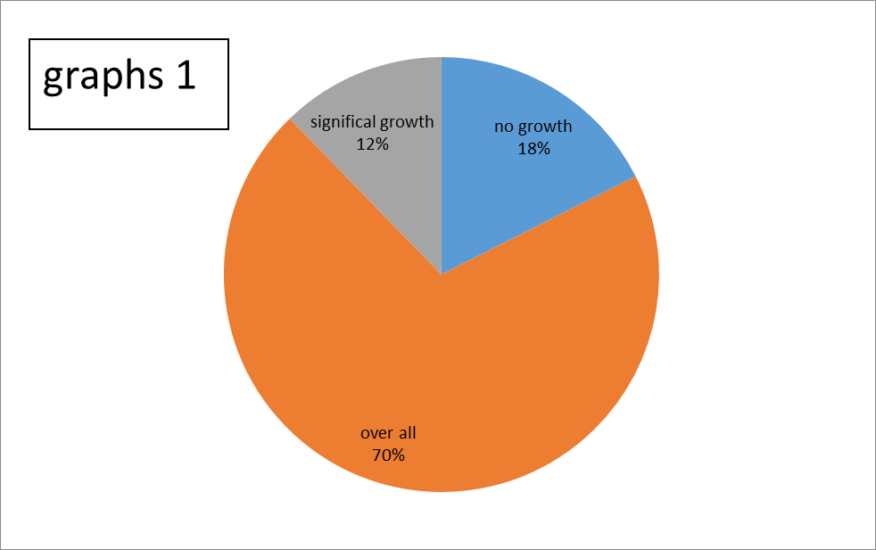
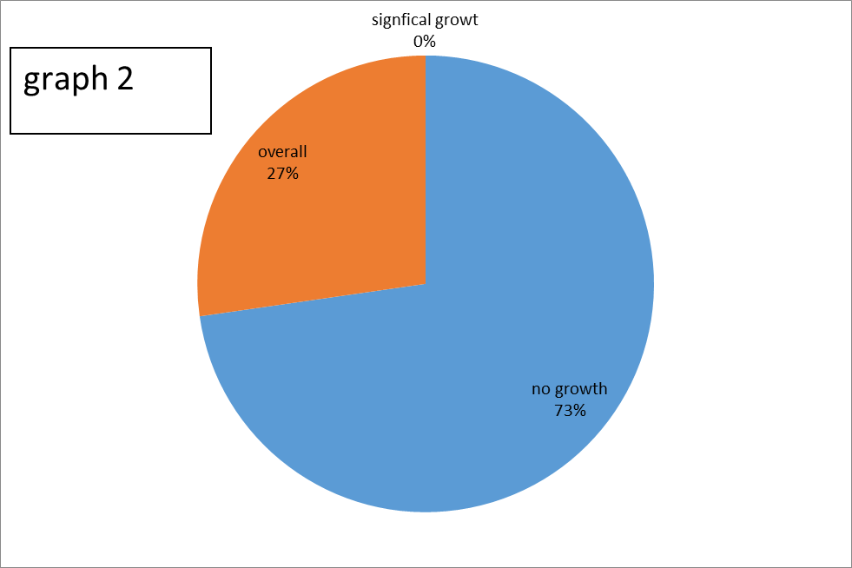

Discussion:

For the reason of that the P-value for this test was 0.019, it is possible to reject the null speculation and finish that the statistics are not polluted. Contrary to what we anticipated, that the results will indicate that there is not a very high prevalence price for main bacteriuria increase. The incidence fee is 0% in men, with most effective eight men showed no development at all, a good deal on my own growth that could be taken into consideration even minimum, despite a sixteen, sixty-six percentage prevalence rate, it's miles nonetheless appreciably lower than predicted for ladies. No matter this 10 out of 12 women tested bacteriuria growth, indicating that most of the people are at risk for developing it, infections with UTI's.

Using this data, we may also draw the reasonable end that men are not mainly at danger for bacteriuria infection, which suits with our prior information. It is far considerably extra difficult for germs to colonize on the male urethra than the woman one considering that it is far longer and farther from the anus in contrast to the women vagina.

Further, even at the same time as women may be more susceptible to bacteriuria, the threat remains now not remarkable sufficient to warrant problem in view that on common, most effective sixteen out of a hundred ladies will enjoy large bacteriuria, and even fewer will experience UTIs.

But, the danger is still gift and far extra ordinary among ladies than amongst men.

It is fascinating that 13 out of 23 human beings in both the male and female corporations had a few shape of bacteriuria growth, even though it is not particularly massive.

This could be a hassle because even non-widespread growth has the ability to turn into considerable increase, which could cause UTI's.

Despite the fact that non-considerable increase does now not usually imply the presence of UTI's, this study suggests that each women and men are nevertheless at a few chance for bacteriuria, as the boom ought to eventually end up large and motive issues with UTI's.

The second item will essentially in no way result in vast growth, and we may additionally fairly rule out men for the maximum part from bacteriuria.

The situation for women, but less than 10% will never have to deal with this drastically extra chance, bacteriuria which remains excessive sufficient to reason women to have problems since the UTI and pyelonephritis issues may result from ordinary screening will be beneficial for detecting ASB earlier before it becomes a problem.

Conclusion:

Despite the fact that this lab may not be perfect, the results confirmed that women have been the organization maximum prone to ASB since it turned into appreciably extra common in them than in men. the pattern length was considered one of this lab's weaknesses, so the test may have been changed if more than one hundred individuals were tested.

Feasible fashionable deviation delivered on by using a few outliers, the advantages could be that collection of sterilized urine in boxes in which both sterilization and the urine become stored in sealed packing containers to save you extraneous interference resources.

However, what we succeeded in the outcomes, within the grand scheme of things, leads us to the simple reality that asymptomatic bacteriuria is an contamination happening mainly in women at a fee which while now not high sufficient to purpose mass panic, continues to be huge sufficient that maximum women would most effective gain from not less than semi-regular screening to reduce the price of UTI's and capacity of pyelonephritis from steady ASB, that may be avoided without difficulty with antibiotics.

References:
- Ranjan A., Sridhar S.T.K., Matta N., Chokkakula S., Ansari R.K. Prevalence of UTI among Pregnant Women and Its Complications in Newborns. Indian J. Pharm. Pract. 2017;10:45. doi: 10.5530/ijopp.10.1.10
- Urinary Tract Infections | UTI | UTI Symptoms | MedlinePlus [Internet]. Medlineplus.gov. 2020 [cited 6 March 2020]. Available from
- Sakamoto, M., et al. "Molecular analysis of bacteria in asymptomatic and symptomatic endodontic infections." Oral microbiology and immunology 21.2 (2006): 112-122
- Moore E.E., Hawes S.E., Scholes D., Boyko E.J., Hughes J.P., Fihn S.D. Sexual intercourse and risk of symptomatic urinary tract infection in post-menopausal women. J. Gen. Intern. Med. 2008;23:595–599. doi: 10.1007/s11606-008-0535-y.
- Afoakwa P, Domfeh S, Afranie B, Owusu D, Donkor S, Sakyi K et al. Asymptomatic Bacteriuria and Anti-Microbial Susceptibility Patterns among Women of Reproductive Age. A Cross-Sectional Study in Primary Care, Ghana. National Library Of Medicine. 2022. [accessed 4 Jun 2022] Available from: https://www.ncbi.nlm.nih.gov/pmc/articles/PMC6313490/

