

Scientific Lab report

Y2 med
2021-2022
Student name\ Skeena Abdullah
Student number \3067

Urinary tract infection

Abstract

Urinary tract infection (uti) are among most common bacterial infection and account for significant part of the workload in clinical microbiology laboratories and enteric bacteria (in particular , Escherichia coli) remain the most frequent cause of UTI and she is resistance to some antibiotic like to clindamycin and ampicin and amoxicillin. Research has shown drinking plenty of water reduce the risk of urinary tract infection among women and 50% of woman will experience an acute UTI in their life time , and third of these will occur before the age of 24. This study aims to determine how the diagnosis uti in lab and determine the best treatment for him. Then collected a sample of urine from donors and plant it in a bacterial culture and antibiotic selection test. Analysis of the sample demonstrated that bacteria grow on cultural and that is sensitive to some antibiotics and resistance to some of them.‎¹

Introduction
- Components of the Urinary System:
The urinary system consists of the kidneys, ureters, urinary bladder, and urethra. The kidneys form the urine and account for the other functions attributed to the urinary system. The ureters carry the urine away from kidneys to the urinary bladder, which is a temporary reservoir for the urine. The urethra is a tubular structure that carries the urine from the urinary bladder to the outside.
- Kidneys
- Ureters
- Urinary bladder
- Urethra

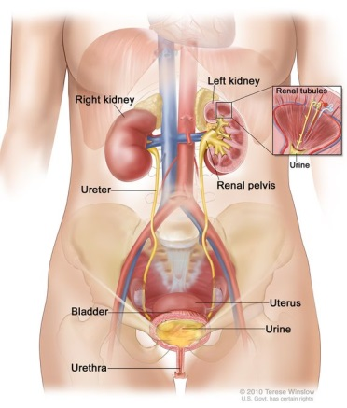
Fig 1.1

- Introduction to the Urinary System:
The principal function of the urinary system is to maintain the volume and composition of body fluids within normal limits. One aspect of this function is to rid the body of waste products that accumulate as a result of cellular metabolism, and, because of this, it is sometimes referred to as the excretory system.
The urinary system maintains an appropriate fluid volume by regulating the amount of water that is excreted in the urine. Other aspects of its function include regulating the concentrations of various electrolytes in the body fluids and maintaining normal pH of the blood.
In addition to maintaining fluid homeostasis in the body, the urinary system controls red blood cell production by secreting the hormone erythropoietin. The urinary system also plays a role in maintaining normal blood pressure by secreting the enzyme renin

- Urinary tract infection (UTI):

A urinary tract infection (UTI) is an infection in any part of your urinary system your kidneys ureters bladder and urethra. Most infections involve the lower urinary tract the bladder and the urethra.

- Types of urinary tract infection:
- Upper UTI occurs either in the kidneys, medically termed pyelonephritis, or in the ureters.
- lower UTI occurs either in the Bladder or in the urethra.

- Symptoms:
- A strong, persistent urge to urinate
- A burning sensation when urinating
- Passing frequent, small amounts of urine
- Urine that appears cloudy
- Urine that appears red, bright pink or cola-colored —a sign of blood in the urine
- Strong-smelling urine
- Pelvic pain.
Symptoms according to parts of urinary tract :
Part of urinary tract affected | Signs and symptoms
Kidneys (acute pyelonephritis) | - Back pain or side (flank) pain  - High fever  - Shaking and chills  - Nausea  - Vomiting
Bladder (cystitis) | - Pelvic pressure  - Lower abdomen discomfort  - Frequent, painful urination  - Blood in urine
Urethra (urethritis) | - Burning with urination  - Discharge

- Asymptomatic bacteriuria
- Those who have bacteria in the urine but no symptoms should not generally be treated with antibiotics. This includes those who are old, those with spinal cord injuries, and those who have urinary catheters. Pregnancy



- Causes:
Urinary tract infections typically occur when bacteria enter the urinary tract through the urethra and begin to multiply in the bladder. Although the urinary system is designed to keep out such microscopic invaders, these defenses sometimes fail. When that happens, bacteria may take hold and grow into a full-blown infection in the urinary tract.
- Infection of the bladder (cystitis). This type of UTI is usually caused by Escherichia coli (E. coli), a type of bacteria commonly found in the gastrointestinal (GI) tract. However, sometimes other bacteria are responsible.
- Sexual intercourse may lead to cystitis, but you don't have to be sexually active to develop it. All women are at risk of cystitis because of their anatomy — specifically, the short distance from the urethra to the anus and the urethral opening to the bladder.
- Infection of the urethra (urethritis). This type of UTI can occur when GI bacteria spread from the anus to the urethra. Also, because the female urethra is close to the vagina, sexually transmitted infections, such as herpes, gonorrhea, chlamydia and mycoplasma, can cause urethritis.^{4,3}

- Treatment:
Antibiotics usually are the first line treatment for urinary tract infections. Which drugs are prescribed and for how long depend on your health condition and the type of bacteria found in your urine.

Frequent infections:
If you have frequent UTIs, your doctor may make certain treatment recommendations, such as:
- Low-dose antibiotics, initially for six months but sometimes longer
- Self-diagnosis and treatment, if you stay in touch with your doctor
- A single dose of antibiotic after sexual intercourse if your infections are related to sexual activity
- Vaginal estrogen therapy if you're postmenopausal

Severe infection:
For a severe UTI, you may need treatment with intravenous antibiotics in a hospital.

Prevention:
You can take these steps to reduce your risk of urinary tract infections:
- Drink plenty of liquids, especially water. Drinking water helps dilute your urine and ensures that you'll urinate more frequently — allowing bacteria to be flushed from your urinary tract before an infection can begin.
- Drink cranberry juice. Although studies are not conclusive that cranberry juice prevents UTIs, it is likely not harmful.^{4,3}
- Materials and methods
We collected 24 urine sample from men and women who do not have any heath problem and then put this urine in sterile specimen container to avoid any contamination and used flame a calibrated wire loop for set up quantitative urine cultures . Calibrated loops are designed to transfer a well-defined sample volume to agar plates and They may be reusable (loops made of nichrome or platinum) or disposable (loops made of plastic).mix the urine and insert the loop vertically into the urine to allow the urine adhere to loop , After that, we distributed the urine to blood agars(such as Columbia agar and MacConkey agar) . then we have to inoculation into selective culture after inoculation the culture palter by spectrophotometry are incubated at 37c extending to 24hours are read the colony counts are made . the number of colony is multiplied by 1000 (if a 0.001ml loop used ) of by100 ( if 0.01 ml loop was used ) .so number of colony on my culture equal832 and loop used0.01ml so when multiple number of colony in 100 equal 83,200.

- Result and biostatistics analysis \
Effect of Gender differences on prevalence and microbial spectrum of asymptomatic bacteriuria
Table1

 | No growth | Overall no significant growth | significant growth
Male | 9 | 3 | 0
Female | 2 | 8 | 2

Statistical process of samples using spps program:

According to
Table2: CFUcat differences among LIMU students.
 |  |  | CFUcat |  | Total
 |  |  | no growth | growth | Total
Gender | male | Count | 9 | 3 | 12
Gender | male | Expected Count | 5.5 | 6.5 | 12.0
Gender | male | % within Gender | 75.0% | 25.0% | 100.0%
Gender | male | % within CFUcat | 81.8% | 23.1% | 50.0%
Gender | female | Count | 2 | 10 | 12
Gender | female | Expected Count | 5.5 | 6.5 | 12.0
Gender | female | % within Gender | 16.7% | 83.3% | 100.0%
Gender | female | % within CFUcat | 18.2% | 76.9% | 50.0%
Total |  | Count | 11 | 13 | 24
 |  | Expected Count | 11.0 | 13.0 | 24.0
 |  | % within Gender | 45.8% | 54.2% | 100.0%
 |  | % within CFUcat | 100.0% | 100.0% | 100.0%

Table3
Chi-Square Tests
 | Value | df | Asymptotic Significance (2-sided) | Exact Sig. (2-sided) | Exact Sig. (1-sided)
Pearson Chi-Square | 8.224ª | 1 | .004
Continuity Correction^{b} | 6.042 | 1 | .014
Likelihood Ratio | 8.795 | 1 | .003
Fisher's Exact Test |  |  |  | .012 | .006
Linear-by-Linear Association | 7.881 | 1 | .005
N of Valid Cases | 24

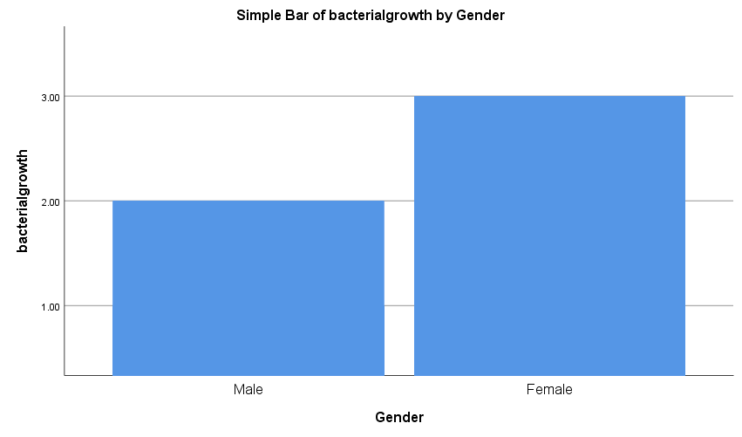
Fig2
The result of the statistical result of the samples:
The result show 2 from the female urine sample was no growth of bacteria , 8was overall no significant growth and 2 significant growth this mean only 8 females has asymptomatic bacteriuria while the result of males is no growth 9 show table 2 ,3 . according to results of fishers exact test in spss p values less than 0.05 so this test is significant so we accept the hypothesis 1
Discussion
In the result of these sample , it was clear that females are more susceptible to bacteria in urine than men the result is difference in the arithmetic mean of samples when we deal with them statistically program statistic (spss). When you use fisher exact test, will depend on the p value to reject or accept the hypothesis according to table3,pwithapeak less than 0.05 we accept H1 which states that there is relationship between gender and growth and reject H0which states that there is no relationship between gender and growth and also simple Bar agrees with this theory, seen fige2.
If there is a bacterial growth on the culture then this person will be infected with uti and if there is no growth then this means that he is not infected with uti. So we can say that women are more susceptible to uti than men, there are several factors that help with that ex
1 Female anatomy. A woman has a shorter urethra than a man does, which shortens the distance that bacteria must travel to reach the bladder.
2Sexual activity. Sexually active women tend to have more UTIs than do women who aren't sexually active. Having a new sexual partner also increases your risk.
3Certain types of birth control. Women who use diaphragms for birth control may be at higher risk, as well as women who use spermicidal agents.
4Menopause. After menopause, a decline in circulating estrogen causes changes in the urinary tract that make you more vulnerable to infection.
According to the results of urine culture that we used in the laboratory and from which we obtained a result equal to.so number of colony on my culture equal832 and loop used0.01ml so when multiple number of colony in 100 equal 83,200 so result negative because the number of bacteria on culture must be equal 10,000 to say it is positive.
Conclusion
According to the statistical results related to the levels of bacterial infection in urine in women and men, that indicate that the variance of the samples for males is greater than that of female sample, due to the above mentioned risk factor.
Uti is a common disease, but is not complicated and treatable, disease, but neglect may cause serious complication from it
Complications of a UTI may include:
•Recurrent infections, especially in women who experience two or more UTIs in a six-month period or four or more within a year.
•Permanent kidney damage from an acute or chronic kidney infection (pyelonephritis) due to an untreated UTI.
•Increased risk in pregnant women of delivering low birth weight or premature infants.
•Urethral narrowing (stricture) in men from recurrent urethritis, previously seen with gonococci urethritis.
•Sepsis, a potentially life-threatening complication of an infection, especially if the infection works its way up your urinary tract to your kidneys.^{2,3}

Reference
1. wilkinsionI.Oxford handbook of clinical medicine.
2.GoldmanE,GreenL. Practical handbook of microbiology. Boca Raton:CRCpress;2009.
3. urinary tract infection (UTIs){internet}.nhs.uk.2022{cited18 june2022}.Available from:https:\\www.nhs.uk\condition\urinary-tract-infection—utis\
4.urinary tract infection(uti)-symptoms and causes{internet}.mayo clinic.2022{cited18 June 2022}.available from:https:\\www.mayoclinic.org\diseases-conditions\urinary- tract-infection \symptoms-causes\ syc-20353447

