
Libyan International Medical University
Second Year Basic Medical science

Asymptomatic bacteriuria (ASB) among undergraduate students

Name إستبرق مسعود عبدالزين مسعود
Student number : 2324
Supervisor's names :
د. انتصار الناجي

Assistant by :
أ. ناجي الحمري -
أ. أسماء الكوافي -
المشرفيين فنيين المعامل –
- د. لجين الشكماك
د. أريج -

This report is made for fulfillments of the requirements of PTS block

ABSTRACT
Asymptomatic bacteriuria (ASB) is defined as the presence of bacteria in urine without having signs and symptoms in the patient . This condition affects all groups male , female ( old and middle age ) and sometimes children (While less than 0.5% of infants and toddlers have asymptomatic bacteriuria) , but women, particularly pregnant women, are more susceptible than men because or due to the shortness of the urethra and easy contamination of the duct or tract with fecal flora , The purpose of this report is to consider the prevalence of Asymptomatic bacteriuria among Libyan international medical university LIMU students , and after they were cultured in the microbiology laboratory , 13 samples revealed bacterial growth, of which 3 samples belong to the males and 9 samples belong to the females , given the percentages the rate of 25.0 percent was a ban for male and 83.3 percent for female respectively, P Value was calculated to see if there was any correlation regarding gender differences (P=0.004), According to another study conducted in the Asian country of Iran , The overall prevalence of ASB among pregnant women was 0.13 (95% CI: 0.09, 0.17) .The prevalence of ASB in the northern and southern regions of Iran was 0.13 (95% CI: 0.09, 0.18) and 0.11 (95% CI: 0.05, 0.16), respectively, The results of this report indicated the prevalence of ASB among women is considerable, thus preventative planning and control of ASB among women is essential and extremely important globally .

Introduction

Asymptomatic bacteriuria (ASB) is defined as the presence of bacteria in urine without having signs and symptoms ( is a positive urine culture in a patient with no signs or symptoms of a urinary tract infection (e.g., dysuria, frequency, urgency, fever, flank pain).
Escherichia coli is the most common bacteria identified in asymptomatic bacteriuria.
ASB is common and often associated with pyuria (urine containing ≥10 white blood cells per
^{high-powered field).}
This condition affects all groups, but women, particularly pregnant women, are more susceptible than men because of a short urethra and easy contamination of the tract with fecal flora Asymptomatic bacteriuria (ASB) is defined as two consecutive voided urine specimens or one properly collected specimen of urine from pregnant women any signs and symptoms of urinary tract infection with isolation of the same bacterial strain in quantitative counts of 105 cfu/mL. ASB during pregnancy relates to the physiologic and anatomic changes in the urinary tract. The prevalence of ABS in pregnant women is estimated to be approximately 1.9–15%, Pregnant women with ASB are at an increased risk for severe outcomes so that without antibiotic therapy, approximately 30% of pregnant women affected by symptomatic bacteriuria may have complications such as preterm delivery and low birth weight infants. In addition, the risk of developing pyelonephritis during pregnancy is approximately 20–30 fold higher than that in women without bacteriuria.
The majority of patients with ASB and/or asymptomatic pyuria SHOULD NOT be treated.
Studies have demonstrated that treatment of ASB does not prevent urinary tract infections
(UTIs), but is associated with adverse events related to antibiotic use and the development of
future UTIs that are antibiotic resistant.
^{But there are some exceptions:}
such as pregnant women or patients:
treatment prevents preterm labor and pyelonephritis.

and Patients about to undergo a urologic procedure in which mucosal bleeding is expected
(not urinary catheter placement): treatment prevents urosepsis.
In addition, foul-smelling or turbid urine does not always indicate the presence of a urinary tract infection.
Accordingly, Do not order urine cultures unless your patient has signs and symptoms of a UTI, including in patients undergoing preoperative evaluation or patients with urinary catheters (except in pregnant patients or those about to undergo a urologic procedure in which mucosal bleeding is
^{expected).}

Aim
The purpose of this report is to look into the prevalence of Asymptomatic bacteriuria among libyan international medical university LIMU students.

Materials and Methods
A sample was collected in a sterile container, the samples were cultured and incubated overnight (24 hours) to detect any observable bacterial growth, and each specimen was checked to determine for its color, curd, and bubbling after the samples were collected. Then the urine culture is used to determine the existence or presence of bacteria in a urine sample by culturing. the samples were cultured on blood agar by manually striking and dispersing them on a Petri-dish.

Results & Discussion
After being cultured ,13 samples revealed bacterial growth, of which 3 samples belong to the males and 9 samples belong to the females , given the percentages the rate of 25.0 percent was a ban for male and 83.3 percent for female respectively , P Value was calculated to see if there was any correlation regarding gender differences (P=0.004), the results after statistically analyzing the numbers indicated that the association between the growth of bacteria in both genders is higher in females than males. ¹
( This is due to the difference in body composition ).
See (Table 1) show bacterial growth in selected individuals

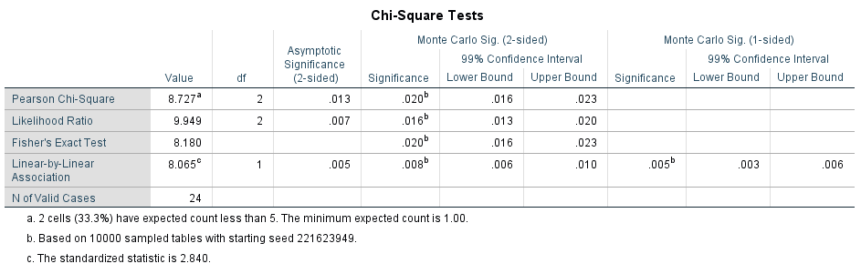
Table 1

bacterialgrowth * Gender Crosstabulation
 |  |  | Gender |  | Total
 |  |  | Male | Female | Total
bacterialgrowth | 1.00 | Count | 9 | 2 | 11
bacterialgrowth | 1.00 | % within bacterialgrowth | 81.8% | 18.2% | 100.0%
bacterialgrowth | 1.00 | % within Gender | 75.0% | 16.7% | 45.8%
bacterialgrowth | 2.00 | Count | 3 | 8 | 11
bacterialgrowth | 2.00 | % within bacterialgrowth | 27.3% | 72.7% | 100.0%
bacterialgrowth | 2.00 | % within Gender | 25.0% | 66.7% | 45.8%
bacterialgrowth | 3.00 | Count | 0 | 2 | 2
bacterialgrowth | 3.00 | % within bacterialgrowth | 0.0% | 100.0% | 100.0%
bacterialgrowth | 3.00 | % within Gender | 0.0% | 16.7% | 8.3%
Total |  | Count | 12 | 12 | 24
 |  | % within bacterialgrowth | 50.0% | 50.0% | 100.0%
 |  | % within Gender | 100.0% | 100.0% | 100.0%
Table 2.
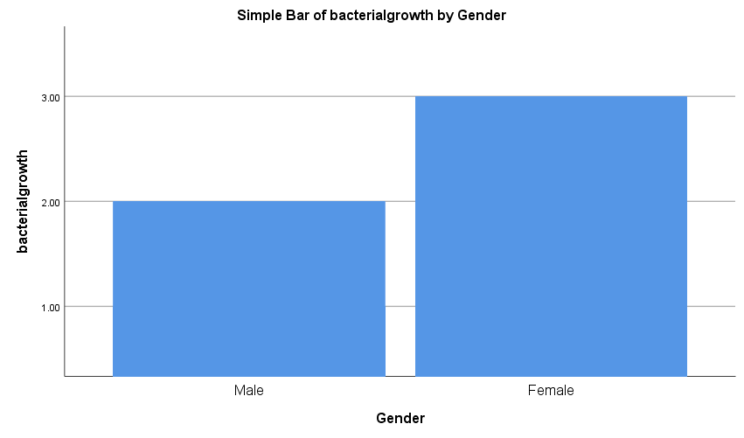
Figure 1

Table 2 reveals the P-value of asymptomatic bacterial growth in. both genders is (0.004).

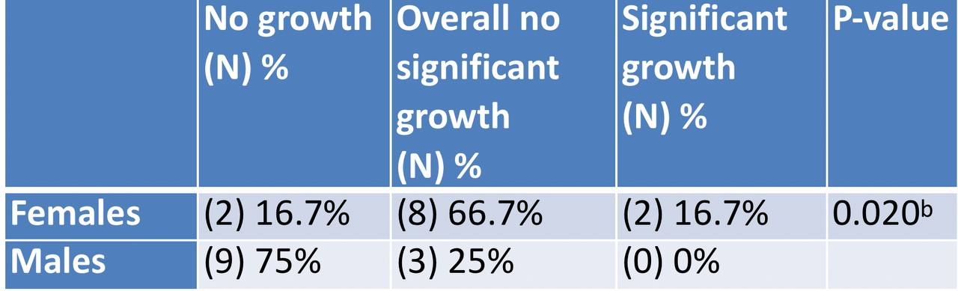
Taple3 ( The summary taple).

Asymptomatic bacteriuria is affected by the age, sexual identity, sexual behaviors(is very common in clinical practice), and the existence of urogenital inconsistencies, When women are in decent shape, the incidence of bacteriuria rises with age, from about 1% in girls aged 5 to 14 to more than 30% in community-dwelling women over the age of 80( as high as 40 to 50 percent after age 80).
and the incidence is 15 percent or greater in men age 65 to 80 (That is, the incidence of infection increases with age in both sexes, but at different rates).

4 Only three male samples have bacterial growth, compared to nine female samples, which is consistent with previous findings. This demonstrates a clear gender divide .
In male Prostate biopsies may occasionally be done through the urethra or perineum, but the most common approach used to both genders is through the rectum. The transrectal approach presents the possibility of additional infectious complications, e.g., ASB or UTI, prostatitis, bacteremia, and/or sepsis, following the procedure. Infection is caused by bacteria present in the rectum prior to the biopsy procedure that are seeded into the prostate, bladder, and/or bloodstream by the hollow-core biopsy needle that passes through the rectum into the prostate/bladder. Studies suggest that prebiopsy urine culture to screen for ASB is unnecessary, except perhaps in men with a history of UTI or urinary retention.
.According to another study conducted in the Asian country of Iran , The overall prevalence of ASB among pregnant women was 0.13 (95% CI: 0.09, 0.17) .The prevalence of ASB in the northern and southern regions of Iran was 0.13 (95% CI: 0.09, 0.18) and 0.11 (95% CI: 0.05, 0.16), respectively. According to the quality based on STROBE checklist, the included studies were divided into three categories: 1 study (5%) had high quality, 12 studies (60%) had intermediate quality, and 7 studies (35%) had low quality. The prevalence of ASB in intermediate quality studies (0.14; 95% CI: 0.08, 0.21) was higher than studies with low quality (0.10; 95% CI: 0.08, 0.13). According to date of study conduction, included studies were divided into two groups: studies conducted from 1996 to 2005 (40%) and studies conducted from 2006 to 2013 (60%)
The results of this meta-analysis showed 13% of pregnant women in Iran had ASB. Our results indicated the difference in prevalence of ASB according to the date of study conduction in Iran was not considerable. Prevalence in recent studies (13%) was slightly lower than older studies (14%). In addition, the prevalence of ASB in southern regions was lower than northern regions. However, the difference was not substantia .

Conclusion
Systematic treatment of asymptomatic bacteriuria is not recommended, and it is associated with a higher probability of the symptomatic UTI and a higher prevalence of antibiotic-resistant bacteria. But with some exceptions:
like a :
1/ pregnant patients :
treatment prevents preterm labor and pyelonephritis.
2/ Patients about to undergo a urologic procedure in which mucosal bleeding is expected
(not urinary catheter placement): treatment prevents urosepsis.
Improving the diagnosis of asymptomatic bacteriuria and optimizing the management of recurrent urinary tract infections, especially through non-antibiotic measures, are needed in order to minimise antimicrobial resistance.
The results of this report indicated the prevalence of Asymptomatic bacteriuria ASB among women is considerable, thus preventative planning and control of ASB among women is essential and extremely important globally .

References
- Ghafari M, Baigi V, Cheraghi Z, Doosti-Irani A. The Prevalence of Asymptomatic Bacteriuria in Iranian Pregnant Women: A Systematic Review and Meta-Analysis. Rosenfeld CS, ed. PLOS ONE. 2016;11(6):e0158031. doi:10.1371/journal.pone.0158031
- Shaikh N, Osio VA, Wessel CB, Jeong JH. Prevalence of Asymptomatic Bacteriuria in Children: A Meta-Analysis. The Journal of Pediatrics. 2020;217:110-117.e4. doi:10.1016/j.jpeds.2019.10.019

