


Libyan international medical university
Faculty of applied medical sciences

Asymptomatic Bacteriuria among LIMU’s students

Name : Mohammed Fathi
Student number : 3145

Abstract

Urine samples obtained from 24 students in 12 males and 12 females are taken to determine if there is a difference in rates between males and females. The results showed that females have higher risk and rates of developing UTI and ASB. which indicates the females specially who are pregnant showed follow the international ways to stay away from developing bacteria in their urinary system, which commonly is E.Coli. and the treatments should be given and followed to prevent the drug resistance

Introduction

Most of the time the urine is sterile with no growth of any bacterial organism in it, and in the presence of infection in the urinary tract system some bacteria may show growth. But recently the scientists figured there may be some growth of bacteria in the urine without having any symptoms which known as Asymptomatic bacteriuria (ASB) which is defined as the presence of two consecutive urine specimens yielding positive cultures (>105 CFU/mL) of the same uropathogen in a patient who is free of any infectious symptoms. It's still unknown why some people with ASB don't get symptoms, especially when the organisms found in their urine are often the same as those found in patients with symptomatic UTIs. In fact, the most prevalent bacteria obtained from these ASB individuals is E. coli. The reason behind this is unclear but the investigators said it most probably because E.Coli is less virulent and tends to form colonization rather than causing an infection. There are other causative agents such as P.aeruginosa and Proteus species, they can cause more serious infection and have greater complications. The prevalence of ASB is variable depending on the age and the gender primary with other factors which can influence the rates. It is documented that the females showed an increasing risk of having ASB that can triple the males cases, and the females infection may persist in more than 80% of females cases and may progress to symptomatic urinary tract infection or acute pyelonephritis. And the age also can affect the growth, in fact the percentage of children 7-10% can jump into 20% by the second and third decade and can reach 65-70% in the age +65. Also it occurs in 5–10% of all pregnancies. If it is left untreated, 20–30% of mothers will develop acute pyelonephritis. And ASB should be distinguished from acute UTI, which is a symptomatic bladder infection characterized by new-onset urinary frequency, urgency, dysuria, and/or suprapubic pain. In case of confirming the bacterial growth, antibiotics should be given immediately.

Method and materials

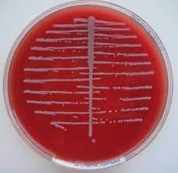
The sample must be taken by one of the following procedures ( suprapubic aspiration, sterile urine bag, catheterization or mid-stream sample ). After taking the sample it should be cultured on agar by using a wire-loop but first it must be sterilized by holding it above the flame of bunsen burner. Then the wire loop is inserted into the urine sample followed by wiping the agar in a zig-zag move with one straight line in the middle. Finally the agar is incubated for 24hrs then the growth can be observed as white circles, which should be measured to determine the severity of the growth. The agars must be McConkey or blood agar, because the most of the causative agents can grow in them. Then the agar must be incubated for 24hrs

Figure (1) shows bacterial growth on McConkey agar from urine sample

Result

The hypothesis we are testing is if the females have a higher risk of developing ASB than males.
From the 24 samples that have been tested in this experiment, we Reject the null hypothesis, Because there is a significant difference between male and female growth of the bacteria. And it was proven statistically.

Table (1) Case Processing Summary
 | Cases
 | Valid |  | Missing |  | Total
 | N | Percent | N | Percent | N | Percent
Gender * UTICATS | 24 | 100.0% | 0 | 0.0% | 24 | 100.0%

Table (2) Gender * UTICATS Cross-tabulation
 |  |  | UTICATS |  |  | Total
 |  |  | No growth | No significant growth | Significant growth | Total
Gender | Male | Count | 9 | 3 | 0 | 12
Gender | Male | Expected Count | 5.5 | 5.5 | 1.0 | 12.0
Gender | Male | % within Gender | 75.0% | 25.0% | 0.0% | 100.0%
Gender | Male | % within UTICATS | 81.8% | 27.3% | 0.0% | 50.0%
Gender | Female | Count | 2 | 8 | 2 | 12
Gender | Female | Expected Count | 5.5 | 5.5 | 1.0 | 12.0
Gender | Female | % within Gender | 16.7% | 66.7% | 16.7% | 100.0%
Gender | Female | % within UTICATS | 18.2% | 72.7% | 100.0% | 50.0%
Total |  | Count | 11 | 11 | 2 | 24
 |  | Expected Count | 11.0 | 11.0 | 2.0 | 24.0
 |  | % within Gender | 45.8% | 45.8% | 8.3% | 100.0%
 |  | % within UTICATS | 100.0% | 100.0% | 100.0% | 100.0%

Table (3) Chi-Square Tests
 |  | Value | df | Asymptotic Significance (2-sided) | Monte Carlo Sig. (2-sided) |  |  | Monte Carlo Sig. (1-sided)
 |  |  |  |  | Significance | 99% Confidence Interval |  | Significance | 99% Confidence Interval
 |  |  |  |  |  | Lower Bound | Upper Bound | Significance | Lower Bound | Upper Bound
 | Pearson Chi-Square | 8.727ª | 2 | .013 | .018^{b} | .014 | .021
 | Likelihood Ratio | 9.949 | 2 | .007 | .012^{b} | .009 | .015
 | Fisher's Exact Test | 8.180 |  |  | .018^{b} | .014 | .021
 | Linear-by-Linear Association | 8.065^{c} | 1 | .005 | .006^{b} | .004 | .008 | .002^{b} | .001 | .003
 | N of Valid Cases | 24
 | a. 2 cells (33.3%) have expected count less than 5. The minimum expected count is 1.00.
 | b. Based on 10000 sampled tables with starting seed 2000000.
 | c. The standardized statistic is 2.840.

Table (4) Summary table of fisher’s exact test
 |  | UTI colony forming units |  |  | p-value
 |  | No growth | No significant growth | Significant growth | 0.018
Gender | Male | 9 | 3 | 0 | 0.018
Gender | female | 2 | 8 | 2 | 0.018
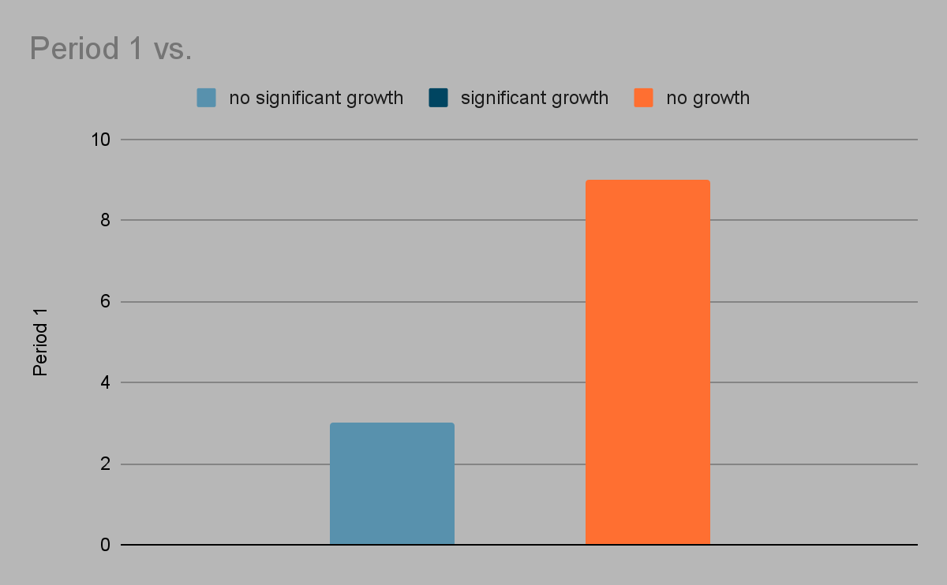

chart(1) shows male results.
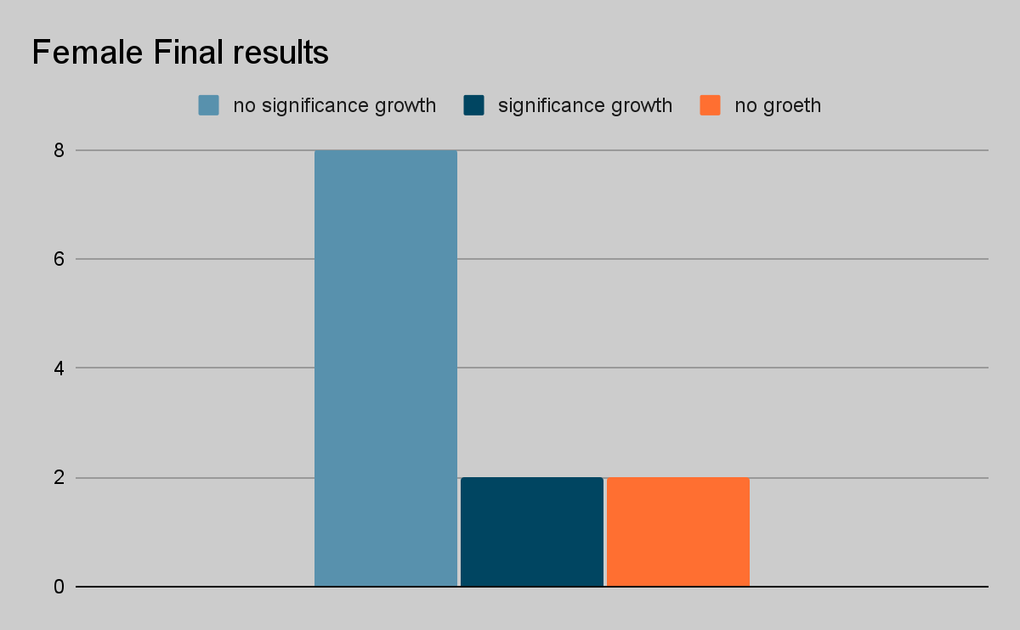

chart(2) shows female results.

Discussion

After evaluating the statistical section, the P-value result was = 0.018, which was more significant than 0.05, indicating that there is a link between the statistical section and the laboratory experiment, indicating that females are more likely than males to have asymptomatic bacteriuria.

The result from this test shows that the females have higher risk of developing urinary tract infection and asymptomatic bacteriuria than males. Which can be agreed on with many studies that have been made.⁽⁵⁾

In comparison to another study that included 82 people that has been made to estimate the difference between the males and females rates it showed nearly the same results as in our experiment. It showed that the females have higher rates than males in different ages and in different situations.⁽⁵⁾

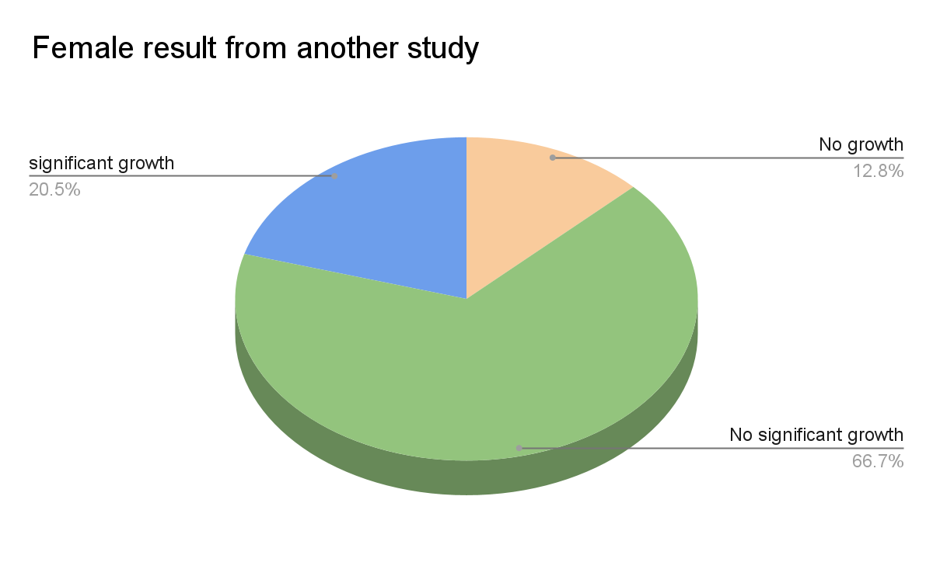

chart(3) shows female results from a compared study

The difference in the rates in the males and females is due to different factors
Such as
1- anatomical difference between males and females : the females has very short urethra compared to the male and lacks the secretions from the prostate that has a defensive mechanism, also because the placement of the urethra is close to the anal that makes it easier for the bacteria to cause the infections⁽¹⁻⁶⁾
2- pregnancy/menopause : both of them has role in the increase incidense of the ASB in the females^{(1,2)}
3- sexuall contact : this depends on the anatomical position of the vagina that is located near the urethra. ⁽⁶⁾

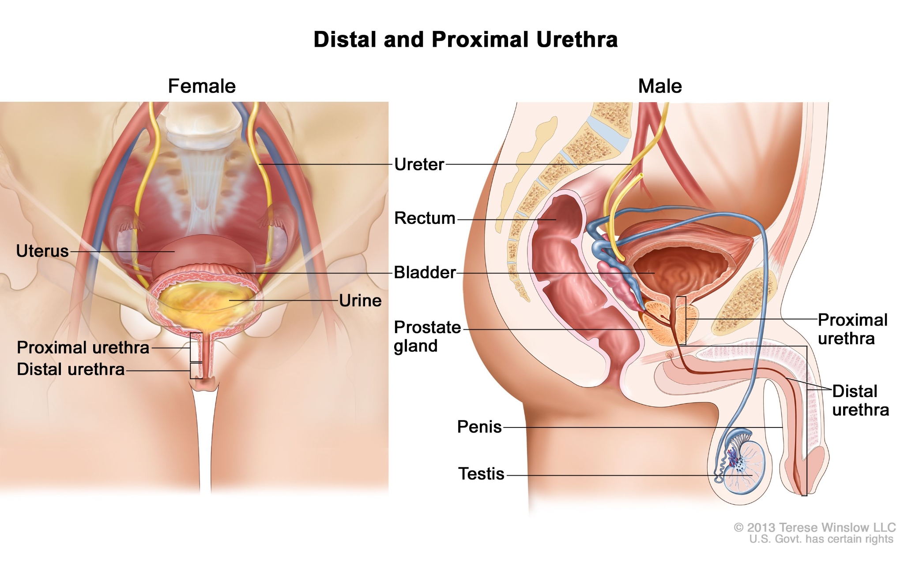

picture(2) shows the difference between the male and females urethra

Also among the females there is a difference in rates, such as in pregnancy. Because pregnant women account for 10% of all UTI cases. And the women have a 28% chance to develop ASB in their pregnancy period.⁽²⁻⁵⁾ which can last for a long time and progress to UTI and pyelonephritis or cystitis. also the bacterial infection can be transmitted to the child during delivery through the if there was any contact between the baby and the mom’s urethra.⁽⁴⁾

Because ASB is common among women the treatment should be started immediately after confirming the presence of the bacteria in the urine by most commonly cephalosporin or ceftriaxone.^{(2,3)}

Also the antimicrobial resistance has been reported in some cases of ASB. most of these cases was in poor or developing countries that the patients cannot afford the coast of the antibiotic or they doesn't know the consequence of not following the treatment⁽¹⁾

Conclusion

From this we conclude that the asymptomatic bacteriuria has become more common among the different societies. that showed an increase in the incidence by age and it can be said to be gender dependent, because the females are having higher risk to develop ASB than males. And also it is considered to be age dependent infection because the increase in the age is followed by increasing the incidence of ASB. The infection is most often caused by E.Coli followed by P.aureigenosa and S.aureus. And the treatment should be started and given depending on the microbial resistance to the antibiotics.

References

- Givler D, Givler A. Asymptomatic Bacteriuria. Ncbi.nlm.nih.gov. https://www.ncbi.nlm.nih.gov/books/NBK441848/. Published 2022. Accessed June 3, 2022.
- Hooton TM, Roberts PL, Stapleton AE. Asymptomatic Bacteriuria and Pyuria in Premenopausal Women. Clin Infect Dis 2021; 72:1332.
- Kass EH. The role of asymptomatic bacteriuria in the pathogenesis of pyelonephritis. In: Biology of Pyelonephritis, Quinn EL, Kass EH (Eds), Little, Brown, Boston 1960. p.399.
- Roos V, Nielsen EM, Klemm P. Asymptomatic bacteriuria Escherichia coli strains: adhesins, growth and competition. FEMS Microbiol Lett 2006; 262:22.
- KASS EH. Asymptomatic infections of the urinary tract. Trans Assoc Am Physicians 1956; 69:56.
- Bettcher C, Campbell E, Petty L et al. Urinary Tract Infection. Ncbi.nlm.nih.gov. https://www.ncbi.nlm.nih.gov/books/NBK572335/. Published 2022. Accessed June 9, 2022.
- Sinawe H, Casadesus D. Urine Culture. Ncbi.nlm.nih.gov. https://www.ncbi.nlm.nih.gov/books/NBK557569/?report=classic. Published 2022. Accessed June 20, 2022.

