
Libyan International
Medical University

Report

By: 3rd year medical science
Supervisor: Eman Elfirjani

assisted by: Abdulmohaimen Faraj
student number : 3090

Date of submission: 20/6/2022

Prevalence of asymptomatic bacteriuria

Abstract:
Asymptomatic bacteriuria (ASB) is the presence of bacteria in a urine specimen received from a patient who does not have symptoms of a urinary tract infection,24 specimens collected from LIMU student's males and females to investigate the relationship between the gender and the prevalence rate of ASB. The collection performed by midstream catch urine specimen method, diagnosis based on colony-forming units (CFUs) per ml of urine. The result of using a FISHER test on SPSS program shows the P value equal 0.018 which is mean there is prevalence rate of ASB and the females.

Introduction:
Asymptomatic bacteriuria (ASB) is characterized by the presence of bacteria in a urine specimen received from a patient who does not have symptoms of a urinary tract infection, with a presentation of 10⁵ CFU/ml of one or more specie, also some investigators defined (ASB) colonization of the specie irrespective of pyuria which means that there is no host immune response to corporate the symptoms. Hence, the presence of pyuria is not sufficient to confirm bacteriuria. Although there have been studies that extrapolate ASB from the presence of pyuria in urine specimens, current guidelines do not include pyuria detection and only require quantitative urine culture for diagnosis. The used criteria, in men one voided urine specimen matched ≥10⁵ CFU/ml defined ASB. In women (including pregnant) two consecutive voided urine specimens should be obtained, ideally within 2 weeks, with the recovery of the same species at levels of ≥10⁵ CFU/ml to meet the criteria for ASB. In clinical practice, asymptomatic bacteriuria is fairly prevalent, and its prevalence rises with age. In women and men aged 65 to 80 years, the incidence is 15% or more, and it can reach 40% to 50% beyond that. In previous data, asymptomatic bacteriuria is found in 2.7% of women aged between 15 and 24 years and increases to 20% to 50% in women older than age 80.⁶In men, the prevalence of asymptomatic bacteriuria is considerably lower but increases from 6% to 20% older than age 80. The purpose of this experiment is to see if there is a difference in the prevalence of asymptomatic bacteriuria between male and female. the expectation is female will have a higher prevalence than male. in. addition the static software that was used is the SPSS. Topics covered in most of the available literature are treatment and management of asymptomatic bacteriuria and antibiotic use, an area where opinions remain.For example, Nicole E. Lindsay states that clinical trials have consistently proved that there is no benefit in the use of antibiotics in the treatment of asymptomatic bacteriuria for spinal injury patients, diabetic women, and elderly nursing home residents.4 On the other hand, Bela Koves et al. stated that the treatment of asymptomatic bacteriuria in pregnant women is beneficial in decreasing the risk of urinary tract infections and low birth weight.

Method:
The samples were collected from different student in LIMU 12 male and 12 female, Urine collection was performed by midstream clean-up, catheterization of the urethra (CATH), tube aspiration, or a sterile urine bag. several hours, the procedure begins with mixing the urine and using a sterile calibrated metal ring, insert the ring vertically to ensure that the sample has been collected, the next method is to spread the sample slowly and gently by drawing a ring in the center of the agar plate up and down, then trace with the same loop holding the sample horizontally in a wavy pattern to ensure that all of the sample has adhered to the agar plate after the sample has been incubated for 24 hours at 37 C, the colonies were counted on the plate agar. The medium selected in this experiment was 5% sheep blood agar, CLED and MacKonkey agar plates that allow the detection of most Gram-negative bacilli, staphylococci, streptococci and enterococci. After all, Colonies were counted after the end of incubation to detect significant growth. Count values collected in the laboratory were entered into SPSS software for analysis. This analysis was performed using a chi-square test to compare the sexes for the presence of bacteriuria and to assess significance.

Result:
To determine that substantial bacteriuria is present, a bacterial count of CFU should be at least 100,000/mL is required to conform positive media by using (in asymptomatic persons) by using med-stream-catch.

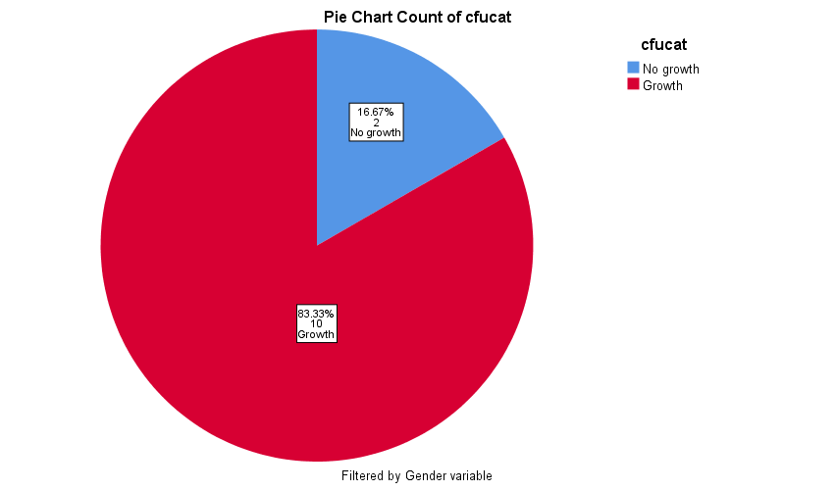

Graph 1 shows the different categories of bacterial growth in females

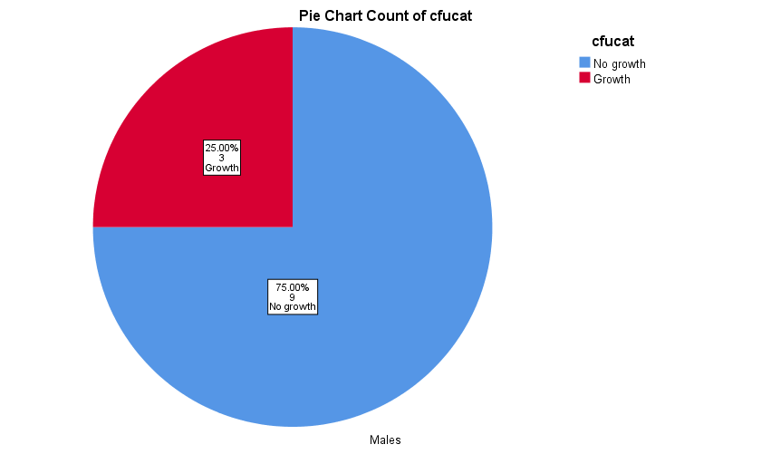
Graph 2 shows the different categories of bacterial growth in males
 | No growth | Growth | P value
Males | 9 (81.8%) | (23.1%) 3
Female | 2 (18.8%) | 10(76.9%) | 0.018

Table 1 shows the growth and non-growth of bacteria in female is higher than male and the P value

Discussion:

After considering the statistical part, the result of the P-value is 0.018 which has shown in table one, which is significant, which confirms that there is a relationship between the statistical part and the laboratory experiment showing that There is a very significant growth of asymptomatic bacteriuria. In females rather than males, the previous study was compared with another reliable study investigating the etiology and epidemiology of this infection. The result of the overall difference between men and women may also be due to differences in urethral anatomy, where females are shorter than males. Its differentiation allows the bacteria to travel less distances to reach the bladder. Besides the difference in length, there are other factors in the urethra of women compared to men that reduce the risk of UTIs, such as the germ-killing zinc secreted by the male prostate gland. Asymptomatic bacteriuria is also particularly common in long-term care facilities with a reported prevalence of 25%-50% in the residents. Infection organisms are varied, as they are in urinary tract infections. Escherichia coli is the most common bacterium involved with asymptomatic bacteriuria. Enterobacteriaceae, Pseudomonas aeruginosa, Enterococcus species, and group B streptococcus are among the others. It is also important to note that organisms isolated from individuals with asymptomatic bacteriuria are impacted by the patients' circumstances. E. coli is more likely to be found in healthy people than in people with comorbidities like diabetes. The expected hypothesis was the prevalence rate of asymptomatic bacteriuria is higher in females than male and it is confirmed by P value shown in table 1.
SPSS software is used and the Chi square test used in the begging but we faced problem so it's changed to Fisher's test. the P value was 0.018 which is proved that there is a significant incidence rate of bacterial growth.
Asymptomatic bacteriuria is also particularly common in long-term care facilities with a reported prevalence of 25%-50% in the residents. Infection organisms are varied, as they are in urinary tract infections. Escherichia coli is the most common bacterium involved with asymptomatic bacteriuria. Enterobacteriaceae, Pseudomonas aeruginosa, Enterococcus species, and group B streptococcus are among the others. It is also important to note that organisms isolated from individuals with asymptomatic bacteriuria are impacted by the patients' circumstances. E. coli is more likely to be found in healthy people than in people with comorbidities like diabetes.

Conclusion

Asymptomatic bacteriuria is common finding among both genders, but in females is higher due to many risk factors and one of them is the shortening of the female urethra and the opening of the urethra is close to the anus, which is the opening of the colon where is one of the normal flora is the most common cause of UTIs which is E.coli. After the collected samples and the MacConkey agar used as the culture media and by using the fisher test, we assumed that there is a significant incidence rate of growth of asymptomatic bacteriuria in females.

References
- NCBI Bookshelf [Internet]. [cited 2022Aug20]. Available from: https://www.ncbi.nlm.nih.gov/books/NBK441848/
- National Center for Biotechnology Information [Internet]. [cited 2022Aug20]. Available from: https://www.ncbi.nlm.nih.gov/books/NBK441848/
- Levinson, Warren. Review of medical microbiology and immunology. 13rd ed. The McGraw-Hill Companies, 2014

