


Libyan international medical university
Faculty of applied medical sciences

Asymptomatic Bacteriuria

Name : Manar Adel

Student number : 2987

Abstract

Urinary tract infection is one of the most common types of infection worldwide, but we are focusing and studying the development of a positive bacterial growth, in the patients without having any signs of infection which is known as asymptomatic bacteriuria.⁽¹⁾ most common cause is E.Coli.⁽⁶⁾ In this study 24 samples were divided to 12 males and 12 females to observe the bacterial growth.about 75% of the males showed no growth and 25% showed minor growth. In costract the female ratio was higher, about 16.7% had high growth, about 66.7% with low growth and only 16.7% were sterile. This difference in ratios happens due to the difference in the anatomical structure between the two genders.

Introduction

Asymptomatic bacteriuria is the discovery of bacteria in a obtained urine sample. or when urine cultures have at least 105 colony-forming units per millimeter (cfu/ml) of.^{(1,3)} from a person who has no symptoms of a urinary tract illness. Nowadays it has become more common in clinical trials. Even the A definitive etiology for asymptomatic bacteriuria has yet to be discovered. But in most of the trials the bacteria which has been found in the culture is E.coli.⁽⁶⁾ which makes this subject more important because it is part of the normal flora of the gastrointestinal tract. This is one of the reasons why the Infants and children are rarely affected, because the normal flora is not well established.⁽⁵⁾ but the prevalence climbs with age, reaching 40% to 50% beyond the age of 65. while the rate is up by 15% in women.^{(2,4)} This is most probably due to the women's urethras being shorter. In fact, most women experience temporary bacteriuria after sexual contact, but only a small percentage of these women will develop symptomatic infections since the body's natural defense mechanisms usually prevent symptomatic infection. Thus, the bacteria from the urethral meatus and the perineum travel a shorter distance to the bladder.⁽³⁾ although, most patients will never develop symptoms in the time they have the bacteria in their urinary tract system. and Most individuals with asymptomatic bacteriuria will never get symptoms. and asymptomatic bacteriuria will have no major implications. in all probability, most women experience temporary bacteriuria after sexual contact, but only a small percentage of these women will develop symptomatic.^{(5,6)} infections since the body's natural defense mechanisms usually prevent symptomatic infection. Incomplete bladder emptying is thought to play a major role in the increased frequency of asymptomatic bacteriuria in the elderly. Finally, the majority of infant cases have been attributed to incomplete urinary system formation or function.

Method and materials

First of all, the urine sample must be taken from the patient. The common way is to take it from the mid-stream urine.⁽³⁾ However, the gold standard is syringe aspiration of urine from the bladder, which reduces the possibility of contamination and incorrect results.
When the sample is taken now, it can be cultured to see the growth of the bacteria if found.^{(2,3)} The procedure is done by taking a sterile wire loop. If it's not sterile, the sterilization is done by putting the head of the loop on fire for a few seconds.⁽³⁾ The head of the loop is then dipped into the urine sample. and it wiped on the agar. Finally, the agar must be incubated for 24 hours. After the incubation time is done, we observe if there is a growth of the bacteria. We measure the growth by colony forming units (CFU). The normal range is 10000 CFU/ml and if there is more than 100000 CFU/ml, the culture could be considered as positive for the bacteria.⁽²⁻⁵⁾ The final result can be seen as in the picture, which shows small colonies of the bacteria in the white small circles.
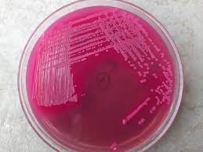

Figure (1) shows E.coli growth on McConkey agar
Result

from the 24 samples that have been tested in this experiment, we can observe that.
- Rejection of the null hypothesis
- There is a significant difference between males and females growth of the bacteria.
Table (1) Gender * UTICATS Cross-tabulation
 |  |  | UTICATS |  |  | Total
 |  |  | No growth | No significant growth | Significant growth | Total
Gender | Male | Count | 9 | 3 | 0 | 12
Gender | Male | Expected Count | 5.5 | 5.5 | 1.0 | 12.0
Gender | Male | % within Gender | 75.0% | 25.0% | 0.0% | 100.0%
Gender | Male | % within UTICATS | 81.8% | 27.3% | 0.0% | 50.0%
Gender | Female | Count | 2 | 8 | 2 | 12
Gender | Female | Expected Count | 5.5 | 5.5 | 1.0 | 12.0
Gender | Female | % within Gender | 16.7% | 66.7% | 16.7% | 100.0%
Gender | Female | % within UTICATS | 18.2% | 72.7% | 100.0% | 50.0%
Total |  | Count | 11 | 11 | 2 | 24
 |  | Expected Count | 11.0 | 11.0 | 2.0 | 24.0
 |  | % within Gender | 45.8% | 45.8% | 8.3% | 100.0%
 |  | % within UTICATS | 100.0% | 100.0% | 100.0% | 100.0%

Chi-Square Tests
 |  | Value | df | Asymptotic Significance (2-sided) | Monte Carlo Sig. (2-sided) |  |  | Monte Carlo Sig. (1-sided)
 |  |  |  |  | Significance | 99% Confidence Interval |  | Significance | 99% Confidence Interval
 |  |  |  |  |  | Lower Bound | Upper Bound | Significance | Lower Bound | Upper Bound
 | Pearson Chi-Square | 8.727ª | 2 | .013 | .018^{b} | .014 | .021
 | Likelihood Ratio | 9.949 | 2 | .007 | .012^{b} | .009 | .015
 | Fisher's Exact Test | 8.180 |  |  | .018^{b} | .014 | .021
 | Linear-by-Linear Association | 8.065^{c} | 1 | .005 | .006^{b} | .004 | .008 | .002^{b} | .001 | .003
 | N of Valid Cases | 24
 | a. 2 cells (33.3%) have expected count less than 5. The minimum expected count is 1.00.
 | b. Based on 10000 sampled tables with starting seed 2000000.
 | c. The standardized statistic is 2.840.

The result shows about 9 of the tested males have no growth, and only 2 females had no growth which statistically has a huge difference. And only about 3 males are said to have only little growth, not significant. And no males have shown significant growth, but 2 females have shown significant growth. this also shows there is an overall difference in the results of the study depending on the gender
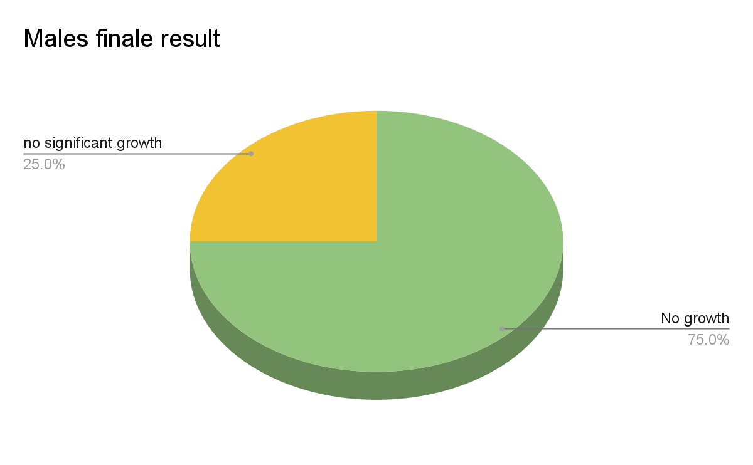

chart(1) shows male results.
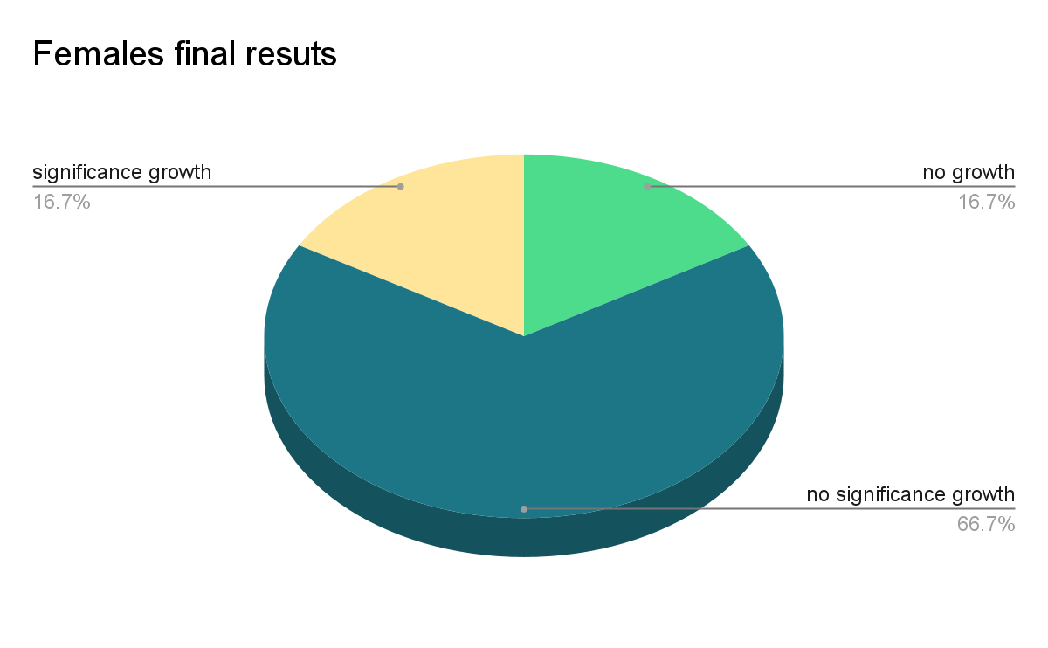

chart(2) shows female results.

Discussion

The urinary tract infection (UTI) has become more common in the last 30 years. and many studies have been made to evaluate the epidemiology and the prevalence of the total infections. Among the studies that have been made they found a new category of the patients. those who have bacterial growth in their urine without having any signs of infection. Those are said to have asymptomatic baceriureia (ASB). which is defined as the presence of bacteria in the urine without any signs or symptoms of infection. The Diagnosis of asymptomatic bacteriuria in the studies is made by urine culture. Either a properly collected clean-catch specimen or a catheterized specimen is acceptable Among these studies they found that the most common cause of asymptomatic bacteriuria (ASB) is E.Coli which is characterized by colonization of the urinary system rather than infection. followed by other organisms such P.aeruginosa and S.aureus that have been said to be less common in causing the infection than E.Coli. In this experiment the volunteers are in mid age, which has the lowest rates of developing or growing bacteria in the urinary system. although some of the samples have shown a significant growth of the bacteria which indicates that they have (ASB). The results show predominantly the female gender in the growth of the bacteria by approximately 8.3% of all the males and females together. And about 16.7% of the females only which is in compare to another study that have been made among 83 patients which include 39 males and 44 females the results shown a similarity compare to the study we’ve made, and the results has shown about 8 cultures with significant growth (9.6%) and they are all females that counts nearly (20.5%), the followings graphs will illustrate the numbers and results

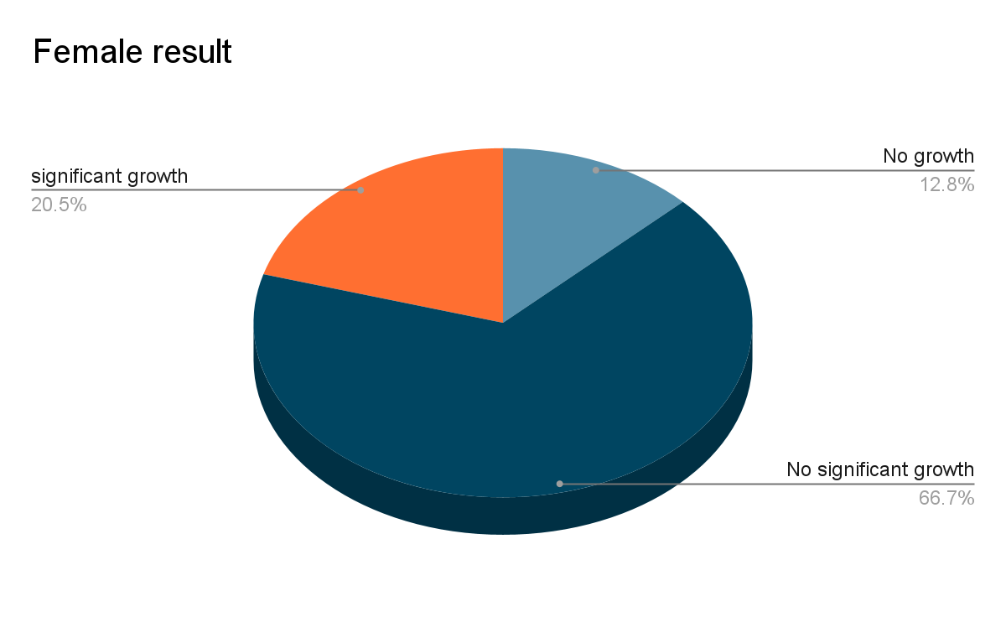

chart(3) shows female results from a compared study

The difference in the rates in the males and females is dependent on different factors
Such as
1- anatomical difference between males and females : the females has very short urethra compared to the male and lacks the secretions from the prostate that has a defensive mechanism, also because the placement of the urethra is close to the anal that makes it easier for the bacteria to cause the infections⁽¹⁻⁶⁾
2- pregnancy/menopause : both of them has role in the increase incidense of the ASB in the females^{(1,2)}
3- sexuall contact : this depends on the anatomical position of the vagina that is located near the urethra. ⁽⁶⁾

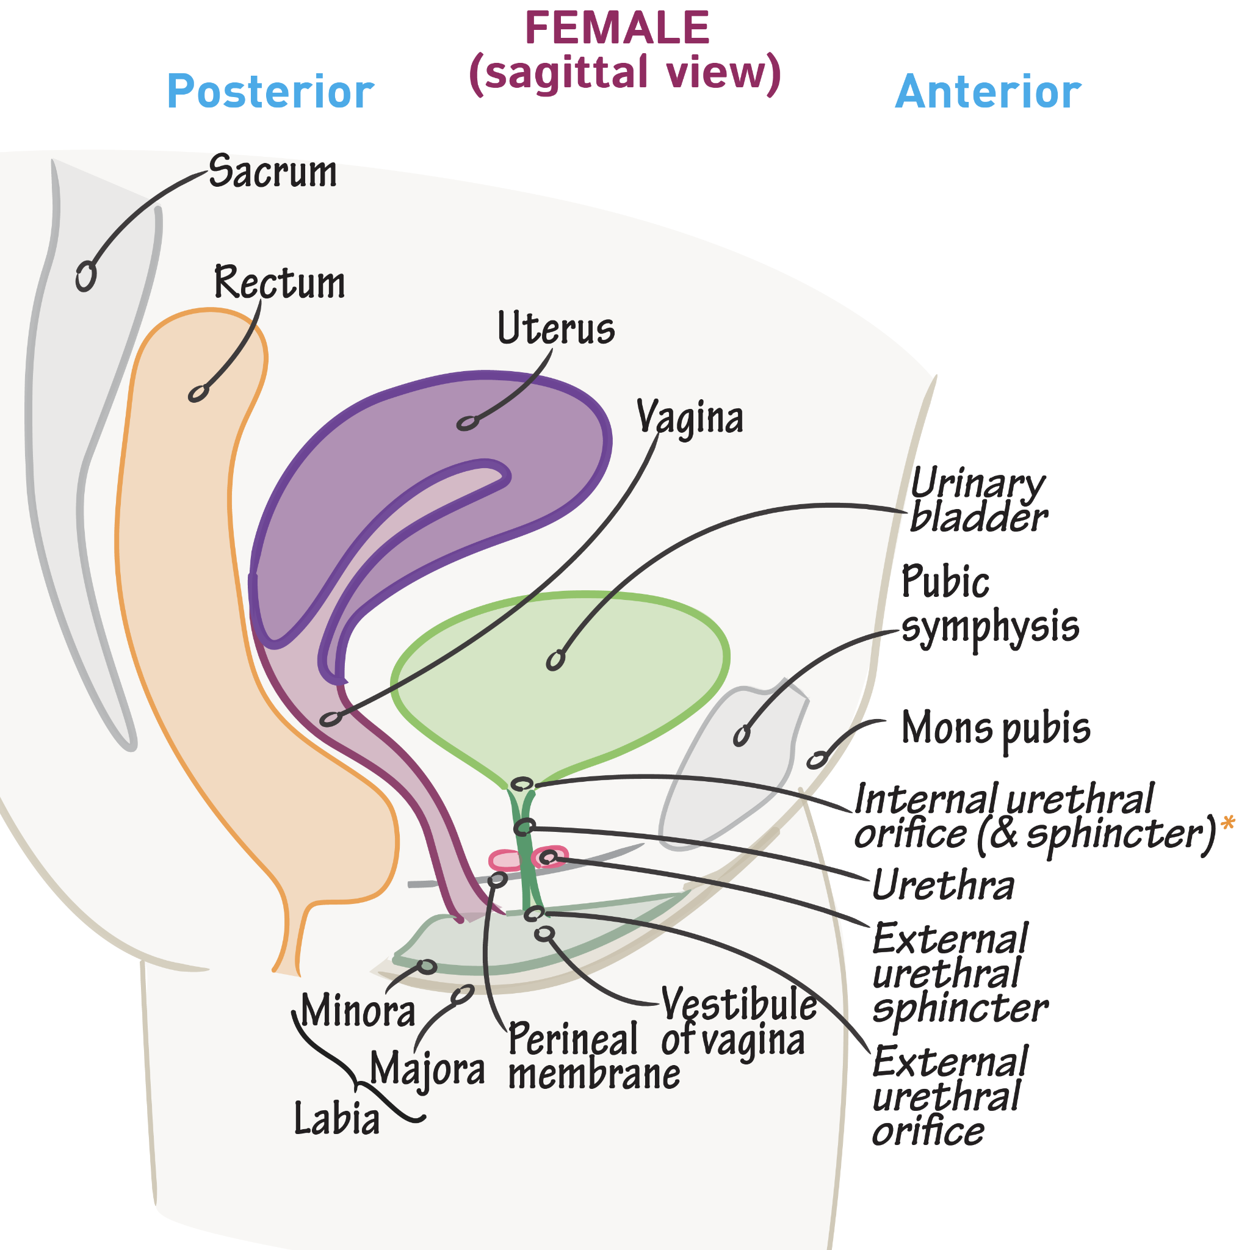

picture(2) shows the anatomical position of female urethra

Conclusion

From this we conclude that the asymptomatic bacteriuria has become more common among the different societies. that showed an increase in the incidence by age and it can be said to be gender dependent, because the females are having higher risk to develop ASB than males. And also it is considered to be age dependent infection because the increase in the age is followed by increasing the incidence of ASB. The infection is most often caused by E.Coli followed by P.aureigenosa and S.aureus. And the treatment should be started and given depending on the microbial resistance to the antibiotics.

References

- Givler D, Givler A. Asymptomatic Bacteriuria. Ncbi.nlm.nih.gov. https://www.ncbi.nlm.nih.gov/books/NBK441848/. Published 2022. Accessed June 3, 2022.
- Hooton TM, Roberts PL, Stapleton AE. Asymptomatic Bacteriuria and Pyuria in Premenopausal Women. Clin Infect Dis 2021; 72:1332.
- Kass EH. The role of asymptomatic bacteriuria in the pathogenesis of pyelonephritis. In: Biology of Pyelonephritis, Quinn EL, Kass EH (Eds), Little, Brown, Boston 1960. p.399.
- Roos V, Nielsen EM, Klemm P. Asymptomatic bacteriuria Escherichia coli strains: adhesins, growth and competition. FEMS Microbiol Lett 2006; 262:22.
- KASS EH. Asymptomatic infections of the urinary tract. Trans Assoc Am Physicians 1956; 69:56.
- COLGAN R, NICOLLE L, MCGLONE A, HOOTON T. Asymptomatic Bacteriuria in Adults. Aafp.org. https://www.aafp.org/pubs/afp/issues/2006/0915/p985.html. Published 2022. Accessed May 28, 2022.

