Libyan International Medical University

Faculty of Basic Medical Science

Year 2 med / PTS)

Student name: Ahmed Al_mabrouk mereez

Student No: 2519
Supervisor name: Naji Alhomry

ABSTRACT

The purpose of this study was to investigate the prevalence of asymptomatic bacteriuria among Libyan International Medical University (LIMU) students, Urine samples were collected from 12 males and 12 females, The materials were grown on blood agar and MacConkey agar. significant Growth was observed in 8.33 % of the samples while there was no significant growth in 45% of the samples and no growth about 45% , The majority of people with asymptomatic bacteriuria will never develop symptomatic urinary tract infections, and asymptomatic bacteriuria will have no deleterious effects, The most prevalent species identified from individuals with asymptomatic bacteriuria are Escherichia coli and gram-negative bacilli.

Introduction

Asymptomatic bacteriuria is characterized as a high bacterial count in the urine of a person who does not have symptoms of urinary tract infections Urine cultures were considered positive if they showed growth of one or multiple species in concentrations of ( ≥10⁵ CFU/ml) in clinical practice, asymptomatic bacteriuria is fairly prevalent The incidence is 15% or higher in women and men aged 65 to 80 years, and it can reach 40% to 50% after the age of 80, There is enough evidence to recommend that a pregnant woman with asymptomatic bacteriuria be treated, Also Patients having urologic procedures that are likely to cause mucosal bleeding, as well as those in the first three months after receiving a kidney transplant based from an article published in The Canadian Journal of Urology: CJU (Can J Urol ) Concerning the research A previous set of guidelines from the Infectious Diseases Society of America (IDSA) for the management of asymptomatic bacteriuria (ASB) and uncomplicated urinary tract infections (UTIs) in women were issued. The most frequent isolated organism is Escherichia coli, but any number of other species can be found, Bacteriuria can be acute or chronic, ranging from days to years and involve the same or various species. , should be treated for asymptomatic bacteriuria. And asymptomatic bacteriuria will. Bacteriuria can go away on its own or as a result of antimicrobial medication given for any reason. Recurrent bacteriuria is common. Bacteriuria has been linked to negative results in a few well-studied groups, where screening and treatment of bacteriuria avoids negative consequences. The key clinical question is; which individuals with asymptomatic bacteriuria benefit from treatment? And the answer is that most patients with asymptomatic bacteriuria do not benefit from therapy, as this study will explain and detail, Imipenem was the only medicine that had an effect or was sensitive.

Material and Methods

The research population included 24 Libyan International Medical University (LIMU) students from Benghazi, Libya. We studied urine samples from each participant and discovered and isolated three bacteria implicated in UTIs, namely (E.coli, citrobacter, and Enterobacter) saprophytic, which were then submitted to antibiotic susceptibility testing to determine the isolates' sensitivity and resistance profile. Participants were questioned about their health condition and given permission to participate. Following sample collection, each item was analyzed to detect color, curd, and foaming. Urine culture is then used to detect bacteria or other microorganisms in a urine sample. The specimen is well mixed first, then a drop from the specimen is looped onto a sheep agar plate and allowed to dry, numerous lines are made in a zigzag pattern inside the agar, and it is finally placed in the incubator for 24 hours. The next stage is to count the colonies; each colony is multiplied by 1000 (10⁴), and considerable growth is proven if there are more than 50000 (10⁵) colonies. The gram stain is then applied to the sample by delicately dipping the bacterium colony to avoid the dissemination of too many germs. Allowing it to dry before passing it three times into the flame, one second between each pass. After adding a few drops of crystal violet stain, let the slide to dry for 1 minute before dipping it three times in water. Following that, we add several drops of iodine, followed by alcohol washing and, finally, safranin addition, after repeating the methods employed earlier with crystal violet. Allow the sample to dry before studying it under a microscope.

Antimicrobial susceptibility test

was performed using antibiotic discs comprising (trimethoprim)-(sulfamethoxazole), (ciprofloxacin), and (levofloxacin), (nitrofurantoin), (Imipenem ). A loopful of each isolate's standardized overnight culture was deposited on Mueller-Hinton agar prepared according to the manufacturer's instructions. The agar was incubated inverted at 37°C for 24 hours. The diameter of the zone of inhibition was measured in millimeters using a well-calibrated measuring ruler..

Result
We discovered in own lab report no growth in the most blood agar after 24 hours and about (9) colony cultures on MacConkey's and (2) colony Significant growth modest growth in female clutter (Table 1), Colony CFUs are multiplied by 100 or 1000 depending on what loop you used to measure the number of germs per ml in the initial material. , The total number of organisms (colonies) is determined, and the amount of live bacteria in the urine sample is expressed in colony forming units per liter (CFU/L). , UTI is usually defined as a bacteria count >10⁸ CFU/L from a midstream urine sample but in Asymptomatic bacteriuria. Count s about (10⁵ CFU/L)
So a cultures on blood agar show no growth, and a urine culture with MacConkey's less growth About (2) culture and pink colonies lactose fragmental maybe (E.coli, citrobacter. Enterobacter) calculate the CFU/ L = 9 ×100 = 900 CFU/L is declared negative. & own result growth maybe Normal Flora because sparse, staphylococci, corynebacteria, enterics normal flora on anterior urethra.
On Mueller-Hinton agar in Antimicrobial susceptibility testing The result showing bacteria highly resistance, not sensitive except one antibiotic (Imipenem ) have less sensitive but acceptable
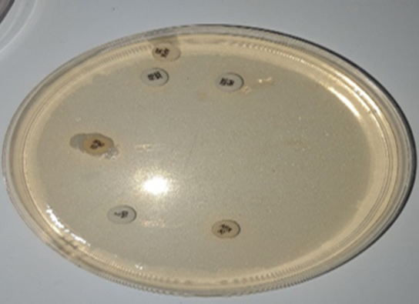
1: The impact of gender variations on the incidence and occurrence of asymptomatic bacteriuria
 | No growth | Overall no significant growth | Significant growth
Males | 9 | 3 | 0
Females | 2 | 8 | 2
The statistical study showing

Table 2 shows the relationship between bacterial growth and gender.

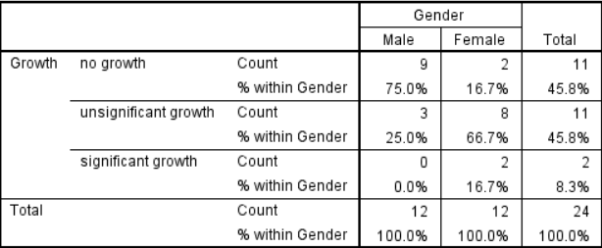

Table 3: Chi - Square Test (p - value is represented by Asymp. Sig. (2 - sided))

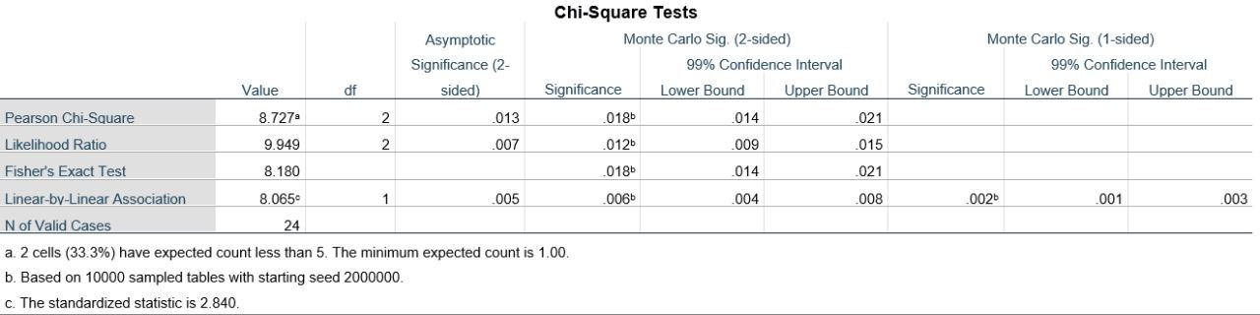

a. cells (33.3%) have expected count less 5. The minimum count is 1.00. b. Based on 1000 sampled tables with starting seed 2000000. c. the standardized statistic is 2.840.

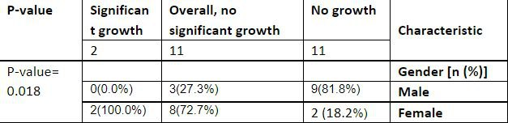
- A p-value less than 0.05 (typically ≤ 0.05) is statistically significant. ...
- A p-value higher than 0.05 (> 0.05) is not statistically significant and indicates strong evidence for the null hypothesis.

The result 0.018 so Under typical conditions, a p-value of less than 0.01 indicates that there is considerable evidence against the null hypothesis. So we reject the reject the null hypothesis and we accept the alternative hypothesis.

Discussion

Bacteriuria has been reported to be preceded by colonization by the particular type of bacteria that causes Urinary Tract infection. Bacteria in such asymptomatic bacteriuria are known to significantly enhance the spread of multi-drug resistant pathogens. Various microorganisms are known to infect and cause bacteriuria. The incidence of asymptomatic bacteriuria in the research. Asymptomatic bacteriuria does not cause symptomatic urinary tract infections in the majority of individuals and has no negative repercussions. Antibiotic therapy for asymptomatic bacteriuria does not help children, diabetic patients, the elderly, patients with spinal cord injuries, or patients with indwelling urinary catheters. Treatment does not increase survival or reduce the prevalence of symptomatic urinary tract infections in these individuals. However, it raises the risk of antibiotic-related side effects and the development of antibiotic-resistant microorganisms, the microorganisms in this study (E.coli, citrobacter. Enterobacter) are highly resistant to the most antibiotic expert (Imipenem) less sensitive. And in this study, the difference in the incidence of asymptomatic bacteriuria between males and females has a significant P-value since it is less than one (0.05). As a result, females experience much more asymptomatic bacteriuria than males. The null hypothesis is rejected since the P-value is less than (0.05). Females are also more susceptible to urinary tract infections and asymptomatic bacteriuria due to the anatomical structure of their reproductive system.

Conclusion:

The outcomes of this study have underlined the need of include testing of asymptomatic bacteriuria as part of the medical checkup for students. More research on the incidence of bacteriuria, infecting organisms, and risk factors is required. Urine culture is used to diagnose asymptomatic bacteriuria. A clean-catch specimen obtained appropriately or a catheterized specimen are both acceptable. The Infectious Diseases Society of America (IDSA) has developed diagnostic criteria for asymptomatic bacteriuria. And E. coli is the most prevalent causal agent since it is part of the natural flora of the colon. More study is needed to determine whether there is a link between bacteriuria and age. Imipenem best antibacterial activity against the study isolates. The high level of resistance of isolates to antibiotics was found among commonly used oral antibiotics, Females have a much greater frequency of asymptomatic bacteriuria than males.

References

1-Asymptomatic Bacteriuria is Harmless and Even Protective: Don't Treat if You Don't Have a Very Specific Reason

2-Recommendations on screening for asymptomatic bacteriuria in pregnancy

3-Asymptomatic Bacteriuria in Women With Diabetes Mellitus: Effect on Renal Function After 6 Years of Follow-up

4-Interventions during pregnancy to prevent preterm birth: An overview of Cochrane systematic reviews

5-What a p-value Tells You About Statistical significanc

6-Assessment of practices in screening and treating women with bacteriuria

7-Asymptomatic Bacteriuria

8-Current controversies in urinary tract infections: ICI-RS 2017

9-MacConkey Agar- Composition, Principle, Uses, Preparation and Colony Morphology

