The prevalence of asymptomatic bacteriuria among different genders

Name: Asma Essa Elshaafi
Student number: 2811

Libyan international medical university
Faculty of applied medical science
Course: Professional and transferable skills
2021-2022

Lab report supervisor: Dr. Intisar Alnagi
Assistant by: Ms. Asma Elkwafi

Abstract

Urinary tract infection is one of the most common infections generally, and asymptomatic bacteriuria, one of its many forms is a positive urine culture in a patient with no symptoms of UTI, yet there is no specific reason behind that until now.
This research focused on the effect of gender differences on the prevalence and microbial spectrum of asymptomatic bacteriuria, and it has proven that bacteriuria is significantly more common among females when compared to males due to women’s anatomy.
Escherichia Coli is the most common bacteria isolated from the urine samples, even though the presence of other organisms is probable.
Treatment and management are not required for all patients with asymptomatic bacteriuria unless the case needs it for any adverse effects that asymptomatic bacteriuria can cause.

Introduction:
Urinary tract infection is one of the most common infections worldwide. These infections are more common in women due to the differences in the anatomy of their urinary tract; shorter urethra.²
UTI diagnosis is identifying associated clinical symptoms with any abnormal urinalysis or growth on urine culture.
Antibiotics are often an effective treatment, even though their resistance has increased.
UTIs have five types:
Urethritis, Asymptomatic bacteriuria (our focus here),
Cystitis, urethral syndrome, and pyelonephritis.
Another classification of UTIs is uncomplicated or complicated,
Generally complicated infections are more challenging to treat and can cause more morbidity and mortality compared to uncomplicated.¹

Asymptomatic bacteriuria is simply a positive urine sample, the presence of ≥1 × 105 CFU/mL of single bacterial classes on two separate urine cultures in a patient that shows no symptoms of a urinary tract infection, yet the reason behind that is still not clear.²
Asymptomatic bacteriuria has a different prevalence depending on numerous factors counting age, gender, and other genitourinary abnormalities.¹
It is more common in many populations containing diabetic patients, patients with anatomical and neurologic abnormalities of the urinary tract, patients with catheters, and even elderly patients.²bacteriuria is not common among young men, yet it is common among elderly women.¹
Because of the non-significant clinical result, the Infectious Diseases Society of America published strategies for the diagnosis and treatment of 18 years and older patients.⁵
These guidelines suggested that screening is fitting if bacteriuria has harmful outcomes that we can prevent by treating with antimicrobial agents, screening and treatment for a pregnant woman is necessary for the ability of this disease to harm the fetus.⁵
In this research, we are testing whether females are more prone to asymptomatic bacteriuria than males by collecting random samples from both genders evenly and later seeing if the growth is significant or not.
Material:
1. Sample
2. Wire loop 0.001mL
3. Blood and MacConckey agar
4. Flame
5. Incubator
Method:
Urine culture of urinary tract infection most likely to be Escherichia coli positive.¹
The urine is usually sterile but may become contaminated by the passing along the external urethra’s normal flora; to avoid this from messing up the results; we should use a midstream void after washing the area, and it is better to take the sample early in the morning.¹
Collecting the sample may need an unusual method like catheterization or suprapubic aspiration.²
Cultures are done one hour after the collection but can last up to eighteen hours if refrigerated at 4C⁰ to lower the chance of contamination.²
In an Asymptomatic patient, the limit of a positive result is 100,000/mL of bacterial growth, whereas, in the symptomatic, a 1000/mL is enough to prove it.
Performing the culture is by taking a loop to streak the media, then incubating it, and later we compare the colonies with the standers to get the concentration of the bacteria.
CFUs are multiplied by 1000(0.001ml loop used) or x100 (0.01ml loop used) to conclude the number of microorganisms per ml in the original sample.²

Result and discussion:
After the data collection, culturing of the samples, and counting of the colony-forming units, the results were the following:
Of the 12 females: two had significant growth, eight had non-significant, and two had none (shown in table 1.2).
Of the 12 males: three had non-significant growth, nine without any, and not one had significant (shown in table 1.2).
These results were significant statistically using the chi-square with a p-value of .013 (shown in table 2.2).
The hypothesis:
H₀: no association between gender and asymptomatic bacteriuria
H_{a}: there is an association between gender and asymptomatic bacteriuria
Assumptions:
Random Sample: Randomly selected from the population
Independence: Observations are independent of each other
Sample Size:
- No more than 20% of the cells have an expected count of < 5
- The expected frequency in each cell must be ≥1

However, the assumptions were not met as two cells (33.3%) have an expected count of less than 5. The minimum expected count is 1.00 (shown in table 2.2), and Fisher’s Exact Test had to be done (Table 3.0).

Since P-value is less than alpha 0.05, we reject the null hypothesis and conclude that there is an association between gender and asymptomatic bacteriuria.

The results support the hypothesis, and they have proven that females are actually more prone to asymptomatic bacteriuria.
As 16.6% of the overall 12 women got significant growth (shown in figure 3.2) while the 12 men had zero (shown in figure 3.3).
These results were expected, as it has already been mentioned in other studies that it is more common among women compared with men, even though the incidence rate in older men and women is related.³
Because of women's shorter urethra and the shorter distance to the bladder.⁴
Escherichia coli has proven to be the most occurring organism identified in asymptomatic bacteriuria cultures.⁴

Female |  | Male
Sub | CFU/mL | Sub | CFU/mL
1 | 10000 | 1 | 0
2 | 100 | 2 | 0
3 | 100000 | 3 | 0
4 | 10000 | 4 | 0
5 | 100 | 5 | 100
6 | 0 | 6 | 1000
7 | 10000 | 7 | 0
8 | 100 | 8 | 0
9 | 100000 | 9 | 0
10 | 10000 | 10 | 100
11 | 100 | 11 | 0
12 | 0 | 12 | 0
Table1.1

Gender | No growth | Non-significant growth | Significant growth
Female | 2 | 8 | 2
Male | 9 | 3 | 0
Table1.2

Case Processing Summary
 | Cases
 | Valid |  | Missing |  | Total
 | N | Percent | N | Percent | N | Percent
CFUcat * Gender | 24 | 64.9% | 13 | 35.1% | 37 | 100.0%

Table2.0
CFUcat * Gender Crosstabulation
 |  |  | Gender |  | Total
 |  |  | female | male | Total
CFUcat | No growth | Count | 2 | 9 | 11
CFUcat | No growth | Expected Count | 5.5 | 5.5 | 11.0
CFUcat | No growth | % within Gender | 16.7% | 75.0% | 45.8%
CFUcat | Overall no significant growth | Count | 8 | 3 | 11
CFUcat | Overall no significant growth | Expected Count | 5.5 | 5.5 | 11.0
CFUcat | Overall no significant growth | % within Gender | 66.7% | 25.0% | 45.8%
CFUcat | Significant growth | Count | 2 | 0 | 2
CFUcat | Significant growth | Expected Count | 1.0 | 1.0 | 2.0
CFUcat | Significant growth | % within Gender | 16.7% | 0.0% | 8.3%
Total |  | Count | 12 | 12 | 24
 |  | Expected Count | 12.0 | 12.0 | 24.0
 |  | % within Gender | 100.0% | 100.0% | 100.0%
Table 2.1

Chi-Square Tests
 | Value | df | Asymptotic Significance (2-sided)
Pearson Chi-Square | 8.727ª | 2 | .013
Likelihood Ratio | 9.949 | 2 | .007
Linear-by-Linear Association | 8.065 | 1 | .005
N of Valid Cases | 24
a. 2 cells (33.3%) have expected count less than 5. The minimum expected count is 1.00.
Table 2.2

Case Processing Summary
 | Cases
 | Valid |  | Missing |  | Total
 | N | Percent | N | Percent | N | Percent
CFUcat * Gender | 24 | 64.9% | 13 | 35.1% | 37 | 100.0%

Table 3.0
CFUcat * Gender Crosstabulation
 |  |  | Gender |  | Total
 |  |  | female | male | Total
CFUcat | No growth | Count | 2 | 9 | 11
CFUcat | No growth | % within CFUcat | 18.2% | 81.8% | 100.0%
CFUcat | No growth | % within Gender | 16.7% | 75.0% | 45.8%
CFUcat | no significant growth | Count | 8 | 3 | 11
CFUcat | no significant growth | % within CFUcat | 72.7% | 27.3% | 100.0%
CFUcat | no significant growth | % within Gender | 66.7% | 25.0% | 45.8%
CFUcat | Significant growth | Count | 2 | 0 | 2
CFUcat | Significant growth | % within CFUcat | 100.0% | 0.0% | 100.0%
CFUcat | Significant growth | % within Gender | 16.7% | 0.0% | 8.3%
Total |  | Count | 12 | 12 | 24
 |  | % within CFUcat | 50.0% | 50.0% | 100.0%
 |  | % within Gender | 100.0% | 100.0% | 100.0%
Table 3.1

Chi-Square Tests
 | Value | df | Asymptotic Significance (2-sided) | Monte Carlo Sig. (2-sided) |  |  | Monte Carlo Sig. (1-sided)
 |  |  |  | Significance | 99% Confidence Interval |  | Significance | 99% Confidence Interval
 |  |  |  |  | Lower Bound | Upper Bound | Significance | Lower Bound | Upper Bound
Pearson Chi-Square | 8.727ª | 2 | .013 | .018^{b} | .014 | .021
Likelihood Ratio | 9.949 | 2 | .007 | .012^{b} | .009 | .015
Fisher's Exact Test | 8.180 |  |  | .018^{b} | .014 | .021
Linear-by-Linear Association | 8.065^{c} | 1 | .005 | .006^{b} | .004 | .008 | .004^{b} | .003 | .006
N of Valid Cases | 24
a. 2 cells (33.3%) have expected count less than 5. The minimum expected count is 1.00.
b. Based on 10000 sampled tables with starting seed 2000000.
c. The standardized statistic is -2.840.

Table 3.2

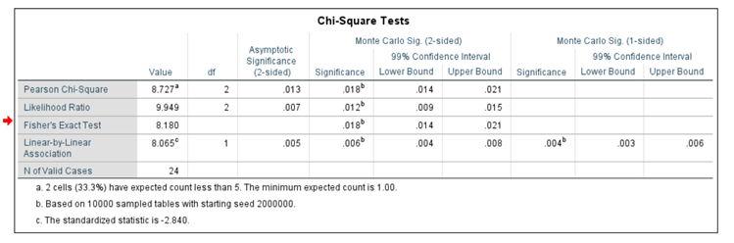
Figure1.0 (smaller version of table3.2)

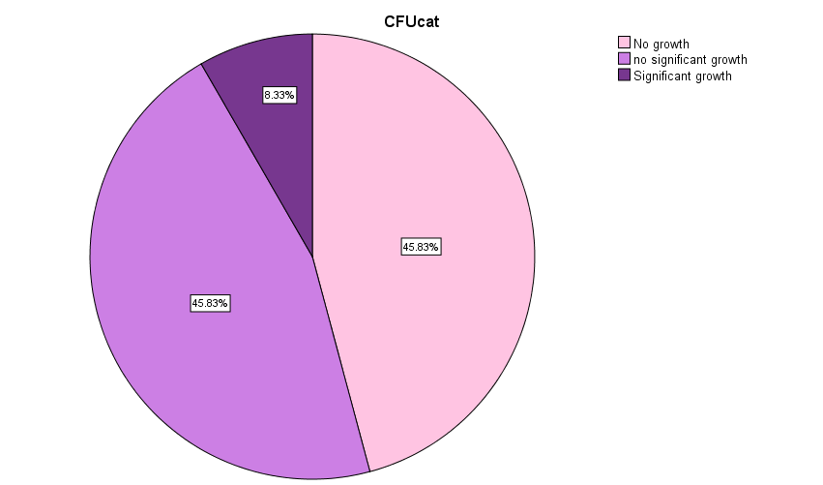

Figure1.1
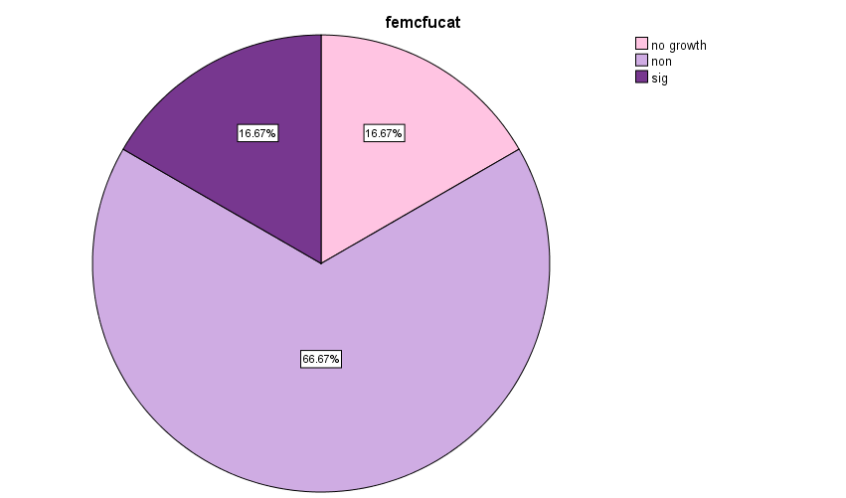

Figure1.2


Figure1.3

Conclusion:
UTIs are common among infections, a common type of them is asymptomatic bacteriuria, a state where the person that is infected shows no signs, and this research discussed whether the gender had any effect on the prevalence of this disease.
The result showed that gender does have an effect and that women are more affected when compared to men.

References:
- Weissfeld, A., Forbes, B. and Sahm, D., n.d. Bailey & Scott's diagnostic microbiology. 12th Ed.
- Levinson, W., Chin-Hong, P., Joyce, E., Nussbaum, J. and Schwartz, B., 2022. Review of medical microbiology and immunology. 15th ed. [S.I.]: Mcgraw-Hill education.
- Harrington RD, Hooton TM. Urinary tract infection risk factors and gender. J Gend Specif Med. 2000;3(8):27-34.
- Givler, D. and Givler, A., 2022. Asymptomatic Bacteriuria.[Accessed 11 June 2022].
- Nicolle LE, Gupta K, Bradley SF, et al. Clinical Practice Guideline for the Management of Asymptomatic Bacteriuria: 2019 Update by the Infectious Diseases Society of America. Clin Infect Dis. 2019;68(10):e83-e110. doi:10.1093/cid/ciy1121

