The effect of gender on the prevalence of asymptomatic bacteriuria

Student: Abedalhameed Uosef Karim (3142)
Libyan International Medical University
Faculty of Applied Medical Science
Supervisor: Dr. Intesar Alnagi

Abstract:
Asymptomatic bacteriuria is the existence of bacteria in a urine sample of a patient with no signs or symptoms. This experiment was done to find out if there is a difference in incidence rates of asymptomatic bacteriuria between males and females. this was done by comparing the growth of bacteria. 24 samples were taken from students at the Libyan international medical university. These samples were taken through a midstream clean catch method of urine collection. Blood Agar, CLED and MacConkey plates were prepared. A flamed wire loop was used to transfer the urine sample into the agar plates. The agar plates were then incubated for 24 hours at 37 degrees Celsius. After the incubation, the growth of bacteria was counted and a CFU (Colony Forming Units) value was calculated for each plate. The experiment showed a significant difference in the incidence rates of asymptomatic bacteriuria between males and females, with females showing 58.3% more cases of significant and non-significant bacterial growth than men.

Introduction:
Asymptomatic bacteriuria is described as the existence of bacteria in a urine sample of a patient who does not show any signs or symptoms of any urinary tract infections. Usually, urinary tract infections tend to show some symptoms, which makes them much easier to diagnose and treat. However, most patients of asymptomatic bacteriuria will never show any symptoms and many of the patients will not benefit from any antibiotic treatment. Incidence rates of asymptomatic bacteriuria have been shown to increase with age, with incidence rates as low as 0.5% in infants and as high as 50% in people over the age of 80.¹
This experiment was done to find out if there is a difference in incidence rates of asymptomatic bacteriuria between males and females. this was done by comparing the significant and insignificant growth of bacteria. After seeing the available data, the result that we expected to see was a higher incidence rate for women than men. The prevalence of asymptomatic bacteriuria has made it a frequently researched topic. There is also a difference in incidence rates between males and females, which could be due to the differences in anatomy. For example, the female urethra is five times shorter than the male urethra, which allows for easier transfer of bacteria into the bladder and the rest of the urinary system leading to urinary tract infections. The most common pathogen that is found in asymptomatic bacteriuria is the bacterium E.coli, however many other types of bacteria may also be present. The matter of discussion in most of the available literature is the treatment and management of asymptomatic bacteriuria and the use of antibiotics, which is still an area of disagreement. For example, Nicole E. Lindsay states that clinical trials have consistently proved that there is no benefit in the use of antibiotics in the treatment of asymptomatic bacteriuria for spinal injury patients, diabetic women, and elderly nursing home residents.⁴ On the other hand, Bela Koves et al. stated that the treatment of asymptomatic bacteriuria in pregnant women is beneficial in decreasing the risk of urinary tract infections and low birth weight.² the hypothesis for this experiment is that there is a significant difference between males and females in the prevalence of asymptomatic bacteriuria.
Methods and materials:
24 samples from different students were taken from students at the Libyan international medical university. These samples were taken through a midstream clean catch method of urine collection. Once the samples were collected, each sample is stored in a refrigerator at 4 degrees Celsius for no longer than 18 hours. 10 ml of each sample is then inserted into a centrifuge after being mixed well and the top 9ml of supernatant are removed, leaving a ten times higher concentration in the sediment, which will make it much easier to detect any microbes. The remaining sediment is then placed under microscope at a magnification of at least x400 after microscopic preparation was done and a gram stain was applied to the sample. Ten different visual fields, which are selected at random, are looked at. Under microscope, pink rod-shaped bacteria were seen. This bacterium was therefore gram negative. Blood Agar, CLED and MacConkey plates were prepared. A flamed wire loop was used to transfer the urine sample from the test tube into the agar plates, ensuring it was spread out well by applying it in a zigzag motion. The agar plates were then incubated for 24 hours at 37 degrees Celsius. After the incubation, the growth of bacteria was counted and a CFU (Colony Forming Units) value was calculated for each plate. These numbers were then analysed and put into the SPSS software. A Chi-square test was done to help work out the difference in bacterial growth between the two genders and to assess the P-value to see if that difference is significant or not.
Results:
The 24 samples were taken from 12 males and 12 females and a CFU value was calculated for each sample. Because we used a mid-stream clean catch method to collect the samples, the threshold CFU value for significant bacterial growth is 1x10⁵ of the number of colonies counted.
The results for each sample were as follows:
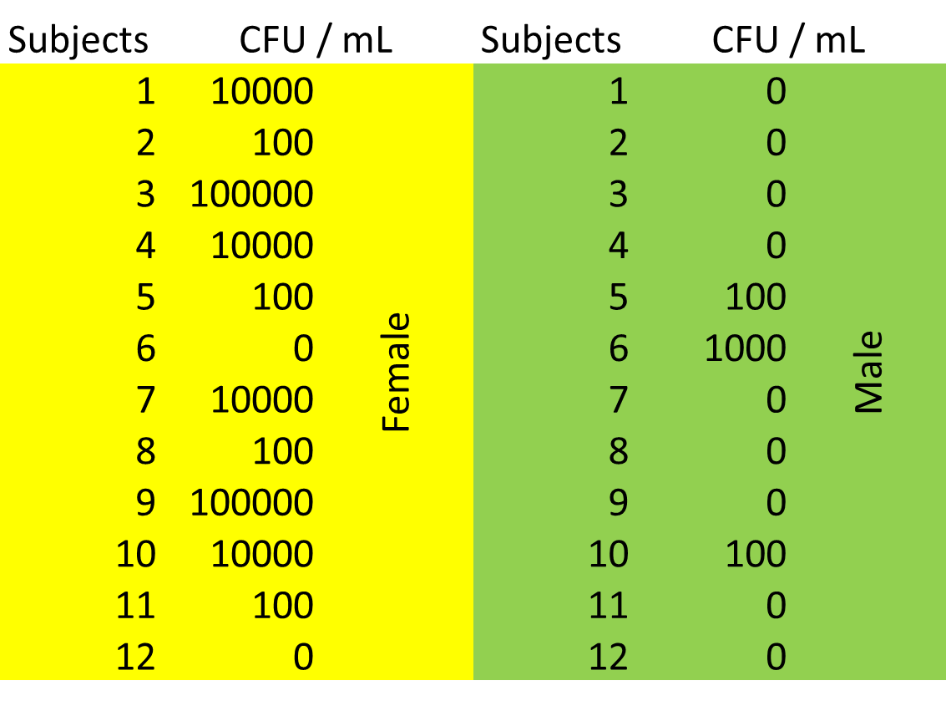
Table 1 shows the CFU value for the 12 male and female samples. No significant growth was seen in 100% of the male samples, while 16.6% of the female samples had significant growth.

gender * bacterial growth significance Crosstabulation
 |  |  | Bacterial growth significance |  |  |  | Total
 |  |  |  | no growth | overall | significant | Total
gender | female | Count | 0 | 2 | 8 | 2 | 12
gender | female | % within gender | 0.0% | 16.7% | 66.7% | 16.7% | 100.0%
gender | female | % Within bacterial growth significance | 0.0% | 20.0% | 72.7% | 100.0% | 50.0%
gender | male | Count | 1 | 8 | 3 | 0 | 12
gender | male | % Within gender | 8.3% | 66.7% | 25.0% | 0.0% | 100.0%
gender | male | % Within bacterial growth significance | 100.0% | 80.0% | 27.3% | 0.0% | 50.0%
Total |  | Count | 1 | 10 | 11 | 2 | 24
 |  | % Within gender | 4.2% | 41.7% | 45.8% | 8.3% | 100.0%
 |  | % Within bacterial growth significance | 100.0% | 100.0% | 100.0% | 100.0% | 100.0%

Table 2 shows the rates of both male and female bacterial growth with percentages. For example, percentage of males with no bacterial growth is 66.7%.
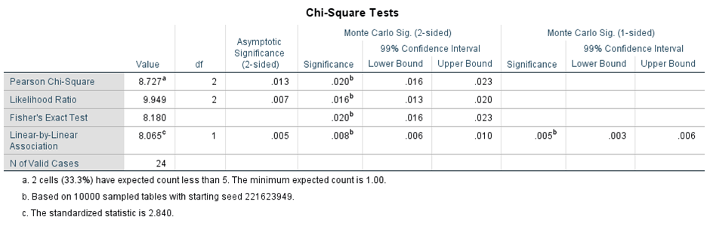
Table 3 shows the Chi-Square test results with Fisher’s exact test. The P-value is 0.020.
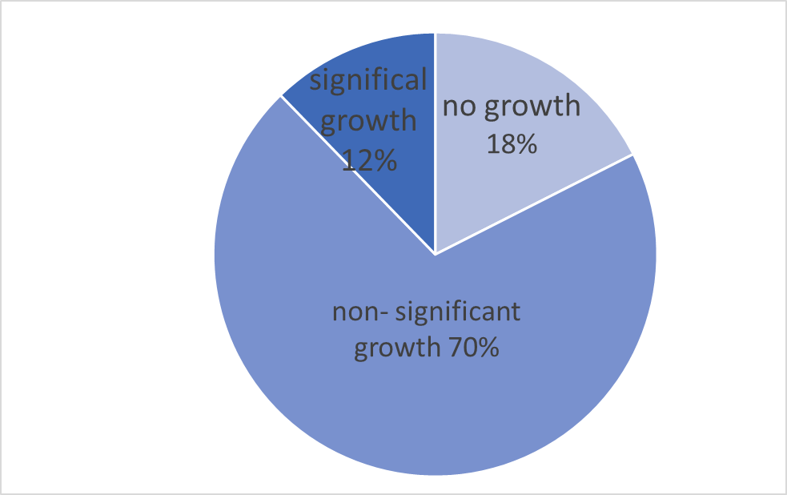
Graph 1 shows a pie chart with the percentages of No growth and significant and non-significant growth for females.

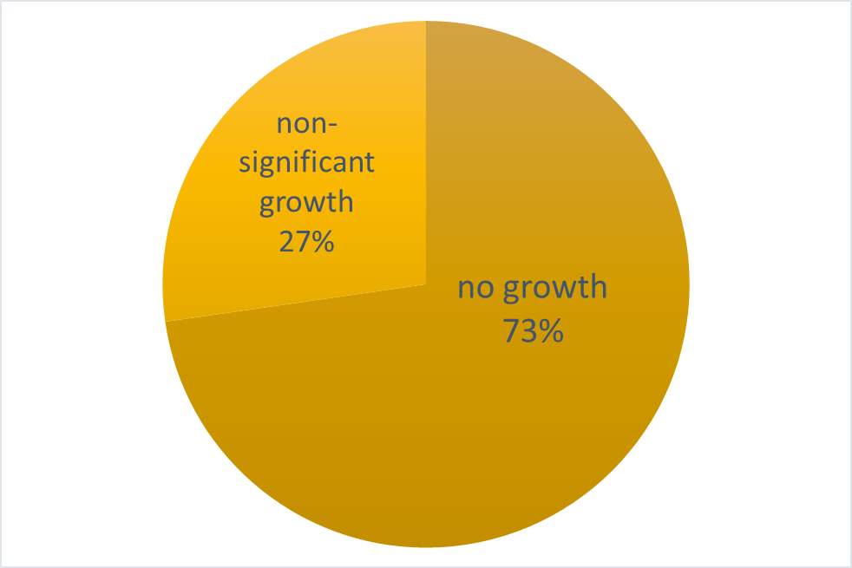
Graph 2 shows a pie chart with the percentages of No growth and significant and non-significant growth for males.

Table 4 shows the summary table with p-value. 0.020 shows that the results are significant.

Discussion:
This experiment was done to see whether there is any variation between the bacterial growth in urine for males and females, which will show if the presence of bacteria in urine is more common in females even with no symptoms.
The results showed that most males tested (75%) had no growth at all, with a CFU of 0. This is much higher than the female samples which only had 16.6% of agar plates with no growth. Furthermore, females that exhibited significant growth (which is any CFU value above 100,000) made up 16.6% of the total number of females tested. While for the men, not a single agar sample showed any significant growth. These results very clearly highlight that there is a difference in growth and urinary presence of bacteria between males and females. this means that, according to this sample, more females have asymptomatic bacteriuria.
The Chi- square test that was initially done was adjusted as some of the assumptions were not met, so Fischer’s test was used instead. This test helped show the difference in percentages of growth and significant growth in both men and women. The P-value being 0.020 shows that the difference is not due to chance and is a significant difference due to gender, which means we accept the hypothesis.
the method that was used for this experiment was a simple method and is different form some of the other methods that were researched prior to carrying out the experiment. For example, the use of a midstream clean catch method to collect the urine is an easier process than using a catheter. The use of catheter collection, which was done in some other experiments is much more technical and time consuming. The use of a catheter would also decrease the threshold CFU for significant bacterial growth from 1x 10⁵ to 1x 10².
Another factor of the used method that can be changed is the sample size. The available pieces of research all use a much higher sample size than the one that we used. 24 participants is a very small amount of people to reach any conclusive results. The low sample size was also one of the reasons for the change of statistical tests carried out. Increasing the sample size would allow for more accurate and conclusive results.
The results that were reached match the current data that is available on asymptomatic bacteriuria according to the literature that we found. The fact that females would have a higher incidence rate of asymptomatic bacteriuria was expected due to many factors, most important of which was the anatomical differences.
The bacterium that was analysed in this experiment was mainly E.coli, because it was the most likely bacterium that was spotted under microscopic examination. Further biochemical examinations were carried out to confirm this. E.coli is already known to be the most common bacteria present in urine. This bacterium is a gram-negative bacilli rod that is present as normal flora of the colon. The transmission of E.coli into the urine can be from the skin or through the rectum to the urethra and the rest of the urinary tract, the use of catheters can also increase the risk of bacteria of the urine. ³

Conclusion:
In conclusion, the results reached with this experiment support the previous studies carried out about the difference between male and female incidence rates. There is a clear and significant difference in the incidence rates of asymptomatic bacteriuria between males and females, with females showing 58.3% more cases of significant and non-significant bacterial growth than men. These results were concluded based on the sample of 24 students that we used for this experiment. Future experiments should use a much higher sample size to ensure that the results reached more accurately portray the incidence rates in the population.

, , , , ,, , , , , , , , , , , ,, , , , , ,, , , , , ,, ,, , ,, , , ,, , , ,, , , ,, , , , ,, , , , ,, ,

Bibliography:
- Givler D, Givler A. Asymptomatic Bacteriuria. Ncbi.nlm.nih.gov. https://www.ncbi.nlm.nih.gov/books/NBK441848/. Published 2021. Accessed June 20, 2022.
- Köves B, Cai T, Veeratterapillay R, et al. Benefits and Harms of Treatment of Asymptomatic Bacteriuria: A Systematic Review and Meta-analysis by the European Association of Urology Urological Infection Guidelines Panel. Eur Urol. 2017;72(6):865-868. doi:10.1016/j.eururo.2017.07.014
- Luu T, Albarillo FS. Asymptomatic Bacteriuria: Prevalence, Diagnosis, Management, and Current Antimicrobial Stewardship Implementations [published online ahead of print, 2022 Mar 31]. Am J Med. 2022;S0002-9343(22)00248-0. doi:10.1016/j.amjmed.2022.03.015
- Nicolle LE, Gupta K, Bradley SF, et al. Clinical Practice Guideline for the Management of Asymptomatic Bacteriuria: 2019 Update by the Infectious Diseases Society of America. Clin Infect Dis. 2019;68(10):1611-1615. doi:10.1093/cid/ciz021

