


The Incidence Rate of Asymptomatic Bacteriuria among LIMU Students

Name: Areej fateh .
Student number: 2807
Instructor: dr. asma
Course Title: P.T.S
Due Date: 18/6/2022

Abstract:
The goal of this study was to see if there was a link between gender and asymptomatic bacteriuria, and to make a reliable comparison between males and females on the subject. The midstream-clean catch method was used to collect urine samples from 24 students at Limu, and the samples were subsequently cultured by inoculating the urine into a medium. The colonies and CFU were counted after the microbes grew. The data was separated into three categories: growth, non-significant growth, and significant growth, and then analyzed with chi-square on spss. Our findings validated the link between gender and asymptomatic bacteriuria, as well as demonstrating that females are more likely than men to develop asymptomatic bacteriuria. As a result, gender should be taken into account as a risk factor.

Introduction:
Asymptomatic bacteriuria (ASB) is defined as the presence of bacteria in a properly obtained urine sample of a person who has no signs or symptoms of a urinary tract infection. Incomplete bladder emptying can raise the likelihood of asymptomatic bacteriuria, which is clinically prevalent and can increase in risk with age. Several studies have found that after the age of 80, ladies had a 40% higher rate of asymptomatic bacteriuria than males (1). Females are more vulnerable than men due to their shorter urethra, absence of prostatic secretions (bactericidal effect), and closeness of the vagina from the anus, all of which might cause the gut microbiome (e.g., E. coli) to assault the genitourinary system.
Males are therefore far less likely to be impacted, according to research, which found that ASB is seldom observed in middle-aged men and is usually seen in individuals over 50 years of age with prostatic infections.
The most prevalent cause of both asymptomatic bacteriuria and acute UTI is E. coli. However, they must be recognized from one another, since an acute UTI is a symptomatic genitourinary tract infection characterized by symptoms such as dysuria, urgency, and suprapubic discomfort.
Female students are expected to be significantly more affected by ASB than male students of the same age, based on past research. The following lab study experiments were done among the 24 LIMU students, 12 females and 12 males, to prove the prior conclusions. Whether or not females have a higher risk of asymptomatic urine infection as a result of their biological makeup.

Materials and method:

A study on asymptomatic urinary tract infections was conducted on LIMU students. A total of 24 samples were taken from students, with 12 of them being male and the rest being female. Mid-stream clean catch was used to gather samples. I put on a pair of gloves first, then took the calibrated loop, which measured 0.01, and sterilized it with the Bunsen burner. I collected the urine sample and vertically introduced the calibrated loop into it after a few seconds under the flame. This process guarantees that the proper amount of urine enters the loop. On a MacConkey Agar plate, samples were grown. The pee was splattered throughout the plate agar surface. I re-grasped the loop and vertically inserted it into the urine sample to transfer a loopful of urine to a second plate, which was then put in the incubator for twenty-four hours at 37°C. I counted the colonies on the agar after 24 hours. To identify the microorganisms, researchers used gram staining to establish if they were gram-negative or positive, as well as microscopy to study the morphology of bacteria and several biochemical experiments (3)(4).
The spss software was used, and chi tests were run, but they didn't work out since more than 20% of the cells had an expected value of less than five, thus Fisher's test was used instead.

Result and Statistics analysis :
Table 1:
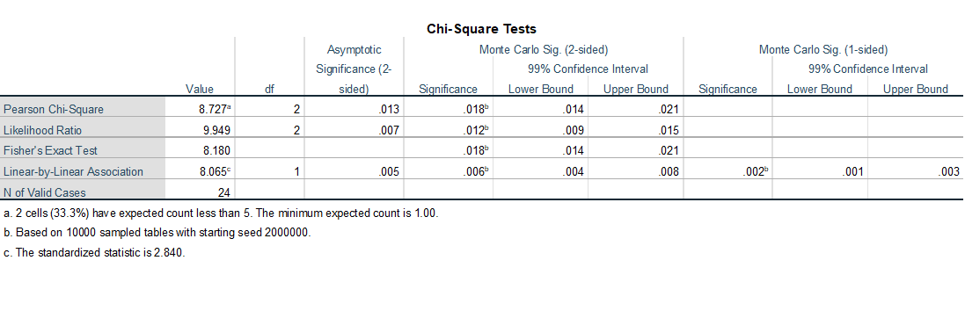
Because 20% is less than the projected count of fewer than five, chi-square would not be used, hence a fisher's test would be used instead. Only two of the females exhibited microbial growth, whereas nine of the men had. There hasn't been a significant growth. Only three males are optimistic, compared to eight women. There were no males that tested positive for substantial growth, but there were two ladies who did.
Table 2:
bacterial growth * Gender Crosstabulation
 |  |  | Gender |  | Total
 |  |  | Male | Female | Total
bacterial growth | 1.00 | Count | 9 | 2 | 11
bacterial growth | 1.00 | % Within bacterial growth | 81.8% | 18.2% | 100.0%
bacterial growth | 1.00 | % Within Gender | 75.0% | 16.7% | 45.8%
bacterial growth | 2.00 | Count | 3 | 8 | 11
bacterial growth | 2.00 | % Within bacterial growth | 27.3% | 72.7% | 100.0%
bacterial growth | 2.00 | % Within Gender | 25.0% | 66.7% | 45.8%
bacterial growth | 3.00 | Count | 0 | 2 | 2
bacterial growth | 3.00 | % Within bacterial growth | 0.0% | 100.0% | 100.0%
bacterial growth | 3.00 | % Within Gender | 0.0% | 16.7% | 8.3%
Total |  | Count | 12 | 12 | 24
 |  | % Within bacterial growth | 50.0% | 50.0% | 100.0%
 |  | % Within Gender | 100.0% | 100.0% | 100.0%
Characteristic | No growth | Overall, no significant growth | Significant growth | P-value
 | 11 | 11 | 2
Gender |  |  |  | 0.020
male | 9(81.9%) | 3(27.3%) | 0(0.0%)
female | 2(18.2%) | 8(72.7%) | 2(100%)
Table 3: summary table.
Figure 1:

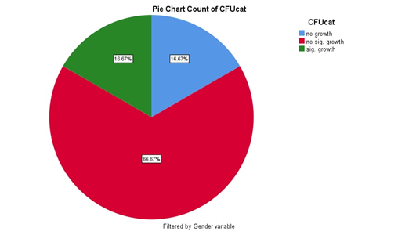
This pie chart shows the result of female samples, there is 2 significant growth, 8 non-significant growth, and 2 no growth.
Figure 2:
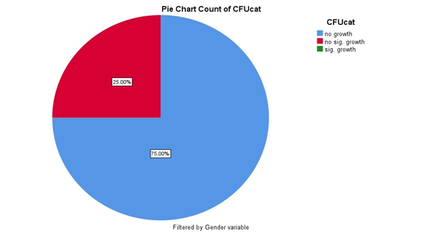
This pie chart shows the result of male samples, there are 3 non-significant growth, 9 no growth, and no significant growth.

Discussion:

The significance level is below 0.05. The null hypothesis was rejected, indicating that there is a link between gender and bacteriuria in the absence of symptoms. There is a lot of evidence showing there is a relationship between gender and asymptomatic bacteriuria that I uncovered. Asymptomatic bacteriuria is more common in women than in men due to the shorter female urethra, which permits germs from the urethral entrance and the perineum to travel a shorter distance to the bladder. The majority of women have transient bacteriuria after sexual interaction, but only a tiny number of these women will develop symptomatic infections since the body's natural defense systems normally prevent infection. The higher prevalence of asymptomatic bacteriuria in the elderly is thought to be due to incomplete bladder emptying. In addition to gender. The higher prevalence of asymptomatic bacteriuria in the elderly is thought to be due to incomplete bladder emptying. Other risk factors for asymptomatic bacteriuria, aside from gender, include rising age, immunosuppressive disorders, immune-suppressing drugs, undergoing urinary tract surgery, receiving a kidney transplant, and urinary tract obstruction, such as stone formation.
The laboratory findings revealed that two cultures had over 100,000 CFU, and the organism was pink and rod-shaped under the microscope, indicating that it was a gram-negative bacillus. It was first assumed to be either pseudomonas aeruginosa or E. coli, however the bacteria was lactose fermenting, indicating that it was E. coli.
E. coli is the most common bacteria that causes asymptomatic community-acquired bacteriuria, to the best of my knowledge. The patient's intestinal flora colonizes the urogenital region, which is where E. coli that causes urinary tract infections is found. Uropathogenic strains have pili containing adhesin proteins that connect to specific receptors on the urinary tract epithelium, which can lead to asymptomatic urinary tract infection. It's possible that E. coli's ability to ascend the urethra into the bladder and ascend the ureter into the kidney is facilitated by its motility against urine flow. Galactose dimers make up the target protein on these receptors (Gal-Gal dimers). Flavonoids in cranberry juice decrease pili binding to receptors, which may help to avoid recurrent urinary tract infections.
There had previously been no investigations on asymptomatic bacteriuria in pregnancy at Usmanu Danfodiyo University Teaching Hospital in Sokoto. The goal of this study was to assess the prevalence and frequency of organisms associated with asymptomatic bacteriuria in pregnancy, as well as their sensitivity patterns, among booked patients at Usmanu Danfodiyo University Teaching Hospital in Sokoto. According to this study, Escherichia coli, Klebsiella spp., and Coliform spp. were the most common causes of asymptomatic bacteriuria in pregnancy at Usmanu Danfodiyo University Teaching Hospital in Sokoto. The medicines nitrofurantoin and gentamicin, which are both widely accessible and inexpensive, are effective against these infections. In pregnant women, asymptomatic bacteriuria should be checked often (2). Urinary stasis produced by uterine compression on the bladder and ureters puts pregnant women at a higher risk than healthy young women. E. coli was found to be the most prevalent bacteria in the study done at Usmanu Danfodiyo University Teaching Hospital in Sokoto, as were the positive samples at LIMU.

Conclusion:

Finally, it was discovered in this study that males had a lower incidence of asymptomatic bacteriuria than girls of the same age, according to their anatomical predisposition. E. coli has been identified as the primary cause of both symptomatic and asymptomatic UTI, which is explained by its presence in the colon as normal flora and its virulence factors, which let it infect the genitourinary tract. The null hypothesis was rejected since the beginning hypothesis was satisfied, i.e., a P value indicating a significant relationship between ABU and gender. However, the accuracy of the microbiological spectrum analysis was limited due to the small sample size employed in the study, which was just 24 pupils. For more credible results that firmly confirm conclusions, future studies must increase sample size.

References:
1- Nicolle L. Asymptomatic Bacteriuria and Bacterial Interference. Microbiol Spectr. 2015;3(5). doi:10.1128/microbiolspec.uti-0001-2012
2- Kuźniar A. O pojęciu zdarzenia będącego złamaniem prawa przyrody. Filozofia Nauki. 2021;29(3):107-123. doi:10.14394/filnau.2021.0017
3- Levinson, Warren. Review of medical microbiology and immunology. 13rd ed. The McGraw-Hill Companies, 2014.
4-Bailey&scotts, diagnostic microbiology,12th ed

