


PTS Assignment – Y3 Med.

Introduction to Project Management

Student Name: منة الله وليد القذافي

Role No.: 2577

Date: 18 March, 2022

- Develop a network diagram for the project specified below. (50 %)
- Identify the Critical Activities and the total duration of the project. (35%)
- Justify which activity would you crash based on some rationale. (15%)

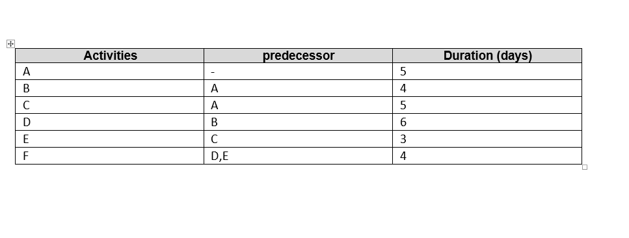

- Develop a network diagram for the project.
6
4
F
4
3
5
5
E
D
C
B
A

- Identify the Critical Activities and the total duration of the project.

Identifying the critical path (longest duration):

Path number 1: A – B – D – F = 5 + 4 + 6 + 4 = 19 days.
Path number 2: A – C – E – F = 5 + 5 + 3 + 4 = 17 days.

For crashing, the critical activities A, B, D and F in the project are to be considered first.
The above project has a duration (Critical path length) of 19 days.

- Justify which activity would you crash based on some rationale.

Project crashing is done to reduce the duration of a project by investing more money. Thus, a time-cost analysis is crucial. Crashing is carried out when a deadline to be met is approaching. Only the critical activities are considered since the time of the project could be decreased by crashing them only. It is important to keep in mind that another non-critical activity could become critical in the upcoming path, and may be put for future crashing itself.

In order to crash an activity, a few things must be considered:

a. Identify critical path and critical activities.
b. Compute crash cost slope (Not specified in this project)
c. Select the activity with the least cost slope (Not specified in this project)
d. Check for the critical path.

In this project, activity D would be most suitable for crashing, since it is one of the identified critical activities and it has the longest duration. If we assume activity D had the lowest cost slope (not specified in this project), this would definitely make it the activity of choice for crashing.

