Laboratory Examination for Urinary Tract infection
Raghad Khalil Elsaiti
2931
Supervised by : Dr.intisar Al harmi , prof.Asma Alkwafe , Dr. Sanusi Sharif

Absrtact :
urinary tract infections in children is a significant problem and commonly caused by E. coli and require early diagnosis and treatment to prevent repeated UTI and renal scarring
This study aim is to evaluate the usefulness of the point to Gram negative stain by physician on suspected UTI in children as a rapid diagnostic test
The study was taken between January 2011 and December 2015
Patient age was 36 months or yonder who were reviewed wo was rivewed to the emergency room with UTI
Urine culture and analysis and point if care gram stain was preform as specimen
We compare the diagnostic performance among rapid diagnostic test kappa static were used to evaluate the agreement between the two results
we also analyzed with antibiotics were susceptible to the patient
patient rewiwed in the study for UTI the sensitivity and susceptibility were 73.2% and 95%
While those at gram stain was 81.4% and 98.3%
Introduction:
Urinary tract infections are serious promblem
A delay in treatment may result in scaring at Urinary tract leading to renal failure There’s approach of antibiotics used when the patient is diagnosed depends on physical and history examination UTI in children including 95 clinical studies And 97,703 children this study aim to determine the use of gram stain for UTI in children.
Materials :
urine sample collected by sterile teqniques and proceed within 2 hours urine culture and gram stain us done as a single urine specimen
Materials used:
solution of crystal violet Grmas iodine 95% of ethanol and or isopropanol and clean glass slides and inculating loops bunden burnner also bibules paper and microscope and immmunsim oil and it will apperar stained within crystal violet followed by iodine solution then washing with 95% ethanol on isoprorpanol The first line therapy for UTI were selected based on microorganism isolation the culture and gram staining (E. coli and klesilla ) cephalosporin
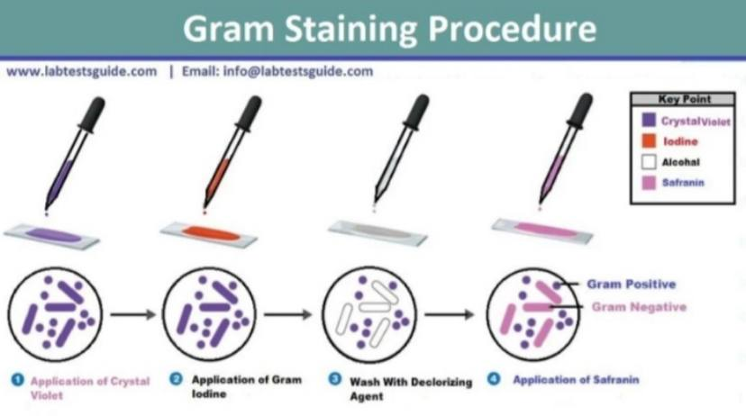

Results :
urine culture at 1594 patient were proceeded 2.9% of patient didn’t have culture or urine analysis or gram stain and 0.1% were excluded Of remaining 1594 patient were girls and median age were 3 months only 12% had a pathogen detection The sensitivity of pyribe was 73.2% and gram stain was 81.4% and 98.2% for it total bacteriaisolared gran stain
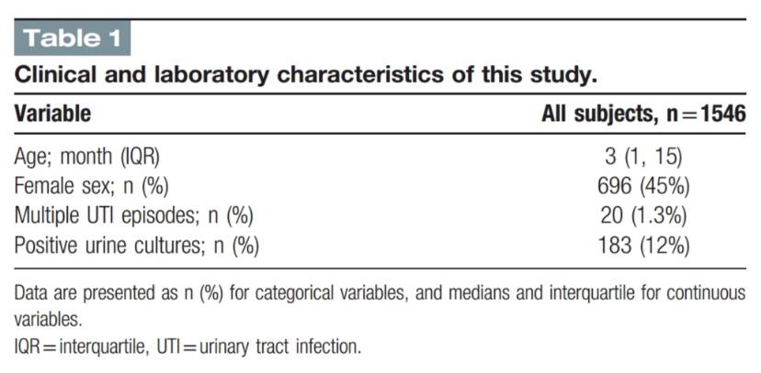
Discussion:
we found that gram stain was supirior to pyuria as rapid as diagnostic test was
But we both was positive the sensitivity was 100%
The gram stain is a rapid diagnostic test for UTI wich can be carried quicklyat a low cost for clean carch. The indicate of bacteria more than 10 CFU/ml and the absence of bacteria on gram stain indicates the probality of twere more than 10 bacteria/ml we should use antibiotics based on gram stain
Finally there may be a limited application for some patien
Conclusion :
our analysis that gram stain is a rapid test for UTI in children less than 36 months
Antibiotics selected based on gram stain compared to empirical therapy recommendations

