

The Libyan International Medical University
Faculty of Basic Medical Science

The incidence rate of Asymptomatic Bacteriuria among LIMU students
Mohammed Ali Alfaia
2798
Report Submitted to fulfill the requirements for Scientific Research Activity
Date of Submission: 18/06/ 2022

Abstract:

Asymptomatic Bacteriuria is the presence of bacteria in urine sample, collected through clean catch method and grown on agar, a positive agar media should have a growth of 100,000 colony forming units (CFU) per milliliter, the patient should also be urinary tract infection symptom free. The samples of data have been collected from 24 LIMU students, 12 male and 12 female. Only two females have shown significant growth rest of samples have shown no growth or no significant growth. The test was to see if there is a statistically significant difference between female and male incidence rate the statical analysis have shown that the difference is statistically significant as shown in Fisher's Exact Test where P value is 0.018.

Introduction:

Asymptomatic bacteriuria is the presence of bacteria in a well collected urine sample from patients that do not show symptoms of urinary tract infection (UTI). Asymptomatic bacteriuria is a very common incident in clinical practice, the incidence rate increases by age, infants are less likely to be diagnosed with asymptomatic bacteriuria, 15% increased rate in woman and patients who are between the age of 65 to 80, 40%-50% increase incidence rate in patients over the age 80 and 100% in catheter users. (1)
The most common bacteria found in urine sample is Escherichia coli, other bacteria include Enterobacteriaceae, Pseudomonas aeruginosa, Enterococcus species and group B streptococcus. As for laboratory criteria to diagnose if a patient is positive asymptomatic, the test for male and female differ slightly, test for female should be done twice and have at least 100,000 colony forming units (CFU) per milliliter of same bacterial sample, for males one sample with a growth of 100,000 (CFU) per milliliter. The importance or the significant of urine culture for asymptomatic patients has been said to be unnecessary by many well established health organizations such as -US Preventive Services Task Force- due to the fact that treatment is unnecessary and in some cases advised against to avoid bacterial resistance, the screening for bacteriuria is necessary if suspected in pregnant woman, resent renal transplant patients as well as children from 5-6 years old, and should be treated if positive as the benefits outweigh the side effects.(2) Lab personal should be careful in doing the test as chance of contamination is very high and if test shows extreme abnormal bacterial growth or random bacteria that even in normal UTI patient isn’t present should be recarried out to make double check and make sure it’s not a laboratory mistake. The data collected in this research is of patients of age between 18-20 making treatment unnecessary however the comparison between male and female incidence may show difference.

Materials and Methods:
Material:
Gloves, Clean catch urine sample, Loop-wire, Agar (MacConkey agar) Incubator, Flame.

Method:
- Tip over the container to re-mix the urine sample.
- Remove the cap and dip the end of a sterile 1-µL inoculating loop (white) into the urine and remove it vertically making sure that there is no urine up the loop.
- Tip and spread the inoculum over the surface of a standard nutrient agar plate (60 × 15 mm) prepared according to the instructions of the manufacturing company
• Make a single streak across the center. Then, spread the inoculum evenly distributed in a Diagnostics cross-zigzag arrangement to the primary streak, as shown in Figure
- Re-dip the end of the same 1-µL loop into the urine and remove it vertically making sure that there is no urine up the loop\
- Tip and spread the inoculum over the surface of a glucose-topped MacConkey agar plate (60 × 15 mm). Spread as described above.
- Re-dip the end of the same 1-µL loop into the urine and remove it vertically making sure that there is no urine up the loop.
- Tip and spread the inoculum over the surface of a standard MacConkey agar plate (60 × 15 mm) prepared according to the instructions of the manufacturing company. Spread as described above.
- Incubate the plates aerobically at 35–37 ◦C for at 18–24 h
- In the following day, count the number of colonies on the surface of each medium. Each colony growing on the agar plate represents one colony forming unit (cfu)/µL (according to the size of the loop), which is equal to 1000 cfu/mL. Remember that nutrient agar is the primary medium used for counting colonies. (3)

Results:

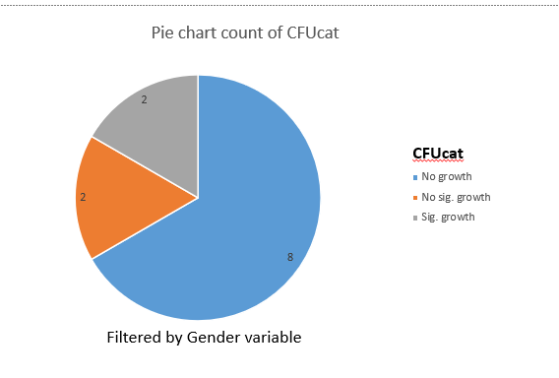
Female samples Male samples
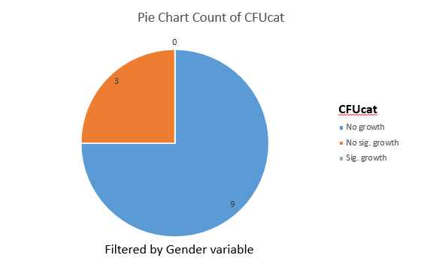

Chi-Square Tests
 | Value | df | Asymptotic Significance (2-sided) | Monte Carlo Sig. (2-sided) |  |  | Monte Carlo Sig. (1-sided)
 |  |  |  | Significance | 99% Confidence Interval |  | Significance | 99% Confidence Interval
 |  |  |  |  | Lower Bound | Upper Bound | Significance | Lower Bound | Upper Bound
Pearson Chi-Square | 8.727ª | 2 | .013 | .018^{b} | .014 | .021
Likelihood Ratio | 9.949 | 2 | .007 | .012^{b} | .009 | .015
Fisher's Exact Test | 8.180 |  |  | .018^{b} | .014 | .021
Linear-by-Linear Association | 8.065^{c} | 1 | .005 | .006^{b} | .004 | .008 | .002^{b} | .001 | .003
N of Valid Cases | 24
a. 2 cells (33.3%) have expected count less than 5. The minimum expected count is 1.00.
b. Based on 10000 sampled tables with starting seed 2000000.
c. The standardized statistic is 2.840.

Female samples: 8 with no growth, 2 with no significant growth, 2 with significant growth.
Male samples: 9 no growth, 3 with no significant growth, 0 with significant growth.

Discussion:

The research is based on collection of urine sample from Libyan International Medical University students, a simple and well-established test was done on the urine samples, the urine culture laboratory test, where urine sample is left to grow on agar for a period of 24 hours to 48 hours to see if there is bacterial growth, if significant growth is seen student can be said to be asymptomatic because none of the student have shown symptoms prior to urine sample collection.

The incidence rate of Asymptomatic Bacteriuria among LIMU students, and is the difference between female and male significant, the data collected was from 12 male LIMU students and 12 female LIMU students, and proper lab cultures were carried out, all students did not show symptoms of any type of infection including urinary tract infection prior to urine sample collection, therefore all students could be said to be healthy 18-20 aged students.
Starting off with female sample, 8 had no growth which means no bacteria is present, 4 had bacterial growth, 2 of which had no significant growth meaning they did not meet the standard of 100,000 colony forming units per milliliter, 2 others had significant growth and could be said to have asymptomatic bacteriuria, by taking the data and turning it into percentages, 16% of females were positive for asymptomatic bacteriuria, the rest being negative for the test.
Male samples, 9 with no growth, 3 no significant growth, and zero for significant growth.
Sample comparison between male and female shows that females are 16% more likely to be infected, which agrees with the later statement that states females are 15% more likely to be asymptomatic bacteriuria positive than males of ages between 18-35 years old. The fact that the difference between the results of LIMU students and general tests done in different labs is less or equal to 1% shows that LIMU students are within healthy environment and are not in an increased risk of urinary tract infection. The 16% increased incidence rate in females can be said to be a statistically significant difference as the “p” is less than 0.05 as shown in Fisher's Exact Test where P value is 0.018.
The total of 24 LIMU students who have done the test, 2 of which were positive, in percentages that is 8% positive and 92% negative, by eliminating the possibility of lab error, the incidence rate of Asymptomatic Bacteriuria among LIMU students can be stated to be statistically insignificant as the “p” value has been shown to be greater than 0.05 in the statistics data.
The two students who have been diagnosed positive for asymptomatic do not need treatment or any follow up as they are not showing symptoms of any kind, related to urinary tract infection or other disease, and it is always recommended to avoid treatment if treatment is not necessary, to avoid possibility of bacterial mutation and resistance. Due to the fact that the incidence rate is not significant no further tests for LIMU students is needed, unless student comes with UTI symptoms and treatment should be given if positive as they are symptomatic and at risk of complications.

Conclusion:

The difference between incidence rate of Asymptomatic Bacteriuria among LIMU male and female students has been determined through sample collection with urine culture, and statistical analysis of results to be statistically significant, which supports the statement that females are more likely to be infected with bacteriuria than males. The increased incidence rate among female student is caused by the shorter urethra than male urethra, which shortens the distance that bacteria must travel to reach the bladder (4). Due to the fact that none of the students show symptoms of urinary tract infection, no treatment is necessary as it can cause unnecessary mutation or resistance of bacteria.

References:

1-Givler D, Givler A. Asymptomatic Bacteriuria. Ncbi.nlm.nih.gov. https://www.ncbi.nlm.nih.gov/books/NBK441848/. Published 2022. Accessed June 18, 2022.

2- https://www.cdc.gov/antibiotic-use/uti.html. Published 2022. Accessed June 18, 2022.

3- Karah N, Rafei R, Elamin W, Ghazy A, Abbara A, Hamze M, Uhlin BE. Guideline for Urine Culture and Biochemical Identification of Bacterial Urinary Pathogens in Low-Resource Settings. Diagnostics. 2020; 10(10):832. https://doi.org/10.3390/diagnostics10100832

4- Urinary tract infection (UTI) - Symptoms and causes. Mayo Clinic. https://www.mayoclinic.org/diseases-conditions/urinary-tract-infection/symptoms-causes/syc-20353447#:~:text=A%20woman%20has%20a%20shorter,who%20aren't%20sexually%20active. Published 2022. Accessed June 18, 2022.

