

Libyan International medical university
Faculty of Applied Medical science



FUROSEMIDE: A SEXIST DIURETIC?



By: Boshiha Gabriel
Student Number: 2339

Abstract
This study consists of 12 volunteers, 6 males and 6 females, that were both given the same amount of water and 40mg of furosemide or lasex and monitored for 6 hours and whilst monitored, a urinary sample was took from them hourly, this lead to the result of furosemide having more of its diuretic effect on males more than females observed mostly in the 6th hour urinating sample.

Introduction :
Urine is whats produced by your kidneys filtering wastes and excess water from your blood. The waste is referred to as urea. It is carried to the kidneys by your blood. Urine goes from the kidneys to the urinary bladder through two narrow tubes called ureters. Urine is stored in the bladder until you are prepared to urinate. When it's full, it expands into a circular form, and when it's empty, it shrinks. Your bladder can comfortably contain up to 16 ounces (2 cups) of urine for 2 to 5 hours if your urinary system is healthy.₁
Females routinely drink more water (83%) than males, and their urinary output rate is also higher. Water intake and urine output are found to be gender-specific. Because females drink larger quantities of water than men, the frequency/volume characteristic of rat micturition is likewise gender-specific.₁
Any medicine that increases the flow of urine is referred to as a diuretic. Excess water, salts, toxins, and stored metabolic products like urea are all removed from the body by diuretics. They help the body getting rid of excess fluid (oedema) that builds up in the tissues as a result of numerous diseases or electrolyte imbalances. Diuretics come in a variety of forms, but they all work by reducing the quantity of fluid reabsorbed by the tubules of the kidneys, from whence the fluid returns to the bloodstream.₂
Loop diuretics are a type of diuretic that works by blocking the sodium-potassium-chloride (Na+/K+/2Cl) co-transporter in the thick ascending loop of Henle in the kidneys (hence the name loop diuretic). As a result, sodium, chloride, and potassium reabsorption is reduced or eliminated, resulting in increased sodium, chloride, and potassium loss into the nephron (the functional unit of a kidney). Water is pulled into the nephron as a result, and urine volume rises. Calcium and magnesium reabsorption are likewise reduced by loop diuretics. Edema caused by heart failure (furosemide being the first choice), liver disease, or renal disease is treated with loop diuretics. They can also be used to treat hypertension.₂
furosemide (water pill) inhibits your body from absorbing too much salt. This permits the salt to flow via urine instead, thereby followed by water.
Fluid retention (edoema) is treated with furosemide in patients who have congestive heart failure, liver illness, or a kidney problem such nephrotic syndrome. High blood pressure is also treated with furosemide (hypertension).₂
In this study we will see if furosemide has a preference in its efficacy between males and females.

Methods and material:
After taking consent of the volunteers.
We started by collecting 6 male and 6 female candidates that had well general health, we started by sampling from each candidate to perform the urine dilution test by giving them each the same amount of water and 40mg of furosemide (Lasix) orally.
Urine samples were taken hourly for six hours (taking a sample each hour) and then calculating the urine output which will be used to detect of how furosemide have acted in each individual (urine output in mL/kg/hr= total urine output in mL / weight in kg x hours)_{.3}
We used the urine output calculation to be included in the statistical analysis using the two independent samples T-test
Then determining by the P value if the statistics were significant or insignificant,
P > 0.05 = are considered to be statistically insignificant
P < 0.05 = are considered to be statistically significant.₂

Results and discussion
As previously discussed in the introduction that females in general had higher urinary output due to the significantly higher levels of water consumption but here in this case both genders were given the same amounts of water so the results would be accurate.
After six hours of taking urine samples hourly, the 6th hour sample showed significant variations towards the male side of the process as it showed that men had significantly higher urinary output, and had higher mean calculation, these calculation have to be kept in mind that they were done on just 12 people so the results are not conclusive for all mankind.
These results show from this study show that furosemide has a preference to males than females as it is shown after calculating the mean of both males and females, the exact explanation of this variations is yet to be understood, it might be the result of the male receptors that furosemide acts on are more abundant than in females, or that the females body architecture is habituated to receive and put out more fluids that when the amount of water entering the body was limited as in this study; the body as a compensatory mechanism tried to keep as much of the water as it could.
[Table 1]: Results of the 6th hour urinary sample and the mean
Gender | 6th hour urine sample (overall) | Mean
Males | 2805 ml | 468.0000
females | 2203 ml | 367.2000

[histogram 1]: shows the mean and standard deviation
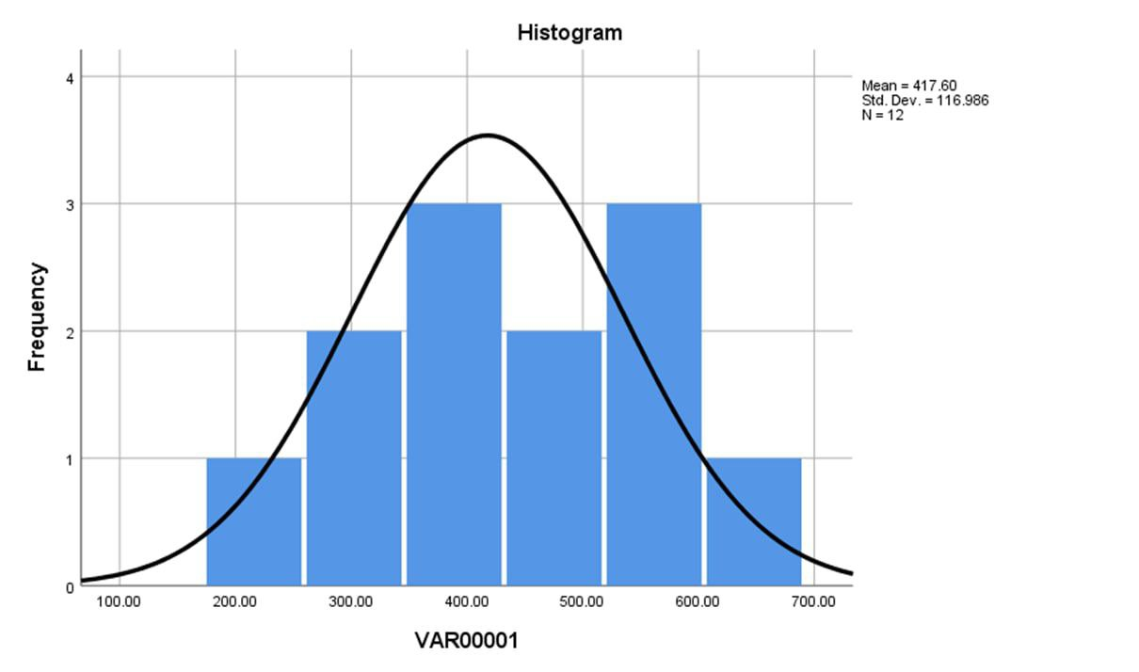
Also the P value was non-significant after being calculated and its result was 0.142, being more than 0.05 meaning that it is statistically non-significant, it could be due to the shortage of number of volunteers.

Conclusion
In conclusion, this study did fit the hypothesis that furosemide has a preference regarding gender, and in this study it is now understood that it has a more potent effect on males than females.
But to be accurate for further studies, the number of volunteers should be increased decently to get a more broad idea of the exact effect, and also the general health and all around more information about the participants regarding their height and weight or BMI, and their daily requirement of fluid intake which makes a major contribution to the variation of any diuretic effect.

References
- Urine and Urination | Urine | MedlinePlus. Urine and Urination | Urine | MedlinePlus. Published May 10, 2021. Accessed June 15, 2022. https://medlineplus.gov/urineandurination.html
- Diuretic | Definition, Examples, & Facts. Encyclopedia Britannica. Accessed June 15, 2022. https://www.britannica.com/science/diuretic
- List of Loop diuretics - Drugs.com. Drugs.com. Accessed June 17, 2022. https://www.drugs.com/drug-class/loop-diuretics.html
- Investigation of Gender Specificity of the Effects of Furosemide in Healthy Female and Male Volunteers - Full Text View - ClinicalTrials.gov. Investigation of Gender Specificity of the Effects of Furosemide in Healthy Female and Male Volunteers - Full Text View - ClinicalTrials.gov. Accessed June 17, 2022. https://clinicaltrials.gov/ct2/show/NCT01156220
- Influence of gender on the diurnal variation of urine production and micturition characteristics of the rat - PubMed. PubMed. Published January 1, 2001. Accessed June 15, 2022. https://pubmed.ncbi.nlm.nih.gov/11385695/

