


Libyian International Medical University
Faculty of Applied Medical Science

Asymptomatic bacteriuria
Hanadi Issa 2390
Supervisor:Dr. Khadiga Mansur
Assistant :Dr.Ahmed Aljibani
Date : 20/6/2022

Abstruct
In the adult population, urinary tract infections are the most prevalent infectious disease. Lower urinary tract symptoms and evidence of bacteriuria (through dipstick tests and/or urine culture) are used to diagnose UTIs. The diagnosis of a urinary tract infection (UTI) is not always straightforward since symptoms might be ambiguous, and patient-related factors can obstruct the diagnostic process while the urine culture is still being performed. In such circumstances, distinguishing between UTIs and asymptomatic bacteriuria (ABU) can be difficult, and the clinician must decide whether or not to begin antibiotic treatment right once. The goal of this study is to look at biomarkers that could aid in the detection of urinary tract infections. Procalcitonin, interleukin-6, neutrophil gelatinase-associated lipocalin, chemokines, lactoferrin, and bone morphogenetic protein-2, seem promising in UTI diagnosis.³

.Introduction
ABU (asymptomatic bacteriuria) is a common disorder that is defined as the presence of one or more types of bacteria growing in the urine at specific quantitative counts without any signs or symptoms of a urinary tract infection (UTI).Another define asymptomatic bacteriuria defined as a positive urine culture in a patient who has no symptoms

The rate of occurrence varies by demography, depending on factors such as age, gender, and underlying conditions (eg, diabetes mellitus or spinal cord injury). In one study of hospitalized patients, obesity and iron deficiency anemia were found to be independent risk factors for ABU. ²

ABU causes 76 percent of morbidity and mortality in older persons, and 76 percent of ABU causes resolve spontaneously. ¹

Premenopausal and non-pregnant women(1-5%), as well as (2.8-8.6%) of postmenopausal women, are affected by ABU (aged 50-70 years). ABU is linked to a higher prevalence of urinary tract infections (UTIs) in these people, but no additional long-term consequences. Antibiotic medication had low effect on the occurrence of symptomatic UTI in this population, and ABU screening is not advised.^{1,4} Treatment prevents urosepsis by preventing mucosal bleeding (not by placing a urinary catheter).
A definitive explanation for asymptomatic bacteriuria has yet to be discovered. The shorter female urethra allows germs from the urethral meatus and the perineum to travel a shorter distance to the bladder, making asymptomatic bacteriuria more likely in women than in men. In truth, most women experience temporary bacteriuria after sexual contact, but only a small percentage of these women will develop symptomatic infections since the body's natural defense mechanisms usually prevent symptomatic infection. Incomplete bladder emptying is thought to play a role in the increased frequency of asymptomatic bacteriuria in the elderly. ⁵

Material and method :

we in lab did two test : on culture media and under microscop :-
the tools that used in culture media is: container,loop ,incubator, culture media
tools used in microscop is :slide , pipette, Bunsen burner, crystal violet, iodine , ethyl alcohol , safranin , microscope

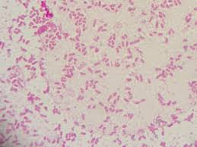
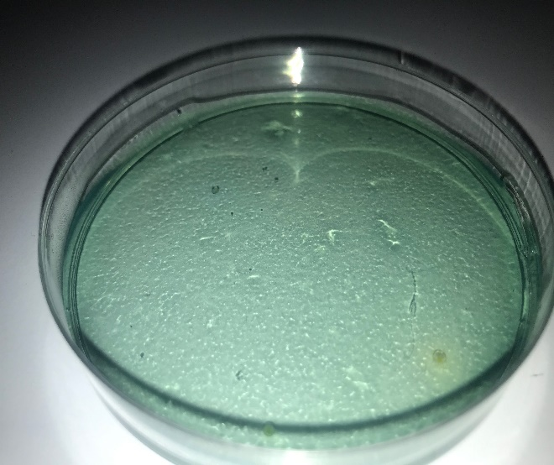
Ex: UTI( proteus mirabilis) : on culture and by gram stain

Result
Effect of Gender differences on prevalence and microbial spectrum of asymptomatic bacteriuria…
Have 24 samples
12 males and 12 females.
have 9 male samples and 2 female samples
3 male samples and 10 female samples has bacterial growth.

Gender * CFUcat Crosstabulation
 |  |  | CFUcat |  | Total
 |  |  | no growth | growth | Total
Gender | male | Count | 9 | 3 | 12
Gender | male | Expected Count | 5.5 | 6.5 | 12.0
Gender | male | % within Gender | 75.0% | 25.0% | 100.0%
Gender | male | % within CFUcat | 81.8% | 23.1% | 50.0%
Gender | female | Count | 2 | 10 | 12
Gender | female | Expected Count | 5.5 | 6.5 | 12.0
Gender | female | % within Gender | 16.7% | 83.3% | 100.0%
Gender | female | % within CFUcat | 18.2% | 76.9% | 50.0%
Total |  | Count | 11 | 13 | 24
 |  | Expected Count | 11.0 | 13.0 | 24.0
 |  | % within Gender | 45.8% | 54.2% | 100.0%
 |  | % within CFUcat | 100.0% | 100.0% | 100.0%

Chi-Square Tests

 | Value |  | df | Asymptotic Significance (2-sided) | Exact Sig. (2-sided) | Exact Sig. (1-sided)
Pearson Chi-Square |  | 8.224ª | 1 | .004
Continuity Correction^{b} |  | 6.042 | 1 | .014
Likelihood Ratio |  | 8.795 | 1 | .003
Fisher's Exact Test |  |  |  |  | .012 | .006
Linear-by-Linear Association |  | 7.881 | 1 | .005
N of Valid Cases |  | 24

P-value greater than alpha 0.05, fail to reject the null hypothesis
The p-value it was 0.004 = significant.

Discussion
The presence of bacteria in the urine (a positive urine culture) without the signs and symptoms of a urinary tract infection is known as asymptomatic bacteriuria (UTI).and in different between UTI and ASB is be difficult ³. Bacteria in the urine is frequent in the elderly, and while there is a risk of morbidity or mortality from ABU in older persons, the majority of cases of ABU resolve spontaneously. In reality, germs may be present in the urine of 15%–30% of men and 25%–50% of women in long-term care facilities without causing any symptoms. ¹
Premenopausal and non-pregnant women, as well as 2.8-8.6% of postmenopausal women, are affected by ABU (aged 50-70 years). ABU is linked to an increased prevalence of urinary tract infections in these people. ^{1,4}
The difference in asymptomatic bacteriuria incidence between men and women has a P-value of (0.004), which is significant because it is less than the national average (0.05). As a result, females experience asytomatic bacteriuria at a far higher rate than males.

Conclusion
Asymptomatic bacteriuria is presence of bacteria in the urine without sign and symtoms, in most cases it resolves spontaneously, In conclusion females have a higher risk of asymptomatic bacteriuria and other UT infections because of shortness of urethra.
References
- 1. Nicolle LE, Gupta K, Bradley SF, Colgan R, DeMuri GP, Drekonja D, et al. Clinical Practice Guideline for the Management of Asymptomatic Bacteriuria: 2019 Update by the Infectious Diseases Society of Americaa. Clin Infect Dis. 2019 Mar 21. 40(5):643-54.
- 2. Cuttitta F, Torres D, Vogiatzis D, Buttà C, Bellanca M, Gueli D, et al. Obesity and iron deficiency anemia as risk factors for asymptomatic bacteriuria. Eur J Intern Med. 2014 Mar. 25(3):292-5.
- 3. Martino FK, Novara G. Asymptomatic Bacteriuria or Urinary Tract Infection? New and Old Biomarkers. International Journal of Translational Medicine. 2022; 2(1):52-65
- 4. US Preventive Services Task Force., Owens DK, Davidson KW, Krist AH, Barry MJ, Cabana M, et al. Screening for Asymptomatic Bacteriuria in Adults: US Preventive Services Task Force Recommendation Statement. JAMA. 2019 Sep 24. 322 (12):1188-1194
- 5. Bigotte Vieira M, Alves M, Costa J, Vaz-Carneiro A. [Bacteriuria. Cochrane Database Syst Rev. 2015;4:CD009534.] Acta Med Port. 2018 Feb 28;31(2):76-79.

