
The Libyan International Medical University
Faculty of Applied Medical Science

Laboratory Examination for Urinary Tract Infection


Abrar Khaled Albarasi

2955

supervised by : Dr.Intisar Al harmi , prof. Naji Al Hamri and Dr. Sanusi sharif

Abstract
Urinary tract infection (UTI) is a common infection in both genders, with women having a higher prevalence, pregnancy increases the occurrence of the infection due to a variety of physiological changes that occur during the course of pregnancy. Furthermore, age is an important factor. UTI can occur due to different organisms but the most common one is Escherichia coli (E.coli) which causes about 70% of cases . UTI can be classified in to complicated and non-complicated UTI.
A urinalysis is used to detect and manage a wide range of disorders, such as urinary tract infections and kidney disease. Abnormal urinalysis results may point to a disease or illness.The aim of this study is to analyze a urine sample using a standard urinalysis . Multiple methods of urinalysis are done to be acquainted of the different organisms that causes UTIs. This included physical appearance of the urine sample , biostatistic study was done to know if the UTI are common in males or females.

Introduction

A urinary tract infection (UTI) refers to any infection that affects the urinary tract, including the kidneys, ureters, bladder, and urethra. The urinary tract is divided into two sections: upper (kidneys and ureters) and lower (urinary bladder and urethra ). is one of the most common infections treated in primary care(1).Enteric bacteria Gram-negative bacteria that are part of the intestinal microbiota are the most common cause of urinary tract infections. Escherichia coli causes about 70% of cases; other bacteria from the intestinal tract, such as Proteus and Klebsiella, cause about 10% of UTIs. Nonintestinal bacteria, such as Pseudomonas and Staphylococcus, occasionally cause UTIs.(2)

Adult males under the age of 50 have a low incidence of UTIs, while adult women are 30 times more likely than men to develop a UTI.Almost half of females have had at least one episode of UTI in their lifetime. It is estimated that 3one in every three women will experience their first episode of UTI by the age of 24.(1) Infants, pregnant women, the elderly, patients with spinal cord injuries and/or catheters, patients with diabetes, patients with acquired immunodeficiency syndrome/human immunodeficiency virus, are all at increased risk of UTI, most common in sexually active young females. Today urinalysis continues to be a powerful tool in obtaining crucial information for diagnostic purposes in UTI.

Appropriate classification of UTI as uncomplicated and complicated. Uncomplicated UTI infection in a healthy, non-pregnant, pre-menopausal female patient with a normal urinary tract anatomically and functionally, it can be treated with oral antibiotics such as; trimethoprim/sulfamethoxazole, ciprofloxacin, nitrofurantoin.Complicated UTI infection associated with factors that promote colonization and reduce therapy efficacy.
This report aims to know are UTI common in male or female.

Materials
1.urine sample.
2..bunsen burner.
3.calibrated wire loop.
4.agar plate.

Method
A sufficient urine sample was collected from a patient, and the urine was examined
using various methods. initially a physical examination( visual exam appearance)was carried out , to check the color of the urine and its appearance after this step was complete a calibrated wire loop was flamed and then the urine sample was mixed the next step was to vertically insert loop into the urine to allow the urine to adhere to the loop and then the urine had been spread over the surface of the agar plate and then without flaming the loop was inserted vertically into the urine again to transfer of loopful to a second plate the agar plate had been incubated for 24hr at 37 C in the air finally, Colonies are counted on each plate.

Result and statistical

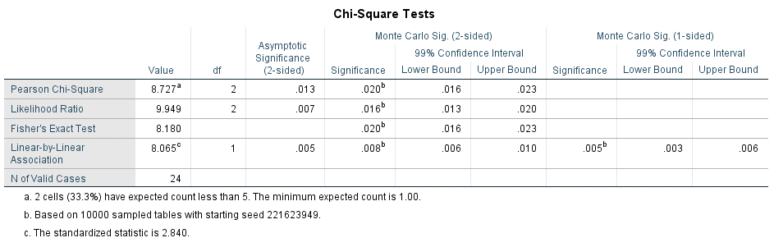

bacterialgrowth * Gender Crosstabulation
 |  |  | Gender |  | Total
 |  |  | Male | Female | Total
bacterialgrowth | 1.00 | Count | 9 | 2 | 11
bacterialgrowth | 1.00 | % within bacterialgrowth | 81.8% | 18.2% | 100.0%
bacterialgrowth | 1.00 | % within Gender | 75.0% | 16.7% | 45.8%
bacterialgrowth | 2.00 | Count | 3 | 8 | 11
bacterialgrowth | 2.00 | % within bacterialgrowth | 27.3% | 72.7% | 100.0%
bacterialgrowth | 2.00 | % within Gender | 25.0% | 66.7% | 45.8%
bacterialgrowth | 3.00 | Count | 0 | 2 | 2
bacterialgrowth | 3.00 | % within bacterialgrowth | 0.0% | 100.0% | 100.0%
bacterialgrowth | 3.00 | % within Gender | 0.0% | 16.7% | 8.3%
Total |  | Count | 12 | 12 | 24
 |  | % within bacterialgrowth | 50.0% | 50.0% | 100.0%
 |  | % within Gender | 100.0% | 100.0% | 100.0%

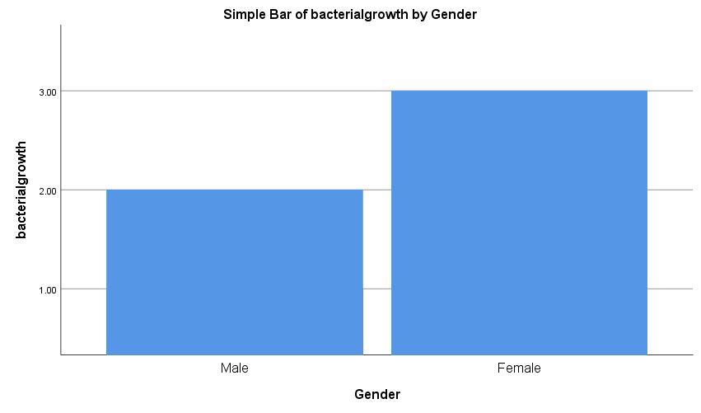 2.9 percent of the 1594 patients whose urine cultures, urinalysis, or gram stain were processed throughout the trial were excluded, and 0.1 percent of the patients were excluded due to regular catheterization. The remaining 1546 patients were 45 percent female, with a median age of 3 months.A pathogen was found in 12 percent of the patients' cultures.The sensitivity and specificity of pyuria were 73.2 percent and 95.1 percent, respectively, while the gram stain had a sensitivity and specifically of 81.4 percent and 98.2 percent, respectively, of the 183 positive urine cultures. Bacteria recovered were E. coli, klebsiella spp.

Discussion
First and foremost, I knew from the data table that bacteria are discovered more frequently in women than in men. 2.9 percent of the 1594 patients whose urine cultures, urinalysis, or gram stain were processed throughout the trial were excluded, and 0.1 percent of the patients were excluded due to regular catheterization. The remaining 1546 patients were 45 percent female, with a median age of 3 months.A pathogen was found in 12 percent of the patients' cultures.The sensitivity and specificity of pyuria were 73.2 percent and 95.1 percent, respectively, while the gram stain had a sensitivity and specifically of 81.4 percent and 98.2 percent, respectively, of the 183 positive urine cultures. Bacteria recovered were E. coli, klebsiella spp.
Sex-based differences influence incidence and outcome of infectious disease. Women have a significantly greater incidence of urinary tract infection (UTI) than men, yet, conversely, male UTI is more persistent with greater associated morbidity. Mechanisms underlying these sex-based differences are unknown, in part due to a lack of experimental models. We optimized a model to transurethrally infect male mice and directly compared UTI in both sexes. Although both sexes were initially equally colonized by uropathogenic E. coli, only male and testosterone-treated female mice remained chronically infected for up to 4 weeks. Female mice had more robust innate responses, including higher IL-17 expression, and increased γδ T cells and group 3 innate lymphoid cells in the bladder following infection. Accordingly, neutralizing IL-17 abolished resolution in female mice, identifying a cytokine pathway necessary for bacterial clearance. Our findings support the concept that sex-based responses to UTI contribute to impaired innate immunity in males and provide a rationale for non-antibiotic-based immune targeting to improve the response to UTI.

Infectious illness incidence and outcome are influenced by gender variations. Although women have a higher rate of urinary tract infection (UTI) than males, male UTIs are more persistent and have higher related morbidity. Because of a dearth of experimental models, the mechanisms underlying these sex-based differences remain unknown. We developed a model to infect male mice transurethrally and compared UTIs in both sexes. Despite the fact that uropathogenic E. coli colonized both sexes equally at first, only male and testosterone-treated female mice remained chronically infected for up to 4 weeks.Following infection, female mice displayed more powerful innate responses, with higher IL-17 expression and more T cells and group 3 innate lymphoid cells in the bladder.
As a result, blocking IL-17 stopped resolution in female mice, indicating the existence of a cytokine pathway involved in bacterial clearance.
Our data support the idea that sex-based responses to UTIs contribute to male innate immunity impairment and provide a justification for immune targeting that isn't antibiotic-based to improve UTI response.
Diagnosis and Tests for Urinary Tract Infections
If you suspect you have a urinary tract infection, see your doctor. You'll give a urine sample to be tested for UTI-causing bacteria.
An ultrasound, CT scan, or MRI scan may be performed to check further if you have recurring UTIs and your doctor suspects a problem with your urinary tract. A cystoscope, a long, flexible tube, may be used to inspect your urethra and bladder
reatments for Urinary Tract Infections .

Antibiotics are the most popular treatment for urinary tract infections if your doctor feels you need them. Always remember to take all of your recommended medications, even if you're feeling better. To help remove the bacteria from your body, drink plenty of water. Your doctor may also prescribe a pain reliever for you. A heating pad could be beneficial.

Cranberry juice is frequently touted as a way to prevent or cure urinary tract infections. The tannin in the red berry may inhibit E. coli bacteria, the most common cause of urinary tract infections, from adhering to the bladder's walls, where they might cause infection. However, research has showed that it does not significantly reduce infection rates. Experts are also researching new strategies to treat and prevent UTIs, such as vaccines and immune-boosting supplements, as well as hormone replacement therapy for postmenopausal women.

.

Conclusion

In conclusion, the Urinary tract infection (UTI ) is a common bacterial infection known to
affect the different parts of the urinary tract and the occurrence is found in both males
and females but most common in females dependent on the biostatistics. UTI mostly caused by E.coli. To treat the UTI we should firstly culture the organism and do an antibiotic sensitivity test before we gave the treatment because by this the way we will give the exact antibiotic to the patient and we will avoid the resistance of antibiotics.

Reference

1.chee wei Tan, macijpiotr chlebbicki ,et al.urinary tract infection in adults.Singapore Med J. 2016 Sep; 57(9): 485–490 p.p. 485.
2 Robert w. Bauman , ‘microbial diseases of the urinary and reproductive systems’,4th edition . microbiology with disease by body system , P.P.485
3.Haber MH. Piesse prophesy: a brief history of urine analysis. Clin Lab Med 1988; 8: 415-430.
4.. Misdraji J, Nguyen PL. Urine analysis. When--and when not--to order . Postgrad Med. 1996;
100:173-6, 181-2, 185-8
5.Levinson, Warren. Review of medical
microbiology and immunology. 13rd ed. The
McGraw-Hill Companies, 2014.
6.Al-Badr A, Al-Shaikh G. Recurrent Urinary Tract Infections Management in Women: A review. Sultan Qaboos Univ Med J. 2013 Aug;13(3):359-67. doi: 10.12816/0003256. Epub 2013 Jun 25. PMID: 23984019; PMCID: PMC3749018
7.Haber MH. Piesse prophesy: a brief history of urine analysis. Clin Lab Med 1988; 8: 415-430.

