

The Effect of Gender Differences on Prevalence and Microbial Spectrum of Asymptomatic Bacteriuria
Ala Elallegy 3110
The Libyan International Medical University
Faculty of Applied Medical Sciences
Supervised By: Dr. Asma Elkawafi & Dr. Alsenussi Alsharif

Abstract
We conducted an experiment to test whether someone’s gender influences their risk of acquiring asymptomatic bacteriuria. We started off by collecting 12 urine samples from female students and 12 from male students, these were students from the Libyan International Medical University. We then cultured those samples and counted the colony-forming units on each plate after leaving them overnight. We found that there were more colonies on the samples we obtained from the females compared to the ones from the males. This was predicted as we are aware of the many factors that put females at higher risk for acquiring such infections. To see whether the growths were significant or not we ran the results through statistical software and we concluded that only a small fraction was significant and that the entire small fraction came from the female samples.

Introduction
Asymptomatic bacteriuria is defined as the detection of bacteria in an individual’s urine sample without showing any symptoms of a urinary tract infection.¹ The bacteria are detected by performing a general urine exam that shows at least 100,000 colonies of a certain bacteria. The most common causative agent is Escherichia Coli. The term bacteriuria is not restricted to asymptomatic bacteriuria, rather it is also used to characterize symptomatic urinary tract infections based on the count of bacteria in a sample as well as the patient's clinical representation. A common misconception that most people believe to be a differentiating factor between asymptomatic bacteriuria and urinary tract infections is pyuria.³ Pyuria refers to the presence of white blood cells in the urine and is a characteristic finding of urinary tract infections but is also often found in asymptomatic bacteriuria. ³ Another misconception is that only urinary tract infections produce cloudy, foul-smelling urine, but it was found that these changes also occur in asymptomatic bacteriuria.³

According to Deepak S. Ipe, although clinical treatment is not recommended for asymptomatic bacteriuria, there are some exceptions. Pregnant women and patients undergoing invasive genitourinary procedures are treated for them because of the complications.² Also, the treatment for subsequent secondary urinary tract infections is not efficient so its avoidance is the best thing.² On the other hand, Donald N. Givler mentioned another group of individuals that includes patients that are within the first three months following a renal transplant procedure.¹ Most articles agree that pregnant women need to be treated but some of them differ in what the other exceptions are.

There are multiple entrances that pathogens can take to cause infection in the urinary tract. From those entrances, the pathogens will end up in one of two places, either the urinary bladder or the kidneys which will be considered the infection’s site of origin.² As we know the anatomy of males and females differs slightly in certain organ systems. Regarding our topic, the difference of major concern is that of the length of the urethra, which plays a great role in the increased incidence in females. There are many other factors that contribute to the increased prevalence in females that we will be discussing later in the report. The goal of this experiment is to determine what the effect of an individual’s gender is on the prevalence of asymptomatic bacteriuria and whether it plays a role in what microbes cause it. We’re predicting that females are at higher risk of acquiring asymptomatic bacteriuria than males and we’re going to prove this by using software that uses statistical analysis.

Materials and Methods
We started by selecting 24 medical students that had no signs or symptoms of urinary tract infection from the Libyan International Medical University, 12 females and 12 males. We provided those individuals with a urine sample cup and gave them instructions on the best way to collect the urine as well as the best time, which is the mid-stream clean catch method taken first thing in the morning. We then asked them to label the cups with their name and the date that the sample was taken. After obtaining the samples we needed to separate the different contents of the urine sample and to do so we placed 5 to 10 mL of each sample in separate centrifuge test tubes and put them into the centrifuge.⁴ Once the sediment we needed was suspended, we flamed a 0.01 microlitres wire loop and vertically inserted it into the sample and spread it over MacConkey agar plates in a zigzag pattern.⁴ We made sure to flame the wire loop between culturing each sample. After all the plates were ready, we placed them in an incubator for 24 hours at 37°C. When the 24 hours were finished, we counted the number of colonies on each plate and multiplied it by 100 to see how many microorganisms there were per millilitre.⁴ For the statistical part of our procedure, we used the Fisher’s Exact test on Statistical Package for Social Sciences which is a statistical software developed by International Business Machines to help us with the development of our data.

Results and Statistical Analysis
After performing the Fisher’s Exact test, we obtained a P-value (table 3 & 4). This value was 0.02, which is less than 0.05 and this means we can reject the null hypothesis. The null hypothesis states that there is no association between males and females and the prevalence of asymptomatic bacteriuria. The value of plates that had no growth for males and females were 75% and 16.7% respectively (table 2). This difference is quite large and coincides with all the factors that we mentioned to support our prediction, so we can say that there is an association between gender and the prevalence of asymptomatic bacteriuria. The category that had insignificant growth was 25% in males and 66.7% in females, and this also is a result that was expected (table 2). The last category was for significant growth, and there was none for the males and 16.7% for the females (table 2). The 16.7% is somewhat a small percentage but this was because of the sample size. If we had a larger sample, the number of significant growths for females would have been higher. The overall difference for the growth was 10:3, with females having the ten growth samples which are more than double that of the males proving that gender makes a big difference.

Statistical Tables
Table 1
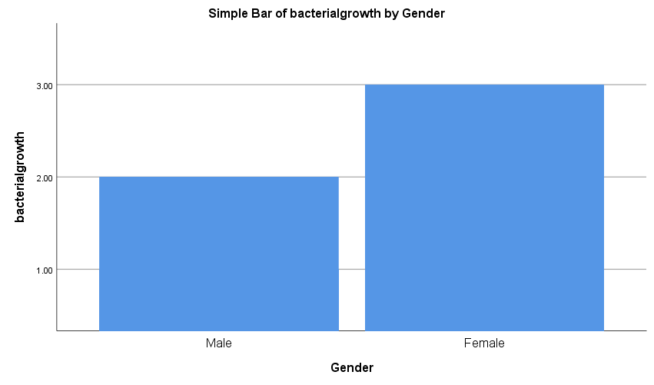
Table 2
Bacterial Growth * Gender Crosstabulation
 |  |  | Gender |  | Total
 |  |  | Male | Female | Total
Bacterial growth | 1.00 | Count | 9 | 2 | 11
Bacterial growth | 1.00 | % within bacterial growth | 81.8% | 18.2% | 100.0%
Bacterial growth | 1.00 | % within Gender | 75.0% | 16.7% | 45.8%
Bacterial growth | 2.00 | Count | 3 | 8 | 11
Bacterial growth | 2.00 | % within bacterial growth | 27.3% | 72.7% | 100.0%
Bacterial growth | 2.00 | % within Gender | 25.0% | 66.7% | 45.8%
Bacterial growth | 3.00 | Count | 0 | 2 | 2
Bacterial growth | 3.00 | % within bacterial growth | 0.0% | 100.0% | 100.0%
Bacterial growth | 3.00 | % within Gender | 0.0% | 16.7% | 8.3%
Total |  | Count | 12 | 12 | 24
 |  | % within bacterial growth | 50.0% | 50.0% | 100.0%
 |  | % within Gender | 100.0% | 100.0% | 100.0%

Table 3
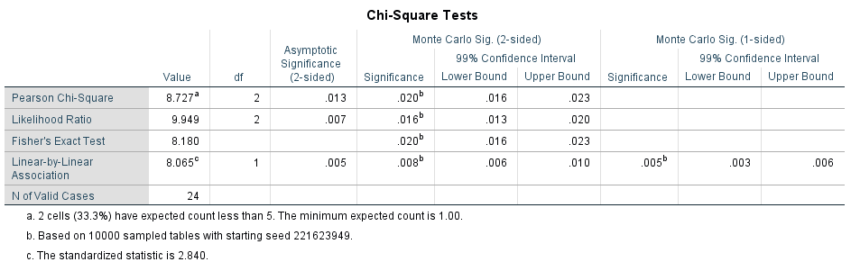

Table 4
Summary Table
Gender | No growth | Non-significant growth | Significant growth | p-value
Female | 2 (16.7%) | 8 (66.7%) | 2 (16.7%) | 0.020
male | 9 (75%) | 3 (25%) | 0 (0%) | 0.020

Discussion
There were some plates that showed growth and others that did not. To determine whether the growth was significant or not we had to count the number of colonies on each plate. Since we used the 0.01 microlitre wire loop and not the 0.001, we multiplied the colony-forming units by 100 instead of 1000. Out of the 24 samples we obtained, only 13 of them had growth therefore we considered the remaining 11 cultures to be negative cultures. Of the 13 colonies, 10 were samples collected from females, a fact that is quite predictable considering the increased prevalence in females compared to males. There are many factors that account for this and one of them is the anatomical differences between the male and female genitourinary systems.² The male urethra is approximately 20 cm in length while the female urethra is only about 3 to 4 cm in length. The urethra is composed of cells that aid in the prevention of infections, the longer it is, the more the bacteria must travel and the longer they’re exposed to those cells that can eradicate them. This means that logically, females are more susceptible to infection via this pathway due to the significant difference in their urethral length. The way that the sample was taken makes a difference in what values are considered significant or not. As stated previously, we asked the individuals to take the sample using the mid-stream clean catch method. The colonies that are
1 × 10⁵ CFU/µL are said to be significant growth for the type of method that was used for this experiment. Regarding the software we used to analyze our findings, we tried three different tests. Initially, we tried to perform the T-test, but it did not work because the number of samples was too small and was not variable. We then resorted to the Pearson Chi-Square test where we discovered that even this test could not be used due to the sample size and because one of the assumptions was not met. Our last option was an alternative for the Chi-Square test called the Fisher’s Exact test. Since the numbers were exact, we categorized them into three categories from zero to 99.9 which is no growth, from 100 to 99999 which is growth and lastly anything above 100000 which is considered significant growth. The majority of samples obtained from males had no growth on them and the majority of the female samples had growth but only two of them were significant. These findings are consistent with our assumption that there is a significant difference between genders in the prevalence of asymptomatic bacteriuria.

Conclusion
This experiment was conducted to test whether someone’s gender has a significant effect on the prevalence of asymptomatic bacteriuria. After selecting the individuals whom we needed to collect urine samples from and following the proper steps to achieve the most accurate results, we found that there was a difference between the two genders' samples. We cannot say that this difference was significant yet because the sample that we had was not large. This sample size set us back and we struggled to find the appropriate statistical test to use for the small sample. This difference was only concluded to be significant after running it through statistical software and performing the Fisher’s Exact test that provided us with the necessary results to confirm our hypothesis. Now we can confidently and firmly say that gender has a significant effect on the prevalence of asymptomatic bacteriuria among individuals and that females are at much greater risk due to many underlying factors. (159)

References
1. Givler D, Givler A. Asymptomatic Bacteriuria. Ncbi.nlm.nih.gov. https://www.ncbi.nlm.nih.gov/books/NBK441848/. Published 2022. Accessed June 19, 2022.

2. Ipe D, Sundac L, Benjamin W, Moore K, Ulett G. Asymptomatic bacteriuria: prevalence rates of causal microorganisms, etiology of infection in different patient populations, and recent advances in molecular detection.

3. Youtube.com. https://www.youtube.com/watch?v=Ul22yigy0Nw. Published 2022. Accessed June 19, 2022.

4. Alnagi E. Urine Analysis Culture and Sensitivity. urine C-S lab.pptx. Google Docs. https://docs.google.com/presentation/d/1B3lqmzALvMpRBJJePhyn_cXrF5dISN57/edit#slide=id.p1. Published 2022. Accessed June 19, 2022.

5. Alsharif A. Lab 5: Contingency Table Analysis (Chi-Square Analysis) Portal.limu.edu.ly. http://portal.limu.edu.ly/pluginfile.php/100931/mod_resource/content/1/LAB5_Chi_square%20%281%29.pdf. Published 2022. Accessed June 19, 2022.

