Libyan International Medical University

Faculty of Basic Medical Science
Rate of incidence of bacteiruria among LIMU student
Name: Mohamed Ramadan alzayani
Student no:2712

Abstract:
asymptomatic bacteriuria is a bacteria that does not cause any serious diseases and it is preferable not to treat it in order not to form resistance to the normal flora of the body.
It affects females and elderly people more than males, and this is due to the difference in the reproductive system between males and females
The main cause of bacteriuria is Escherichia coli, and Klebsiella pneumoniae, Pseudomonas aeruginosa, Staphylococcal, and Enterococcal species are among the other pathogens of the disease.

Introduction:
Bacteria are present on almost every surface, living or non-living, and almost all bacteria are harmless except for a relatively small percentage.
These bacteria either cause symptoms and damage or do not cause any symptoms and cause harm to the human body, and this report talks about the second type in the urinary system.
In general, normal human urine is sterile and does not contain bacteria. When we find a large percentage of bacteria in the urine and there are no symptoms of any disease, this is called asymptomatic bacteriuria, Most patients with asymptomatic bacteriuria will never develop symptomatic urinary tract infections and will have no adverse consequences from asymptomatic bacteriuria, According to some studies, it was found that women are more susceptible to bacteriuria than men, due to the difference in the reproductive system between women and men.
And bacteriuria often does not cause any diseases and does not cause any side effects, and this means that it does not need to be treated except in some cases, such as pregnancies because it may cause serious conditions to the fetus and the mother, and in transplant kidney the patient should not undergo treatment in order to avoid antibiotic resistance.

Materials and methods:
1-heat a calibrated wire loop.
2-Mix the urine right.
3-insert the loop vertically into the urine to allow the urine adhere to the loop.
4-spread the urine over all the surface of the agar plate.
5- without flaming insert the loop vertically into the urine again to transfer of loopful to a second plate.
6- incubate for 24 hour at 37 C in air Colonies are counted on each plate.
Note: The number of Colony Forming Units is multiplied by 1000( if a 0.001 ml loop used) or by 100 (if a 0.01 ml loop was used) to determine the number of microorganisms per ml in the original specimen.

Results and Statistical analysis:


Table one.

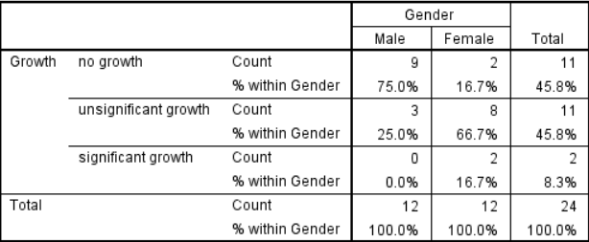
Table two.
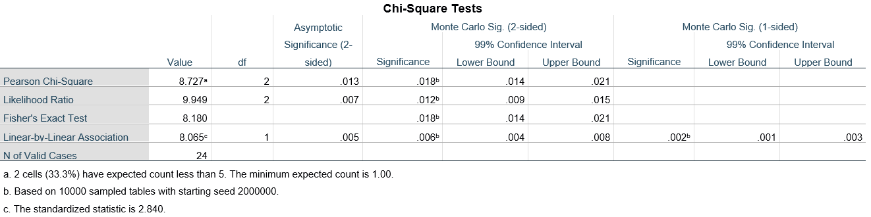
Table three.


Graph one


Table four.

As shown in Table 1, there is a link between the gender and the asymptomatic bacteriuria, to see if this link is significant, a Chi-Square test was used. The hypothesis was that there is a clear link between the two variables between the gender and the asymptomatic bacteriuria, while the null hypothesis states that there is none. However, the assumption of less than 20% of the cells having an expected value of less than five was not met, so a fisher test was used instead.
Because the p-value was less than 0.05 in Table 3, we reject the null hypothesis, meaning that there is a link between gender and the prevalence of bacteriuria.

Discussion:
All theoretical results support that there is a relationship between sex and bacteriuria. Females have a higher rate of infection than males, as shown in Chart 1, where 75 percent of males have no growth at all, and 25 percent have unremarkable growth, and no None of them were positive for asymptomatic bacteriuria, while only about 17 percent of females had no growth, 67 percent had unremarkable growth, and about 17 percent were positive for asymptomatic bacteriuria.
This is due to many factors, including the anatomical configuration of the female urinary tract. Females have a smaller urethra, which is responsible for removing urine from the body. Bacteria enter the urinary tract through the urethra, and a shorter urethra makes it easier for bacteria to enter because they have to travel a shorter distance. Another factor is the proximity of the urethra to the rectum, which harbors Escherichia coli, the most common cause of asymptomatic bacterial urine and urinary tract infections (UTIs). Females are more likely to have UTIs and asymptomatic bacteriuria due to the physical anatomy of the reproductive system.
In older women after menopause, the risk of developing asymptomatic bacteriuria increases due to the lack of estrogen hormone, which leads to weakness in the vaginal muscle and thus is more susceptible to infection, and because of the change in hormones, pregnancy increases the risk of asymptomatic bacteriuria, which It can lead to vesicoureteral reflux, which means urine flows back into the bladder and then into the kidney. This increases the risk of developing pyelonephritis, which is dangerous. Some medications, such as spermicide, increase the risk of asymptomatic bacteriuria by causing irritation of the vagina, which can create a favorable environment for the development of bacteria.
Most people with asymptomatic bacteriuria do not show any symptoms of the disease, and among those infected are children, diabetics and the elderly.
People who undergo urological surgery and are at risk of mucosal bleeding should be treated, and patients who have had a kidney transplant should be treated within the first three months after surgery, and pregnant women should also be treated to avoid pyelonephritis, low birth weight and premature birth. It is best not to treat people who do not need treatment as this increases the potential for antibiotic resistance.
Escherichia coli is the most common cause of asymptomatic bacteriuria, This is because the Escherichia coli is a normal part of the colon's flora. Klebsiella pneumoniae, Pseudomonas aeruginosa, Staphylococcal, and Enterococcal species are among the other pathogens of the disease.

Conclusion and future directions:
In the summary of this report, and according to most studies on asymptomatic bacteriuria, we see that females have a higher rate of infection than males, and this is due to the difference in the reproductive system between them. In most cases, asymptomatic bacteriuria does not develop into a serious disease except in a few rare cases.
Thus, we do not have to treat it, because its treatment may cause bacteria in the body to become resistant to antibiotics, except in certain necessary circumstances, such as a pregnant woman, because it is possible to infect the mother or fetus with serious diseases and kidney transplant patients.
More research could be done if bacteriuria is related to hormones such as estrogen or diseases such as acquired immunodeficiency virus.

References:
1.Ditkoff EL, Theofanides M, Aisen CM, Kowalik CG, Cohn JA, Sui W, Rutman M, Adam RA, Dmochowski RR, Cooper KL. Assessment of practices in screening and treating women with bacteriuria. Can J Urol. 2018 Oct;25(5):9486-9496. [PubMed]
2.Averbeck MA, Rantell A, Ford A, Kirschner-Hermanns R, Khullar V, Wagg A, Cardozo L. Current controversies in urinary tract infections: ICI-RS 2017. Neurourol Urodyn. 2018 Jun;37(S4):S86-S92. [PubMed]
3.Wullt B, Sundén F, Grabe M. Asymptomatic Bacteriuria is Harmless and Even Protective: Don't Treat if You Don't Have a Very Specific Reason. Eur Urol Focus. 2019 Jan;5(1):15-16. [PubMed]
4.Bigotte Vieira M, Alves M, Costa J, Vaz-Carneiro A. [Bacteriuria. Cochrane Database Syst Rev. 2015;4:CD009534.] Acta Med Port. 2018 Feb 28;31(2):76-79. [PubMed]
5.Dahiya A, Goldman RD. Management of asymptomatic bacteriuria in children. Can Fam Physician. 2018 Nov;64(11):821-824. [PMC free article] [PubMed]
6.Albu S, Voidazan S, Bilca D, Badiu M, Truţă A, Ciorea M, Ichim A, Luca D, Moldovan G. Bacteriuria and asymptomatic infection in chronic patients with indwelling urinary catheter: The incidence of ESBL bacteria. Medicine (Baltimore). 2018 Aug;97(33):e11796. [PMC free article] [PubMed]
7.Moore A, Doull M, Grad R, Groulx S, Pottie K, Tonelli M, Courage S, Garcia AJ, Thombs BD., Canadian Task Force on Preventive Health Care. Recommendations on screening for asymptomatic bacteriuria in pregnancy. CMAJ. 2018 Jul 09;190(27):E823-E830. [PMC free article] [PubMed]
8.Medley N, Vogel JP, Care A, Alfirevic Z. Interventions during pregnancy to prevent preterm birth: an overview of Cochrane systematic reviews. Cochrane Database Syst Rev. 2018 Nov 14;11:CD012505. [PMC free article] [PubMed]
9.Coussement J, Maggiore U, Manuel O, Scemla A, López-Medrano F, Nagler EV, Aguado JM, Abramowicz D., European Renal Association-European Dialysis Transplant Association (ERA-EDTA) Developing Education Science and Care for Renal Transplantation in European States (DESCARTES) working group and the European Study Group for Infections in Compromised Hosts (E. COLLABORATORS (IN ALPHABETICAL ORDER). European Renal Association-European Dialysis Transplant Association (ERA-EDTA) Developing Education Science and Care for Renal Transplantation in European States (DESCARTES) working group and the European Study Group for Infections in Compromised Hosts (ESGICH) of the European Society of Clinical Microbiology and Infectious Diseases (ESCMID). Diagnosis and management of asymptomatic bacteriuria in kidney transplant recipients: a survey of current practice in Europe. Nephrol Dial Transplant. 2018 Sep 01;33(9):1661-1668. [PubMed]
10.Kulchavenya E. Editorial Comment to Role of increasing leukocyturia for detecting the transition from asymptomatic bacteriuria to symptomatic infection in women with recurrent urinary tract infections: A new tool for improving antibiotic stewardship. Int J Urol. 2018 Sep;25(9):806-807. [PubMed]
11.Keller SC, Feldman L, Smith J, Pahwa A, Cosgrove SE, Chida N. The Use of Clinical Decision Support in Reducing Diagnosis of and Treatment of Asymptomatic Bacteriuria. J Hosp Med. 2018 Jun 01;13(6):392-395. [PMC free article] [PubMed]
12.Skelton F, Martin LA, Evans CT, Kramer J, Grigoryan L, Richardson P, Kunik ME, Poon IO, Holmes SA, Trautner BW. Determining Best Practices for Management of Bacteriuria in Spinal Cord Injury: Protocol for a Mixed-Methods Study. JMIR Res Protoc. 2019 Feb 14;8(2):e12272. [PMC free article] [PubMed]

