Libyan international medical university
Faculty of applied medical sciences

Effect of gender differences on prevalence of asymptomatic bacteriuria

Student name : Hadel Milad Ali
Student number : 2731

Abstract
Urinary tract infection (UTI) is a common bacterial illness that affects many sections of the urinary tract, and it can affect both men and women.
Although both men and women are susceptible to the illness, women are more sensitive due to their anatomy and reproductive system.
Bacterial invasion of the urinary tract, comprising the lower and upper urinary tract, is the most common cause of infection.
Escherichia coli is the most common bacterial species, accounting for 80 to 85 percent of infections, followed by Staphylococcus species, which account for 10 to 15 percent.
the bacterial species Klebsiella, Pseudomonas, Proteus, and Enterococcus have a limited role in the transmission of illness.

Introduction
Asymptomatic bacteriuria is a common clinical condition that often leads to unnecessary treatment.
It has been shown that incidence of asymptomatic bacteriuria increases with age and are more prominent in women than men
asymptomatic bacteriuria is when you have bacteria in your urinary tract but you don’t have the symptoms that usually go along with UTIs.
Older adults are more likely than young people to have asymptomatic bacteriuria. People who have a urinary catheter – a small tube that is inserted into the bladder to drain it— also have an increased risk of having asymptomatic bacteriuria.
UTIs are common infections that happen when bacteria, often from the skin or rectum, enter the urethra, and infect the urinary tract.
The infections can affect several parts of the urinary tract, but the most common type is a bladder infection (cystitis)
Kidney infection (pyelonephritis) is another type of UTI.
Women are at greater risk of developing a UTI than are men. Infection limited to your bladder can be painful and annoying. However, serious consequences can occur if a UTI spreads to your kidneys

Doctors typically treat urinary tract infections with antibiotics. But you can take steps to reduce your chances of getting a UTI in the first place but more serious than bladder infections
Urinary tract infections don't always cause signs and symptoms, but when they do they may include :
A strong, persistent urge to urinate
A burning sensation when urinating
Passing frequent, small amounts of urine
Urine that appears cloudy
Urine that appears red, bright pink or cola-colored — a sign of blood in the urine
Strong-smelling urine
Pelvic pain, in women — especially in the center of the pelvis and around the area of the pubic bone
Urinary tract infections are prevalent in women, and many of them have many infections throughout their lives.
UTI risk factors that are particular to women include:
Anatomy of a woman A woman's urethra is shorter than a man's, reducing the distance bacteria must travel to reach the bladder
UTIs are more common in sexually active women than in non-sexually active women.
Having a new sexual partner raises your risk as well
Certain types of birth control are available. Women who use diaphragms for birth control, as well as those who use spermicidal drugs, may be at a higher risk
Menopause a decrease in circulating estrogen after menopause produces changes in the urinary tract that make you more susceptible to infection

Materials and method
-Sample of people and must they contain of men and women to collect the sample from them
-Collect the urine sample from them due to The urine flows out of the nephron tubule into a collecting duct.
It passes out of the kidney through the renal pelvis, into the ureter, and down to the bladder so the UTI infection found in the urine
-flame a calibrated wire loop
-Mix the urine
-insert the loop vertically into the urine to allow the urine adhere to the loop.
-spread the urine over the surface of the agar plate.
- without flaming insert the loop vertically into the urine again to transfer of loop fall to a second plate
Most bacteria will grow well using nutrient agar as a colony
After that will count the colony on the blood agar to know if the patient infected or not
After that use the antibiotic disc on the agar if the zone of inhibition ( clear zone around the antibiotic disc) appear that mean the microorganism sensitive to this type of antibiotic if not seen the mean the microorganism resistance to the antibiotic

Chi-Square Tests
 | Value | df | Asymptotic Significance (2-sided)
Pearson Chi-Square | 8.727ª | 2 | .013
Likelihood Ratio | 9.949 | 2 | .007
Linear-by-Linear Association | 8.065 | 1 | .005
N of Valid Cases | 24
a. 2 cells (33.3%) have expected count less than 5. The minimum expected count is 1.00.

CFUcat * Gender Crosstabulation
 |  |  | Gender |  | Total
 |  |  | Female | Male | Total
CFUcat | No growth | Count | 2 | 9 | 11
CFUcat | No growth | Expected Count | 5.5 | 5.5 | 11.0
CFUcat | No growth | % within Gender | 16.7% | 75.0% | 45.8%
CFUcat | Overall no significant growth | Count | 8 | 3 | 11
CFUcat | Overall no significant growth | Expected Count | 5.5 | 5.5 | 11.0
CFUcat | Overall no significant growth | % within Gender | 66.7% | 25.0% | 45.8%
CFUcat | Significant growth | Count | 2 | 0 | 2
CFUcat | Significant growth | Expected Count | 1.0 | 1.0 | 2.0
CFUcat | Significant growth | % within Gender | 16.7% | 0.0% | 8.3%
Total |  | Count | 12 | 12 | 24
 |  | Expected Count | 12.0 | 12.0 | 24.0
 |  | % within Gender | 100.0% | 100.0% | 100.0%

Case Processing Summary
 | Cases
 | Valid |  | Missing |  | Total
 | N | Percent | N | Percent | N | Percent
CFUcat * Gender | 24 | 64.9% | 13 | 35.1% | 37 | 100.0%

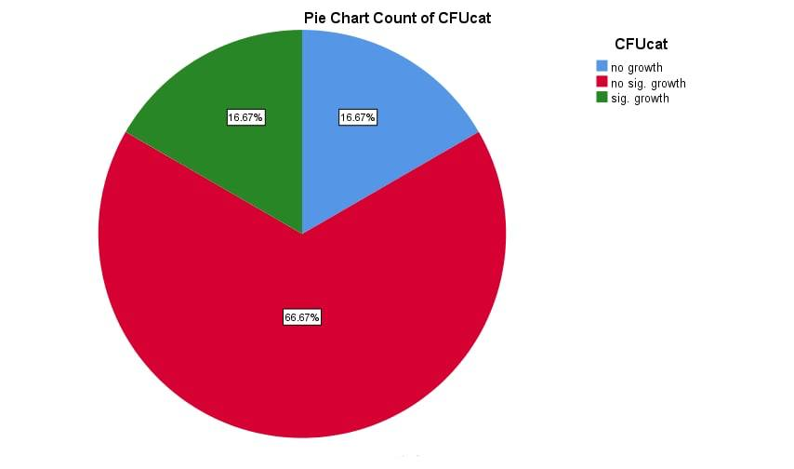

Males' results suggest that 60% of them have no bacteria growth and 40% have no statistical significance for bacterial growth. Females' results suggest that 39% have no statistical significance, while just 9% have statistical significance. The result: All of these antibiotics have resistances to E.coli except polymyxin and imipenem, according to the lab microbiology section, which means no growth in blood agar and macCKonKey agar, which means no bacteria in urine.
section on pharmacology
Prior to prescribing antibiotics, further study is required.
investigaton
routine examination (RBC)
special investigation (when RBC elevated and to know if bacteria recurrent )
Abdominal ultrasound and X-ray
Creatinine in the blood
Test for antibiotic sensitivity
Asymptomatic bacteriuria is the presence of bacteria in the properly collected urine of a patient that has no signs or symptoms of a urinary tract infection. Asymptomatic bacteriuria is very common in clinical practice.
While few infants and toddlers have asymptomatic bacteriuria, the incidence increases with age. The incidence is up to 15% or greater in women and men age 65 to 80 years and as high as 40% to 50% after age 80. Most patients with asymptomatic bacteriuria will never develop symptomatic urinary tract infections and will have no adverse consequences from asymptomatic bacteriuria. In an age when decreasing unnecessary antibiotic use is emphasized, the important clinical question is this: Which patients with asymptomatic bacteriuria benefit from treatment? The answer is that most patients with asymptomatic bacteriuria do not benefit from treatment. There are, however, a few exceptions. There is sufficient evidence that a pregnant woman with asymptomatic bacteriuria should be treated
UTI can also harm a donated kidney. In persons whose immune systems are impaired by drugs or disorders, a UTI can lead to a potentially lethal bloodstream infection. The immune system can be weakened as a result of cancer chemotherapy. Asymptomatic bacteriuria is also sometimes treated in persons who have specific types of kidney stones that can't be removed (and thus cause recurrent UTIs) or in those who are having a urinary tract surgical operation.
Doctors don't normally treat asymptomatic bacteriuria because it isn't frequently treated.

Conclusion
In women, UTIs are among the most common clinical bacterial infections. UTIs are less prevalent and are usually caused by the same disease reinfecting the body. Urinalysis, urine cultures, and other radiological techniques should be used to rule out reasons of recurrence and assess probable anatomical or functional urinary tract abnormalities in women who have RUTIs. Although antimicrobial medication is the standard of care for UTIs, there are other options for reducing antibiotic exposure, such as methenamine salts, probiotics, cranberry juice, immunoprophylaxis, and vaginal estrogens in postmenopausal women. In some patients, continuous antibiotic prophylaxis, postcoital prophylaxis, and acute self-treatment are cost-effective therapy options for reducing the frequency of UTIs.
Reference
1. Al-Badr A, Al-Shaikh G. Recurrent Urinary Tract Infections Management in Women: A review. Sultan Qaboos Univ Med J. 2013;13(3):359-367. doi:10.12816/0003256
2. Urinary tract infection (UTI) - Symptoms and causes [Internet]. Mayo Clinic. 2022 [cited 19 June 2022].
3. Urinary tract infections (UTIs) [Internet]. nhs.uk. 2022 [cited 19 June 2022].
4. Luu T, Albarillo FS. Asymptomatic Bacteriuria: Prevalence, Diagnosis, Management, and Current Antimicrobial Stewardship Implementations. Am J Med.

