Assignment to be submitted in Moodle
• Develop a network diagram for the project specified below. (50 %)
• Identify the Critical Activities and the total duration of the project. (35%)
• Justify which activity would you crash based on some rationale (15%)
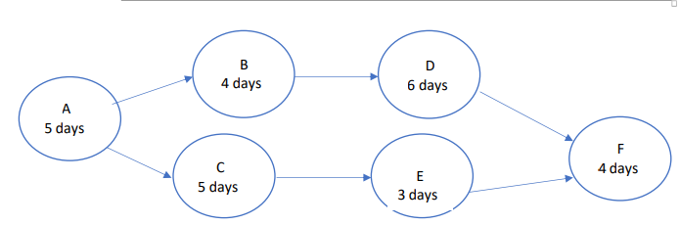

Pathway number A: A-B-D-F which will take approximately 19 days
Pathway number B: A-C-E-F Which will take approximately 17 days
The critical pathway is pathway number A because it is the longer than other
The activities which would be crashed those with low budget because when doubling the low budget activity that’s would reduce the duration to the half of the activity which in return make the project more faster with minimal or no loss of resources.
Name :ELTAIB ABDELMALIK
ST NO:2427
GROUP A1

