The incidence rate of asymptomatic bacteriuria among LIMU students

Name: Tamim Suliman Meelad
ST NO: 2721
University: Libyan International Medical University
Faculty: Applied Medical Science

Abstract:
This experiment was done to see if there was a relation between the incidence of asymptomatic bacteriuria and gender, it was done on 24 individuals 12 males and 12 females. The urine sample was taken midway through the urination process and the test was done in less than an hour a fisher’s test was done to see the significance of this relation and the p-value was less than 0.05 meaning this relation was significant. This is due to many reasons including the anatomical structure of the female urinary and reproductive system, going go through menopause also increases the risk for asymptomatic bacteriuria because the estrogen levels will decrease, further studies may be done to see its relation with age or its relation with immunity affecting diseases such as diabetes.

Introduction:
Asymptomatic bacteriuria is known as the presence of a positive urine culture collected from a patient without symptoms of a urinary tract infection (UTI). Asymptomatic bacteriuria is common but most patients do not develop any symptoms or have any adverse consequences thus most of them do not benefit from antibiotic therapy. Asymptomatic bacteriuria can be caused by several reasons including having a urinary catheter, aging, pregnancy, being sexually active, and having genitourinary abnormalities. Asymptomatic bacteriuria is diagnosed by the presence of 100,000 or more colony-forming units in a urine culture in case the midstream catch clean method was used and 100 or more colony-forming units if the sample was catheterized.
This experiment was done to measure the incidence rate of asymptomatic bacteriuria among 24 LIMU students, half males and half females, specifically to determine if there was a relationship between gender and the presence of asymptomatic bacteriuria, and considering that there is a relation, statistical analysis was done to see if this relation is significant or not. The null hypothesis states that there is no relation between asymptomatic bacteriuria and gender while the alternative hypothesis states that there is a relation between them.
Method and Materials:
Urine samples were gathered from 24 individuals 12 males and 12 females, the sample was taken midway through the urination process for better results. The culture was grown a few minutes after the sample was taken considering that it should be done in less than an hour. The equipment needed were a test tube for the urine sample, a calibrated wire loop, a Bunsen burner, an incubator, and an agar plate with a culture media, preferably CLED or MacConkey agar because they allow detection of most gram-negative bacilli, staphylococci, streptococci, and enterococci. (6)
The loop was flamed using the Bunsen burner and the urine was mixed after that the loop was inserted vertically into the urine to allow it to adhere to the loop then it was spread by touching the tip to the center of the plate and was dragged across the diameter, the loop was then inserted again in the urine and was spread in a Zig-Zag pattern, the plate is then incubated in the air at 37 C for 24 hours. The number of colonies was counted and multiplied by 100 due to the usage of a 0.01 ml loop if the Colony-forming unit is ≥1 × 10^5 CFU/mL then there is significant growth. (6)
Results and statistical analysis:
Significant growth | Insignificant growth | No growth
0 | 3 | 9 | Males
2 | 8 | 2 | Females
Table 1: Effect of Gender differences on the prevalence of asymptomatic bacteriuria

As seen in Table 1 there is a relationship between gender and asymptomatic bacteriuria, however, a Chi-Square test was done to determine if this relation is significant the hypothesis was that there is an association between the two variables, whereas the null hypothesis states that there is no relation, however, the assumption of less than 20% of the cells having an expected value of less than five was not met so a fisher test was done as an alternative, the results were as follows: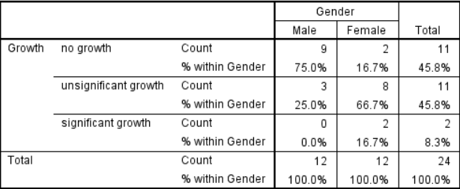
Table 2: bacterial growth and gender correlation.
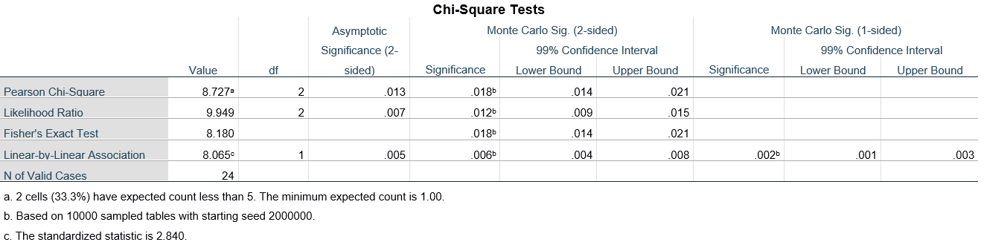
Table 3: Chi-Square ( Fisher ) Test (Fisher exact test/significance represents the p-value)
Table 3 states that the p-value was less than 0.05 so we reject the null hypothesis indicating there is an association between gender and the prevalence of asymptomatic bacteriuria.

Graph 1: difference in growth between males and females
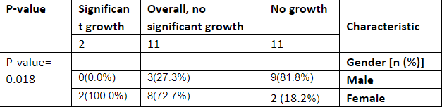
Table 4: the summary table

Discussion:
The results support the hypothesis that states that there is an association between gender and asymptomatic bacteriuria. Graph 1 shows that females have a higher rate, as seen 75% of males showed no growth at all and 25% showed insignificant growth while none were positive for asymptomatic bacteriuria, whereas in females only about 17% showed no growth while about 67% showed insignificant growth and about 17% were positive for asymptomatic bacteriuria. This is due to many factors, some of these reasons are the anatomical structure of the female urinary tract. Females have a smaller urethra which functions to carry the urine out of the body, the bacteria use the urethra to get into the urinary tract, having a shorter urethra makes it easier for the bacteria because it will have to cross a smaller distance. Another cause is the placement of the urethra closer to the rectum which contains Escherichia coli (E.Coli) which is the most common causative agent of asymptomatic bacteriuria and UTIs. The anatomical structure of the reproductive system in females also makes them more prone to contract UTIs and asymptomatic bacteriuria. (3)
The risk for asymptomatic bacteriuria increases while going through menopause as well. Going through menopause means estrogen levels will diminish, this leads to a thinner vaginal tissue making it more prone to infection. Pregnancy also increases the risk of asymptomatic bacteriuria due to hormonal changes that may cause vesicoureteral reflux which means flowing the urine back to the bladder and later the kidney, this means the risk for pyelonephritis will also increase making it dangerous. Some drugs increase the risk for asymptomatic bacteriuria as well, one such type of drug is the spermicide which causes vaginal irritation that can create an environment for bacterial growth. (2)
The majority of patients with asymptomatic bacteriuria do not develop symptoms such patients are children, diabetic patients, and older patients. In contrast, patients undergoing urologic surgery where mucosal bleeding is expected should be treated, patients in the first three months following renal transplant should be treated as well, Pregnant women also need to be treated to avoid pyelonephritis, low weight birth, or preterm birth. Treating patients that do not need treatment should be avoided because it increases the risk of antimicrobial resistance. (5)
As mentioned earlier E.Coli is the predominant causative pathogen for asymptomatic bacteriuria this is due to E.Coli being a part of the normal flora of the colon. Other pathogens include Klebsiella pneumoniae, Pseudomonas aeruginosa, Staphylococcal, and Enterococcal species. (1)
Conclusion:
This experiment proved that there is an association between gender and asymptomatic bacteriuria, specifically demonstrating that females are more susceptible to it for a variety of reasons such as the anatomical structure of the female reproductive system. Asymptomatic rarely develops into a serious infection and causes another disease thereby it does not need treatment except for some cases such as pregnancies because it may cause fatal conditions for both the child and the mother and also in kidney transplant patients, thus its treatment better be avoided to decrease the risk of antibiotic resistance. The most common causative agent is E.Coli because it is part of the normal flora of the colon. Further experiments may be done to see the relation between bacteriuria and age or its relation with immunity affecting diseases such as diabetes and auto immune deficiency syndrome (AIDS).
References:
1- Givler DN, Givler A. Asymptomatic Bacteriuria. In: StatPearls. Treasure Island (FL): StatPearls Publishing; May 1, 2022.
2- Colgan R, Jaffe GA, Nicolle LE. Asymptomatic Bacteriuria. Am Fam Physician. 2020;102(2):99-104.
3- Geerlings SE. Clinical Presentations and Epidemiology of Urinary Tract Infections. Microbiol Spectr. 2016;4(5):10.1128/microbiolspec.UTI-0002-2012. doi:10.1128
4- Cortes-Penfield NW, Trautner BW, Jump RLP. Urinary Tract Infection and Asymptomatic Bacteriuria in Older Adults. Infect Dis Clin North Am. 2017;31(4):673-688. doi:10.1016/j.idc.2017.07.002
5- Almaimani AO. Asymptomatic Bacteriuria in Post Renal Transplant Patients: To Treat or Not?. Cureus. 2021;13(6):e15713. Published 2021 Jun 17. doi:10.7759/cureus.15713
6- Levinson, Warren. Review of medical microbiology and immunology. 13rd ed. The McGraw-Hill Companies, 2014.

