
LIBYAN INTERNATIONAL MEDICAL UNIVERSITY
APPLIED MEDICAL SCIENCES –THIRD YEAR
P.T.S. BLOCK
Assignment
Project management workshop

Name: فاطمه محمد Roll number:2389 Group: A2

- Develop a network diagram for the project specified below. (50 %)
- Identify the Critical Activities and the total duration of the project. (35%)
- Justify which activity would you crash based on some rationale (15%)
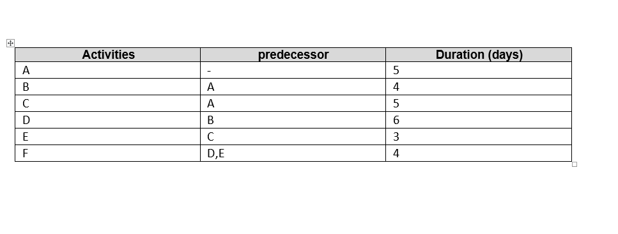

Answer 1: Diagram network for the project
F
E
D

B

A

C

Answer 2: the Critical Activities and the total duration of the project:
Path number 1: A B D F, it is the longest pathway; the total duration is 19 days.
Path number 2: A C E F, the total duration is 17 days.
The total duration of all project is 27 days.

Answer 3: the activity that would be crash is number D
Because it takes more days.
Because it is present in the longest path of the project.
The opposite step it in the project (E) has a few days (3 days) and this allows it flexibility.

