Libyan International Medical University
Faculty of Applied Medical Science

Asymptomatic bacteriuria

Student name: Najat Ahmad Elgemati.
Student number: 2756.

Assistant by: Dr. Entesar Alngai .
Assistant by :
Dr. Naji Elhemri
Dr. Asma Elkawafi
Dr. Alsenusi Alsherif

Abstract
Asymptomatic bacteriuria (ABU) is a prevalent clinical disease that frequently results in the overuse of antibiotics. Although the urine system is typically sterile, it can get polluted by gut flora or other organisms, resulting in urinary illness. The most prevalent bacterium found in asymptomatic bacteriuria is Escherichia coli. In midstream void samples, 1 > 105 CFU/L is indicative of infection, in catheterization samples, 1 >102 CFU/L is indicative of infection. Due to the length of the urethra, bacteria are more prevalent in women than in men. However, there is large number of antibiotics that can be used in case of UTIs such as quinolones, chloramphenicol, aminoglycosides, macrolides and lastly tetracycline.

1
Introduction

A urinary tract infection (UTI) is a general term for an infection of the lower or upper urinary tract. Although the urine system is typically sterile, it can get polluted by gut flora or other organisms, resulting in urinary illness. The most frequent bacteria that cause urinary tract infections are Escherichia coli, Klebsiella pneumoniae, Proteus mirabilis and Staphylococcus saprophyticus (1)

asymptomatic bacteria is a common clinical finding. Asymptomatic bacteriuria affects less than 0.5 percent of newborns and toddlers, but the rate rises with age. It ranges from 5% or less among healthy premenopausal women to 15% or more among women and men aged 65 to 80, and it continues to rise after age 80, reaching as high as 40% to 50% of long-term care residents. The most prevalent bacterium found in asymptomatic bacteriuria is Escherichia coli . (2)

Escherichia coli is a very common bacterium because it is part of the common intestinal flora, which is found in water, sunflower and vegetables . (3)

Asymptomatic bacteriuria is more common in women than men due to the female urethra, which allows bacteria from the urethral meatus and perineum to travel a short distance to the bladder. In fact, most women have bacteriuria that passes after having sex, but only a small number of these women will have symptomatic infections because the body's natural immune systems often prevent this. The high incidence of asymptomatic bacteriuria in the elderly is thought to be due to another imperfection (1).

Urine in the bladder is usually sterile. The colon-forming unit (CFU) per milliliter of numerical index was created to prove infection as sample
2
contamination can occur when urine flows to the outer part of the urethra.

For samples retrieved in the middlestream void, 1> 105 CFU / L is associated with infection. In catheterization samples, 1> 102 CFU / L is associated with infection. (3)
In this report we use 24 sample (12 females and 12 males) samples are taken from middlesterm than but the number of bacteria in each sample in SPSS program to measure the p value and know if there are any associated between bacteria growth and gender .

Materials and methods

You should collect your pee (urine) sample in a totally clean (sterile) container, and if you can't hand in your urine sample within 1 hour, place it in a sealed plastic bag and store it in the fridge at around 4 degrees Celsius. It should not be kept for more than 24 hours.

A random specimen, a first morning specimen, or a timed collection are all examples of urine samples that may be requested.

To obtain a urine sample, follow these steps:
. 1 Clearly mark a sterile, screw-top container with your name, birth date, and the date.
2 Start peeing and collect a sample of urine "mid-stream" in the container, then screw the lid tight and wash your hands thoroughly.
3

To calculate the number of microorganisms per ml in the original specimen, multiply the number of CFUs by 1000 (if a 0.001 ml loop was used) or by 100 (if a 0.01 ml loop was used).

After 24 to 48 hours of incubation, if it is no or minimal growth on the agar, the urine culture is termed negative
After calculate the bacteria number but in SPSS program and measured the P value by using the Fisher's test to know if there are any associated between gender and bacteria growth

Result and Statistics analysis

4




5
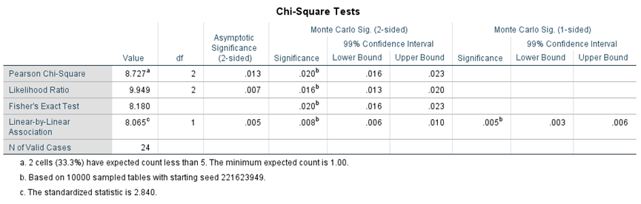

As previously stated, chi-square would not be utilized because 20% is less than the predicted count of fewer than five, hence a fisher's test would be employed instead.
6
Nine of the men had no microbial growth, whereas just two of the females did. There has been no major increase. Only three men are positive, while eight women are. No males tested positive for considerable growth, while two females tested positive for significant growth.

Discussion

Hypothesis: H0: There is no link between gender and bacterial proliferation.
Ha : There is an association between gender status and bacterial growth
There's a link between gender and bacterial proliferation, it turns out.
The significance level is below 0.05. The null hypothesis was rejected, indicating that there is a link between gender and bacteriuria in the absence of symptoms.
Bacteriuria is more common in women than in men due to the shorter female urethra, which permits germs from the urethral meatus and perineum to travel a shorter distance to the bladder. The increased frequency of asymptomatic bacteriuria in the elderly is assumed to be due to complete bladder emptying.
Under the microscope, it was pink and rod-shaped, indicating that it was a gram-negative bacillus. The bacteria was initially assumed to be either pseudomonas aeruginosa or E. coli, but subsequent biochemical testing revealed that it was E. coli. E. coli is the most common bacterium that causes asymptomatic community-acquired bacteriuria, according to my knowledge. Uropathogenic strains have adhesin proteins in their pili that connect to specific receptors on the urinary tract epithelium, such as a- d galactopyranosyl-beta-d glactopyranoside, which can cause asymptomatic urinary tract infection. E. coli's motility may aid its ability to ascend the urethra into the bladder and ascend the ureter into the kidney.
7

Conclusion
It was discovered in a trial involving 24 persons, including 12 women and 12 men, that the rate of no bacterium growth was 18 in women and 73 in men.
Bacteriuria is more common in women than in men due to the shorter female urethra, which permits germs from the urethral meatus and perineum to travel a shorter distance to the bladder.
The increased frequency of asymptomatic bacteriuria in the elderly is assumed to be due to complete bladder emptying.
Referencing

1 Ditkoff EL, Theofanides M, Aisen CM, Kowalik CG, Cohn JA, Sui W, Rutman M, Adam RA, Dmochowski RR, Cooper KL. Assessment of practices in screening and treating women with bacteriuria. Can J Urol. 2018 Oct;25(5):9486-9496

2 Dahiya A, Goldman RD. Management of asymptomatic bacteriuria in children. Can Fam Physician. 2018 Nov;64(11):821-82

3 Levinson, Warren. Review of medical microbiology and immunology. 13rd ed. The McGraw-Hill Companies, 2014
8

