(2021/2022)
LIMU/YEAR2
BLOCK: PTS

Lap Report
Use of urinary gram stain for detection of urinary tract infection in childhood

Student name: Doaa Mohammed Alfarsi
Student number: 3008

Supervisor name: DR. Entisar Elnaji
Assistant by :
DR. Asma alkowafi
DR. Lojain salah
Date: 2022/6/20

Abstract:

In this experiment, urine culture, Gram stain, and other urine analysis procedures were used.
In 100 children with signs of urinary tract infection, "leucocyte esterase, nitrate, microscopy for bacteria, and pyuria" were evaluated. The goal of this study was to see how well a urinary Gram stain compared to a combination of Gram stain and entire urine analysis, such as nitrate positiveness, leukocyte esterase, bacteria microscopy, and white blood cell microscopy.
70 percent of 100 children (aged 2 days to 15 years) had a positive urine culture, with 43 percent of boys and 57 percent of girls. The pathogen E.coli was the most frequently isolated (Escherichia coli). The urinary Gram stain's sensitivity and specificity were 80 percent and 83 percent, respectively, as were the pyuria + Gram stain's 42 percent and 90 percent, and the 3.5 percent of total urine analysis.
In symptomatic individuals, no urine screen, according to our data, can replace a urine culture.

Introduction:

Urinary tract infection (UTI) is a common childhood infection that affects 3-5 percent of females and 1% of males.
In this age group, prompt treatment is crucial because even a minor delay could have long-term implications. Some of the quick screening methods include urine analysis (microscopic pyuria), enhanced urine analysis (white blood cell "WBC" count per cubic millimeter with Gram stain), urine dipstick (leukocyte esterase or nitrate), and urine screen (catalase test). None of them have proven to be sufficient.
In this study, urine culture, urinary Gram stain, and four urine analysis tests, leukocyte esterase, nitrate, bacteria microscopy, and pyuria microscopy, were all evaluated in children with symptoms suggesting UTI. The purpose of this study was to see how reliable the urinary Gram stain was compared to a combination of pyuria with Gram stain and total urine analysis.

Materials and Methods:

Between January and June 1999, 100 children with symptoms suggesting UTI were admitted to the hospital's department of popocliatrics.
All of the children were given physical examinations, and urine samples were taken in a sterile manner. Microscopy for bacteria and pyuria was performed on a centrifuged urine specimen. Leukocyte esterase was assessed positively in automated urinalysis if at least a (trace) was present, and nitrate was read qualitatively as (positive) or (negative) (negative).
Pyuria was defined as the presence of more than fine WBCs on unstained microcopy, and bacteria was defined as the presence of at least a (slight) reading pre-average high-powered field on unstained microcopy (40 x magnification).
Quantitative urine culture was inoculated onto sheep blood agar and eosin methylene blue agar culture plates using a loop calibrated to provide 0.01 ml.

to inoculate sheep blood agar and eosin methylene blue agar culture plates.
All plates were incubated at 35C0 and read at 48 hours for bacterial identification and colony count.
Gram staining was performed on all specimens using the following procedure:
• Centrifuged urine, Gram's iodine (2 g potassium iodine in 300 mL distilled water plus 1 g iodine crystals), 95 percent ethanol and/or isopropanol acetone combination (1:3), and safranin
• Clear, fingerprint-free glass slides.
• A Bunsen burner is a gadget that allows you to heat water in a closed-loop.
• A staining rack is a piece of equipment that is used to apply stains to a surface. • Immersion oil is a liquid that is used to create a submerged atmosphere.
• Difco Bacto Gram Stain Reagents for Three-Step Gram Stain (Difco Bacto Gram Stain Reagents for Three-Step Gram Stain)
A culture was considered positive if it contained more than 100.000 colonies of a single pathogen.
To evaluate the data and do statistical analysis, the X square test was performed

Results:

The study comprised 100 children ranging in age from 2 days to 15 years old, with 48 percent boys and 52 percent girls.
A positive urinary culture was found in 70% of the children, with 43 percent of boys and 57 percent of girls.
The majority of these children were under the age of five.
There is a clear distinction between gender and age groupings (Table 1).
47 percent of the cultures tested positive for E. coli, 18.5 percent for Klebsiella pneumonia, 10% for Proteus mirabilis, and 8.5 percent for staphylococci, among other bacteria. Gram stain sensitivity, specificity, and predictive values for pyuria + Gram stain, and overall urine analysis, for example, 8.5 percent for Proteus mirabilis and 8.5 percent for staphylococci, etc.
The urinary Gram stain had the highest specificity of 90%, whereas the combination of pyuria and Gram stain had the highest sensitivity of 80%.

Discussion:
Although numerous studies have been carried out to explain the use of urine gram stain in infants and children, the results have been varied. In a study of 207 symptomatic infants younger than 6 months of age, the Gram stain showed a sensitivity of 94% and specificity of 92%, whereas the whole urine analysis test had a sensitivity of 67% and specificity of 79%.
Although both Gram-stained smears and dipsticks exhibited a minor positive predictive value, a study of 1,019 symptomatic pediatric patients found that Gram-stained smears were somewhat more sensitive than dipsticks (97.6% vs. 90.2%).

Conclusion:

According to our findings, a combination of pyuria and Gram stain had the highest specificity (90%) but the lowest sensitivity (50%) of all the tests (42 percent ).
The urinary gram stain showed the highest specificity (90%) while the total urine analysis had the lowest specificity (3.5%).
We feel that neither urine screening nor urine culture should be employed in symptomatic pediatric patients in light of these findings.

Result of the statistical analysis:

The purpose of this study was to examine the presence of
bacteria in urine samples from 24 middle-aged LIMU
understudies. There were twelve young ladies and twelve
young men.
asymptomatic bacteriuria was discovered.
There were 7 (29.2%) understudy whose urine tests
developed less than 10,000 CFU/mL, 6 (25%) cases with
10,000 CFU/mL and more, and 11 (45.8%) with no
development. As a result, asymptomatic bacteriuria was
prevalent in 18% of LIMU understudies.
(75%) and as followed in the table
 |  |  | Gender |  | Total
 |  |  | Female | Male | Total
CFU | No growth | Count | 2 | 9 | 11
CFU | No growth | Expected Count | 5.5 | 5.5 | 11.0
CFU | No growth | % within Gender | 16.7% | 75.0% | 45.8%
CFU | Overall no significant growth | Count | 8 | 3 | 11
CFU | Overall no significant growth | Expected Count | 5.5 | 5.5 | 11.0
CFU | Overall no significant growth | % within Gender | 66.7% | 25.0% | 45.8%
CFU | Significant growth | Count | 2 | 0 | 2
CFU | Significant growth | Expected Count | 1.0 | 1.0 | 2.0
CFU | Significant growth | % within Gender | 16.7% | 0.0% | 8.3%
Total |  | Count | 12 | 12 | 24
 |  | Expected Count | 12.0 | 12.0 | 24.0
 |  | % within Gender | 100.0% | 100.0% | 100.0%

\

 | Case processing summary
 | Valid |  | Missing |  | Total
 | N | Percent | N | Percent | N | Percent
CFUcat * Gender | 24 | 64.9% | 13 | 35.1% | 37 | 100.0%
\

Chi-Square Tests
 | Value | df | Asymptotic Significance (2-sided) | Monte Carlo Sig. (2-sided) |  |  | Monte Carlo Sig. (1-sided)
 |  |  |  | Significance | 99% Confidence Interval |  | Significance | 99% Confidence Interval
 |  |  |  |  | Lower Bound | Upper Bound | Significance | Lower Bound | Upper Bound
Pearson Chi-Square | 8.727ª | 2 | .013 | .018^{b} | .014 | .021
Likelihood Ratio | 9.949 | 2 | .007 | .012^{b} | .009 | .015
Fisher's Exact Test | 8.180 |  |  | .018^{b} | .014 | .021
Linear-by-Linear Association | 8.065^{c} | 1 | .005 | .006^{b} | .004 | .008 | .004^{b} | .003 | .006
N of Valid Cases | 24
a. 2 cells (33.3%) have expected count less than 5. The minimum expected count is 1.00.
b. Based on 10000 sampled tables with starting seed 2000000.
c. The standardized statistic is -2.840.

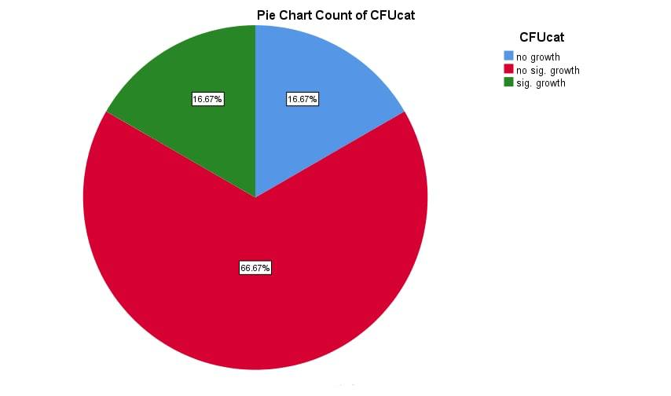

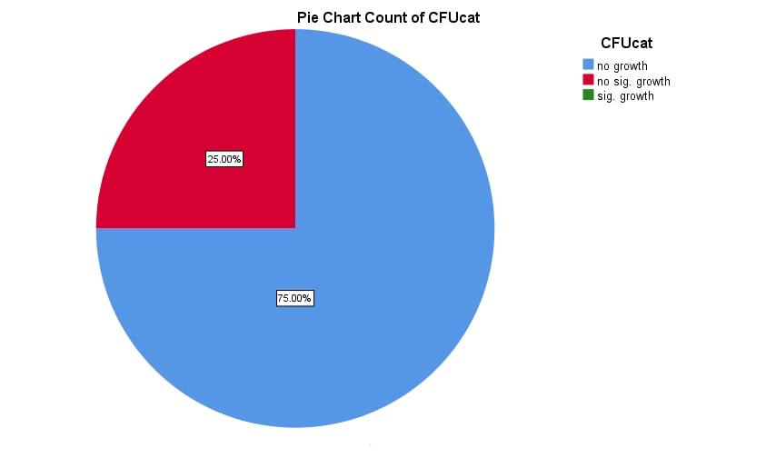
REFERENCES:
- Levinson, Warren. Review of medical microbiology and immunology. 14rd ed. The McGraw-Hill Companies, 2016
- Arslan S, Caksen H, Rastgeldi L, Uner A, Oner AF, Odabaş D. Use of urinary gram stain for detection of urinary tract infection in childhood. Yale J Biol Med. 2002;75(2):73-78
- Gorelick MH, Shaw KN. Screening tests for urinary tract infection in children: A meta-analysis. Pediatrics. 1999;104(5):e54. doi:10.1542/peds.104.5.e54
- Lockhart GR, Lewander WJ, Cimini DM, Josephson SL, Linakis JG. Use of urinary gram stain for detection of urinary tract infection in infants. Ann Emerg Med. 1995;25(1):31-35. doi:10.1016/s0196-0644(95)70351-9
- Levinson, Warren. Review of medical microbiology and immunology. 14rd ed. The.McGraw-Hill Companies, 2016

