The Incidence Rate of Asymptomatic Bacteriuria among LIMU Students

Name: Adnan Fouad Abed Asheibi.
Student number: 2780
Instructor: dr. asma
Course Title: P.T.S
Due Date: 20/6/2022

Abstract:
This aim of this research was to observe wither there is an association between gender and asymptomatic bacteriuria and to establish a valid comparison between males and females on such topic. The experiment consisted of collecting urine samples from 24 students at LIMU using the midstream-clean catch method, then the samples were cultured by inoculating the urine into a media. Following the growth of the microorganisms the colonies were counted and the CFU was calculated. Once the data was obtained, it was categorized into growth, non-significant and significant growth, then analyzed using chi-square on spss. Our data confirmed the association between gender and asymptomatic bacteriuria as well as showing that females are more prone to acquiring asymptomatic bacteriuria than man. Therefore, gender should be considered as a risk factor when diagnosing asymptomatic bacteriuria.
Introduction:
Asymptomatic bacteriuria is a term used in regards to bacteria isolated from urine samples collected from individuals who do not have UTI, patients in general do not experience any manifestations. (1)
Females are generally more prone to UTIs than men because of physical factors such as the short length of their urethra as it is considered an entrance for microorganisms, the proximity of the urethra to the anus that increases the risk of catching E. coli which is the most common causes of UTIs constituting approximately 51% of overall cases as well as biological or physiological factors such as menopause in which there are low levels of estrogen that make the vaginal tissue thinner and more prone to infection and also in pregnancy, changes in urine formation and immune system as well as the increasing pressure to the bladder that decreases urine flow leading stasis which favors bacterial growth, another factor is to lack of antiseptic properties of semen in women. (2) (3)(4)
Based on that, we established a hypothesis that there are an association between gender and asymptomatic bacteriuria and that females are more susceptible for it than males due to the fact that they are more likely to acquire it.

Method and Materials:
Using the midstream clean-catch method, urine samples were collected from 24 students in Libyan International Medical University to be cultured for experimenting.
The equipment used was urine samples, a 0.001ml wire loop, a Bunsen burner and a growth media, typically 5% sheep agar plate, CLED and MacConkey which permits the detection of most gram-negative bacilli.
After the samples were obtained, a wire loop was heated for sterilization and left till cool, then the loop was dipped into the urine sample to let the urine adhere to it and subsequently the loop was spread across the surface of agar plate in a zigzag line. The loop was dipped once more in the urine samples to inoculate a second agar plate without flaming the loop in order not to kill the microorganism. Lastly, the medias were incubated for 24 hours at 37c in air.
Following the growth of the microorganism the number of CFU was counted and multiplied by 1000 to measure the number of microorganisms per ml in the specimen and the data was first analyzed using chi-square then then due to more than 20% of cells having an expected value less than 5, a fisher's test was used.
Results:
 | CFU/mL
Characteristic | No growth | Overall, no significant growth | Significant growth | P-value
Characteristic | 11 | 11 | 2 | P-value
Gender [n (%)] |  |  |  | P-value= 0.018
Male | 9(81.8%) | 3(27.3%) | 0(0.0%) | P-value= 0.018
Female | 2 (18.2%) | 8(72.7%) | 2(100.0%) | P-value= 0.018

Table 1

As shown in Table 1, a total of 11 subjects showed no growth and those consisted of 9 males constituting 81.8% of no growth samples and 2 females representing the remaining 18.2%. 11 subjects showed growth however it was not significant as it was below 100,000 and those consisted of 3 males (27.3%) and 8 females (72.7%). The remaining subjects showed a significant growth of 100,000 and higher and consisted solely of 2 females.
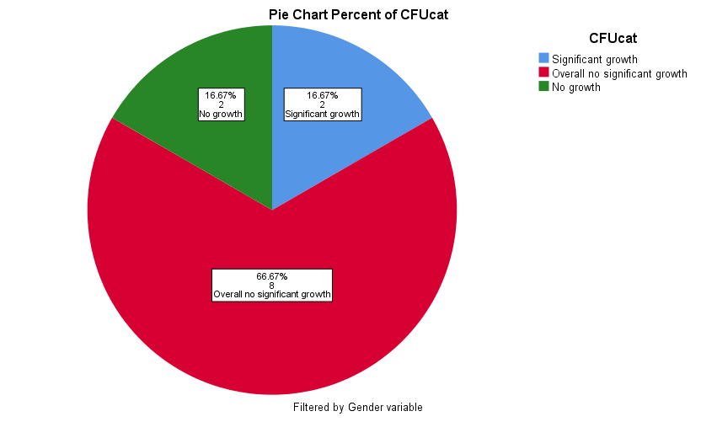
Figure 1
As shown in Figure 1, from the total number of samples obtained from female subjects, 16.67% of samples from females showed no growth and 16.67% of them showed significant. The remaining majority showed an overall non-significant growth.
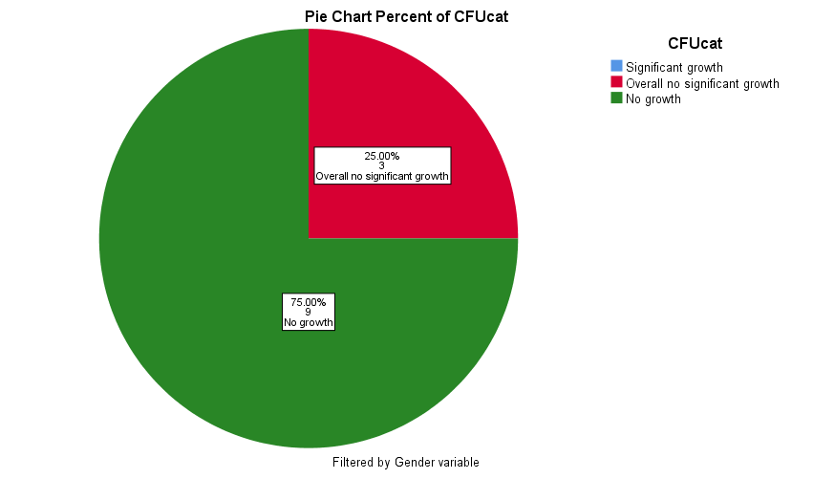
Figure 2
As shown in Figure 2, 75% of samples obtained from male subjects had no growth and the remaining 25% showed non-significant growth.

Discussion:
As shown in Table 1, the p value is equal to 0.018 which is greater than 0.05 and therefore it confirms that there is an association between gender and CFU which meets our assumption, and from comparing values between Figure 1 and Figure 2 it determines that females are more likely to acquire an asymptomatic bacteriuria and that is due to many reasons or causes, a major one being sexual intercourse and use of spermicidal contraceptive, In addiction to anatomical factors as in the close proximity of the vagina to anus and can also be associated with physiological factors such as estrogen deficiency.(5)

Though our assumption was met, the results and data obtained are weak in terms of illustrating a more descriptive comparison between males and females, in addition to the data facing a couple of difficulties during the analysis and that is due to multiple reasons, a major one being the sample size. So therefore increasing the size of the sample and including more students would improve the results and provide a more statistically accurate comparison. However, it should be kept in mind that increasing the sample size makes the experiment more expensive and harder to conduct. Another contributing factor to our weak results was that the subjects were within the same age group, so varying the age group within the sample would provide a stronger data to illustrate a more precise comparison.

Even though, the samples size was small and it faced difficulties analyzing data, the results matched other studies of showing that females are generally mor susceptible to acquire an asymptomatic bacteriuria. In fact, one study shows that premenopausal women have approximately 5% risk of asymptomatic bacteriuria and that both men and woman within the age group 65-80 years old have 15% risk that continues to rise to up to 40-50% by the age of 80 years. Never the less, at any given age, women have a greater risk of acquiring asymptomatic bacteriuria than men. (6)

The goal of the experiment to assess the microbial spectrum of asymptomatic bacteriuria could not be achieved as the sample size was rather small and inappropriate for such finding as only two samples showed significant and showed growth of E. coli which according to multiple researchers it is the most common pathogen of asymptomatic bacteriuria constituting approximately 70-80% of clinical cases. (3) (7)(8)

A number of other gram-negative bacteria may also cause asymptomatic bacteriuria, and these include Klebsiella, Proteus mirabilis and pseudomonas aeruginosa. Gram positive bacteria including enterococcus species, staphylococcus saprophyticus and group B streptococci can cause asymptomatic bacteriuria, in addition to candida species. (3)(8)

Conclusion:
The goal of this experiment was to determine the association between asymptomatic bacteriuria and gender in addition to providing a comparison between males and females as well as covering the microbial spectrum of asymptomatic bacteriuria.
The experiment consisted of first urine collection followed by sample culturing and then following the growth, the number of CFU was calculated. Once the data was assembled and obtained, it was analyzed using chi-square.
Despite the errors faced, the data confirmed our hypothesis and we can confidently view gender as a risk factor of asymptomatic bacteriuria.

References
- UpToDate [Internet]. Uptodate.com. 2022. Available from: https://www.uptodate.com/contents/asymptomatic-bacteriuria-in-adults#:~:text=The%20term%20asymptomatic%20bacteriuria%20refers,urinary%20tract%20infection%20(UTI).
- 7 Reasons Why Women Get More UTIs Than Men [Internet]. Virginia Physicians for Women. 2022 [cited 5 June 2022]. Available from: https://vpfw.com/blog/7-reasons-why-women-get-more-utis-than-men/
- LEVINSON W. REVIEW OF MEDICAL MICROBIOLOGY AND IMMUNOLOGY. 15th ed. [S.l.]: MCGRAW-HILL EDUCATION; 2018.
- UpToDate [Internet]. Uptodate.com. 2022. Available from: https://www.pregnancybirthbaby.org.au/urinary-tract-infections-utis-during-pregnancy#:~:text=During%20pregnancy%2C%20many%20changes%20occur,and%20lead%20to%20an%20infection.
- RD H, TM H. Urinary tract infection risk factors and gender [Internet]. PubMed. 2022 [cited 31 May 2022]. Available from: https://pubmed.ncbi.nlm.nih.gov/11253265/
- Givler D, Givler A. Asymptomatic Bacteriuria [Internet]. Ncbi.nlm.nih.gov. 2022 [cited 31 May 2022]. Available from: https://www.ncbi.nlm.nih.gov/books/NBK441848/
- Le T, Bhushan V, Skelley N. First aid for the USMLE step 2 CK. New York: McGraw-Hill Medical; 2019.
- Asymptomatic Bacteriuria in Pregnancy: Causes, Treatment and More [Internet]. Healthline. 2022 [cited 1 June 2022]. Available from: https://www.healthline.com/health/pregnancy/infections-asymptomatic-bacteriuria

