


Use of urinary gram stain for detection of urinary tract infection in childhood

Student Name: Sally Salem Alzaidi
Student Number: 2915
Supervisor: Dr: Entisar Elnaji
Assisted by: Dr: Asma Alkwafi and Dr: Lojain

Abstract:
In this study, urinary culture, Gram stain, and tests within the urine analysis.
In 100 children with symptoms of urinary tract infection," Leucocyte esterase, nitrate, Microscopy for bacteria and pyuria " were examined.
We intended to establish the validity and benefits of the urinary Gram stain compared with a combination of Gram stain and overall urine analysis " positiveness of nitrate, leukocyte esterase, microscopy for bacteria or microscopy for white blood cells".
Of 100 children (age: 2 days-15 years), 70% had a positive urinary culture : 43% boys and 57% girls.
The most common isolated agent was E.coli (Escherichia coli).
The sensitivity and specificity of the urinary Gram stain were 80% and 83%, and for both pyuria plus Gram stain 42% and 90%, and that of the overall urine analysis was 3.5% respectively.
Our findings showed there is no route of urine screen that can replace a urine culture in symptomatic patients.

Introduction:
Urinary tract infection (UTI) urinary traction infection (UTI) is a very common type of infection in your urinary system. A UTI can involve any part of your urinary system, and it is a common disease in childhood approximately 3-5 % of girls and 1 % of boys develop a UTI.
In childhood, effective treatment and early diagnosis are essential to prevent permanent complications.
There are several rapid screening techniques such as urine screen (catalase test ), urine analysis (microscopic pyuria), enhanced urine analysis( white blood cell “WBC” count per cubic milli meter plus Gram stain ), urine dipstick ( leukocyte esterase or nitrate). None of them have shown to be satisfactory.
In this study, urinary culture, urinary Gram stain, and four tests within the urine analysis, leukocyte esterase, nitrate, microscopy for bacteria, and microscopy for pyuria, were examined in children with symptoms suggesting UTI.
Our study aimed to determine the validity of the urinary Gram stain compared with a combination of pyuria plus Gram stain and overall urine analysis.
Materials and Methods:
The study included 100 children who were admitted to the hospital with symptoms suggesting UTI, between January 1999 and Jun 1999.
Physical examination was performed for all children and urine samples were collected by sterile technique.
Urine analysis, leukocyte esterase, and nitrate studies were performed in fresh and un centrifuged urine by using an automated urine analyzer.
Microscopy for bacteria and pyuria was performed on a centrifuged urine specimen, within automated urinalysis, leukocyte esterase was considered positive if at least a (trace ) was present, and nitrate was read qualitatively as ( positive ) or ( negative).
Pyuria was considered present if more than fine WBCs were noted on unstained microcopy, and bacteria was present if at least a (slight) reading was noted pre-average high-powered field (40 x magnification).
Quantitative urine culture was done, using a loop calibrated to deliver 0.01 ml to inoculate sheep blood agar and eosin methylene blue agar culture plates.
All plates were incubated at 35C0 and read at 48 hours for bacterial identification and colony count.
Gram stains were performed on all specimens using:
- Centrifuged urine.
- Staining rack.
- Clean glass slides.
- Immersion oil.
- Solutions of crystal violet, Gram’s iodine (2 g potassium iodide in 300 ml distilled water plus 1g iodine crystals),95% ethanol and/or isopropanol _ acetone mixture (1:3), and safranin .
- Inoculating loop.
- Bunsen burner.
- Bibulous paper.
- Bacto Gram stain reagents from disco for the three _ step gram stain.

Figure:
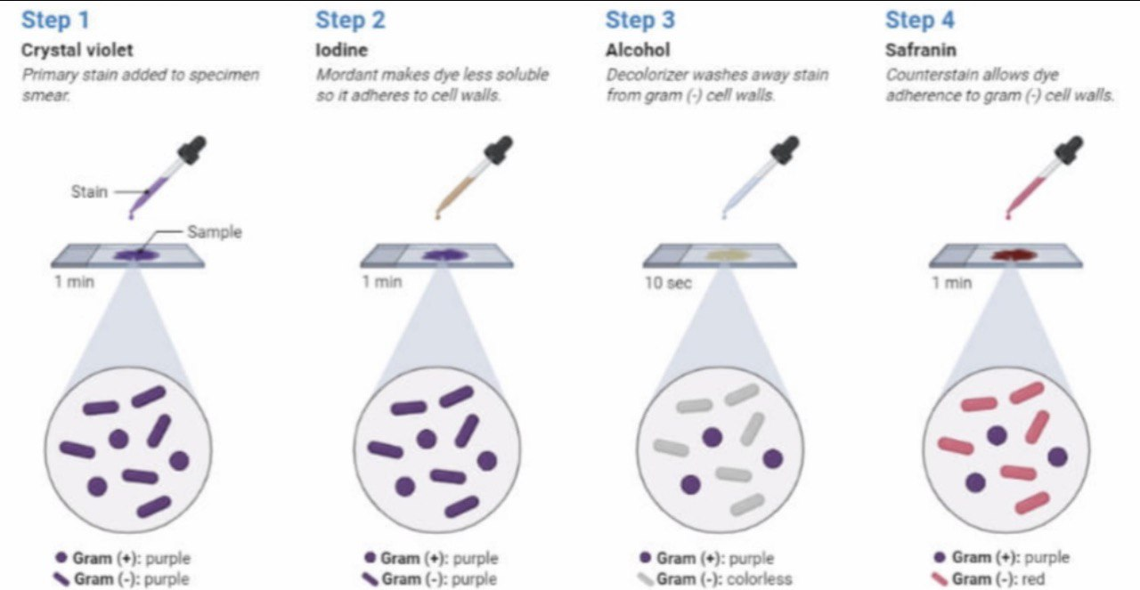

Cultures were considered positive if the culture showed more than 100.000 colonies of a single pathogen.
The results were analyzed and statistical analysis was performed by using the X _ square test.

Results:
A total of 100 children, aged 2 days to 15 years, were included in the study: 48%boys, and 52% girls.
Of these children, 70% had a positive urinary culture, 43% were boys and 57% were girls.
Most of these children were below 5 years old.
There is a significant difference between gender and age groups (Table 1).
Of the cultures , 47% were positive for E-coli, 18.5% for klebsiella pneumonia , 10% for proteus mirabilis , and 8.5% for staphylococci ,etc.
(Table 2) (Table 3) summarizes sensitivity, specificity , and predictive values for Gram stain, a combination of pyuria plus Gram stain, and overall urine analysis.
The highest 80% sensitivity was determined in urinary Gram stain, The highest 90%specificity was observed in the combination of pyuria plus Gram stain.
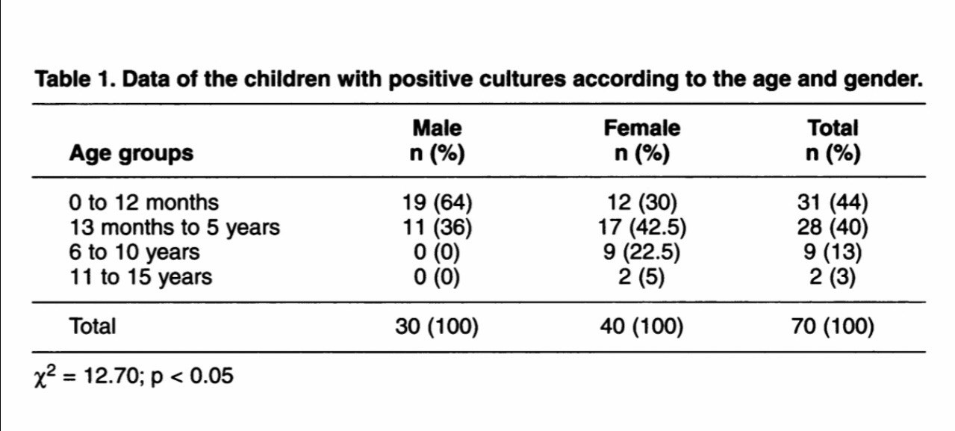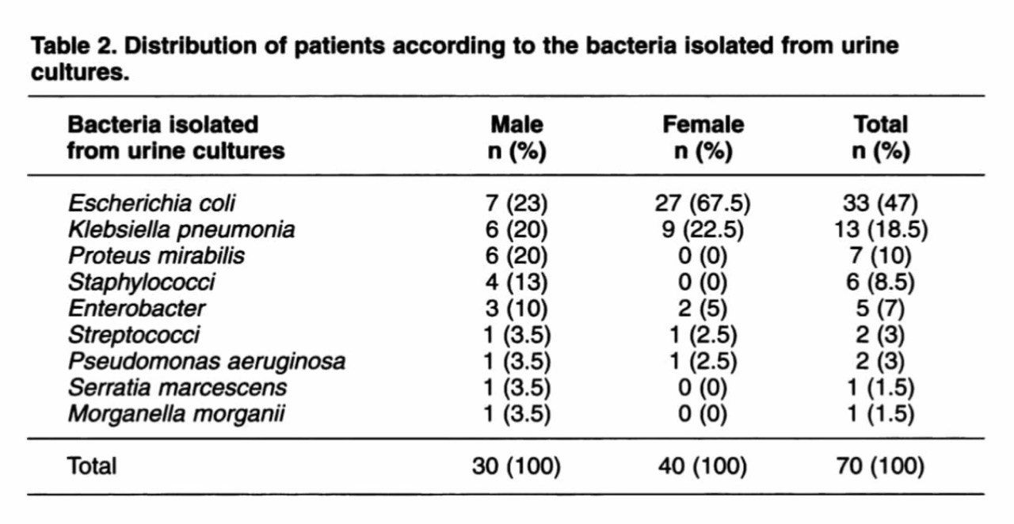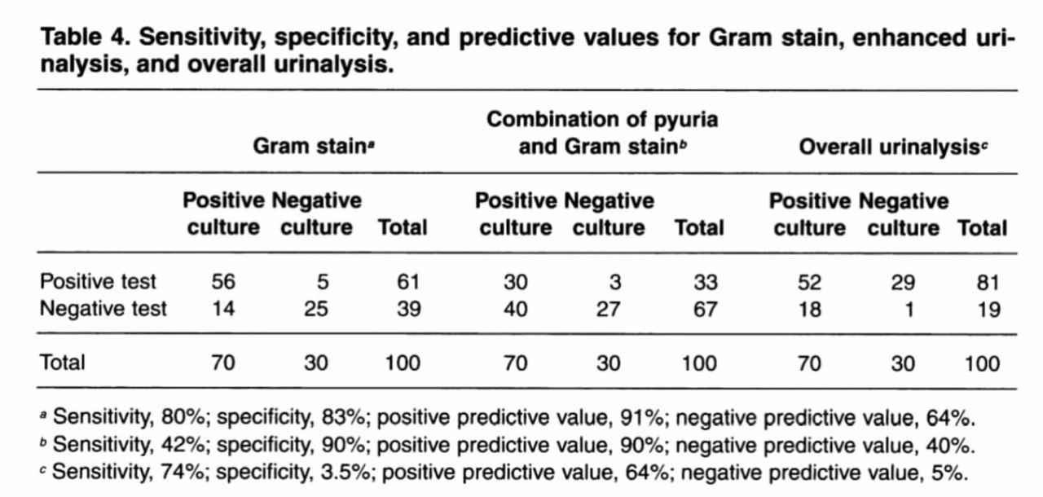

Discussion:

Although several studies have explained the use of urinary gram stain in infants and children, the results of investigations are different.
A study of 207 symptomatic infants younger than 6 months of age revealed the Gram stain to have a sensitivity of 94% and specificity of 92%, and the overall urine analysis test to have a sensitivity of 67% and specificity of 79%.
A review of 1,019 symptomatic pediatric patients revealed that Gram-stained smear was slightly more sensitive than dipstick (97.6% vs 90.2%), but the positive predictive value was low for both.
Conclusion:
In conclusion, our findings demonstrated that the combination of pyuria plus Gram stain gave the highest 90% specificity, but the lowest 42% sensitivity.
The highest 90% specificity was for urinary gram stain and overall urine analysis showed the lowest 3.5% specificity.
SO our findings illustrates there is no method for urine screen can substitute for urine culture in the symptomatic pediatric patients.

Paraphrasing:
Urinary culture, Gram stain, and assays from urine analysis were used in this investigation.
"Leucocyte esterase, nitrate, Microscopy for bacteria, and pyuria" were tested in 100 children with signs of urinary tract infection.
Our goal was to compare the validity and benefits of a urinary Gram stain to a combination of Gram stain and total urine analysis, such as nitrate positiveness, leukocyte esterase, bacteria microscopy, and white blood cell microscopy.
A positive urinary culture was found in 70 percent of 100 children (aged 2 days to 15 years): 43 percent of boys and 57 percent of girls.
E.coli was the most commonly isolated agent (Escherichia coli)
The urine Gram stain has a sensitivity and specificity of 80% and 83 percent, respectively, for both pyuria and pyuria plus.
Urinary tract infection (UTI) or urinary traction infection (UTI) is a frequent infection of the urinary tract. A urinary tract infection (UTI) can affect any portion of your urinary system, and it's a common pediatric ailment that affects 3-5 percent of girls and 1% of boys.
Effective treatment and early diagnosis are critical in childhood to avoid long-term consequences.
Urine screen (catalase test), urine analysis (microscopic pyuria), enhanced urine analysis (white blood cell "WBC" count per cubic millimeter with Gram stain), and urine dipstick are all examples of quick screening techniques ( leukocyte esterase or nitrate).
None of them have been shown to be adequate.
Urinary culture, urinary Gram stain, and four assays were used in this investigation.
Between January and June 1999, 100 children were taken to the hospital with symptoms that suggested they had a UTI.
All of the children were given a physical examination and a urine sample was taken using a sterile procedure.
An automated urine analyzer was used to perform urine analysis, leukocyte esterase testing, and nitrate testing in fresh and non-centrifuged urine.
On a centrifuged urine specimen, microscopy for microorganisms and pyuria was done. In automated urinalysis, leukocyte esterase was judged positive if at least a (trace) was present, and nitrate was read qualitatively as (positive) or (negative).
Pyuria was defined as the presence of more than fine WBCs on unstained microcopy, and bacteria was defined as the presence of at least a (slight) reading before an average high-powered field (40).
The study comprised 100 children ranging in age from 2 days to 15 years old, with 48 percent boys and 52 percent girls.
A positive urinary culture was found in 70% of the children, with 43 percent of boys and 57 percent of girls.
The majority of these children were under the age of five.
There is a clear distinction between gender and age groupings (Table 1).
47 percent of the cultures tested positive for E. coli, 18.5 percent for Klebsiella pneumonia, 10% for Proteus mirabilis, and 8.5 percent for staphylococci, among other bacteria.
(See Table 2)
The sensitivity, specificity, and predictive values for Gram stain, pyuria with Gram stain, and overall urine analysis are summarized in Table 3.
Urinary Gram stain had the maximum sensitivity of 80 percent, whereas urinary Gram stain had the highest specificity of 90 percent.
Even though a number of research have been conducted to explain the usage of urine gram stain in infants and children, the outcomes of these investigations have been mixed.
The Gram stain had a sensitivity of 94 percent and specificity of 92 percent in a trial of 207 symptomatic infants younger than 6 months of age, and the total urine analysis test had a sensitivity of 67 percent and specificity of 79 percent.
A study of 1,019 symptomatic pediatric patients found that Gram-stained smears were somewhat more sensitive than dipsticks (97.6% vs. 90.2%), although both had a modest positive predictive value.
Finally, our findings revealed that the combination of pyuria and Gram stain had the best specificity (90%) but the lowest sensitivity (42%).
Urinary gram stain had the highest specificity of 90 percent, whereas whole urine analysis had the lowest specificity of 3.5 percent.
As a result, our findings show that no urine screening tool can replace urine culture in symptomatic pediatric patients.

References:
- Westwood ME, Whiting PF, Kleijnen J. How does study quality affect the results of a Whiting P, Westwood M, Watt I, Cooper J, Kleijnen J. Rapid tests and urine sampling techniques for the diagnosis of urinary tract infection (UTI) in children under five years: a systematic review. BMC Pediatr. 2005;5(1):4. Published 2005 Apr 5. doi:10.1186/1471-2431-5-4diagnostic meta-analysis?. BMC Med Res Methodol. 2005;5:20. Published 2005 Jun 8. doi:10.1186/1471-2288-5-20.
- Whiting P, Westwood M, Watt I, Cooper J, Kleijnen J. Rapid tests and urine sampling techniques for the diagnosis of urinary tract infection (UTI) in children under five years: a systematic review. BMC Pediatr. 2005;5(1):4. Published 2005 Apr 5. doi:10.1186/1471-2431-5-4.
- Warren L. Review Of Medical Microbiology And Immunology. 14th ed. McGraw-HillCompanies; 2016.

Results and statistical analysis:

Gender * bacterialgrowhsignificance Crosstabulation
 |  |  | bacterialgrowhsignificance |  |  |  | Total
 |  |  |  | no growth | overall | signific | Total
gender | female | Count | 0 | 2 | 8 | 2 | 12
gender | female | % within gender | 0.0% | 16.7% | 66.7% | 16.7% | 100.0%
gender | female | % within bacterialgrowhsignificance | 0.0% | 20.0% | 72.7% | 100.0% | 50.0%
gender | male | Count | 1 | 8 | 3 | 0 | 12
gender | male | % within gender | 8.3% | 66.7% | 25.0% | 0.0% | 100.0%
gender | male | % within bacterialgrowhsignificance | 100.0% | 80.0% | 27.3% | 0.0% | 50.0%
Total |  | Count | 1 | 10 | 11 | 2 | 24
 |  | % within gender | 4.2% | 41.7% | 45.8% | 8.3% | 100.0%
 |  | % within bacterialgrowhsignificance | 100.0% | 100.0% | 100.0% | 100.0% | 100.0%

Chi-Square Tests
 | Value | df | Asymptotic Significance (2-sided) | Monte Carlo Sig. (2-sided)
 |  |  |  | Significance | 99% Confidence Interval
 |  |  |  |  | Lower Bound | Upper Bound
Pearson Chi-Square | 8.873ª | 3 | .031 | .019^{b} | .015 | .022
Likelihood Ratio | 10.372 | 3 | .016 | .015^{b} | .012 | .018
Fisher's Exact Test | 8.225 |  |  | .019^{b} | .015 | .022
N of Valid Cases | 24
a. 4 cells (50.0%) have an expected count of less than 5. The minimum expected count is .50.
b. Based on 10000 sampled tables with starting seed 2000000.

Result

Hypothesis: H0: No association between gender status and bacterial growth.
HA: There is an association between gender status and bacterial growth.

 | No growth | Overall | Significant growth
Males | 8 | 3 | 0
Females | 2 | 8 | 2
Summary table

A p-value of Fisher’s is 0.019
Decision: except to reject the null hypothesis (FTR) Since the P-value lesser than alpha 0.05, we except to reject the null hypothesis.

Conclusion there is an association between gender status and bacterial growth

